Project Title: StayHub-Integrated Hotel Management System

- Department
Insert:
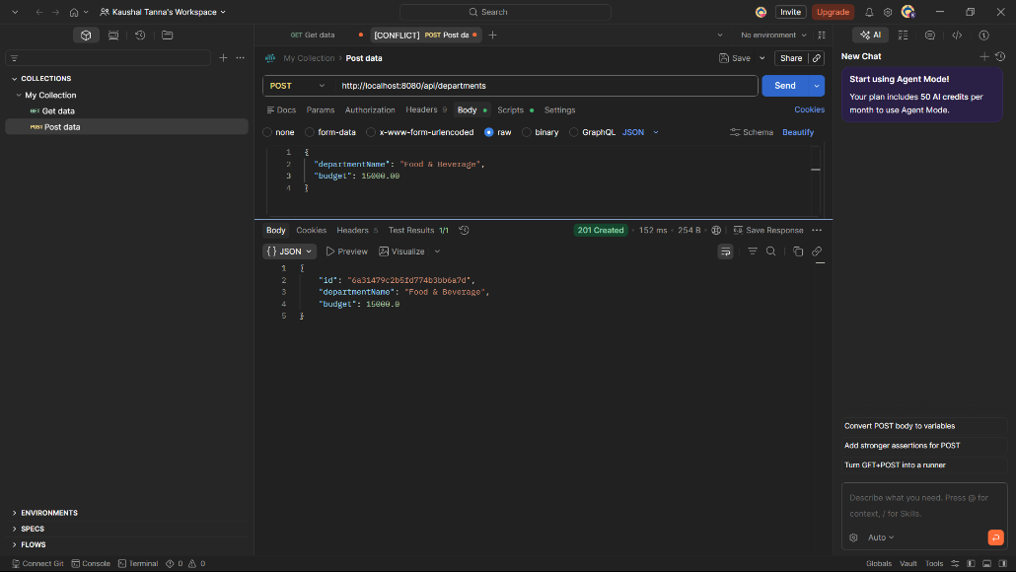
Read:
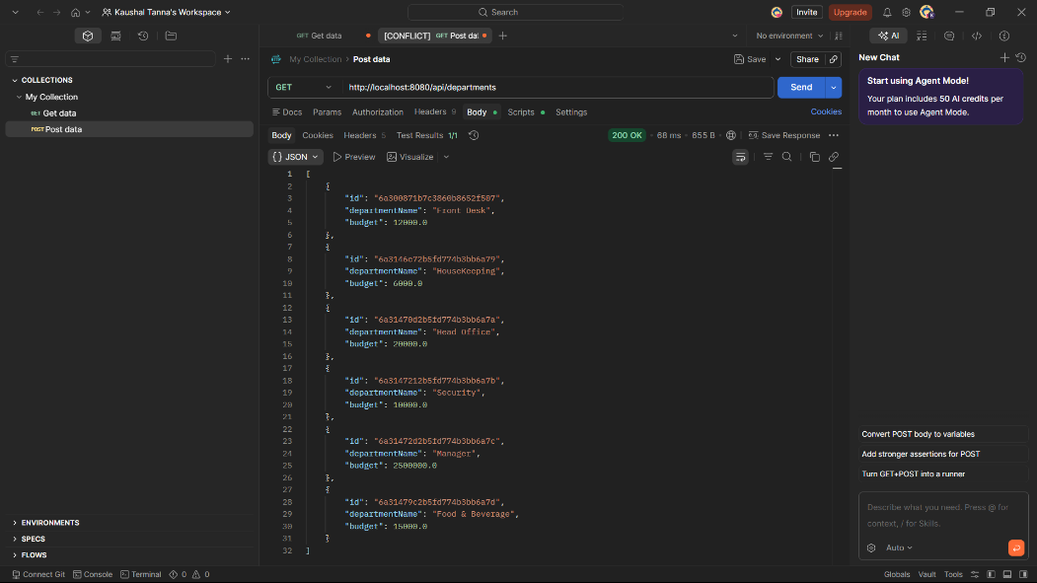
Update: I had updated the HouseKeeping department to Cleaning department using PUT.
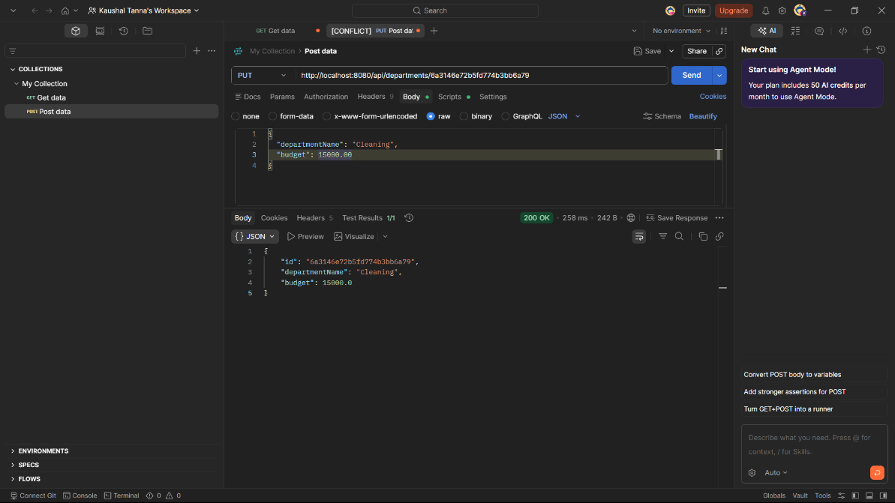
Delete: I had deleted the Food & Beverage department.
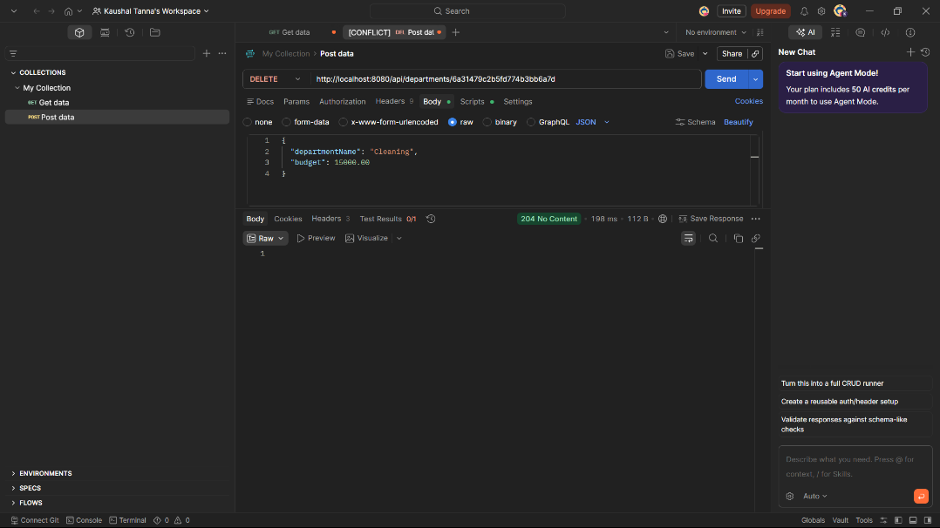

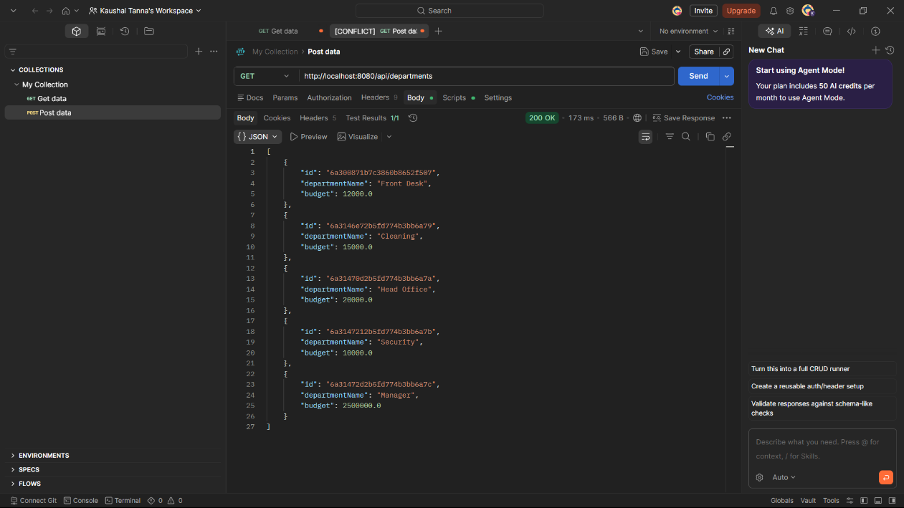

- Rooms
Insert:
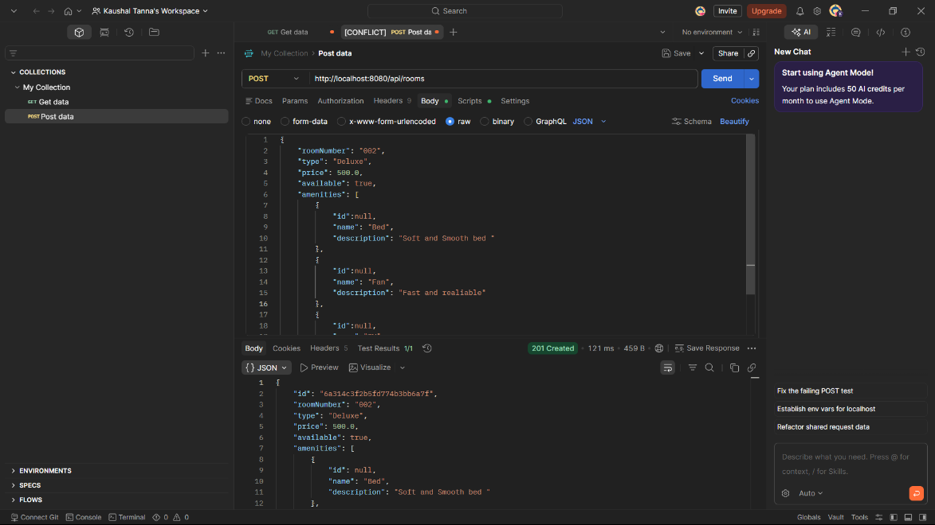
Read:
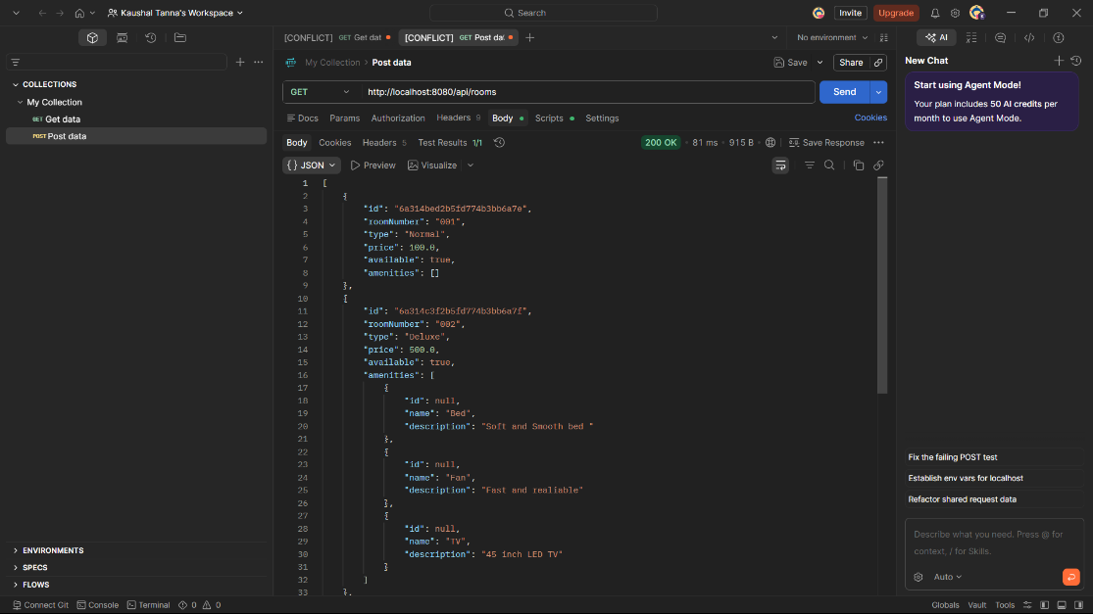
Update: Previously, the room no 001 has no amenities now using PUT I have updated the amenities in room no 001.
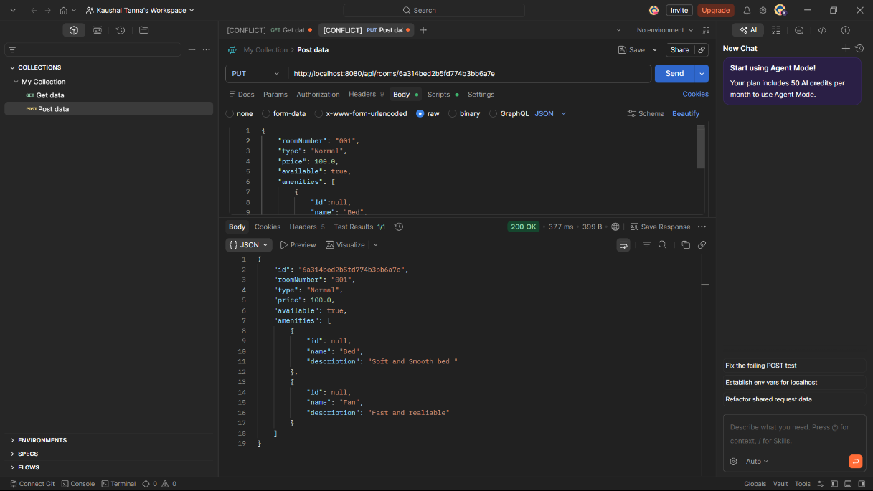
Delete: I have deleted the room no 003 using it’s ID.
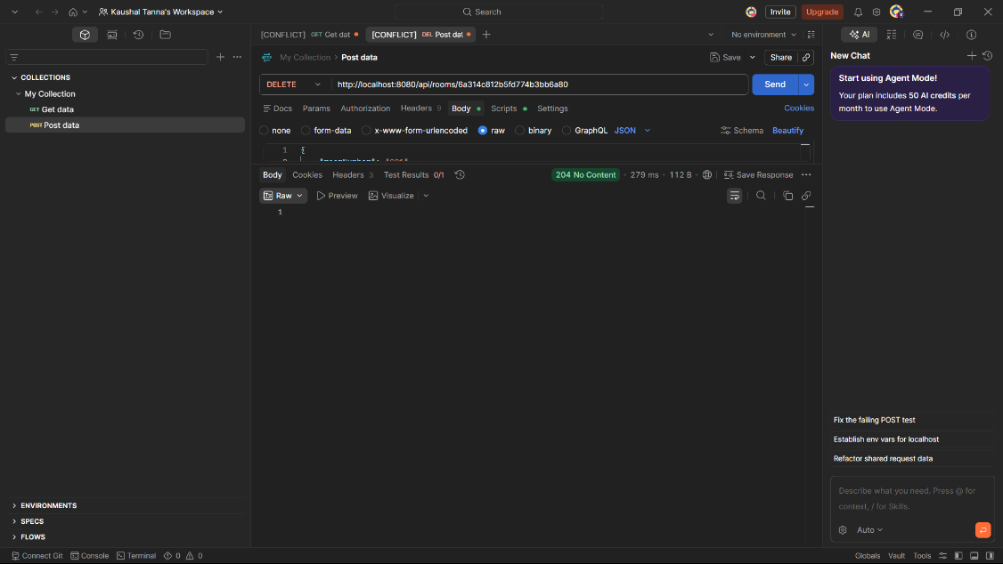
- Guests
Insert:
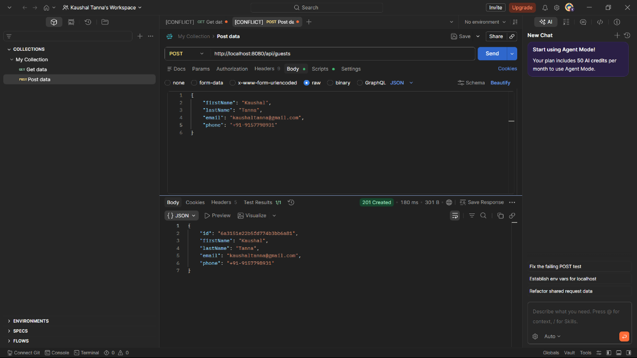
Read:
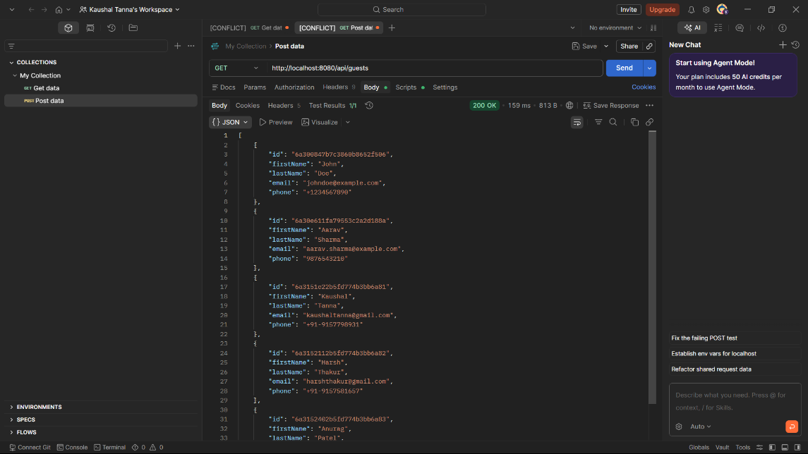
Update: I had updated the John Doe to Anand Tanna and as a unipue name, the email id and phone should unique. Therefore, I updated the whole guest section.
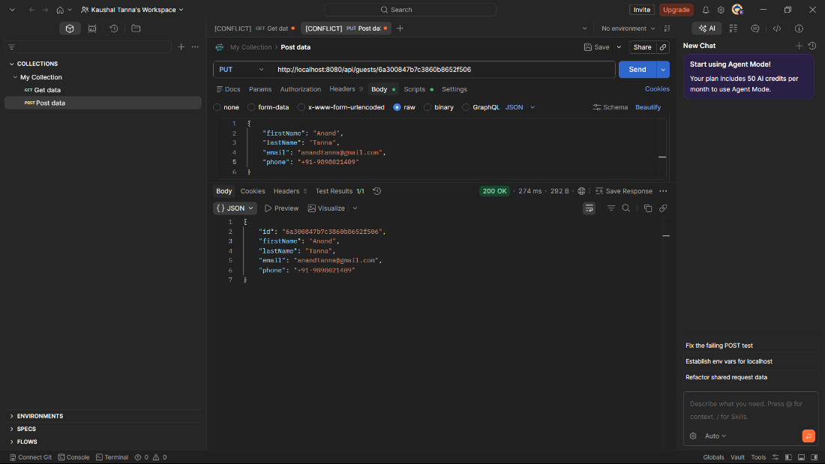
Delete: I had deleted the Harsh Thakur guest from the guest list using it’s ID.
