StayHub
Integrated Hotel Management Platform
Project Report — API Documentation & Screenshots
Java Spring Boot + MongoDB Atlas

Submitted by
Kaushal Tanna
Registration No: 24BCE10364

Technology: Java Spring Boot | Database: MongoDB Atlas | Testing: Postman & Swagger

1. Project Overview
StayHub is a backend REST API-based Hotel Management Platform developed using Java Spring Boot and MongoDB Atlas. The system manages core hotel operations including guest management, room bookings, staff records, payment tracking, and department management, entirely through REST APIs with no frontend interface.

This report documents the tools used, the API structure, and provides screenshots of every module tested through Postman and MongoDB Atlas, demonstrating that all CRUD operations and relationship mappings function correctly.

2. Project Outcome
The StayHub Hotel Management System was successfully developed using Java Spring Boot and MongoDB Atlas. The project provides a centralized backend platform for managing key hotel operations, including guest management, room management, bookings, payments, departments, staff, and amenities.
The system successfully achieved the following outcomes:
- Implemented complete CRUD (Create, Read, Update, Delete) operations for all core entities.
- Developed and tested RESTful APIs using Postman and Swagger UI.
- Successfully integrated MongoDB Atlas as the cloud database.
- Implemented and verified multiple MongoDB relationship mappings:
- One-to-One (Booking ↔ Payment)
- One-to-Many (Department → Staff, Guest → Bookings)
- Many-to-One (Booking → Guest, Staff → Department)
- Many-to-Many (Room ↔ Amenities)
- Ensured proper data persistence and retrieval through MongoDB Atlas.
- Demonstrated a clean 3-layer architecture consisting of Controller, Service, and Repository layers.
- Validated API functionality through extensive testing and database-level verification.

3. Tools & Technologies Used

Tool / Technology | Version | Purpose
Java | 21 | Core programming language
Spring Boot | 3.4.3 | Backend REST API framework
Spring Data MongoDB | Bundled with Spring Boot 3.4.3 | Database interaction layer (repositories)
MongoDB Atlas | Cloud (M0 Free Tier) | NoSQL cloud database
Springdoc OpenAPI (Swagger) | 2.8.5 | API documentation and in-browser testing
Spring Boot Starter Validation | Bundled | Request body validation
Maven | 4.0.0 (POM model) | Build automation and dependency management
Eclipse IDE | with Spring Tools Suite (STS) | Development environment
Postman | Desktop App | Manual REST API testing
MongoDB Compass / Atlas Data Explorer | Web-based | Visual inspection of stored documents

4. Entities & Relationship Mappings
StayHub manages 7 core entities, with all four MongoDB relationship types implemented:

Entity | Description
Guest | Stores guest personal and contact information
Room | Tracks room details, type, price, and availability status
Booking | Links guest and room with check-in/check-out dates
Payment | Records payment details for each booking
Staff | Hotel employee records and role assignments
Department | Groups staff by department (e.g. Housekeeping, Reception)
Amenity | Hotel facilities like Bed, Fan, TV, Pool, WiFi

Relationship Type | Entities Involved
One-to-One | Booking and Payment
One-to-Many | Guest to Bookings / Department to Staff
Many-to-One | Bookings to Guest / Staff to Department
Many-to-Many | Room to Amenities

5. API Testing — Module-wise Screenshots
Each module below was tested using Postman against the running Spring Boot application on localhost:8080. Screenshots show the request body, HTTP method, response status, and response body for each operation.

5.1 Guest Module
Endpoints tested: POST /api/guests, GET /api/guests, PUT /api/guests/{id}, DELETE /api/guests/{id}
Create Guest (POST)
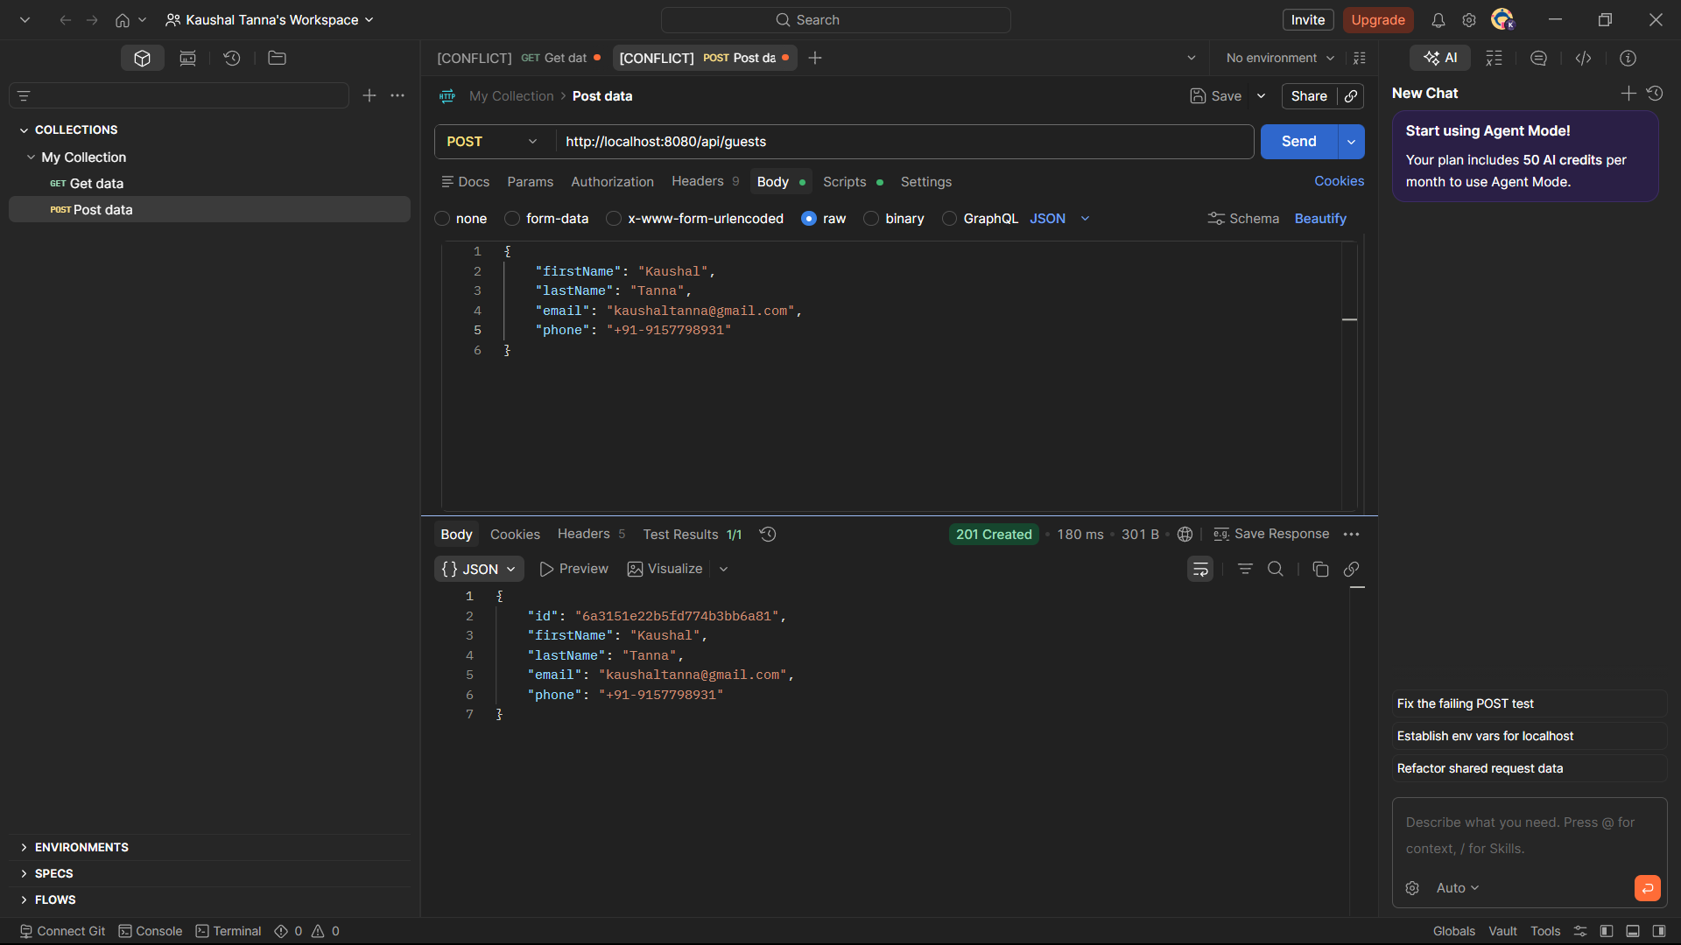
Fig 5.1.1 — Creating a new guest record via POST /api/guests
Description:
This screenshot demonstrates the creation of a new guest record using the POST API endpoint. The request body contains guest details such as name, email, and contact number. The successful response confirms that the guest document has been stored in MongoDB Atlas
Get All Guests (GET)
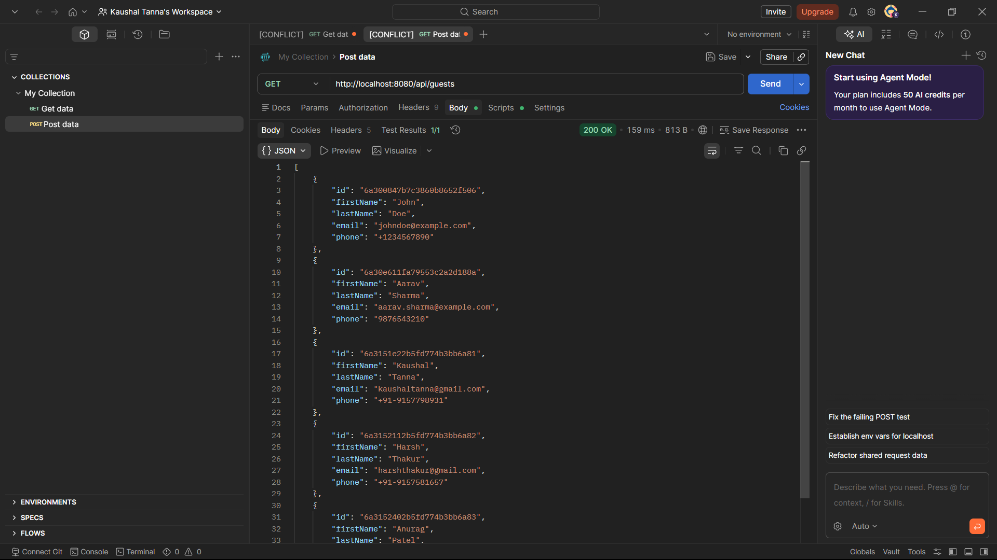
Fig 5.1.2 — Retrieving all guest records via GET /api/guests
Description:
This operation retrieves all guest records available in the database. The response verifies that guest information is correctly persisted and can be accessed through the REST API.
Update Guest (PUT)
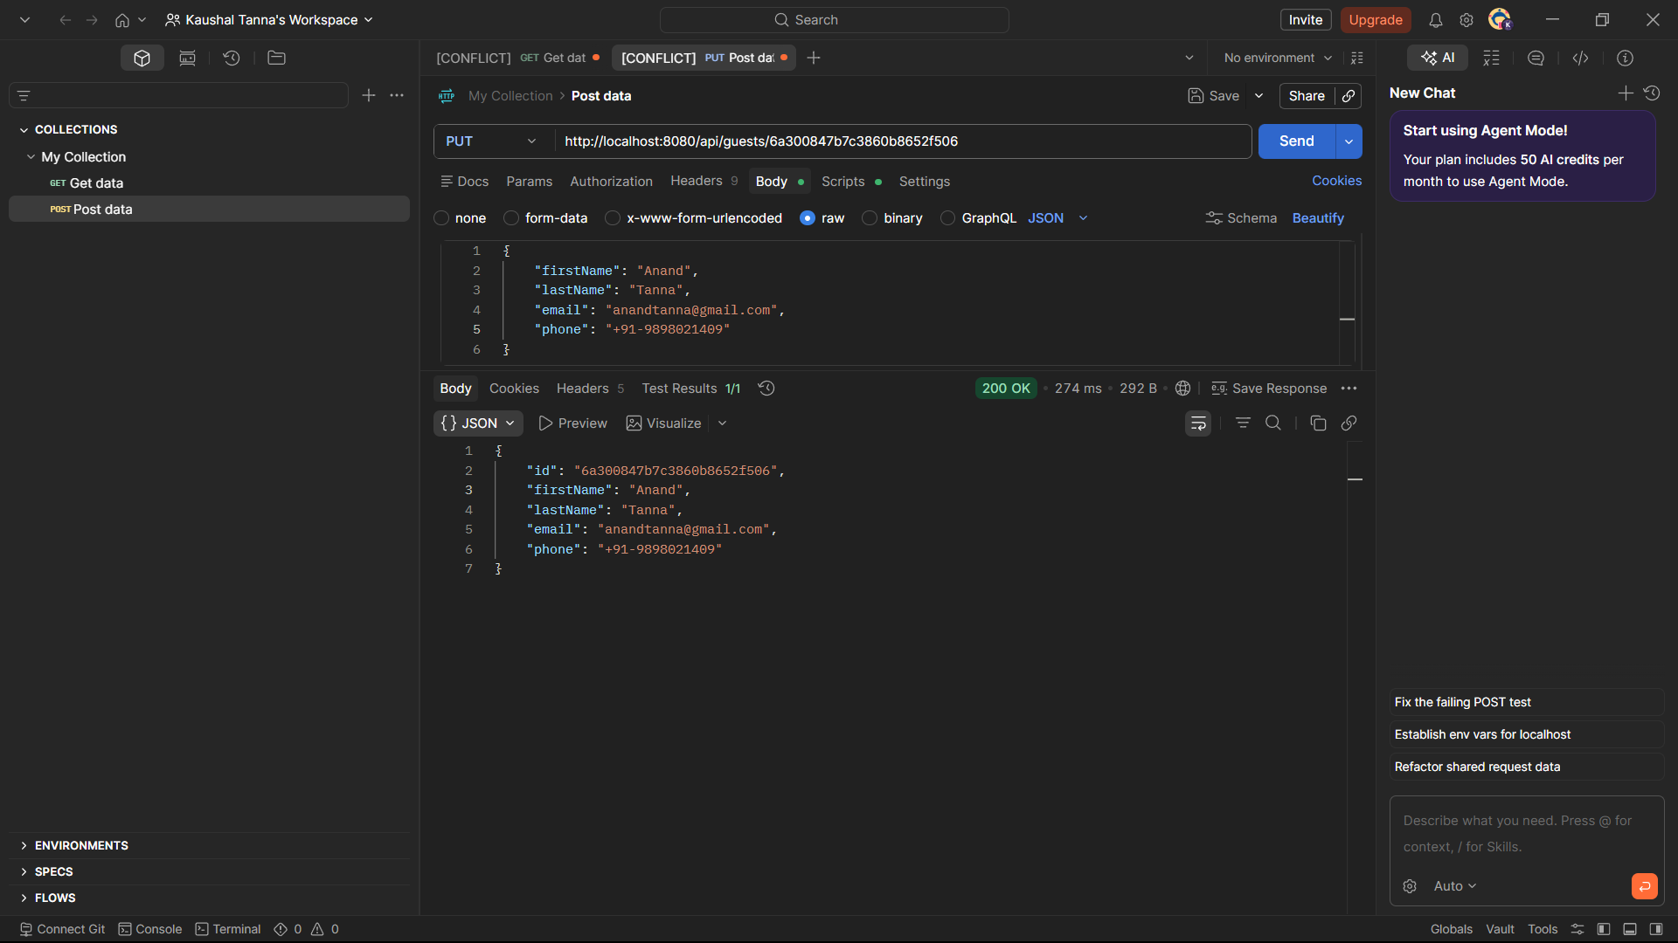
Fig 5.1.3 — Updating an existing guest record via PUT /api/guests/{id}
Description:
This screenshot shows the modification of an existing guest record. Updated guest details are submitted through the request body, and the response confirms that the changes have been successfully applied.
Delete Guest (DELETE)
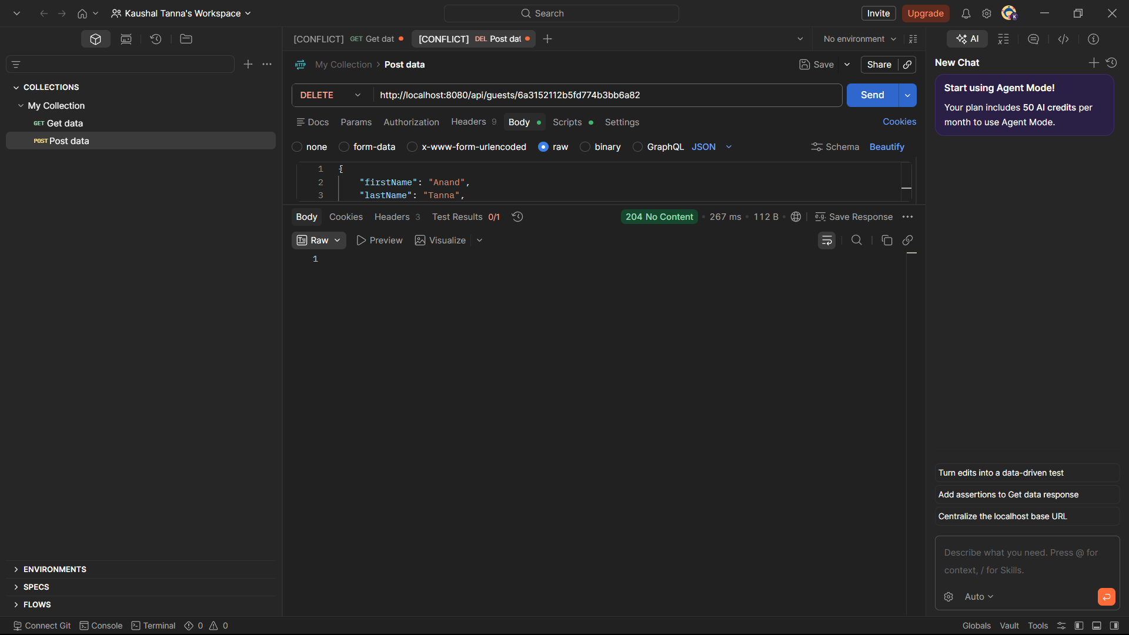
Fig 5.1.4 — Deleting a guest record via DELETE /api/guests/{id} (204 No Content)
Description:
This operation removes a guest record from the database. The HTTP 204 No Content response indicates that the deletion was completed successfully.

5.2 Room Module
Endpoints tested: POST /api/rooms, GET /api/rooms, PUT /api/rooms/{id}, DELETE /api/rooms/{id}. This module also demonstrates the Many-to-Many relationship between Room and Amenities.
Create Room (POST)
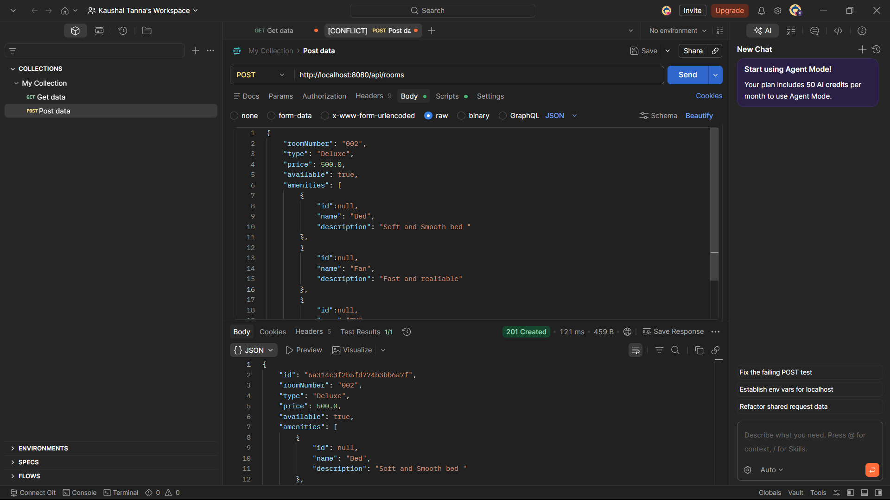
Fig 5.2.1 — Creating a new room record via POST /api/rooms
Description:
This screenshot demonstrates the creation of a hotel room record along with associated amenities. The response confirms successful insertion of room details into the database.
Get All Rooms with Amenities (GET)
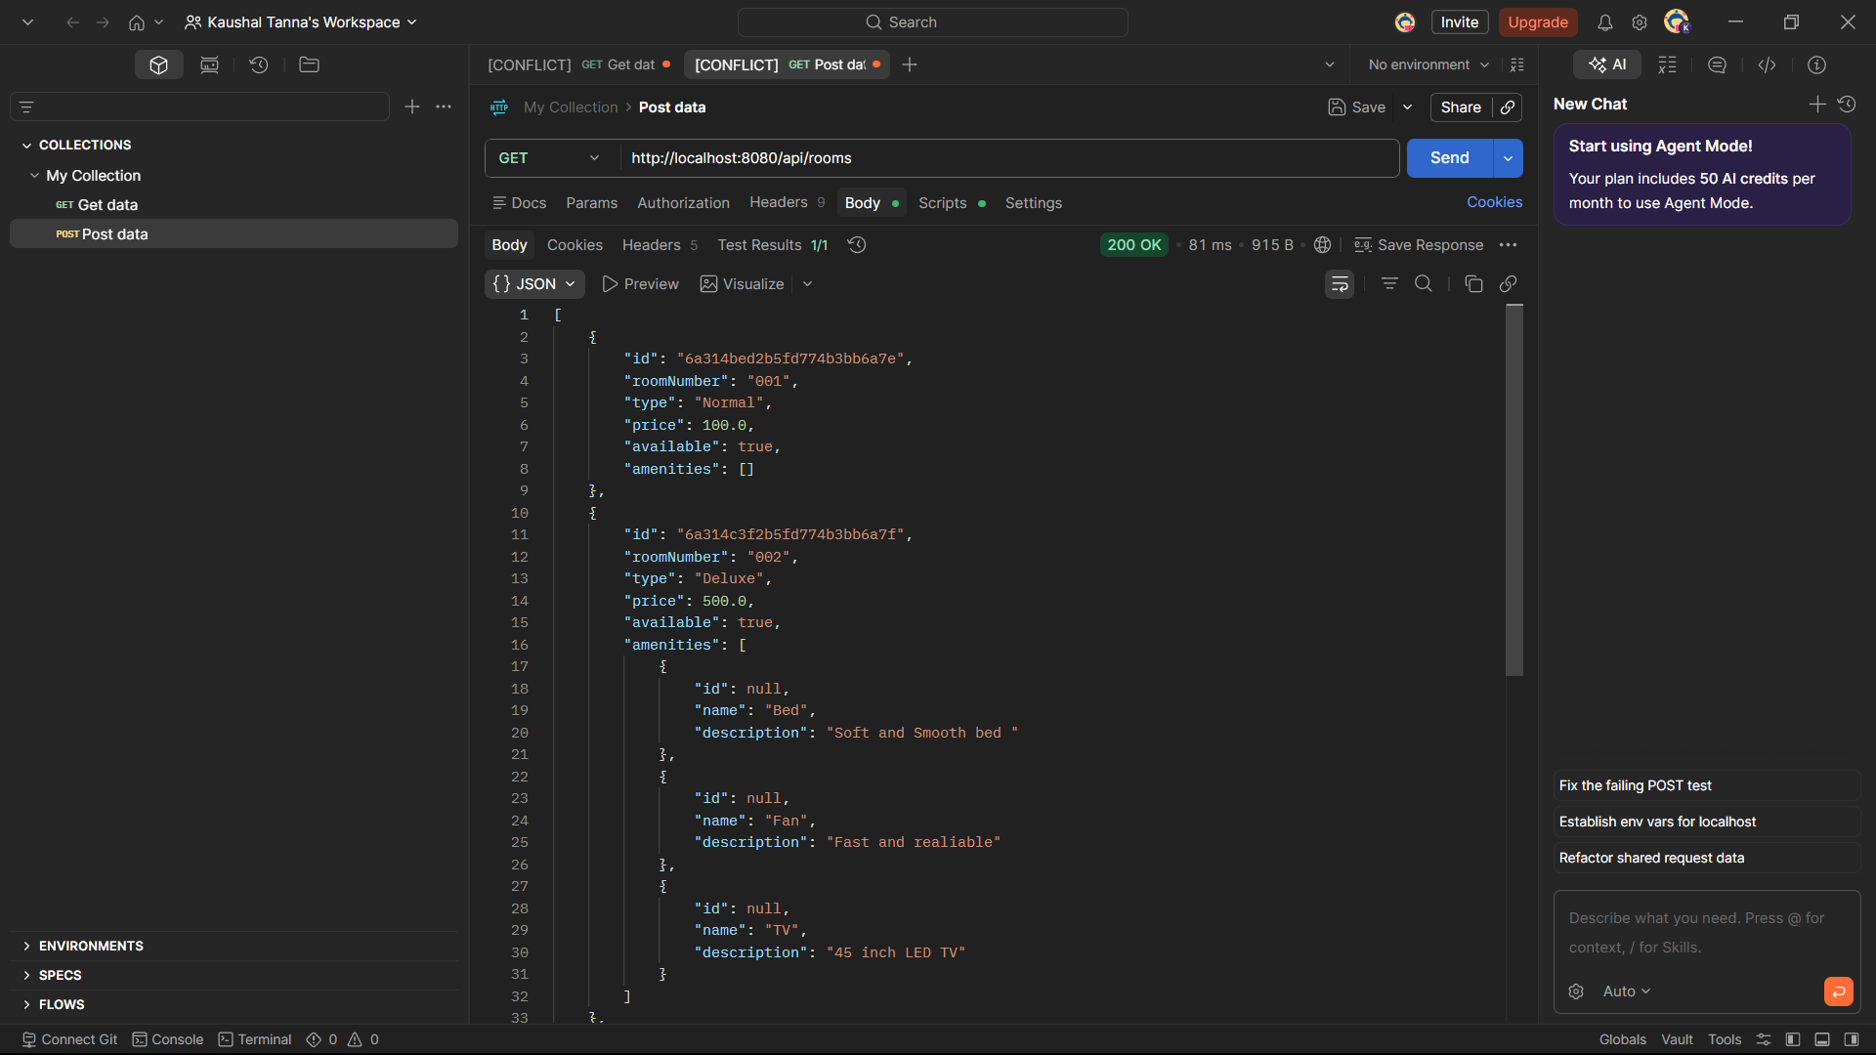
Fig 5.2.2 — Retrieving rooms with embedded amenities, demonstrating the Many-to-Many mapping
Description:
This operation retrieves all room records along with their linked amenities. The response validates the implementation of the Many-to-Many relationship between rooms and amenities.
Update Room (PUT)
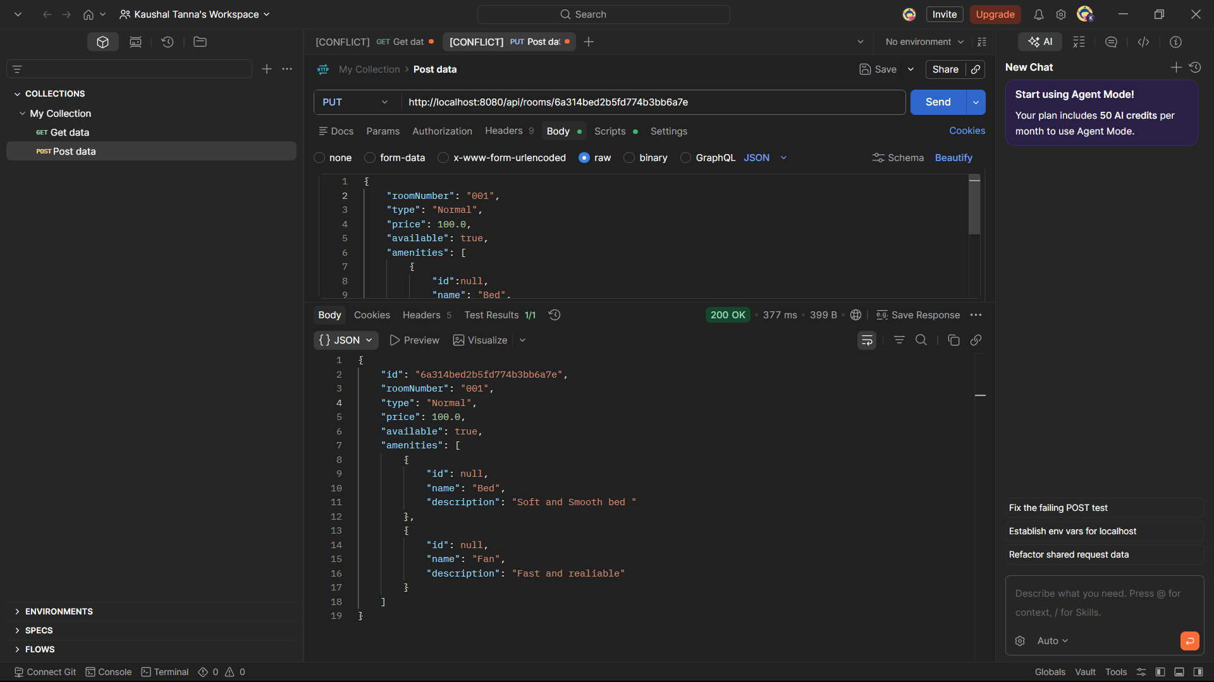
Fig 5.2.3 — Updating room details and confirming amenity associations via PUT /api/rooms/{id}
Description:
This screenshot shows updating room information such as room type, pricing, availability status, or amenities. The response confirms that the room details have been updated successfully.
Delete Room (DELETE)
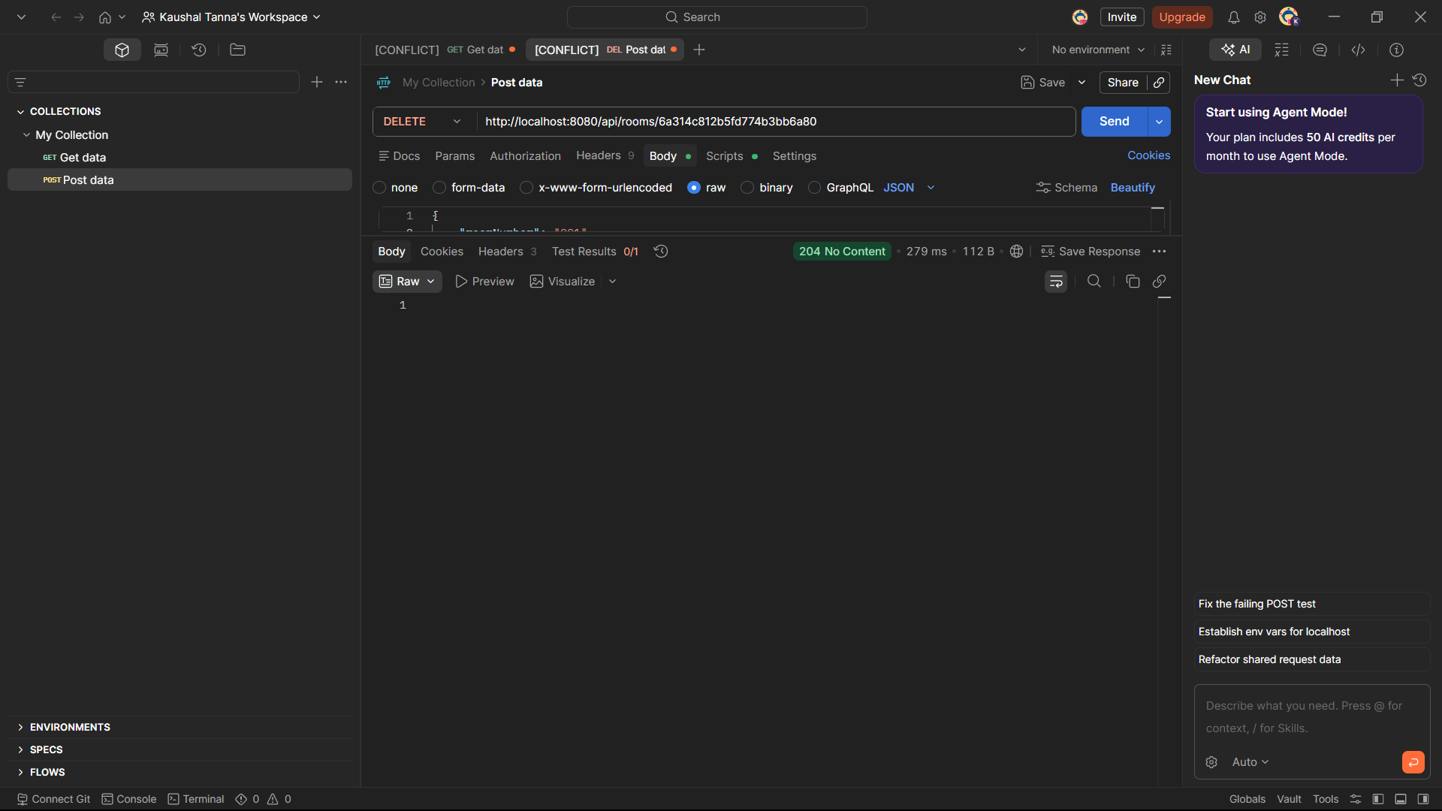
Fig 5.2.4 — Deleting a room record via DELETE /api/rooms/{id} (204 No Content)
Description:
This operation removes a room record from the database. The successful deletion is indicated by the HTTP 204 No Content status code.

5.3 Booking Module
Endpoints tested: POST /api/bookings, GET /api/bookings, PUT /api/bookings/{id}, DELETE /api/bookings/{id}. This module demonstrates the Many-to-One relationship (Booking to Guest, Booking to Room) and the One-to-One relationship (Booking to Payment).
Create Booking (POST)
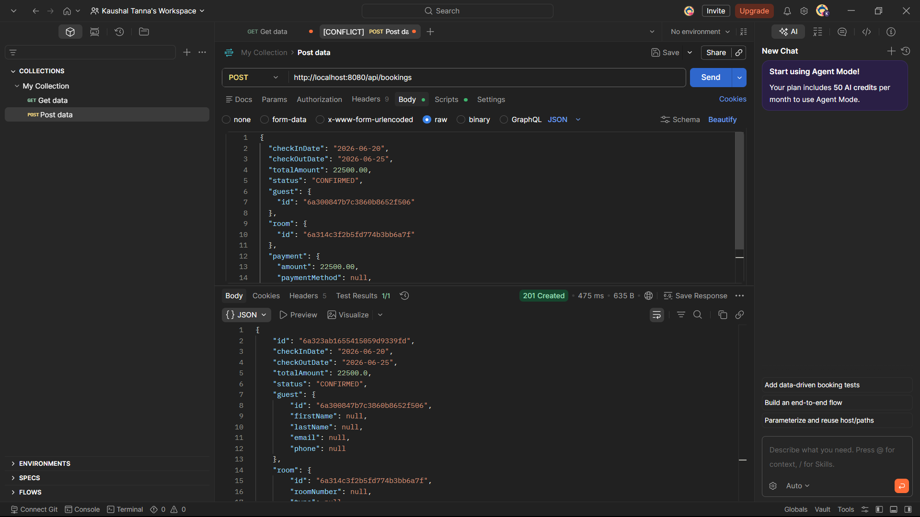
Fig 5.3.1 — Creating a booking by referencing a Guest ID and Room ID via POST /api/bookings
Description:
This screenshot demonstrates the creation of a booking by referencing existing guest and room records. It validates the relationship mapping between booking, guest, and room entities.
Get All Bookings with Nested Guest, Room & Payment (GET)
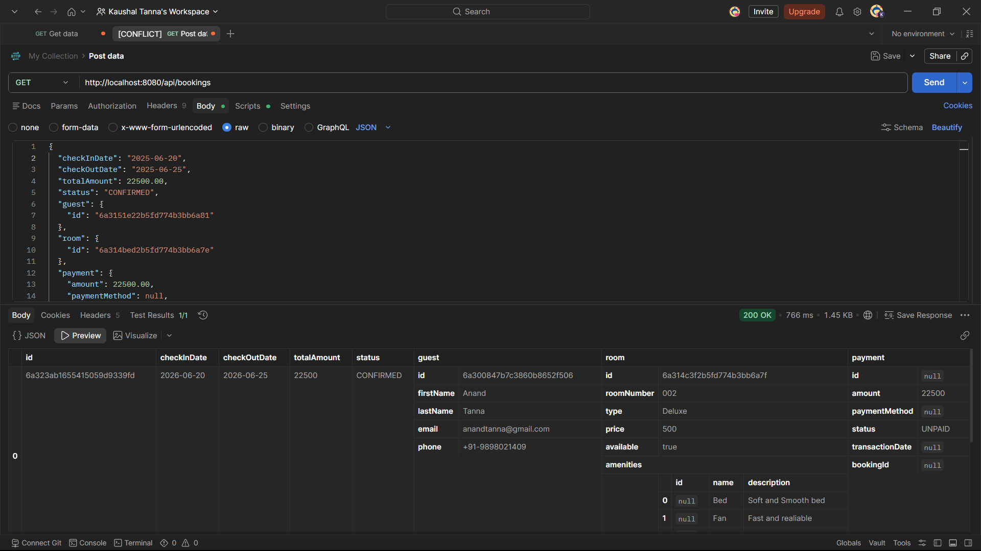
Fig 5.3.2 — Retrieving bookings with fully resolved guest, room, and payment details
Description:
This operation retrieves booking information along with nested guest, room, and payment details. The response confirms successful DBRef resolution and relationship mapping.
Update Booking (PUT)
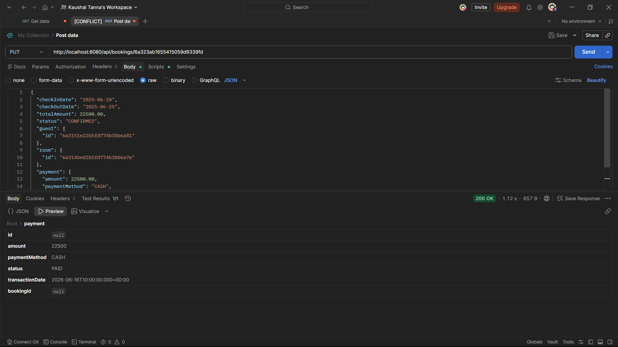
Fig 5.3.3 — Updating booking and payment details via PUT /api/bookings/{id}
Description:
This screenshot shows updating booking details including dates, status, or payment information. The successful response verifies that booking modifications are stored correctly.
Cancel / Delete Booking (DELETE)
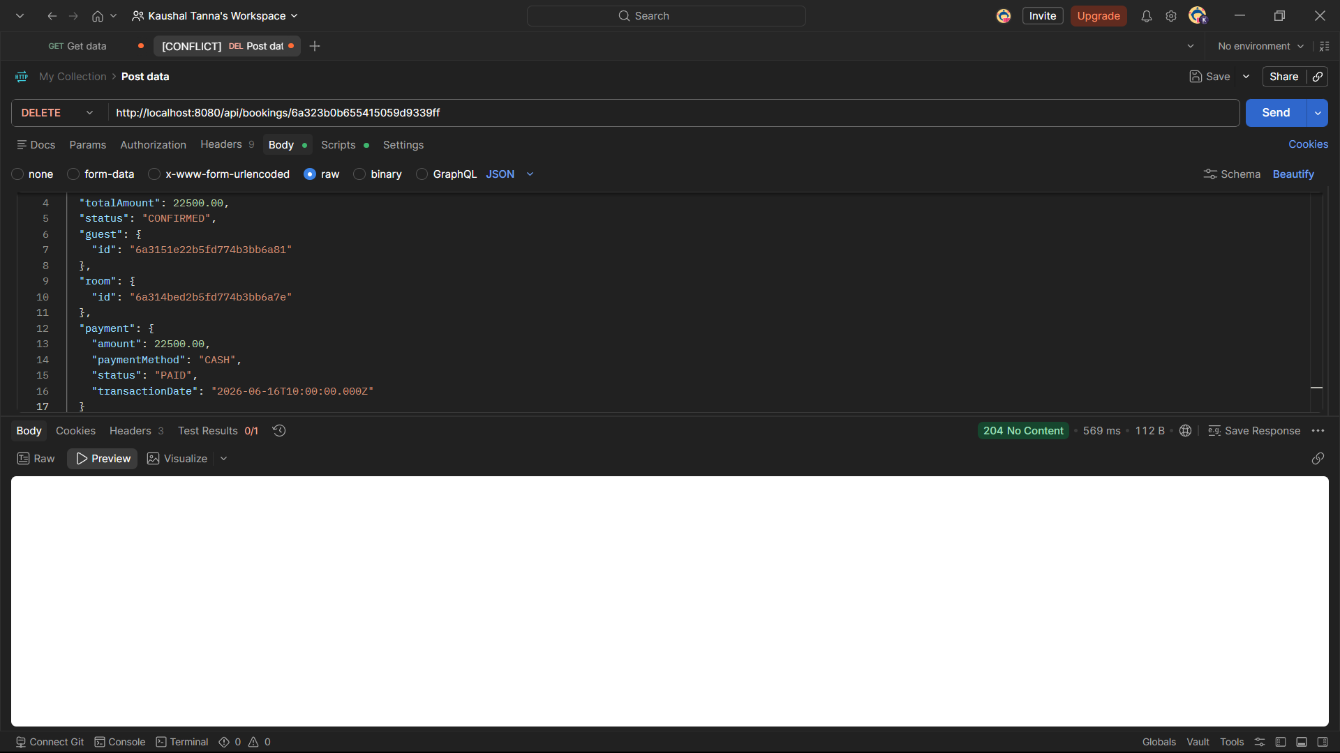
Fig 5.3.4 — Cancelling a booking via DELETE /api/bookings/{id} (204 No Content)

5.4 Department Module
Endpoints tested: POST /api/departments, GET /api/departments, PUT /api/departments/{id}, DELETE /api/departments/{id}. This module demonstrates the One-to-Many relationship between Department and Staff.

Create Department (POST)
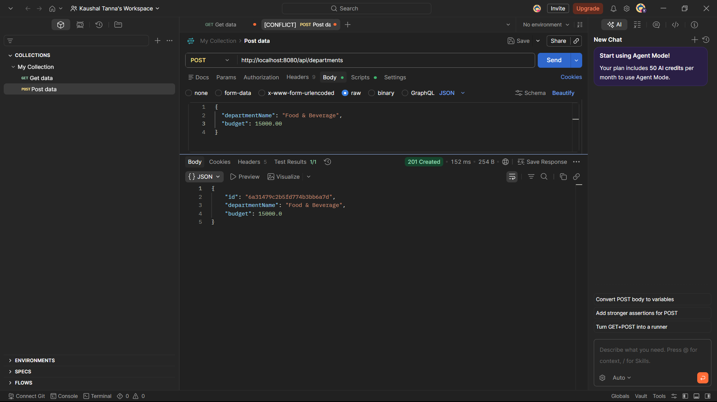
Fig 5.4.1 — Creating a new department record via POST /api/departments
Description:
This screenshot demonstrates the creation of a new department record. Department details such as department name and budget are stored successfully in MongoDB Atlas.
Get All Departments (GET)
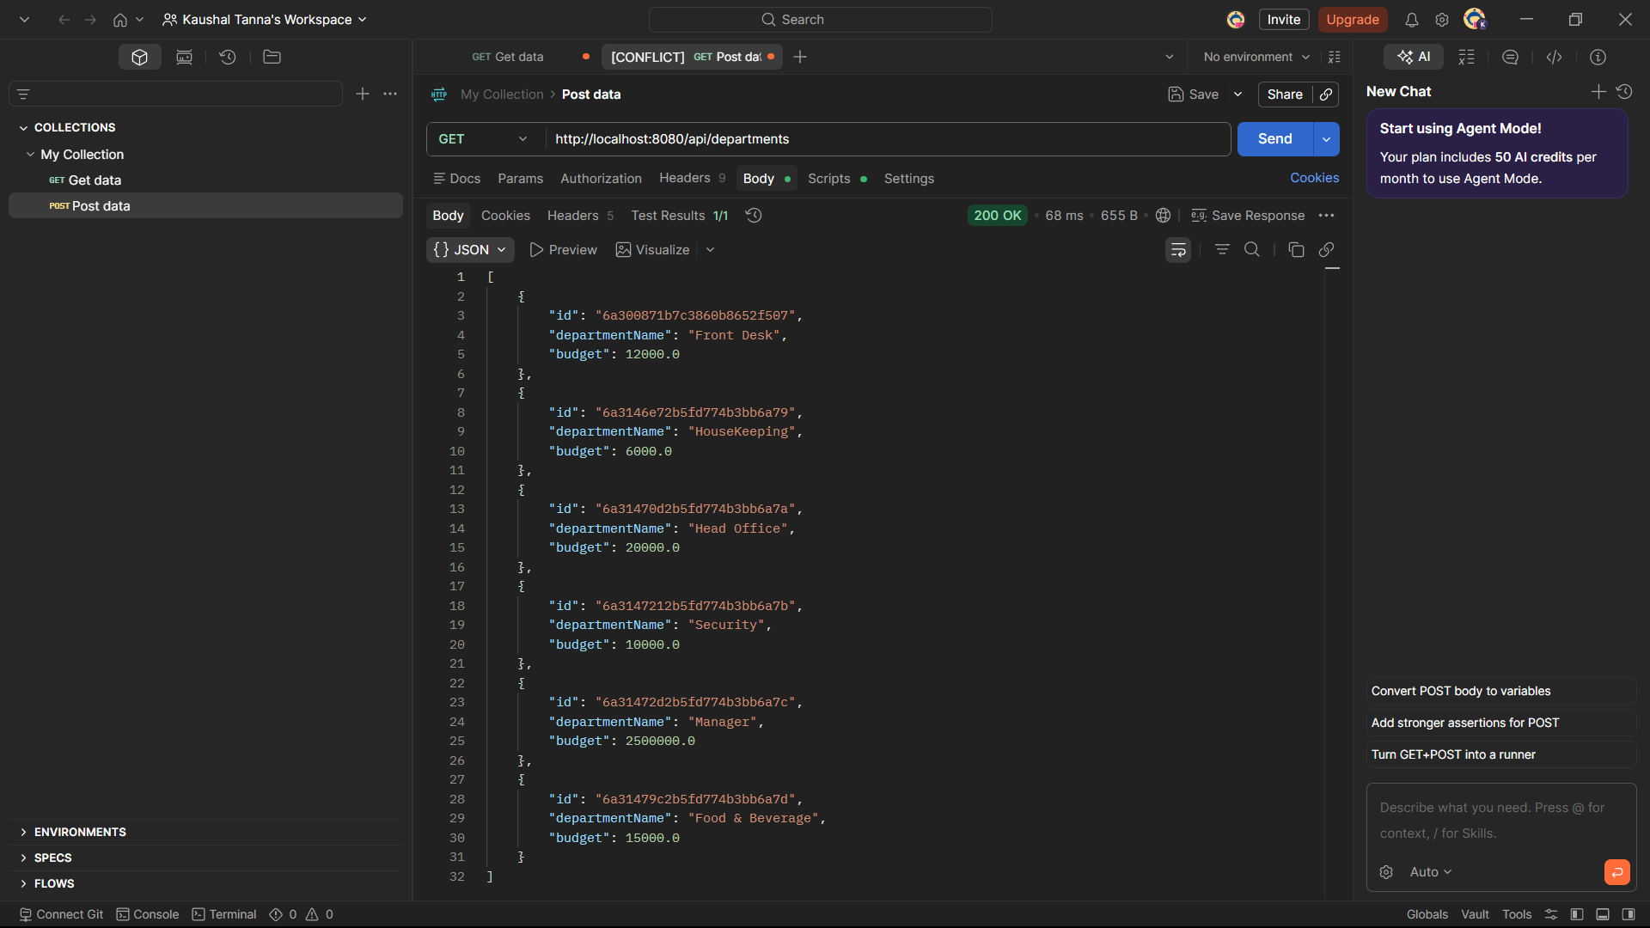
Fig 5.4.2 — Retrieving all department records via GET /api/departments
Description:
This operation retrieves all department records maintained within the hotel management system. The response confirms successful data retrieval.
Update Department (PUT)
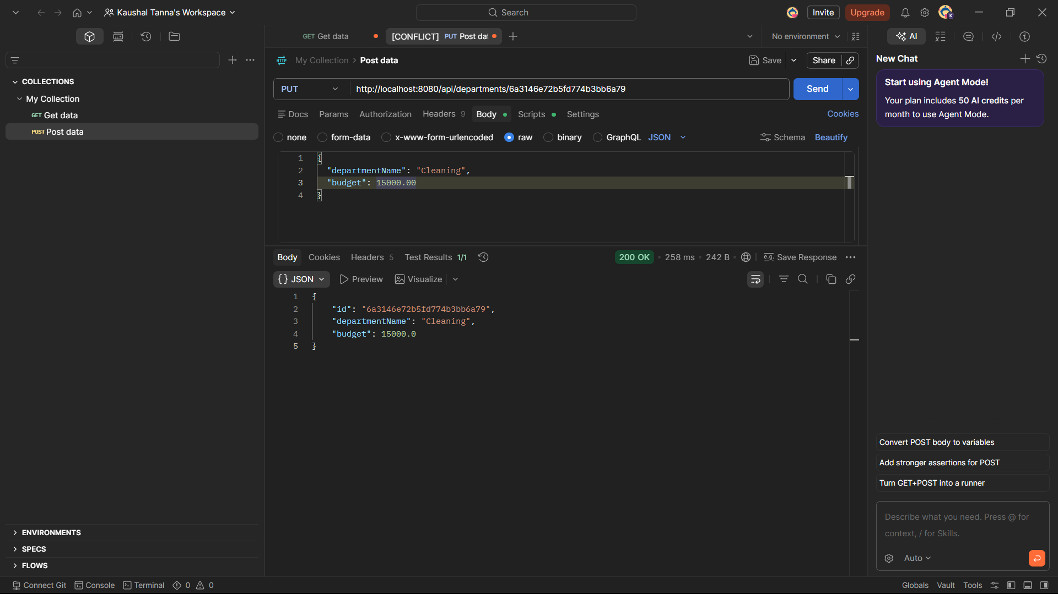
Fig 5.4.3 — Updating a department's name and budget via PUT /api/departments/{id}
Description:
This screenshot shows updating department information, including department name and allocated budget. The response confirms successful modification of department data.
Delete Department (DELETE)
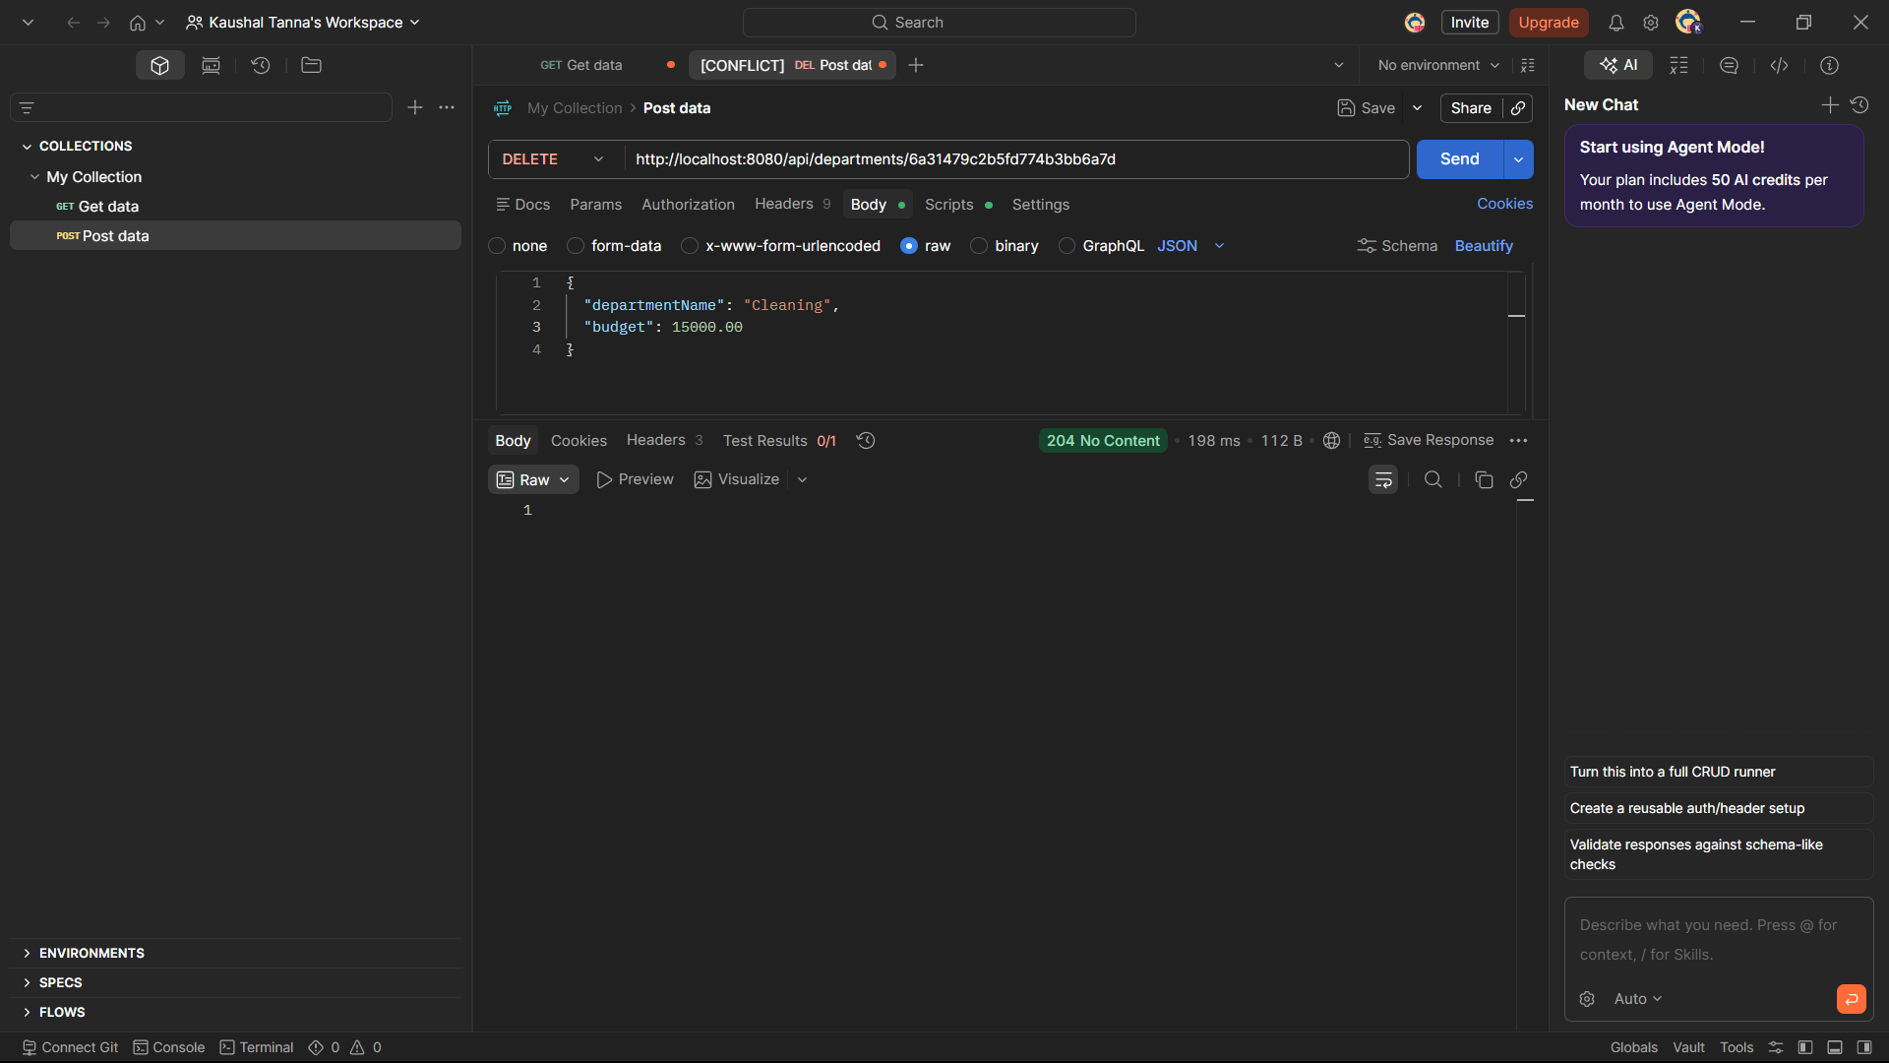
Fig 5.4.4 — Deleting a department record via DELETE /api/departments/{id} (204 No Content)
Description:
This operation removes a department record from the database. The HTTP 204 response confirms successful deletion.

6. Conclusion
StayHub is a comprehensive backend Hotel Management System that fulfills all stated academic project requirements. The screenshots in this report provide direct evidence that:
- Complete CRUD operations work correctly across all 7 entities
- All four MongoDB relationship mapping types are implemented and verified
- REST APIs were systematically tested using Postman with correct request/response behavior
- Data persistence was independently verified using MongoDB Atlas Data Explorer

The project demonstrates practical backend development skills using Java Spring Boot and MongoDB in a realistic hotel management context.

