**Smart-phone City**

Introduction

Smart-phone city is project which offers verities of smartphone that the user wants according to their requirement. In this project, series of opinions are taken from the user so that the user finds the smartphone that likely suits them. The opinion such as the budget that the user wants to spend on a smart-phone, purpose of buying the smart-phone and the requirement needed by the user in the smartphone. After taking the opinion from the user, smart-phone city project processes the opinion and provides the suitable options of smart-phone to the user. If the user wants to buy that suitable smartphone then there will also be the link to the store that they could buy from. The smartphone city will feature almost all the smart-phone currently available in Nepal.

Aim

The main aim of this project is to educate the user from spending unnecessary budget on the smart-phone with unnecessary features that the user will rarely use and the other aim is to provide best of the best smart-phone within the budget, features and requirement to the user who do not have any idea about buying the smart-phone.

Objective

* To provide as much information as we can about the smart-phone to users.
* To provide the latest smart-phones available in Nepal.
* To save time of user in choosing the smart phone.
* To make user an easy choice of smart-phone which perfectly fits them.

Features

The smart-phone city project totally features about the smart-phone. Firstly the project takes opinion from the user, processes the opinion and gives the final output which hopefully satisfies the user.

Functionalities

The first page of this project features the welcome screen.

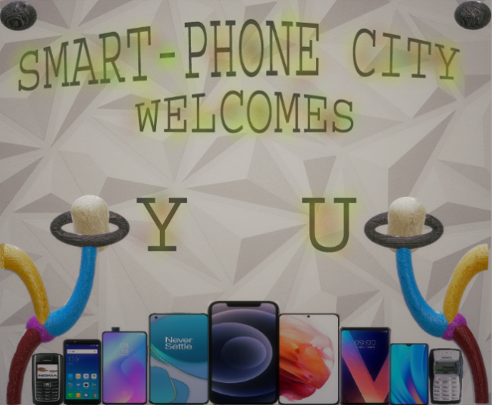

The second page of this project features the budget

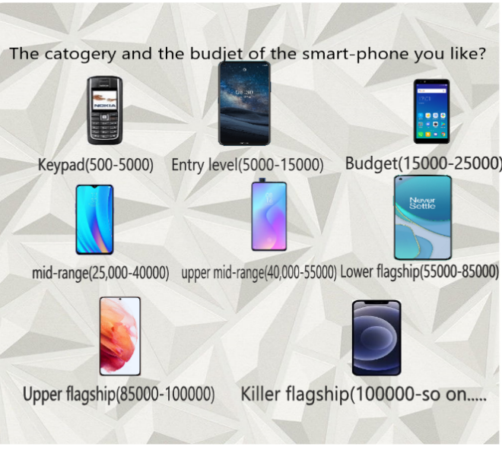

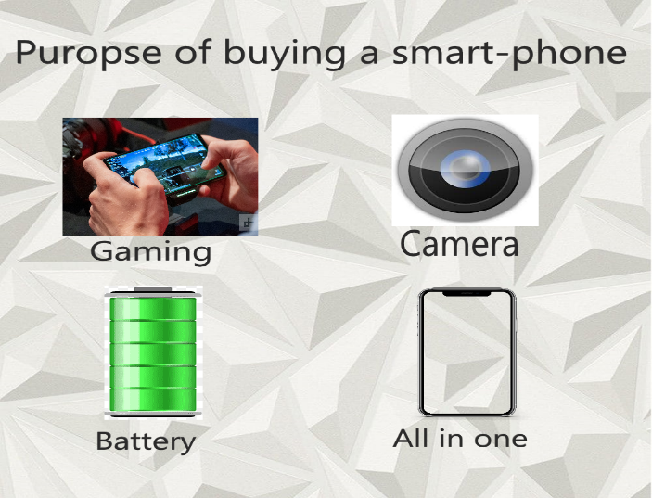The third page asks the purpose and requirement in the smart-phone.

The fourth page presents the smart-phone.

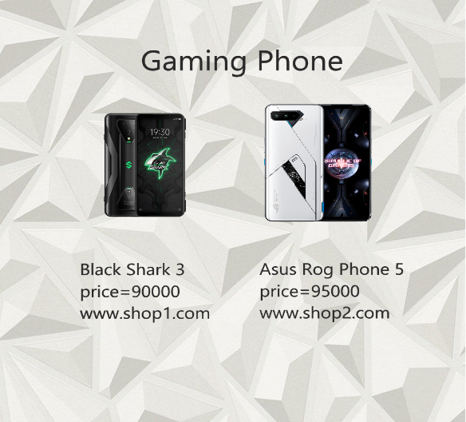

Scope

If any user using the smart-phone project buys the smartphone whether they have bought smart-phone before or they are buying for first time, they will have a clear vison of the smart-phone that perfectly fits them.