Name: KAUSHAL KOTKAR Department: Cyber Security

Div: BE-15 Roll No: 54

Subject: DSO

|  |  |  |  |  |
| --- | --- | --- | --- | --- |
| **Experiment No. – 1** | | | | |
| **Date of Performance:** | 15/7/2024 | | | |
| **Date of Submission:** | 22/7/2024 | | | |
| Program Execution/ formation/ correction/  ethical practices (06) | Timely Submission  (01) | Viva (03) | Experiment Total (10) | Sign with Date |
|  |  |  |  |  |

**Experiment No. 1**

**Aim:** To Understand Version Control System / Source Code Management, install git and to perform various GIT operations on local remote repositories.

**Lab Outcome:** CSL701.1Understand the concepts of distributed version control using GIT and GITHUB

**Theory:**

**Definition of Git**

Git is an open-source version control system for projects of all sizes, ensuring quick and efficient collaboration among developers. It is used to track changes and coordinate work within teams, allowing teamwork in the same workspace.

Git forms the basis of services like GitHub and GitLab, although it can be used independently. It is usable both privately and publicly.

Created in 2005 by Linus Torvalds for the Linux Kernel, Git is vital for DevOps and distributed version control. It is user-friendly, high-performance, and surpasses other tools like Subversion, CVS, and ClearCase.

**Features of Git**

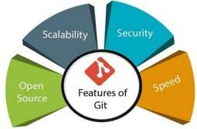

1. **Open Source**:

Git is an open-source tool. It is released under the GPL (General Public License).

1. **Scalable**:

Git is scalable, which means when the number of users increases, the Git can easily handle such situations.

1. **Distributed**:

One of Git's great features is that it is distributed. Distributed means that instead of switching the project to another machine, we can create a "clone “of the entire repository.

Also, instead of just having one central repository that you send changes to, every user has their own repository that contains the entire commit history of the project.

We do not need to connect to the remote repository; the change is just stored on our local repository. If necessary, we can push these changes to a remote repository.

1. **Security**

Git is secure, using SHA-1 to uniquely identify objects in its repository.

Files and commits are verified during checkout using checksums.

Commit IDs depend on the entire development history, enhancing security.

Once published, old versions cannot be altered, maintaining integrity.

**Output:**

Installation of Git:

Go to the website and download the ‘git’ file according to your system configuration.

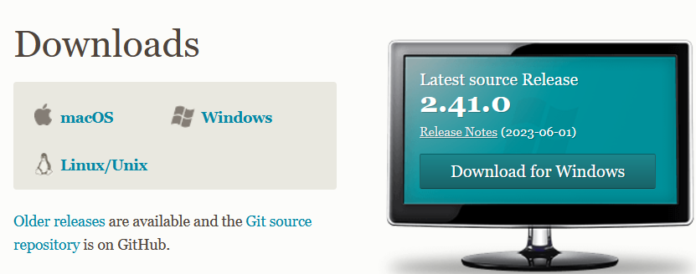

**Operations on GIT**

**1. Config**

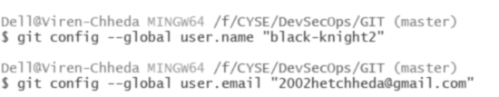

**2. Git init & add**

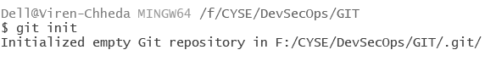

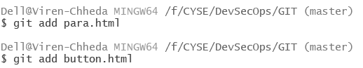

**3. Diff**

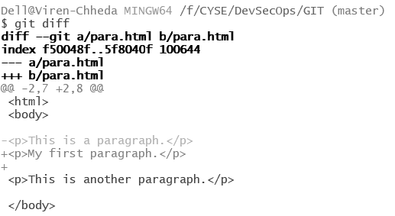

**4. Status**

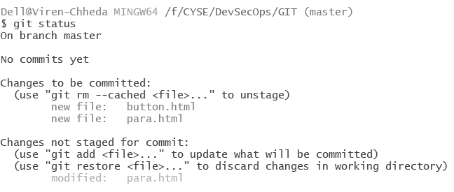

**5. Remote**

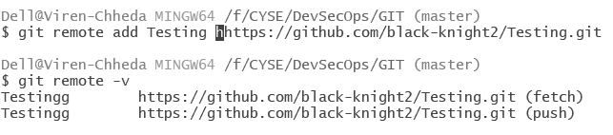

**6. Commit**

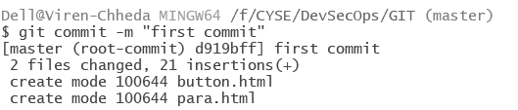

**7. Branch & checkout**



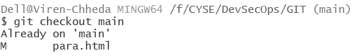

**8. Push**

Push the file from remote server

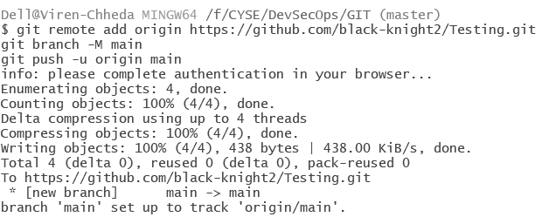

**9. Log**

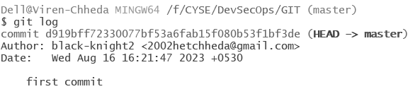

**10. Reset**

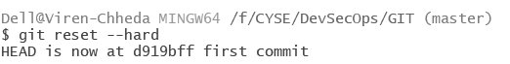

**11. Stash**

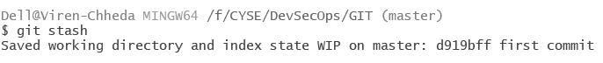

**GitHub repository**

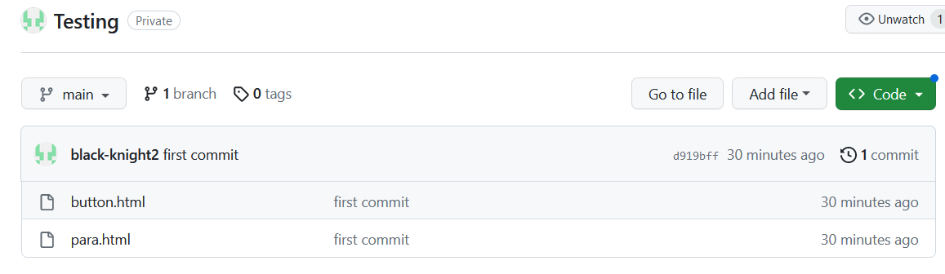

**Conclusion:**

The Version Control System was understood in this experiment. Git was installed and Git bash was exercised. A GitHub account was created, and a repository was made. Difference between Git and GitHub was made clear.