Name: Kaushal Kotkar Department: Cyber Security

Div: BE-15 Roll No: 54

Subject: DSO

|  |  |  |  |  |
| --- | --- | --- | --- | --- |
| **Experiment No. – 11** | | | | |
| **Date of Performance:** | 07/10/2024 | | | |
| **Date of Submission:** | 14/10/2024 | | | |
| Program Execution/ formation/ correction/  ethical practices (06) | Timely Submission  (01) | Viva (03) | Experiment Total (10) | Sign with Date |
|  |  |  |  |  |

**Experiment No. 11**

**Aim:** To create and work with virtual machines on cloud (GCP / AWS / Azure).

**Lab Outcome:** Implement Terraform scripts to manage VMs on a cloud.

**Theory:**

**Cloud Platform:** A cloud platform is a set of cloud computing services and resources that provide on-demand access to computing power, storage, databases, networking, and other IT resources over the internet. It allows users to provision and manage resources without the need for physical hardware or infrastructure.

**Why Use a Cloud Platform:**

* Scalability: Easily scale resources up or down based on demand.
* Cost-Efficiency: Pay only for the resources you use, reducing upfront costs.
* Accessibility: Access resources from anywhere with an internet connection.
* Flexibility: Choose from a wide range of services and configurations to meet specific needs.

**AWS (Amazon Web Services):** AWS is a leading cloud platform that offers a comprehensive suite of cloud services, including computing, storage, databases, machine learning, analytics, and more. It provides a reliable and scalable infrastructure for running applications and services.

**Steps Followed:**

1. **Login as IAM User:**
   * Log in to the AWS Management Console as an IAM user with appropriate permissions.
2. **Launch an EC2 Instance:**
   * Search for EC2 and select it from the AWS Console.
   * Click "Launch Instance" to create a virtual machine.
3. **Configure Instance Details:**
   * Fill in instance details, including the instance name, Amazon Machine Image (AMI), instance type, network settings, storage, and more.
4. **Launch the Instance:**
   * Proceed with launching the instance. AWS will create a virtual machine based on your specifications.
5. **View All Instances:**
   * In the EC2 dashboard, view all instances to see the newly launched instance.
6. **Check Instance Status:**
   * Initially, the instance status will be "Initializing." Wait for a few minutes until it shows "2/2 checks passed," indicating that the instance is fully operational.
7. **Connect to the EC2 Instance:**
   * Use SSH (for Linux) or Remote Desktop Protocol (RDP) (for Windows) to connect to the EC2 instance.
   * Access the instance's operating system and perform tasks as needed.
8. **Manage the Instance:**
   * You can stop or terminate the instance when you no longer need it, helping to control costs.

**Output:**

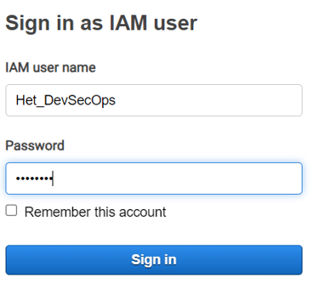

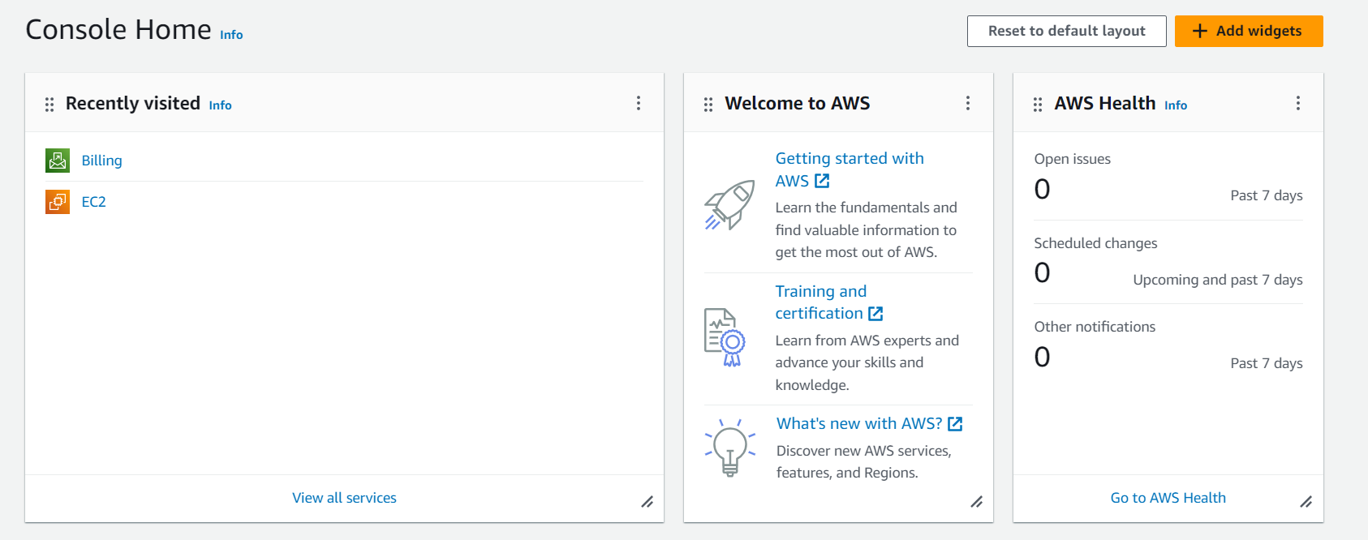

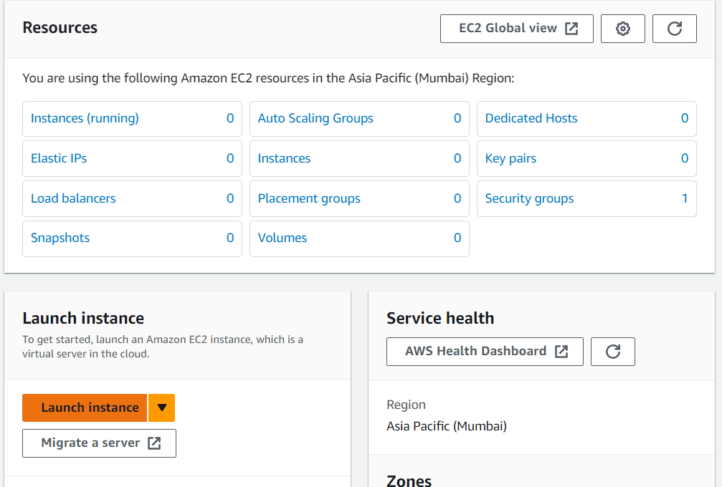

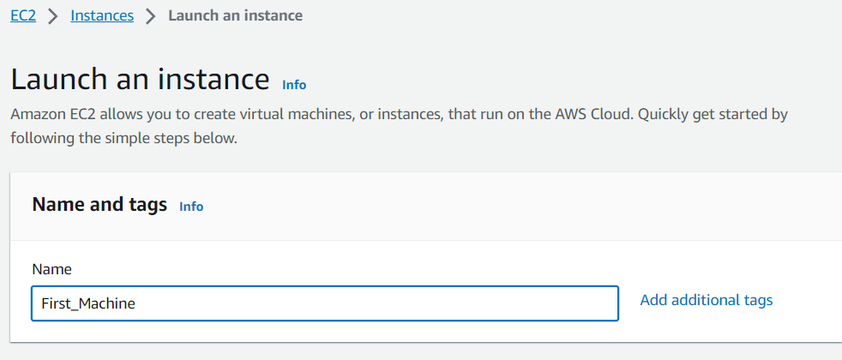

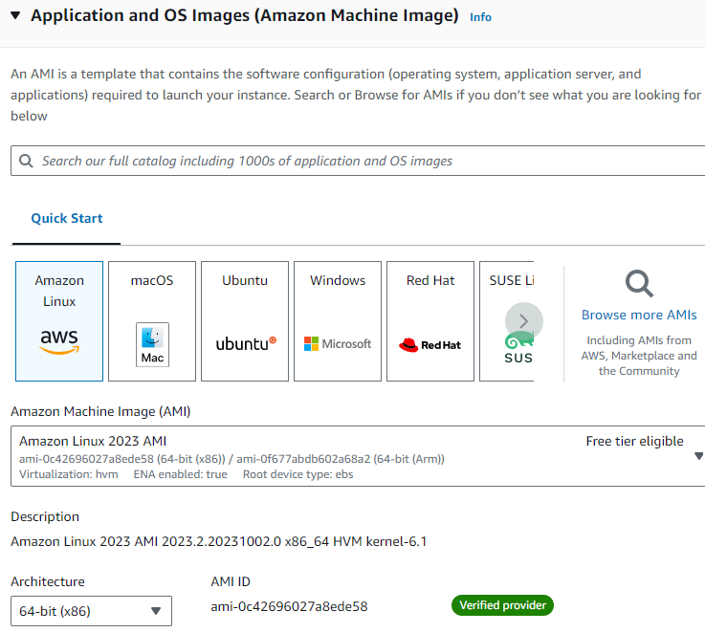



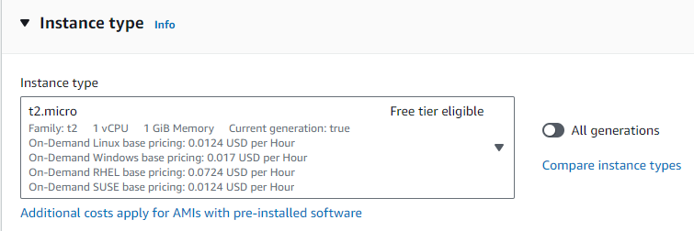

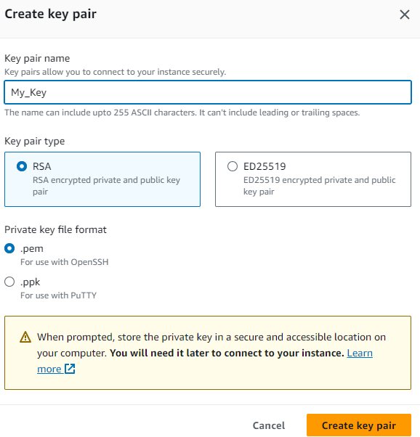

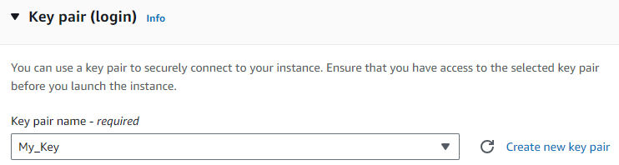

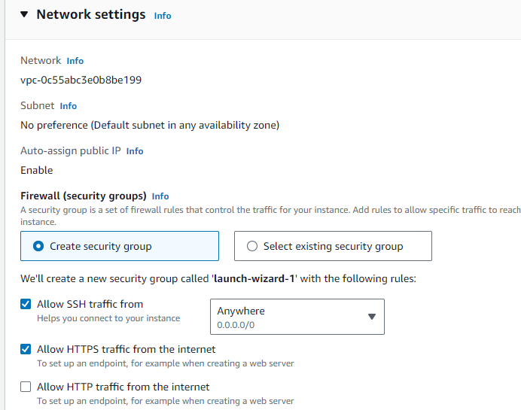

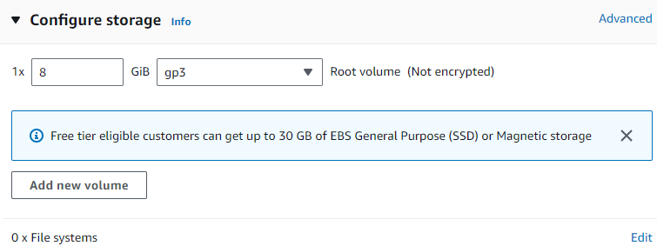

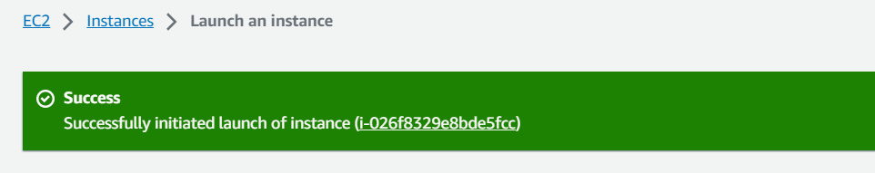

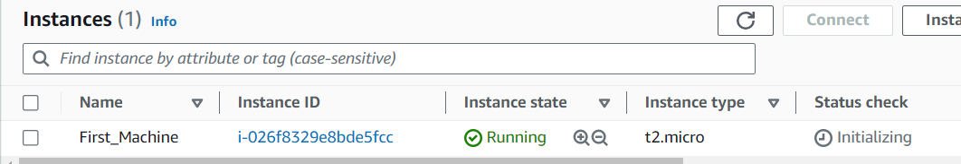

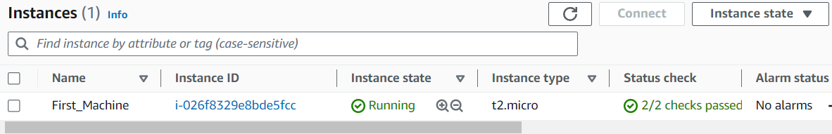

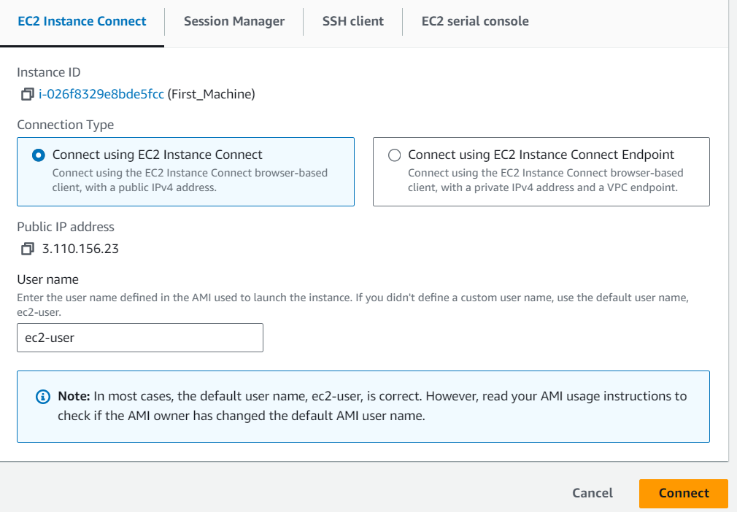

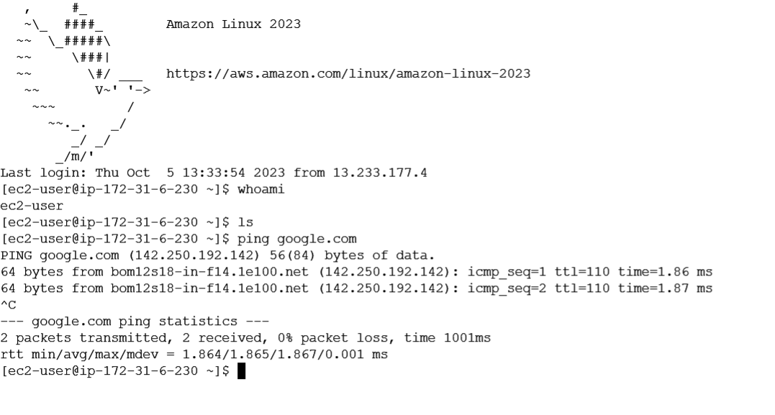

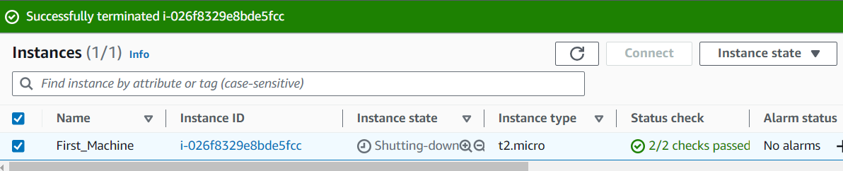

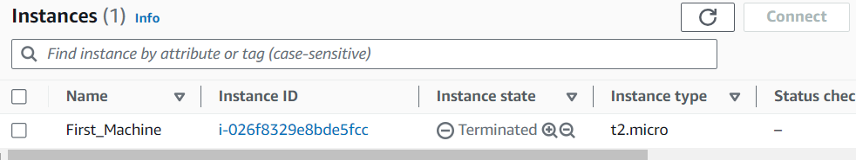

**Conclusion:**

In this experiment, we successfully created and worked with virtual machines on AWS. AWS's Elastic Compute Cloud (EC2) service provided a scalable and accessible infrastructure for deploying and managing virtual machines. This hands-on experience demonstrates the practicality and versatility of cloud computing for various applications and workloads.