Name: Kaushal Kotkar Department: Cyber Security

Div: BE-15 Roll No: 54

Subject: DSO

|  |  |  |  |  |
| --- | --- | --- | --- | --- |
| **Experiment No. – 2** | | | | |
| **Date of Performance:** | 22/7/2024 | | | |
| **Date of Submission:** | 29/7/2024 | | | |
| Program Execution/ formation/ correction/  ethical practices (06) | Timely Submission  (01) | Viva (03) | Experiment Total (10) | Sign with Date |
|  |  |  |  |  |

**Experiment No. 2**

**Aim:** To implement version control using GitHub to sync local git repositories and perform various related operations

**Lab Outcome:** CSL701.1Understand the concepts of distributed version control using GIT and GITHUB

**Theory:**

**Git init**

Create a local repository**:** $ git init

**Git clone**

Make a local copyof the server repository: $ git clone

**Git diff**

Track the changes that have not been staged: $ git diff

Track the changes that have staged but not committed: $ git diff --staged

Track the changes after committing a file: $ git diff HEAD

Track the changes between two commits: $ git diff

Git Diff Branches: $ git diff < branch 2>

**Git status**

Display the state of the working directory and the staging area: $ git status

**Git show**

Shows objects: $ git show

**Output:**

Installation of Git:

Go to the website and download the ‘git’ file according to your system configuration.

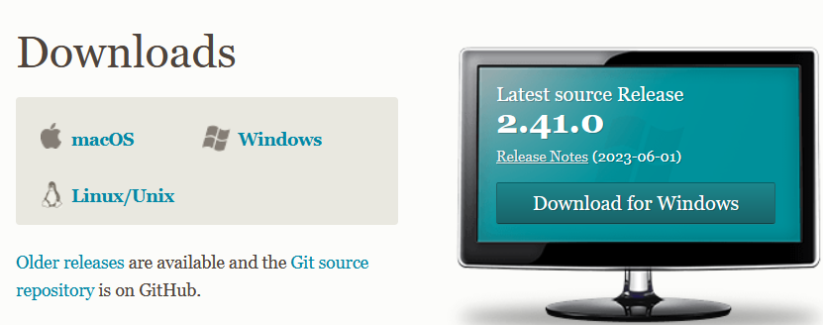

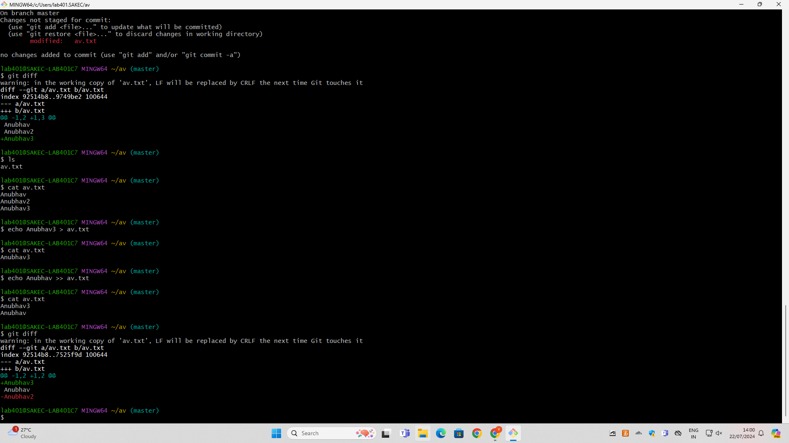

**Conclusion:**

Hence, I have learned and executed various git commands to perform task like creating directory, uploading data to directory, fetching data from directory etc.