Name: Kaushal Kotkar Department: Cyber Security

Div: BE-15 Roll No: 54

Subject: DSO

|  |  |  |  |  |
| --- | --- | --- | --- | --- |
| **Experiment No. – 7** | | | | |
| **Date of Performance:** | 26/08/2024 | | | |
| **Date of Submission:** | 02/09/2024 | | | |
| Program Execution/ formation/ correction/  ethical practices (06) | Timely Submission  (01) | Viva (03) | Experiment Total (10) | Sign with Date |
|  |  |  |  |  |

E**xperiment No. 7**

**Aim:** To implement Application and code security testing using snyk.

**Lab Outcome:** Use Sonarqube and snyk to perform code quality checks and Threat Dragon to create threat models to identify threats in the system

**Theory:**

**What is Snyk:**

Snyk is a developer-first security platform that helps developers find and fix vulnerabilities in their code and open-source dependencies early in the development process. It scans code and dependencies for known vulnerabilities and offers remediation guidance. It provides tools for both application security (AppSec) and open-source security.

**Why Use Snyk:**

1. **Vulnerability Detection:** Snyk scans your code and dependencies to identify known vulnerabilities in libraries and frameworks.
2. **Continuous Monitoring:** It offers continuous monitoring, alerting you to new vulnerabilities as they are discovered.
3. **Integration:** Snyk integrates seamlessly into the development workflow, including CI/CD pipelines.
4. **Developer-Friendly:** Snyk is developer-friendly, providing actionable insights and fixes for vulnerabilities.
5. **Open-Source Security:** It helps secure open-source libraries, which are commonly used in software development.

**Steps to Implement Security Testing Using Snyk:**

1. **Go to Snyk Website:**

Visit the Snyk website (<https://snyk.io/>).

1. **Create an Account:**

Sign up for a Snyk account if you don't already have one.

1. **Choose Integration Method:**

Decide how you want to integrate Snyk into your development workflow, such as using the Snyk CLI or integrations with your CI/CD pipeline.

1. **Install Snyk CLI:**

If you choose to use the Snyk CLI, follow the installation instructions for your platform. For Windows, you can use the following command:

**curl https://static.snyk.io/cli/latest/snyk-win.exe -o snyk.exe**

1. **Authenticate Your Machine:**

Run the command **snyk auth** to authenticate your machine with your Snyk account.

1. **Scan for Security Issues:**

Before scanning, navigate to your project's directory.

Ensure Snyk Code is enabled in the Snyk settings.

Run the following command to scan your code for vulnerabilities:

**snyk code test --org=04c00119-817c-4791-bc5a-a814134efa86**

**Output:**

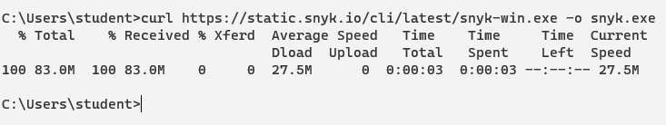

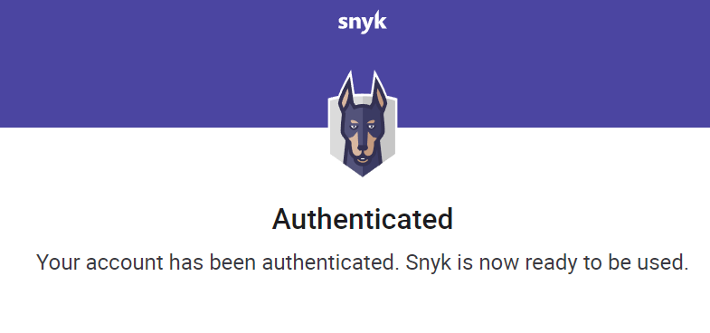

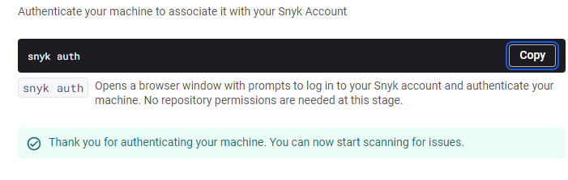

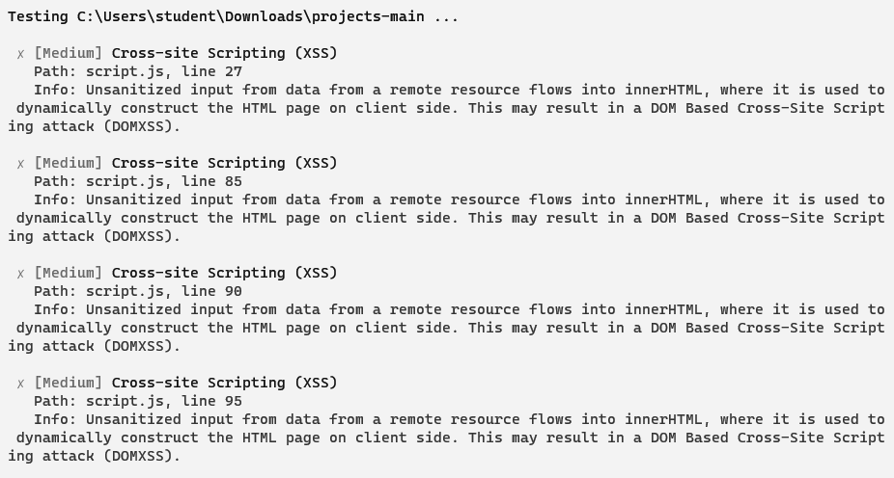

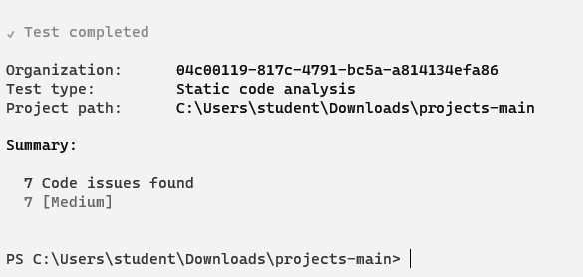

**Conclusion:**

Implementing security testing using Snyk is crucial for identifying and fixing vulnerabilities in your applications and code early in the development process. By integrating Snyk into your workflow, you can enhance the security of your software and reduce the risk of deploying insecure code.