Name: Devang Dedhia
Roll No: 66
Department: CYSE
Div: BTech-15
Sub: Mobile Forensic Lab

Experiment No: 5
Date of Performance: | 27/03/2025
Date of Submission: | 03/04/2025
Program formation/ Execution/ ethical practices (06) | Timely  Submission  (01) | Viva Answer (03) | Experiment Marks  (10) | Teacher Signature with  date

Experiment No. 5
Aim: Android Data Extraction Techniques - Manual Data Extraction/ Root Access/ Logical Data Extraction/ Physical Data Extraction.
Lab outcome: To demonstrate tools and techniques used for data acquisition and recovery of data from Android mobile devices
Theory:

Logical Data Extraction in Android

Logical data extraction is a crucial method for retrieving data from Android devices without altering the firmware or system files. This non-invasive approach ensures that the device’s original state remains intact while accessing user-generated data and system information through standard Android interfaces and APIs.

Techniques Used in Logical Data Extraction
Logical extraction employs various methods to acquire a wide range of data, including contacts, messages, call logs, media files, and application data. Key techniques include:
- Android Debug Bridge (ADB): Allows interaction with the device for file access and command execution.
- Content Provider Querying: Retrieves structured data from applications using content resolvers.
- File System Access: Extracts data stored in accessible directories and partitions.
- Backup and Restore Functionalities: Utilizes Android’s backup system to acquire application and user data.

Significance in Forensic Investigations and Security Audits
Logical data extraction is widely used in digital forensics, security audits, and data recovery operations due to its ability to:
- Preserve data authenticity and evidentiary value, ensuring compliance with legal and regulatory frameworks.
- Minimize risks of data corruption or unintended modifications, maintaining the integrity of retrieved information.
- Provide investigators with reliable and accurate insights, essential for analytical and investigative purposes.

Applications in Investigations
Logical data extraction supports various forensic and investigative tasks, including:
- Digital forensics: Recovering data for criminal investigations and legal proceedings.
- Incident response: Analyzing compromised devices in cybersecurity cases.
- Data recovery: Retrieving lost or deleted information from mobile devices.

Methods of Data Acquisition:
- Manual Acquisition:
  - Browsing the device and manually copying files.
  - Suitable for non-technical users but lacks deep-level data retrieval.
- Logical Acquisition:
  - Extracting files and databases via Android Debug Bridge (ADB).
  - Example: adb pull /sdcard/DCIM/ (to copy photos from internal storage).
- File System Acquisition:
  - Capturing file structures, including hidden files and app data.
  - Tools: Oxygen Forensic Detective, MOBILedit Forensic.
- Physical Acquisition:
  - Dumping the entire memory, including deleted files.
  - Requires root access or custom recovery mode.
  - Tools: UFED (Cellebrite), Magnet AXIOM, Autopsy.
Output:
1. Lists all Android devices connected to the computer.
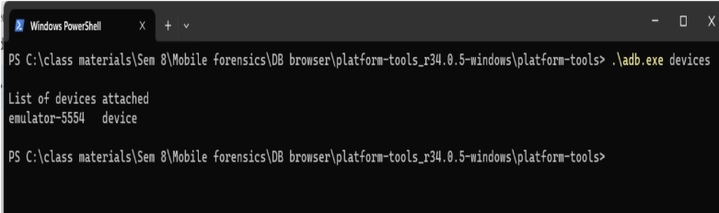

2. Execute adb root device_name command to check if root access is available, if not it will try to root the device.
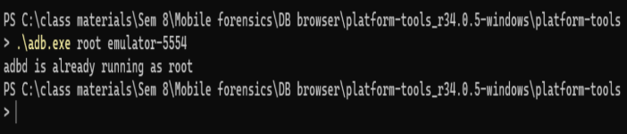

3. To extract contacts from the device, execute the command adb pull
/data/data/com.android.providers.contacts/databases. It will pull contacts information/database from the device.
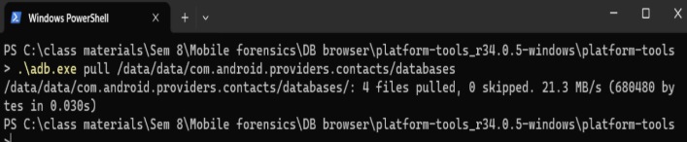

4. If the path is not specified, the adb pull command will pull/copy the database in the present working directory. The contact database folder contains the following database files shown below.
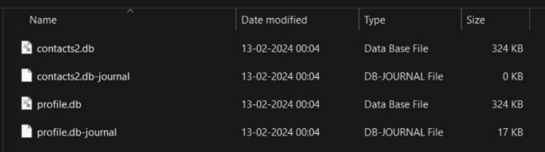

5. We can view the .db files in the DB Browser for SQLite as shown below.
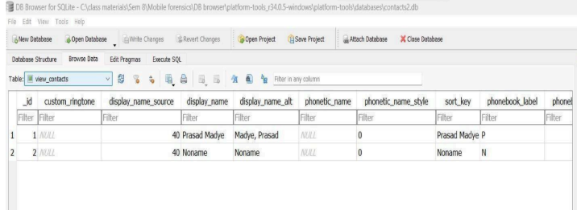

6. To extract messages, execute the command:
adb pull/data/data/com.android.providers.telephony/databases/
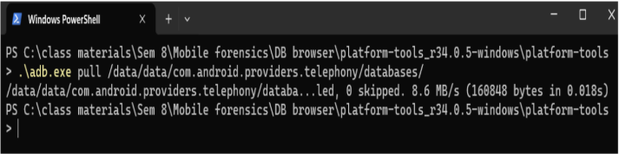
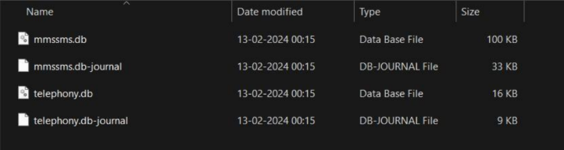

7. The below image shows the contents of mmssmms.db file
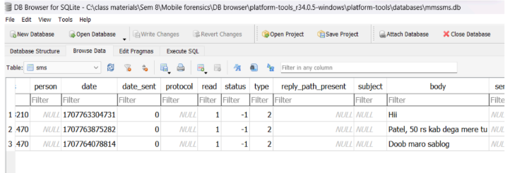

Conclusion:
Here we were able to successfully execute the Logical Data Extraction technique to extract the messages and contacts from an android device.

