c

Experiment No: 4
Date of  Performance: | 20/03/2025
Date of  Submission: | 27/03/2025
Execution of  practical/  ethical  practices (06) | Timely  Submission (01) | Viva Answer  (03) | Experiment  Marks  (10) | Teacher Signature with date

Experiment No. 4
Aim: iOS Data analysis and Recovery through timestamps/ SQLite databases/property list.
Lab outcome: Demonstrate tools and techniques used for data acquisition, analysis and recovery of data from iOS mobile devices.
Theory:

SQLite Databases in iOS Data Storage and Forensics

Introduction
iOS devices extensively utilize SQLite databases for data storage, making them a critical component in forensic investigations. Many built-in applications—such as Phone, Messages, Mail, Calendar, and Notes—as well as third-party applications, rely on SQLite databases to manage user data. These databases are commonly found with .sqlitedb or .db file extensions, though they may sometimes lack an extension.

Key SQLite Databases in iOS
Each SQLite database file can contain valuable information for forensic analysis. Some key databases include:
- Address Book (AddressBook.sqlitedb) – Stores contact information.
- Call History (CallHistory.storedata) – Logs incoming, outgoing, and missed calls.
- Messages (sms.db) – Contains text and multimedia messages (SMS and iMessages).

Third-Party Application Data Storage
- Third-party apps create unique subdirectories under /private/var/mobile/App/ for data storage.
- These directories often contain files in SQLite and plist formats, which can be examined for forensic relevance.

Challenges in Data Recovery
With each new iOS release, Apple modifies how SQLite databases are managed, leading to frequent database cleanups. This impacts forensic investigations in several ways:
- Automatic Deletion: Older records are frequently purged, making historical data harder to retrieve.
- Increased Cleanup Activity: iOS 11 and 12 introduced more aggressive cleanup mechanisms for SMS and iMessages, significantly reducing the chances of recovering deleted messages.
- Encryption and Security Enhancements: Apple continuously improves data security, complicating direct database extraction.
Procedure & Output:
1. Install Libplist-utils library.

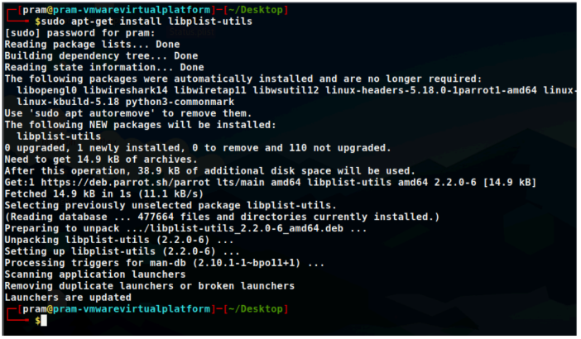

2. Use plistutil command to display the contents of the .plist files. The below file is Status.plist, this file contains information like the Date, Time and version of the backup or Snapshot at the time when it was taken.
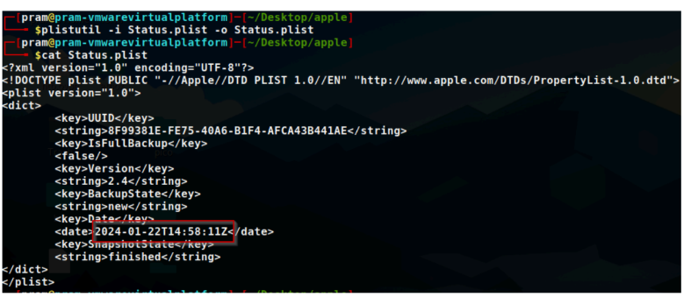

3. The manifest.plist file contains the information like the CFBundleIndentifier, Build version, Device name, etc.
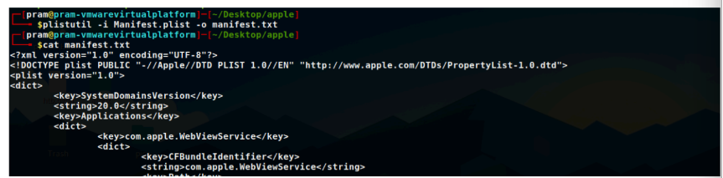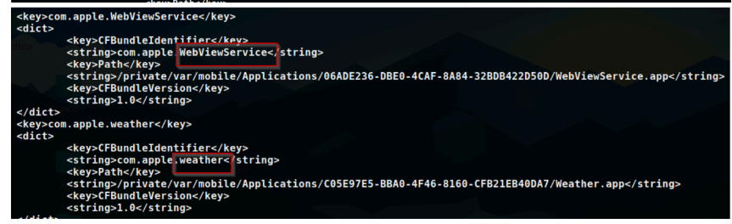
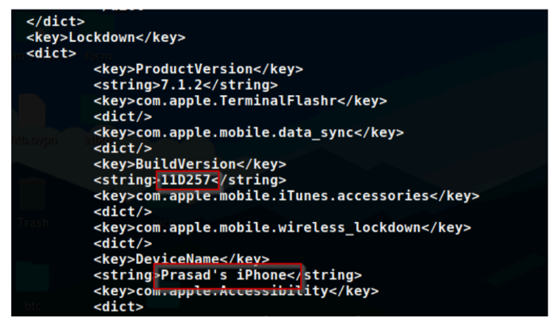
Conclusion:
In this experiment, we demonstrated how to install the Libplist-utils library, use the `plistutil` command to display the contents of `.plist` files, and understand the information contained in `Status.plist` and `manifest.plist`. We also discussed the importance of SQLite databases in iOS devices and the challenges posed by frequent database cleanups in newer iOS versions.

