**QuickSort** is a sorting algorithm based on the[**Divide and Conquer algorithm**](https://www.geeksforgeeks.org/divide-and-conquer-algorithm-introduction/) that picks an element as a pivot and partitions the given array around the picked pivot by placing the pivot in its correct position in the sorted array.



*QuickSort*

**How does QuickSort work?**

The key process in **QuickSort** is a partition(). The target of partitions is to place the pivot (any element can be chosen to be a pivot) at its correct position in the sorted array and put all smaller elements to the left of the pivot, and all greater elements to the right of the pivot.

This partition is done recursively which finally sorts the array. See the below image for a better understanding.

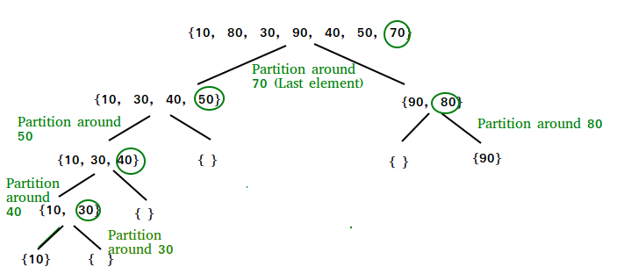

**Choice of Pivot:**

There are many different choices for picking pivots.

* [Always pick the first element as a pivot](https://www.geeksforgeeks.org/implement-quicksort-with-first-element-as-pivot/).
* Always pick the last element as a pivot (implemented below)
* [Pick a random element as a pivot](https://www.geeksforgeeks.org/quicksort-using-random-pivoting/).
* Pick the middle as the pivot.

**Partition Algorithm:**

There can be many ways to do partition. The logic is simple, we start from the leftmost element and keep track of the index of smaller (or equal to) elements as i. While traversing, if we find a smaller element, we swap the current element with arr[i]. Otherwise, we ignore the current element.

**Pseudo Code for Quick Sort:**

/* low  –> Starting index,  high  –> Ending index */

**quickSort**(arr[], low, high) {  
    if (low < high) {  
        /* pi is partitioning index, arr[pi] is now at right place */  
        pi = partition(arr, low, high);  
        quickSort(arr, low, pi – 1);  // Before pi  
        quickSort(arr, pi + 1, high); // After pi  
    }  
}

**Pseudo code for partition():**

/* This function takes last element as pivot, places the pivot element at its correct position in sorted array, and places all smaller (smaller than pivot) to left of pivot and all greater elements to right of pivot */

partition (arr[], low, high)  
{  
    // pivot (Element to be placed at right position)  
    pivot = arr[high];

    i = (low – 1)  // Index of smaller element and indicates the   
    // right position of pivot found so far

    for (int j = low; j <= high- 1; j++){

        // If current element is smaller than the pivot  
        if (arr[j] < pivot){  
            i++;    // increment index of smaller element  
            swap arr[i] and arr[j]  
        }  
    }  
    swap arr[i + 1] and arr[high])  
    return (i + 1)  
}

[Solve Problem](https://practice.geeksforgeeks.org/problems/quick-sort/1?utm_source=gfg&utm_medium=article&utm_campaign=bottom_sticky_on_article" \o "Permalink to Quick Sort)

Submission count: 1.2L

Illustration of partition():

Consider: arr[] = {10, 80, 30, 90, 40, 50, 70}

Indexes:  0   1   2   3   4   5   6

low = 0, high =  6, pivot = arr[h] = 70

Initialize index of smaller element, i = -1

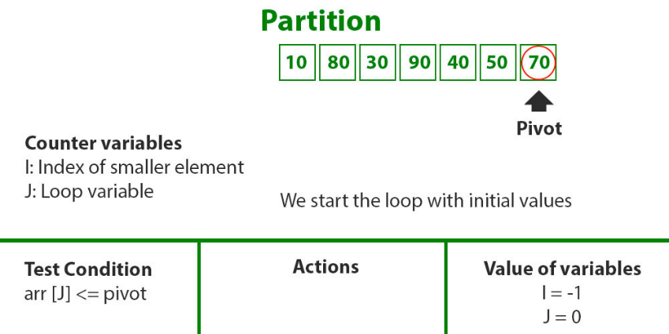

*Compare pivot with first element*

Traverse elements from j = low to high-1

j = 0: Since arr[j] <= pivot, do i++ and swap(arr[i], arr[j])

i = 0

arr[] = {10, 80, 30, 90, 40, 50, 70} // No change as i and j are same

j = 1: Since arr[j] > pivot, do nothing

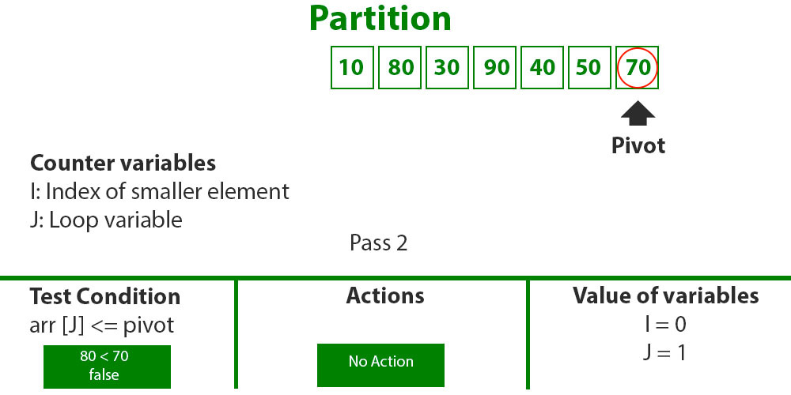

*Compare pivot with arr[1]*

j = 2 : Since arr[j] <= pivot, do i++ and swap(arr[i], arr[j])

i = 1

arr[] = {10, 30, 80, 90, 40, 50, 70} // We swap 80 and 30

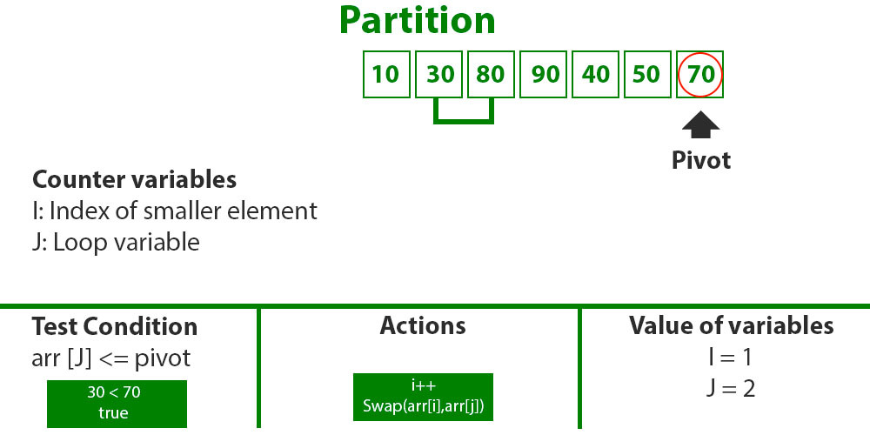

*Compare pivot with arr[2]*

j = 3 : Since arr[j] > pivot, do nothing // No change in i and arr[]

j = 4 : Since arr[j] <= pivot, do i++ and swap(arr[i], arr[j])

i = 2

arr[] = {10, 30, 40, 90, 80, 50, 70} // 80 and 40 Swapped

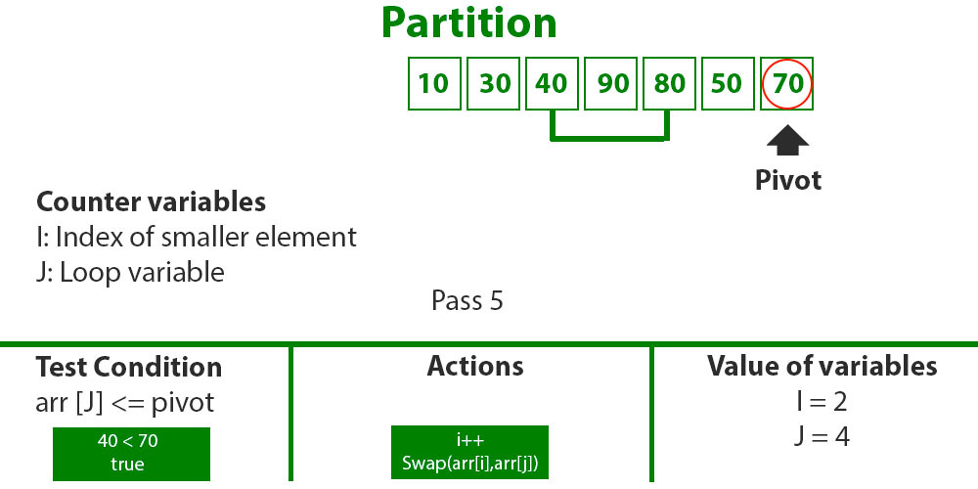

*Compare pivot with arr[4]*

j = 5 : Since arr[j] <= pivot, do i++ and swap arr[i] with arr[j]

i = 3

arr[] = {10, 30, 40, 50, 80, 90, 70} // 90 and 50 Swapped

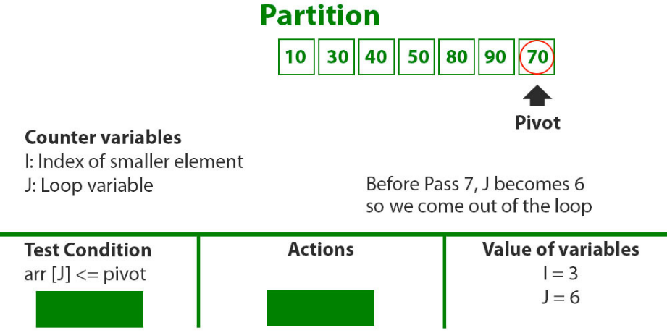

*Compare pivot with arr[6]*

We come out of loop because j is now equal to high-1.

Finally, we place pivot at correct position by swapping arr[i+1] and arr[high] (or pivot)

arr[] = {10, 30, 40, 50, 70, 90, 80} // 80 and 70 Swapped

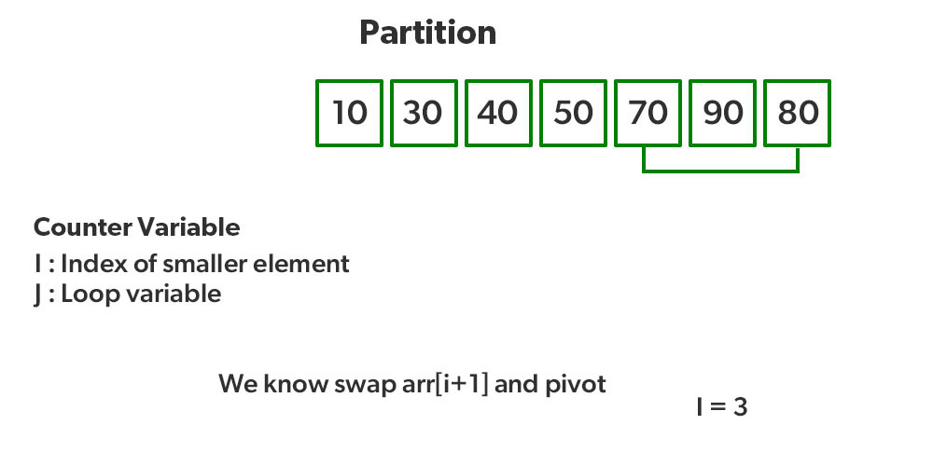

*Swap arr[i+1] with pivot*

Now 70 is at its correct place. All elements smaller than 70 are before it and all elements greater than 70 are after it.

Since quick sort is a recursive function, we call the partition function again at left and right partitions

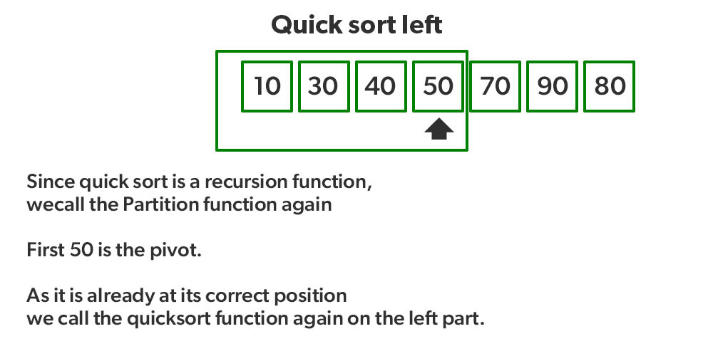

*Recursively sort the left side of pivot*

* *Again call function at right part and swap 80 and 90*

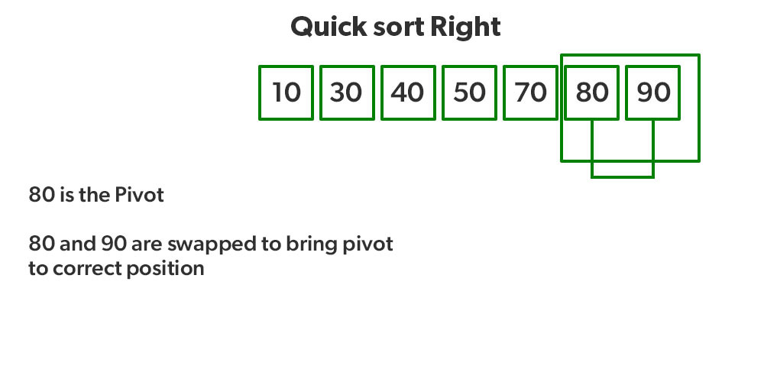

*.Recursively sort the right side of pivot*

* Program to implement QuickSort:
* Follow the below steps to implement the algorithm:
* Create a recursive function (say quicksort()) to implement the quicksort.
* Partition the range to be sorted (initially the range is from 0 to N-1) and return the correct position of the pivot (say pi).
* Select the rightmost value of the range to be the pivot.
* Iterate from the left and compare the element with the pivot and perform the partition as shown above.
* Return the correct position of the pivot.
* Recursively call the quicksort for the left and the right part of the pi.

|  |
| --- |
| // Java implementation of QuickSort  **import** java.io.*;    **class** GFG {        // A utility function to swap two elements  **static** **void** swap(**int**[] arr, **int** i, **int** j)      {  **int** temp = arr[i];          arr[i] = arr[j];          arr[j] = temp;      }        // This function takes last element as pivot,      // places the pivot element at its correct position      // in sorted array, and places all smaller to left      // of pivot and all greater elements to right of pivot  **static** **int** partition(**int**[] arr, **int** low, **int** high)      {          // Choosing the pivot  **int** pivot = arr[high];            // Index of smaller element and indicates          // the right position of pivot found so far  **int** i = (low - 1);    **for** (**int** j = low; j <= high - 1; j++) {                // If current element is smaller than the pivot  **if** (arr[j] < pivot) {                    // Increment index of smaller element                  i++;                  swap(arr, i, j);              }          }          swap(arr, i + 1, high);  **return** (i + 1);      }        // The main function that implements QuickSort      // arr[] --> Array to be sorted,      // low --> Starting index,      // high --> Ending index  **static** **void** quickSort(**int**[] arr, **int** low, **int** high)      {  **if** (low < high) {                // pi is partitioning index, arr[p]              // is now at right place  **int** pi = partition(arr, low, high);                // Separately sort elements before              // partition and after partition              quickSort(arr, low, pi - 1);              quickSort(arr, pi + 1, high);          }      }      // To print sorted array  **public** **static** **void** printArr(**int**[] arr){  **for** (**int** i = 0; i < arr.length; i++) {              System.out.print(arr[i]+" ");          }      }      // Driver Code  **public** **static** **void** main(String[] args)      {  **int**[] arr = { 10, 7, 8, 9, 1, 5 };  **int** N = arr.length;            // Function call          quickSort(arr, 0, N - 1);          System.out.println("Sorted array:");          printArr(arr);      }  }    // This code is contributed by Ayush Choudhary  // Improved by Ajay Virmoti |

Output

Sorted array:

1 5 7 8 9 10

Analysis of QuickSort:

Time taken by QuickSort, in general, can be written as follows.

 T(n) = T(k) + T(n-k-1) + (n)

The first two terms are for two recursive calls, the last term is for the partition process. k is the number of elements that are smaller than the pivot.

**Worst Case:**

The worst case occurs when the partition process always picks the first or last element as the pivot. If we consider the above partition strategy where the last element is always picked as a pivot, the worst case would occur when the array is already sorted in increasing or decreasing order. Following is the recurrence for the worst case.

T(N) = T(0) + T(N-1) + (N) which is equivalent to  
T(N) = T(N-1) + (N)

The solution to the above recurrence is O(n2).

Best Case:

The best case occurs when the partition process always picks the middle element as the pivot. The following is recurrence for the best case.

 T(N) = 2T(N/2) + (N)

The solution for the above recurrence is O(N * logN). It can be solved using case 2 of the [Master Theorem](http://en.wikipedia.org/wiki/Master_theorem).

**Average Case:**

To do an average case analysis, we need to consider all possible permutations of the array and calculate the time taken by every permutation which doesn’t look easy.

We can get an idea of an average case by considering the case when partition puts O(N/9) elements in one set and O(9N/10) elements in the other set. Following is the recurrence for this case.

 T(N) = T(N/9) + T(9N/10) + (N)

The solution of the above recurrence is also O(N * logN):

Although the worst case time complexity of QuickSort is O(N2) which is more than many other sorting algorithms like [Merge Sort](https://www.geeksforgeeks.org/merge-sort/) and [Heap Sort](https://www.geeksforgeeks.org/heap-sort/), QuickSort is faster in practice, because its inner loop can be efficiently implemented on most architectures and in most real-world data. QuickSort can be implemented in different ways by changing the choice of pivot so that the worst case rarely occurs for a given type of data. However, merge sort is generally considered better when data is huge and stored in external storage.

**Advantages of Quick Sort:**

It is a divide-and-conquer algorithm that makes it easier to solve problems.

It is efficient on large data sets.

It has a low overhead, as it only requires a small amount of memory to function.

Disadvantages of Quick Sort:

It has a worst-case time complexity of O(N2), which occurs when the pivot is chosen poorly.

It is not a good choice for small data sets.

It is not a stable sort, meaning that if two elements have the same key, their relative order will not be preserved in the sorted output in case of quick sort, because here we are swapping elements according to the pivot’s position (without considering their original positions).

Some Frequently asked Questions (FAQs) on QuickSort:

**How to pick any element as pivot?**

With one minor change to the above code, we can pick any element as pivot. For example, to make the first element as pivot, we can simply swap the first and last elements and then use the same code. Same thing can be done to pick any random element as a pivot

**Is QuickSort**[**stable**](https://www.geeksforgeeks.org/stability-in-sorting-algorithms/)**?**

The default implementation is not stable. However, any sorting algorithm can be made stable by considering indices as a comparison parameter.

**Is QuickSort**[**In-place**](https://www.geeksforgeeks.org/in-place-algorithm/)**?**

As per the broad definition of in-place algorithm, it qualifies as an in-place sorting algorithm as it uses extra space only for storing recursive function calls but not for manipulating the input.

**What is 3-Way QuickSort?**

In simple QuickSort algorithm, we select an element as pivot, partition the array around pivot and recur for subarrays on left and right of pivot.   
Consider an array which has many redundant elements. For example, {1, 4, 2, 4, 2, 4, 1, 2, 4, 1, 2, 2, 2, 2, 4, 1, 4, 4, 4}. If 4 is picked as pivot in Simple QuickSort, we fix only one 4 and recursively process remaining occurrences. In 3 Way QuickSort, an array arr[l..r] is divided in 3 parts:

arr[l..i] elements less than pivot.

arr[i+1..j-1] elements equal to pivot.

arr[j..r] elements greater than pivot.

See [this](https://www.geeksforgeeks.org/3-way-quicksort/) for implementation.

**How to implement QuickSort for Linked Lists?**

[QuickSort on Singly Linked List](https://www.geeksforgeeks.org/quicksort-on-singly-linked-list/)   
[QuickSort on Doubly Linked List](https://www.geeksforgeeks.org/quicksort-for-linked-list/)

Can we implement QuickSort Iteratively?

Yes, please refer [Iterative Quick Sort](https://www.geeksforgeeks.org/iterative-quick-sort/).

**Why Quick Sort is preferred over MergeSort for sorting Arrays ?**

Quick Sort in its general form is an in-place sort (i.e. it doesn’t require any extra storage) whereas merge sort requires O(N) extra storage, N denoting the array size which may be quite expensive.

Allocating and de-allocating the extra space used for merge sort increases the running time of the algorithm. Comparing average complexity we find that both types of sorts have O(N logN) average complexity but the constants differ. For arrays, merge sort loses due to the use of extra O(N) storage space.

Most practical implementations of Quick Sort use randomized versions. The randomized version has an expected time complexity of O(N logN). The worst case is possible in the randomized version also, but the worst case doesn’t occur for a particular pattern (like sorted array) and randomized Quick Sort works well in practice.

Quick Sort is also a cache friendly sorting algorithm as it has a good locality of reference when used for arrays.

Quick Sort is also tail recursive, therefore tail call optimizations are done.

Why MergeSort is preferred over QuickSort for Linked Lists ?

In the case of linked lists, the case is different mainly due to the difference in memory allocation of arrays and linked lists. Unlike arrays, linked list nodes may not be adjacent in memory.

Unlike arrays, in linked lists, we can insert items in the middle in O(1) extra space and O(1) time. Therefore merge operation of merge sort can be implemented without extra space for linked lists.

Unlike arrays, we can not do random access in linked lists. Quick Sort requires a lot of this kind of access. In a linked list to access the ith index, we have to travel each and every node from the head to ith node as we don’t have a continuous block of memory. Therefore, the overhead increases for quicksort. Merge sort accesses data sequentially and the need for random access is low.

How to optimize QuickSort so that it takes O(log N) extra space in the worst case?

As the recursion call is performed at the end of the recursive function, we can use the concept of tail recursion to optimize the space taken by Quicksort. Please refer to [QuickSort Tail Call Optimization (Reducing worst case space to log N)](https://www.geeksforgeeks.org/quicksort-tail-call-optimization-reducing-worst-case-space-log-n/).

Conclusion:

To sum up, it can be said that Quicksort is a fast and efficient sorting algorithm with an average time complexity of O(N logN). It is a divide-and-conquer algorithm that breaks down the original problem into smaller subproblems that are easier to solve. It can be easily implemented in both iterative and recursive forms and it is efficient on large data sets, and can be used to sort data in place. However, it also has some drawbacks such as the worst case time complexity of O(N2) which occurs when the pivot is chosen poorly. The performance of quicksort is sensitive to the choice of the pivot.

Please write comments if you find anything incorrect, or you want to share more information about the topic discussed above.