QUESTION 2

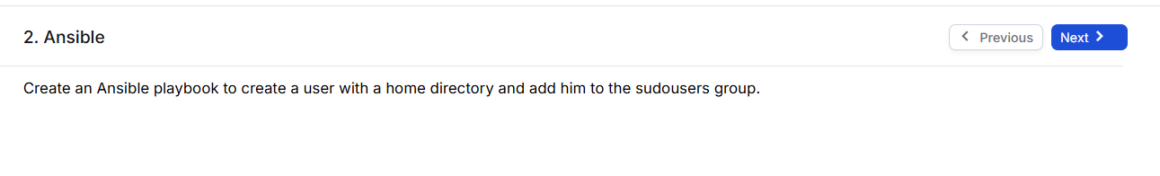

**SOLUTION:**

- name: Create sudo-user with home directory

 hosts: all

 become: yes

 vars:

   new_user: kaushal2118

 tasks:

   - name: Ensure the user exists with a home directory

     user:

       name: "{{ new_user }}"

       state: present

       shell: /bin/bash

       create_home: yes

   - name: Ading to group

     user:

       name: "{{ new_user }}"

       groups: sudo

       append: yes

**OUTPUT:**

1. **YAML FILE FOR CREATING AN USER WITH HOME DIRECTORY AND ADDING THEM INTO SUDO GROUPS**

1. **SUCCESSFULLY EXECUTED YAML FILE**

1. **USER CREATED AND ADDED INTO THE SUDO GROUPS**

