QUESTION 3

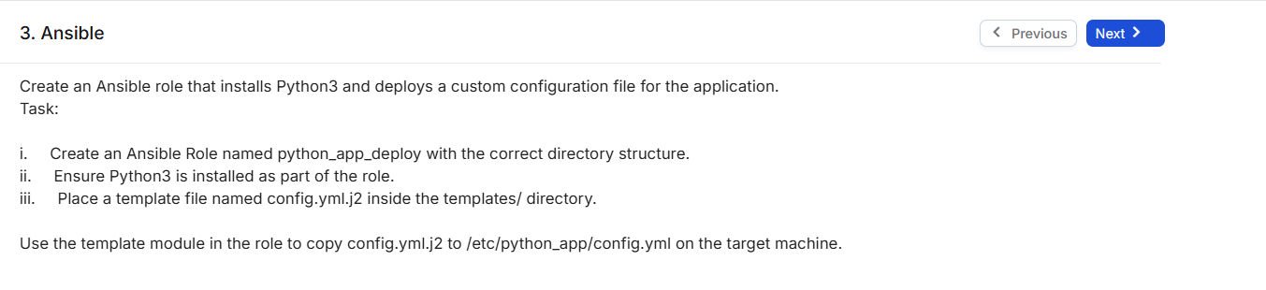

SOLUTION:

1. CREATING ROLE



1. Created main.yml to define tasks for installing Python3 and deploying config.

1. Created hosts file to define target machines for Ansible deployment.

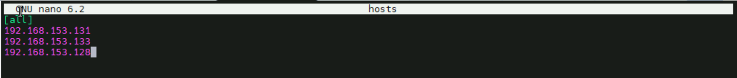

1. Created .j2 file to generate config dynamically based on environment settings



1. OUTPUT

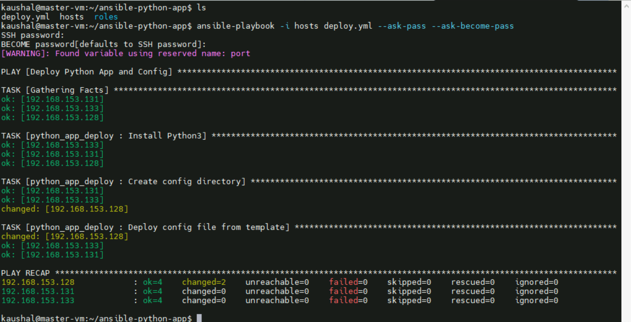

**ALL FILES :**

* **deploy.yaml file:**

---

- name: Deploy Python App and Config

 hosts: all

 become: yes

 vars:

   env: staging

   debug: true

   port: 8080

 roles:

   - python_app_deploy

* **hosts file**

[all]

192.168.153.131

192.168.153.133

192.168.153.128

* main.yml
* file inside roles/python_app_deploy/tasks/main.yml

---

- name: Install Python3

 ansible.builtin.package:

   name: python3

   state: present

- name: Create config directory

 ansible.builtin.file:

   path: /etc/python_app

   state: directory

   mode: '0755'

- name: Deploy config file from template

 ansible.builtin.template:

   src: config.yml.j2

   dest: /etc/python_app/config.yml

   mode: '0644'