QUESTION 4

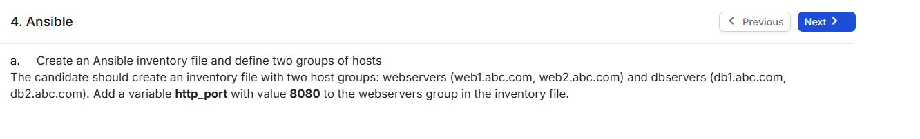

SOLUTION:

1. Created hosts file to define groups of remote machines and their connection details for Ansible to manage.

1. The output shows that the playbook ran successfully, performed the intended tasks, and made changes on the target machines.

**FILES CREATED :**

[webservers]

web1.abc.com ansible_host=192.168.153.131

web2.abc.com ansible_host=192.168.153.133

[webservers:vars]

http_port=8080

[dbservers]

db1.abc.com ansible_host=192.168.153.131

db2.abc.com ansible_host=192.168.153.128