QUESTION 5

SOLUTION:

1. Created hosts file to define groups of remote machines and their connection details for Ansible to manage.

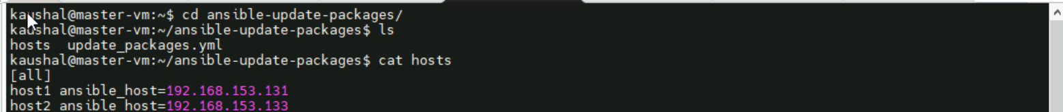

1. Yaml file for updating packing on machines

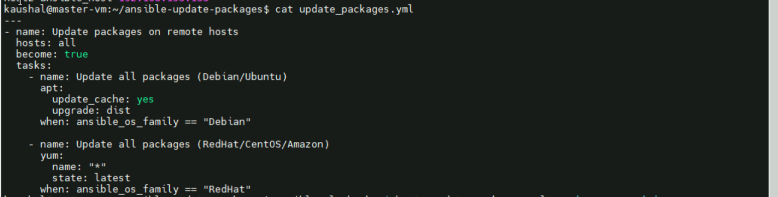

1. Output for the SUCCESSFUL UPDATE PACKAGES

**FILES USED:**

1. **HOST FILE**

kaushal@master-vm:~/ansible-update-packages$ cat hosts

[all]

host1 ansible_host=192.168.153.131

host2 ansible_host=192.168.153.133

1. **UPDATE.PACKAGE.YAML FILE FOR UPDATEING THE PACKAGE**

---

- name: Update packages on remote hosts

 hosts: all

 become: true

 tasks:

   - name: Update all packages (Debian/Ubuntu)

     apt:

       update_cache: yes

       upgrade: dist

     when: ansible_os_family == "Debian"

   - name: Update all packages (RedHat/CentOS/Amazon)

     yum:

       name: "*"

       state: latest

     when: ansible_os_family == "RedHat"