**QUESTION 6**

**SOLUTION:**

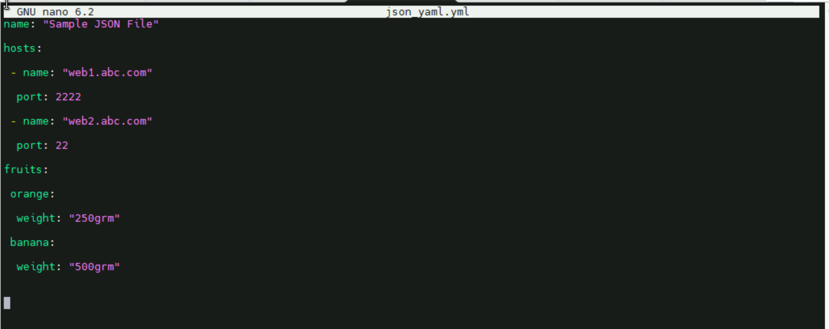

Files converted from JSON to YAML

name: "Sample JSON File"

hosts:

 - name: "web1.abc.com"

  port: 2222

 - name: "web2.abc.com"

  port: 22

fruits:

 orange:

  weight: "250grm"

 banana:

  weight: "500grm"