**Settings in eclipse and STS**

1. **Save Actions Settings**

Go to windows🡪 preferences🡪 Java🡪 Editor🡪 Save Actions

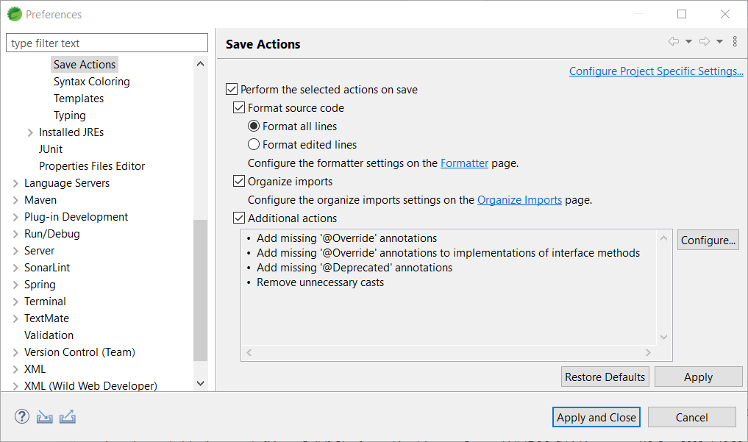

1. **Formatter Setting**

Go to windows🡪 preferences🡪 Java🡪Code Style🡪 Formatter

Active Profile 🡪 Edit

Or import file sentient.xml

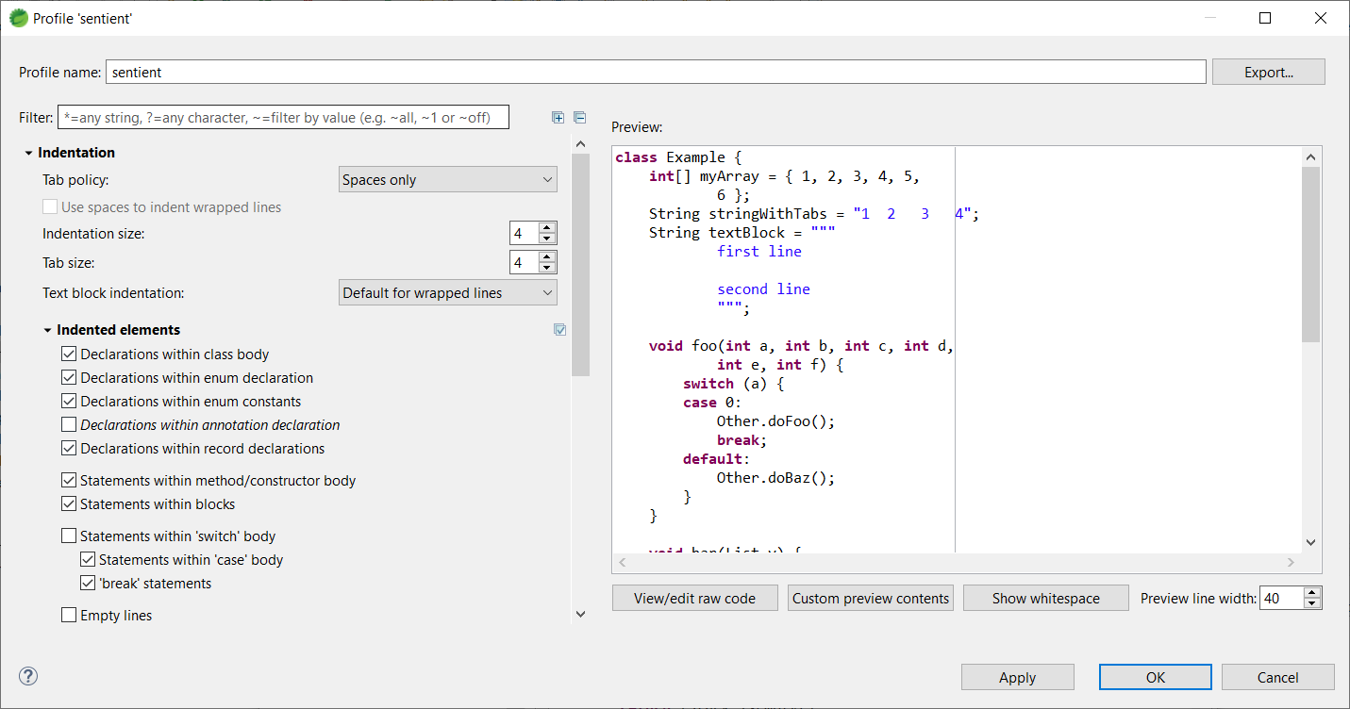

1. **Code Templates**

Go to windows🡪 preferences🡪 Java🡪Templates

1. Comments🡪 Files

Note : Replace “Test Company” with “Sentient Energy Inc.”

/**

* Copyright 2022, Test Company

*

*/

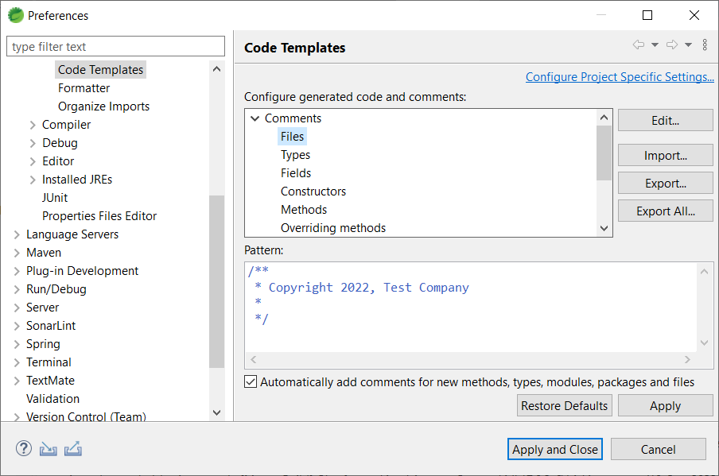

Comments🡪 Types

Note Replace “kaushlender sharma” with “Sentient Energy”

/**

*

* **@author** kaushlender sharma

*

* ${tags}

*/

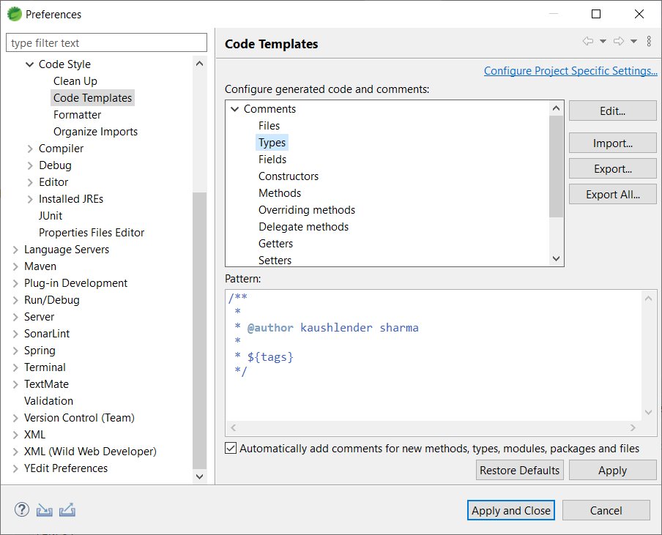

Apply and apply close