Name:Kaushal Kishor ray
USN:1BF25CS124
Lab program-1

import java.util.Scanner;
class Student
{
String name, usn;
void accept()
{
Scanner sc=new Scanner(System.in);
System.out.println("Enter the name of student:");
name=sc.nextLine();
System.out.println("Enter the usn of the student:");
usn=sc.nextLine();
}
void display()
{
System.out.println("Student Name:"+name);
System.out.println("Student USN:"+usn);
}
}
class StudentRun
{
public static void main(String a[])
{
Student s[]=new Student[3];
for(int i=0;i<3;i++)
{
s[i]=new Student();
s[i].accept();
s[i].display();
}
}
}

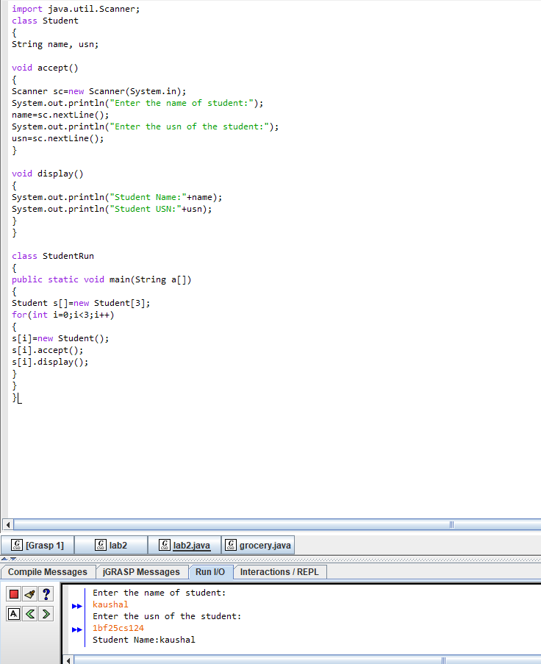

Grocery problem

class Grocery
{
double q_dal,q_pulse,q_sugar;
Grocery()
{
q_dal=0;
q_pulse=0;
q_sugar=0;
System.out.println((q_dal*150)+(q_pulse*120)+(q_sugar*70));
}
Grocery(double val)
{
q_dal=q_pulse=q_sugar=val;
System.out.println((q_dal*150)+(q_pulse*120)+(q_sugar*70));
}
Grocery(double d,double p, double s)
{
q_dal=d;
q_pulse=p;
q_sugar=s;
System.out.println((q_dal*150)+(q_pulse*120)+(q_sugar*70));
}
}
class GroceryRun
{
public static void main(String a[])
{
Grocery g1=new Grocery();
Grocery g2=new Grocery(2);
Grocery g3=new Grocery(1,2,3);
}
}

