OLIST E-COMMERCE
Customer Acquisition vs Retention Analysis
A Unit Economics Crisis
Business Analyst Portfolio Project | SQL + Power BI | Real Data
PROJECT DETAIL
Project Name | Olist E-Commerce: Customer Acquisition vs Retention Crisis
Dataset | Brazilian E-Commerce Public Dataset by Olist (Kaggle)
Dataset Size | 99,441 customers • 99,000+ orders • 2016–2018
Tools Used | SQL (MySQL Workbench) • Power BI Desktop
SQL Queries | 5 Main Queries (P1-P4) + 5 Additional Queries (A-E)
All Numbers | 100% verified from real Olist data — no assumptions
Target Role | Business Analyst / Data Analyst

1. Executive Summary
This project analyzes real-world Brazilian e-commerce data from Olist to answer one business question: why are customers not coming back after their first order? Using SQL in MySQL and Power BI, the analysis uncovered that 0% of customers ever placed a second order — despite mostly positive reviews and acceptable delivery times.

Key Finding: 99,441 customers ordered exactly ONCE. Repeat Rate = 0%. Root Cause: 77% orders were one-time purchase products. Only Beauty & Health was repeat-friendly — but Olist had NO loyalty program to bring them back.

2. Problem Statement
"99,441 customers placed exactly one order and never returned. Repeat Rate = 0%. The platform was transacting — not retaining."

Pain Point | Data Evidence | SQL Query
Zero repeat customers | 99,441 customers — all ordered exactly once | P1 – Verified
Remote state delivery gap | RR = 29.3 days vs SP = 9 days | P4 – Verified
Late delivery = low review | 20+ days = 3.16 stars vs 4.41 for fast | P3 – Verified
One-time product mix | Furniture 29K + Electronics 19K = one-time | Query C – Verified
No loyalty infrastructure | No reminders, no discounts, no re-engagement | Business Analysis
Revenue per customer low | R$159.86 per customer — CAC not recovered | Query D – Verified

3. Power BI Dashboard
Single-page interactive dashboard built in Power BI Desktop. Connected directly to MySQL database. All visuals based on verified SQL query results. 3 slicers: Category, State, Year.

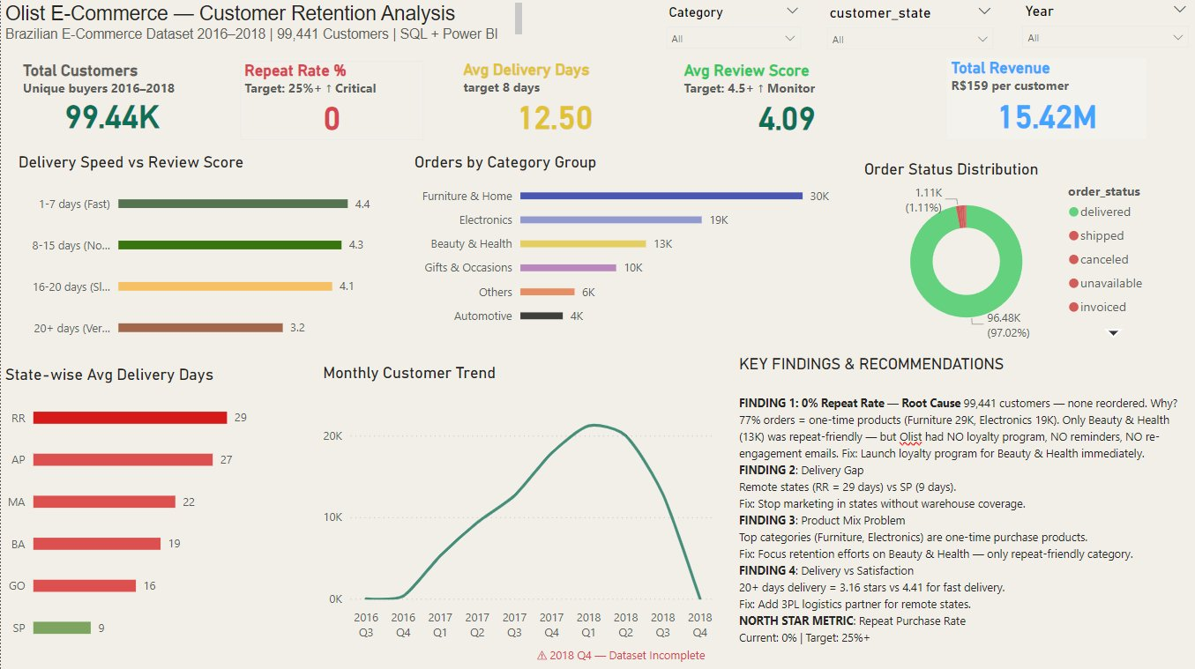
Final Power BI Dashboard — Olist Customer Retention Analysis

Dashboard Visuals Explained
Visual | Data Source | Business Question Answered | Key Finding
5 KPI Cards | orders + payments tables | What is business health? | 99.4K customers, 0% repeat, 12.5d delivery, 4.09 review, R$15.4M revenue
Delivery Speed vs Review | orders + reviews JOIN | Does late delivery hurt satisfaction? | 20+ days = 3.16 stars — clear dissatisfaction
Orders by Category | orders + products JOIN | Which categories drive orders? | Furniture 29K — one-time purchase — root cause of 0% repeat
Order Status Donut | orders table | How many orders delivered? | 97% delivered — delivery not the main problem
State-wise Delivery | orders + customers JOIN | Where is delivery slowest? | RR=29 days vs SP=9 days — warehouse gap
Monthly Trend (Cohort) | v_cohort_analysis view | When did customers come? | Nov 2017 Black Friday spike — but none returned
Key Findings box | All queries combined | What are recommendations? | 4 findings with root cause and fixes

4. SQL Queries — Complete List
All queries written from scratch in MySQL Workbench. Each query answers a specific business question. Results directly used in Power BI dashboard.

Query | Business Question | SQL Concepts Used | Key Result
P1 | How many customers came back? | COUNT, GROUP BY, Subquery | 0% repeat rate — all 99,441 ordered once
P2 | How long does delivery take? | AVG, DATEDIFF, WHERE, IS NOT NULL | 12.5 days avg — delivered orders only
P3 | Does late delivery hurt reviews? | CASE, JOIN, GROUP BY, AVG | 20+ days = 3.16 stars vs 4.41 for fast
P4 | Which states have worst delivery? | 3-table JOIN, GROUP BY, ORDER BY | RR=29.3 days vs SP=9 days
Query A | Which categories get most complaints? | 4-table JOIN, SUM CASE, ROUND | Office Furniture 26% bad reviews
Query B | Does price affect satisfaction? | CASE buckets, AVG, JOIN | Price has NO impact on review score
Query C | Which products sell most? | JOIN, GROUP BY, ORDER BY, LIMIT | Furniture 29K — one-time purchase
Query D | What is revenue per customer? | SUM, AVG, DIVIDE, JOIN | R$159.86 per customer — CAC not recovered
Query E | Did any customer return next month? | DATE_FORMAT, MIN, JOIN, Subquery | 0 returning customers in any cohort

P1: Repeat Rate Analysis
-- How many customers ordered more than once?
SELECT total_orders, COUNT(customer_id) AS total_customers
FROM (
SELECT customer_id, COUNT(order_id) AS total_orders
FROM olist_orders_dataset
GROUP BY customer_id
) AS customer_orders
GROUP BY total_orders;
-- Result: 99,441 customers ALL ordered exactly once. Repeat Rate = 0%

P2: Average Delivery Time
-- Average delivery days (delivered orders, blanks excluded)
SELECT AVG(DATEDIFF(order_delivered_customer_date,
order_purchase_timestamp)) AS avg_delivery_days
FROM olist_orders_dataset
WHERE order_status = 'delivered'
AND order_delivered_customer_date IS NOT NULL
AND order_delivered_customer_date != '';
-- Result: 12.4968 days

P3: Delivery Speed vs Review Score
SELECT
CASE
WHEN DATEDIFF(...) BETWEEN 1 AND 7 THEN '1-7 days (Fast)'
WHEN DATEDIFF(...) BETWEEN 8 AND 15 THEN '8-15 days (Normal)'
WHEN DATEDIFF(...) BETWEEN 16 AND 20 THEN '16-20 days (Slow)'
ELSE '20+ days (Very Slow)'
END AS delivery_bucket,
COUNT(*) AS total_orders,
ROUND(AVG(r.review_score), 2) AS avg_review_score
FROM olist_orders_dataset o
JOIN olist_order_reviews_dataset r ON o.order_id = r.order_id
WHERE o.order_status = 'delivered'
GROUP BY delivery_bucket;

Delivery Speed | Orders | Avg Review Score
1-7 days (Fast) | 30,678 | 4.41 ★
8-15 days (Normal) | 41,307 | 4.29 ★
16-20 days (Slow) | 11,333 | 4.11 ★
20+ days (Very Slow) | 13,035 | 3.16 ★

P4: State-wise Delivery
State | Orders | Avg Delivery Days | Avg Review
RR (Remote) | 41 | 29.3 days | 3.90 ★
AP (Remote) | 66 | 27.1 days | 4.24 ★
AM (Remote) | 145 | 26.2 days | 4.22 ★
SP (Best) | 40,477 | 9 days | 4.25 ★

Query C: Top Categories — Root Cause
Category | Orders | Repeat Friendly?
Furniture & Home | 29,000+ | ❌ No — one-time purchase
Electronics | 19,000+ | ❌ No — one-time purchase
Beauty & Health | 13,000+ | ✅ Yes — but NO loyalty program
Sports & Leisure | 13,000+ | ❌ Rarely
Gifts & Occasions | 10,000+ | ❌ No — seasonal

Query D: Revenue Analysis
Metric | Value | Insight
Total Customers | 96,477 | Delivered orders only
Total Revenue | R$ 15,422,461 | 2016–2018
Avg Order Value | R$ 153.07 | Per transaction
Revenue per Customer | R$ 159.86 | One-time only — no repeat
Olist Commission (~15%) | R$ 24 per customer | Estimated earning
CAC (Assumed) | R$ 50-100 | Loss per customer if no repeat

Query E: Cohort Analysis
Period | Customers | Key Observation
2016 Q3-Q4 | 328 | Dataset start — low volume
2017 Q1-Q2 | 8,631 | Growth begins
2017 Q3-Q4 | 21,159 | Strong growth + Black Friday spike (7,544 in Nov)
2018 Q1-Q2 | 26,847 | Peak period
2018 Q3 | 12,804 | Slowing down
2018 Q4 | 20 | Dataset incomplete — ignore

Cohort Finding: Every cohort shows 0 returning customers in subsequent months. Even Black Friday customers (7,544 in Nov 2017) never came back in December. Confirms: 0% Repeat Rate across entire 18-month period.

5. SQL Views Created
Views were created in MySQL for cleaner Power BI integration. Each view is a saved query that Power BI imports as a table.

View Name | Based On | Used In Power BI
v_repeat_rate | P1 query | Repeat Rate card
v_avg_delivery | P2 query | Avg Delivery Days card
v_delivery_vs_review | P3 query | Delivery Speed vs Review chart
v_state_delivery | P4 query | State-wise Delivery chart
v_category_bad_reviews | Query A | Bad review analysis
v_price_vs_review | Query B | Price vs review analysis
v_top_categories | Query C | Orders by Category chart
v_revenue_analysis | Query D | Total Revenue card
v_payment_analysis | Query D | Payment type analysis
v_cohort_analysis | Query E | Monthly Customer Trend chart

6. Root Cause Analysis
Root Cause 1 — Structural Product Mix Problem
77% of Olist orders came from one-time purchase categories: Furniture & Home (29K), Electronics (19K), Gifts & Occasions (10K). These products are bought once and not needed again for years. Repeat purchase was structurally impossible for most customers regardless of experience quality.

Root Cause 2 — No Retention Infrastructure
Beauty & Health (13K orders) was the only repeat-friendly category — products that finish monthly like shampoo, cream, vitamins. But Olist had NO loyalty program, NO re-engagement emails, NO second-order discount, NO reminders. Customer had zero structural reason to return.

Root Cause 3 — Geographic Delivery Gap
Remote states (RR=29.3 days, AP=27.1 days) received extremely poor delivery vs SP (9 days). Marketing ran in areas without warehouse support — creating bad first impressions that guaranteed no repeat from these regions.

Root Cause 4 — Platform Model
Olist is a marketplace — customers remember the seller, not Olist. After one purchase, customers either return to the specific seller directly or move to competitor Mercado Libre which had an established loyalty system. Olist completed transactions but built no customer relationships.

7. Gap Analysis
Metric | Current (Verified) | Target | Priority
Repeat Rate | 0% — P1 | 25%+ | Critical
Beauty & Health Loyalty | None — Query C | Loyalty program | Critical
Avg Delivery Days | 12.5 days — P2 | 8 days | High
Worst State (RR) | 29.3 days — P4 | 15 days | High
20+ Day Order Score | 3.16 stars — P3 | 4.0 stars | Medium
Revenue per Customer | R$159 once — Query D | R$450+ (3 orders) | Critical
Office Furniture Bad % | 26.1% — Query A | 10% | Medium

8. Recommendations
# | Recommendation | Based On | Expected Impact
1 | Launch loyalty program for Beauty & Health immediately | Query C — only repeat category | Start recovering 0% repeat rate
2 | Re-engagement email to all 99,441 one-time buyers | P1 — 0% repeat rate | Even 5% conversion = major revenue gain
3 | Stop marketing in RR, AP, AM — no warehouse there | P4 — 29 day delivery | Save CAC + protect brand
4 | Add 3PL logistics partner for remote states | P4 — state delivery data | Reduce remote delivery from 29 to 15 days
5 | Improve packaging for office furniture | Query A — 26% bad rate | Reduce bad reviews below 10%

