|  |  |  |  |
| --- | --- | --- | --- |
| **For DataFrame** | **For Graph** | **For Student Database** | **For Exit** |
| **1.Create DataFrame**  **i.Create New DataFrame**  **ii.Save DataFrame** | **Graph:**  **1.Line Graph**  **2.bar Graph**  **3.Barh Graph**  **4.Main Menu** | **1.Insert Data**  **1.Admission Number**  **2.Name**  **3.Class**  **4.DOB**  **5Father Name**  **6.Mobile Number** | **Bye…Bye…** |
| **2. Read csv File**  **3.Main Menu** | **For All Graph**  **1.Title Name**  **2.X axis value**  **3.Y axis value**  **4.X axis label**  **5.Y axis label**  **6.Save graph**  **7.Show Graph** | **2.Update Data**  **i.Name**  **ii.Class**  **iii.DOB**  **iv.Father Name**  **v.Mobile Number** |  |
|  |  | **3.Delete Data**  **i.Specific Record**  **ii.All Record** |  |
|  |  | **4.Searh Data**  **i.Admission Number**  **ii.Class** |  |
|  |  | **5.Show All Data**  **6.Add Student Marks**  **i.Term I Marks**  **ii.Term II Marks**  **iii.Total Marks**  **7.Show Bar Graph Student Marks Wise**  **8.Main Menu** |  |

**DATABASE MANAGEMENT AND VISUALIZATION SYSTEM**

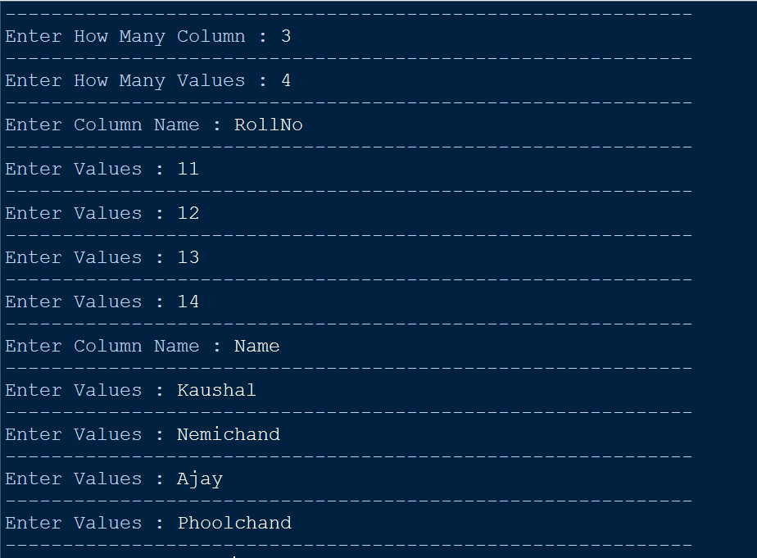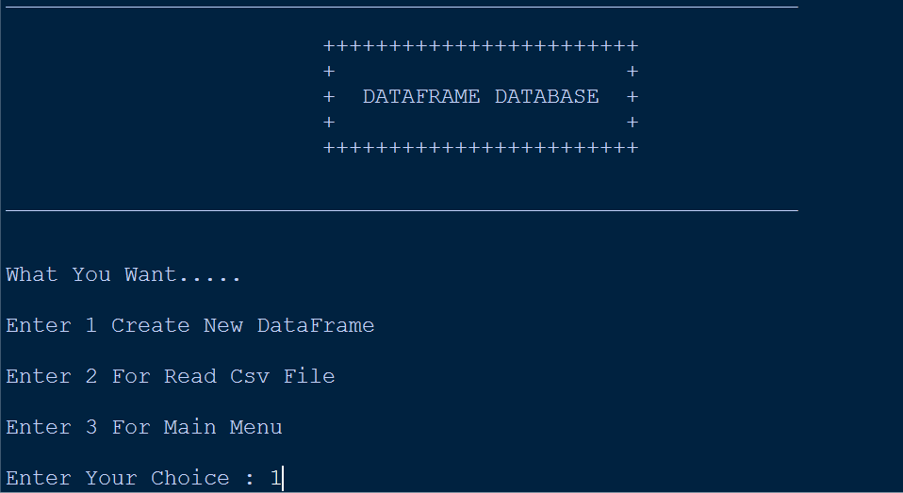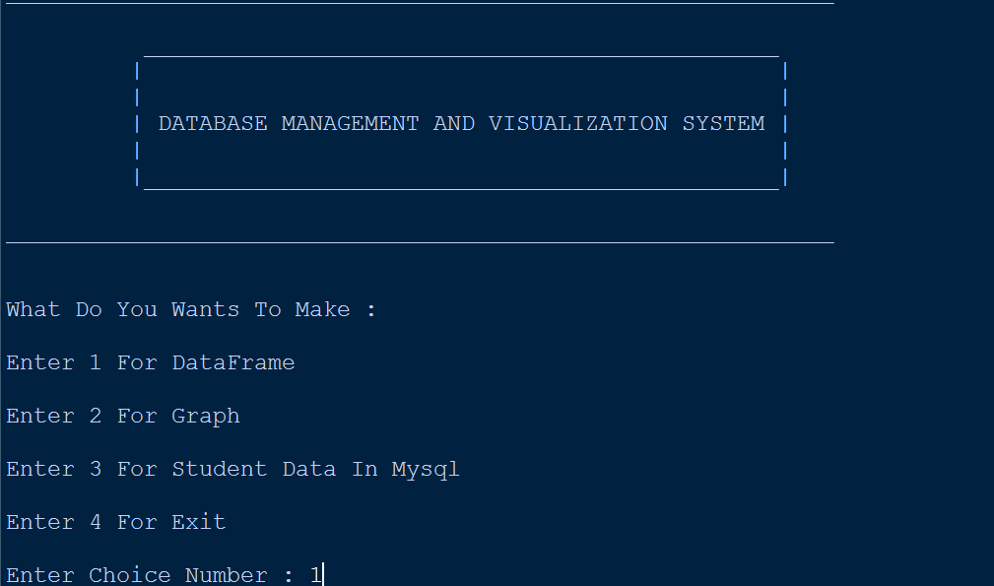 **Creating a DAtaFRame**

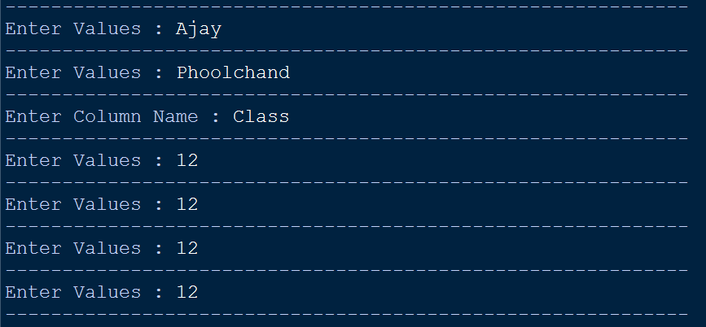

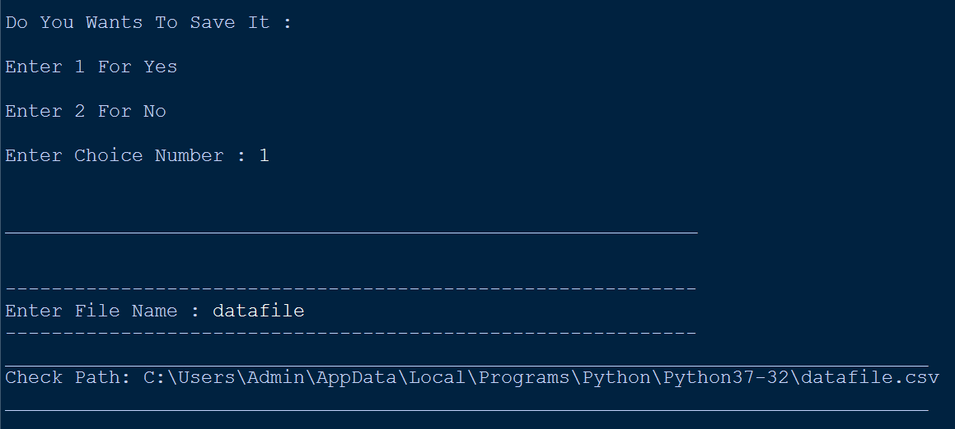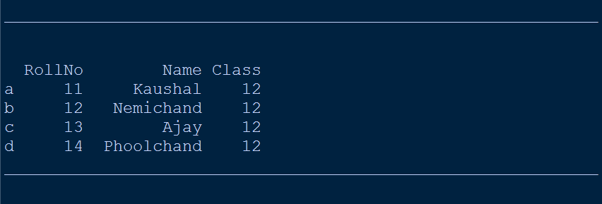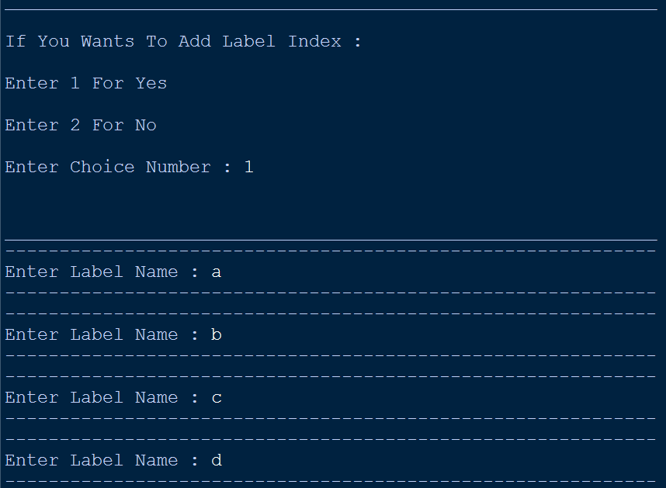

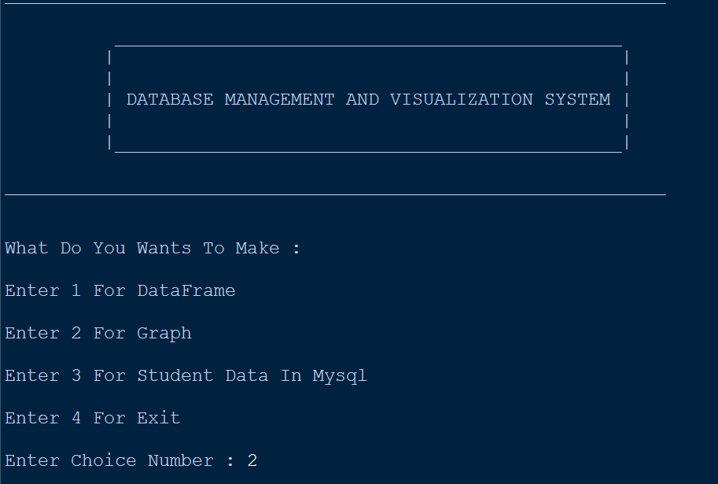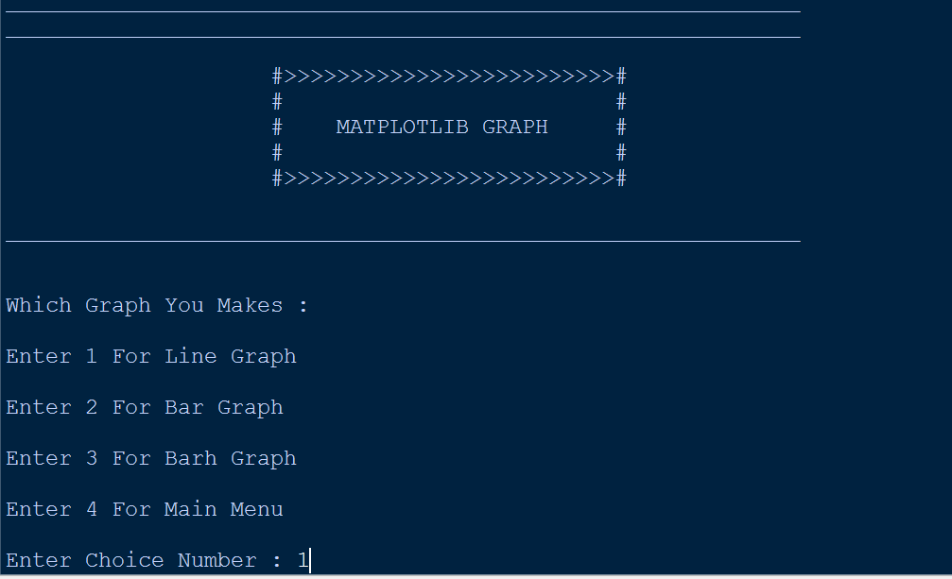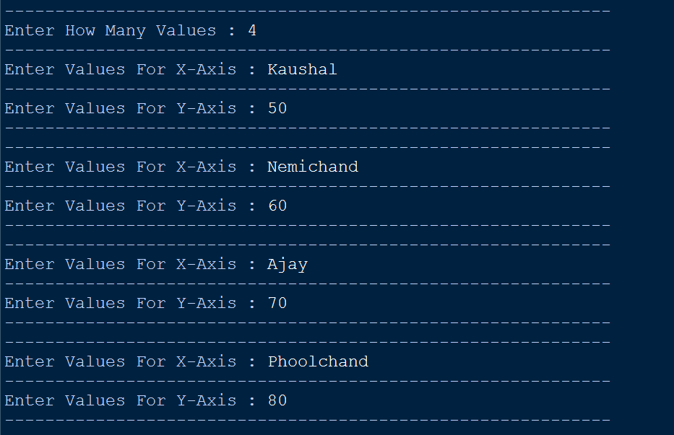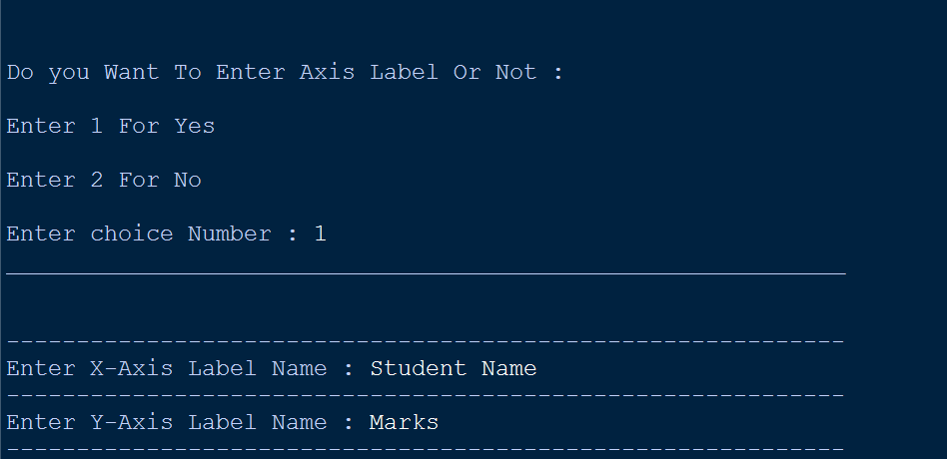 **Creating a graph**

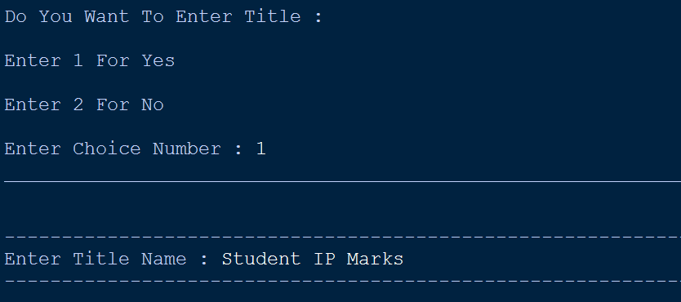

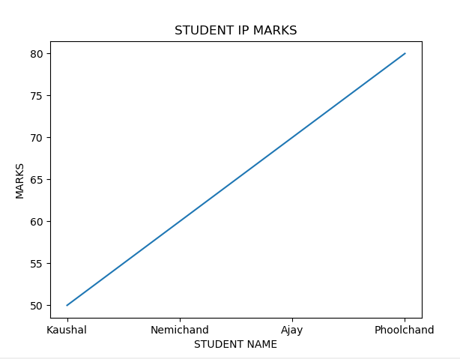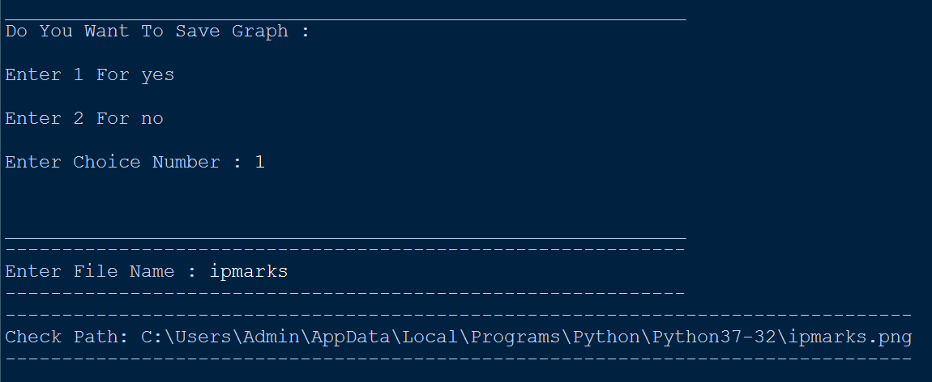

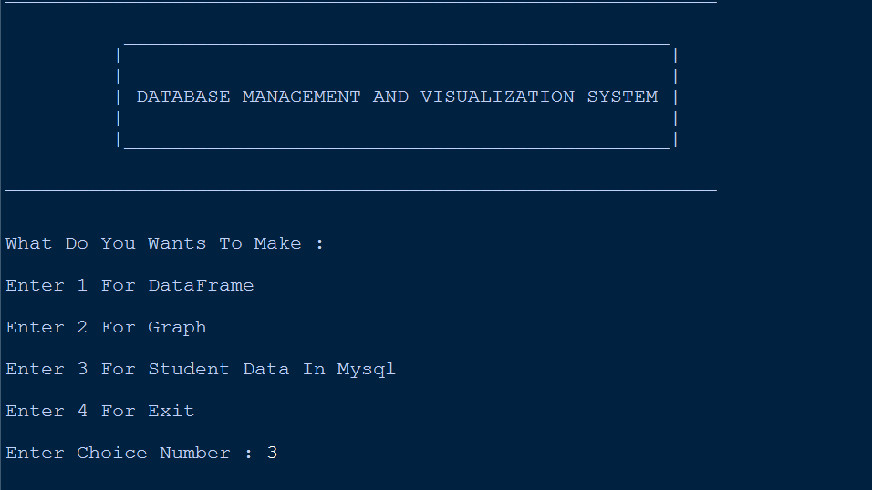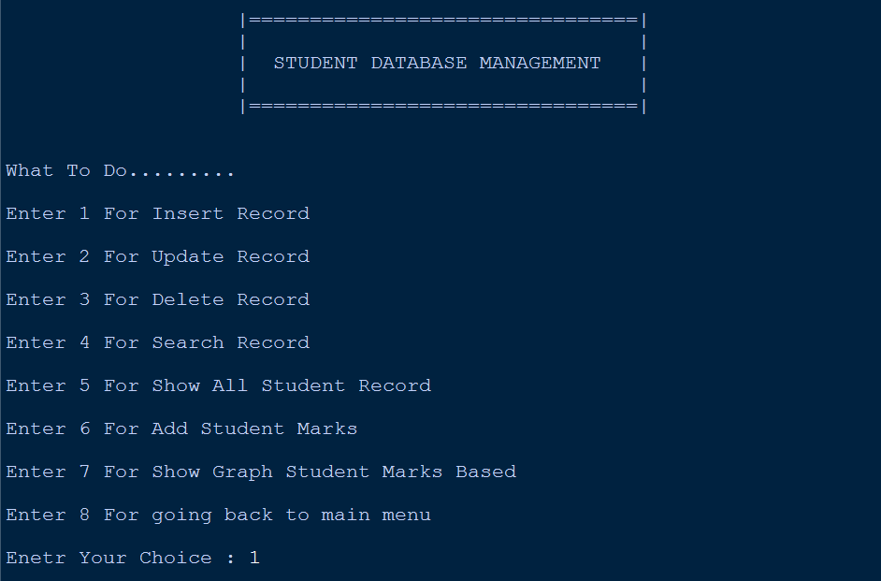 **Mysql student data manage**

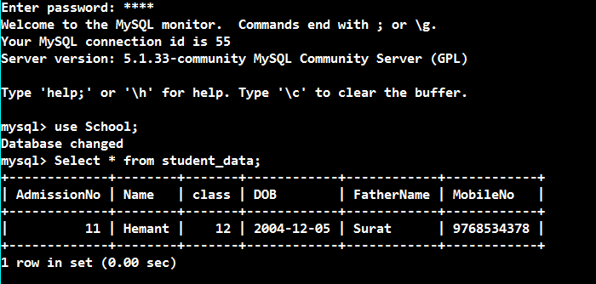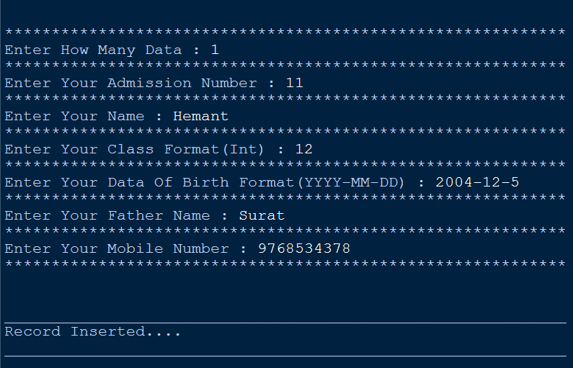

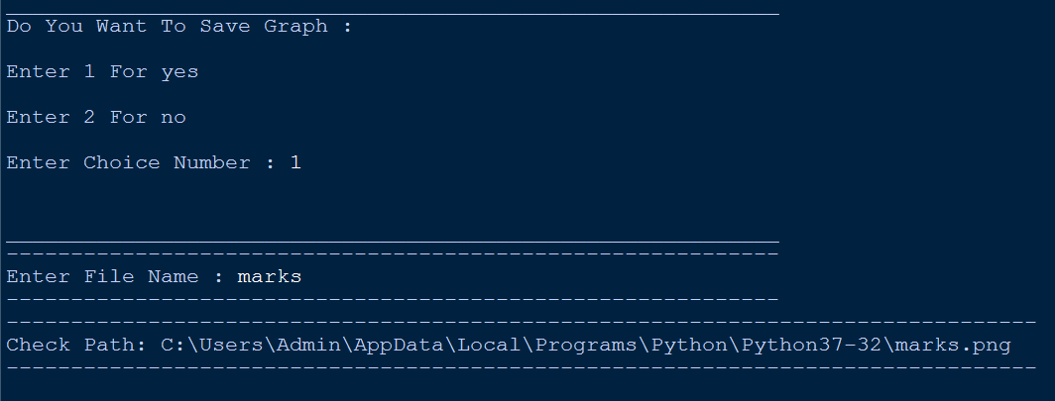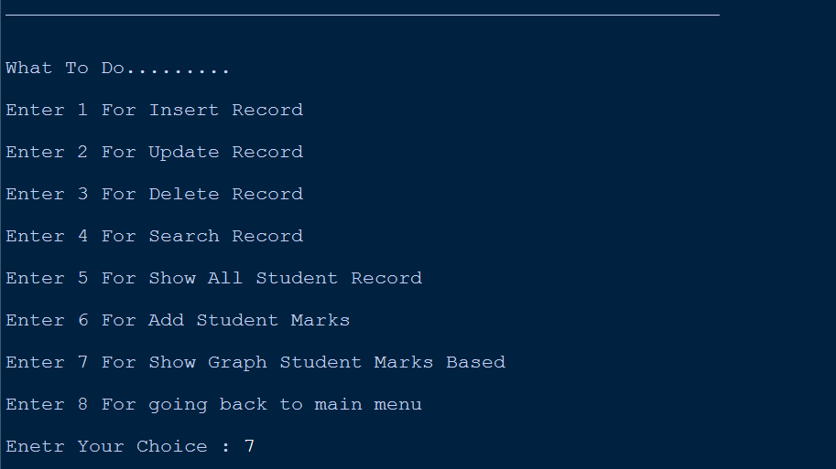

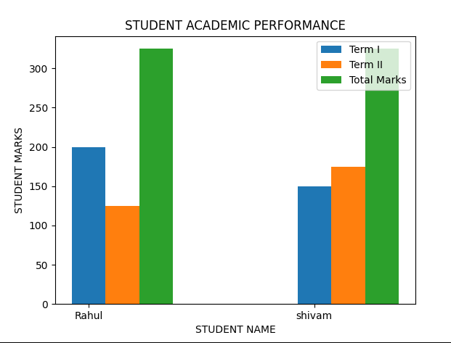

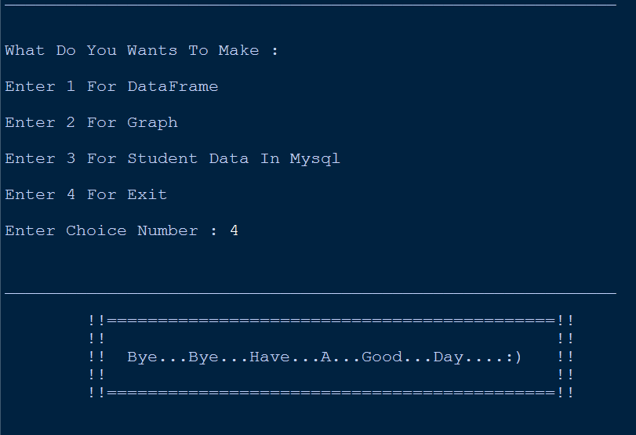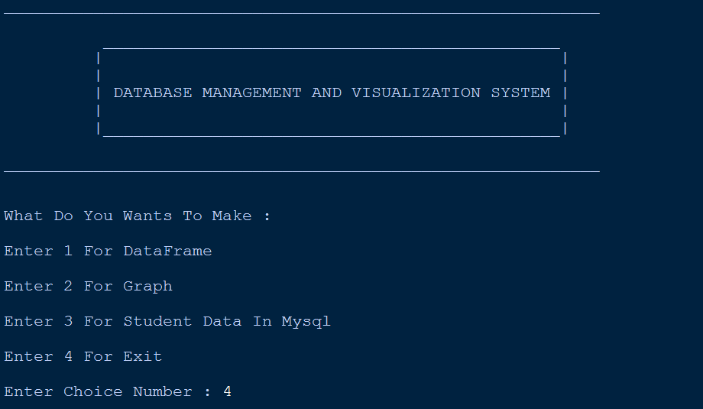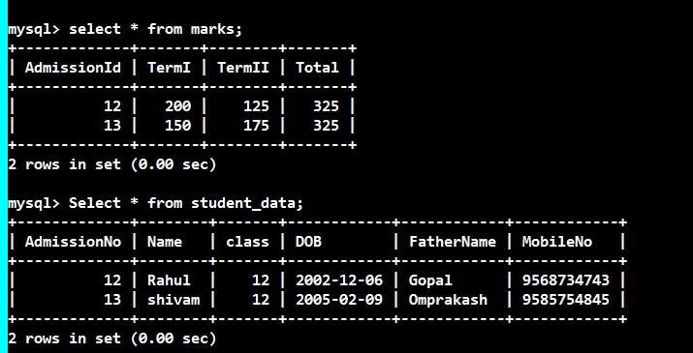 **for exit**