**Vendor Forms Detail**-

- title

- email

- mobile number (OTP verify)

- password

- pin

- address - city – state

- **Business Detail**

- Business name

- GSTIN Provisional ID

- TAN

- CIN

- Signature – file(jpg/png)

- Registered Business Address – add1, add2, Pincode, City, State

- **Bank Details**

- Account holder name

- Account number

- Retype account number

- IFSC Code

- State

- City

- Branch

- **KYC Document**

- Business type - Proprietor/Company

- Personal PAN – file

- Address Proof – file

- Cancelled Check – file

- **Store Detail**

- Display Name

- Business Description

-

**Vendor Panel**

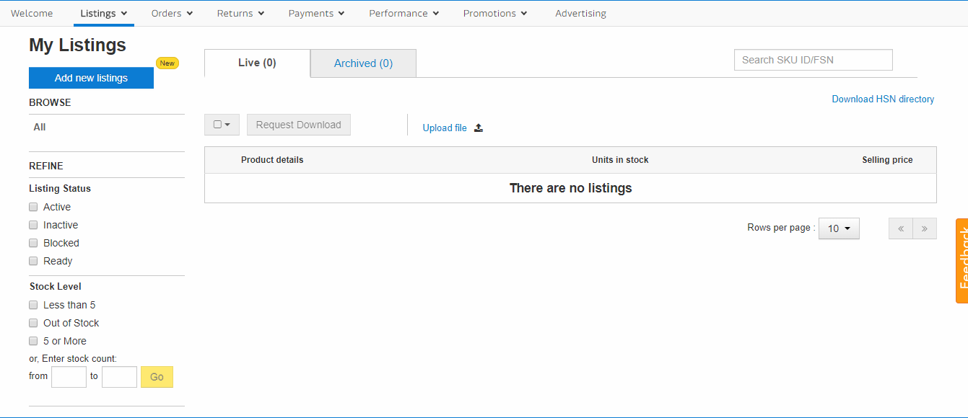

**Product Forms-**

- title

- description

- SKU

- category

- category

- regular price

- sale price

- Author

- image

- Highlight

- Seller

- Specification

- Questions & Answers

- avg rate

- Language

**Vendor panel detail flipkart –** [**kaushalmehra.btech@gmail.com**](mailto:kaushalmehra.btech@gmail.com) **/ mehra@123**

1. **Update all code on latest technology with updated database.**
2. **Fix all designs in a single layout, a master layout for all designs. Now Eduncle has 5-6 types of designs.**
3. **Learn and grow session should be start again, by this everyone can share their knowledge and team can grow .**
4. **If some want to learn modern technology or upgrade himself by tuitions, certified course, attend seminar and webinar company should help that person on their level like MNC does.**
5. **If team lead rate a team member, then team lead should share the information, where employee have to improve, to get full points.**

1. Freeze requirements for a time period so that all the teams can complete their work within given time period.

2. Remove Communication Gaps among teams so that there is no confusion and teams can take firm decisions.

3. Final developed product should be gone in testing phase almost 10-12 days before launch so that we will be able to deliver quality product.

4. There should be a Technical Head and Technical Manager with best technical knowledge who will be able to handle all team works with time management.

5. Organize Personality Development Program to create good working Environment in company, Building confidence and boosting enthusiasm in employees with positive thoughts and pleasing personality.