|  |  |  |
| --- | --- | --- |
| **WBD** | **TASK** | **DURATION (mins)** |
| **1** | **UI Layout design** |  |
| 1.1 | MainActivity |  |
| 1.2 | PagerTabs | 30 |
| 1.3 | DetailActivity | 30 |
| **2** | **Firebase setup** |  |
| 2.1 | Account creation | 15 |
| 2.2 | Integration to app | 10 |
| **3** | **Logic design** |  |
| 3.1 | MainActivity- Submit data | 60 |
| 3.2 | Main Activity – Populate RecyclerView | 120 |
| 3.3 | Detail Activity – Update data | 45 |
| 3.4 | Detail Activity – Delete data | 15 |
| **4** | **Code cleanup** | 30 |

**WORK BREAK DOWN:**

**Min SDK version: 21**

**Target SDK version: 24**

**Library dependencies used:**

'com.android.support:appcompat-v7:24.2.0'  
'com.android.support:design:24.2.0'  
'com.firebase:firebase-client-android:2.4.0'  
'com.jakewharton:butterknife:7.0.1'  
'com.google.firebase:firebase-core:9.2.1'  
'com.google.firebase:firebase-database:9.2.1'  
'com.android.support:cardview-v7:24.+'

**Firebase DB link**: <https://service-fusion.firebaseio.com/>

**ACTION BUTTONS:**

1. **SUBMIT**

Layout: Form Fragment

Action: Submit user details to Firebase database

1. **CLEAR**

Layout: Form Fragment

Action: Clear all data in the form

1. **USER CARD**

Layout: List Fragment

Action: Open detail view with all user information

1. **EDIT FLOAT BUTTON**

Layout: Detail Activity

Action: Open edit dialog box

1. **UPDATE BUTTON**

Layout: Edit dialog box

Action: Update current user details in UI and in Firebase Database

1. **DELETE BUTTON**

Layout: Edit dialog box

Action: Delete current user in UI and in Firebase Database

**SCREEN SHOTS**

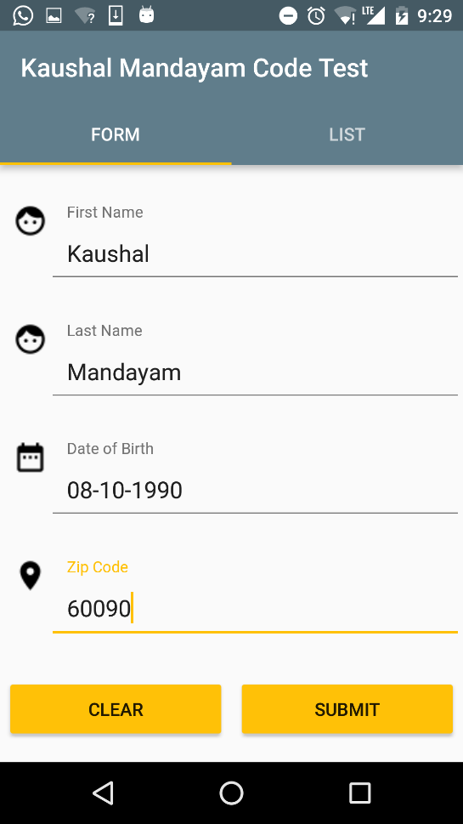

1. Splash Screen 2. Form input page

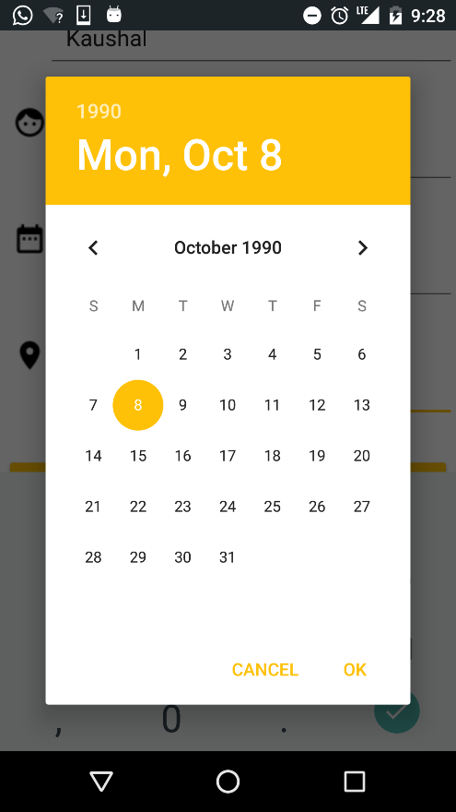 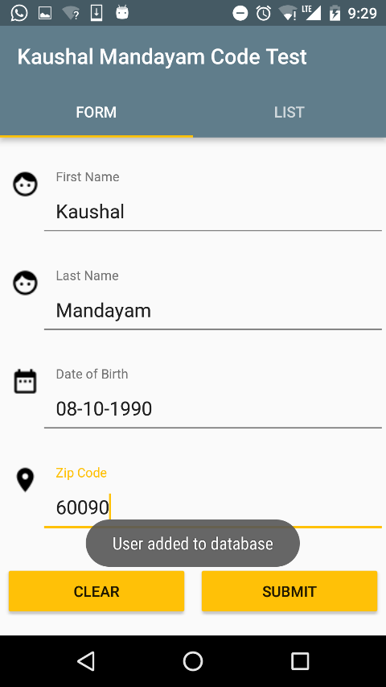

3. Open calendar dialog on clicking date of birth 4. Add user to database on submit

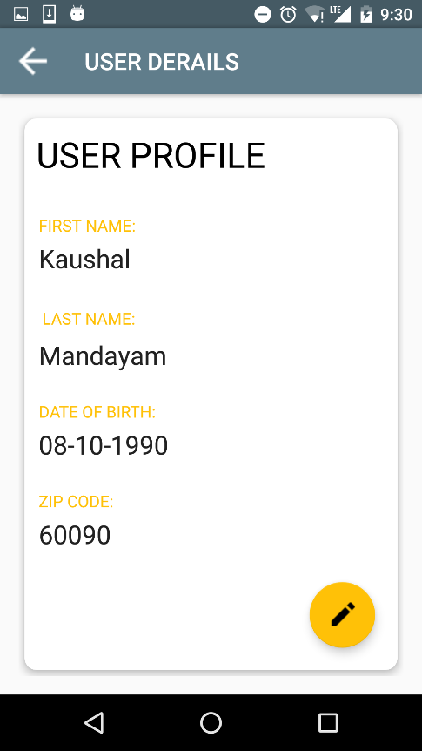 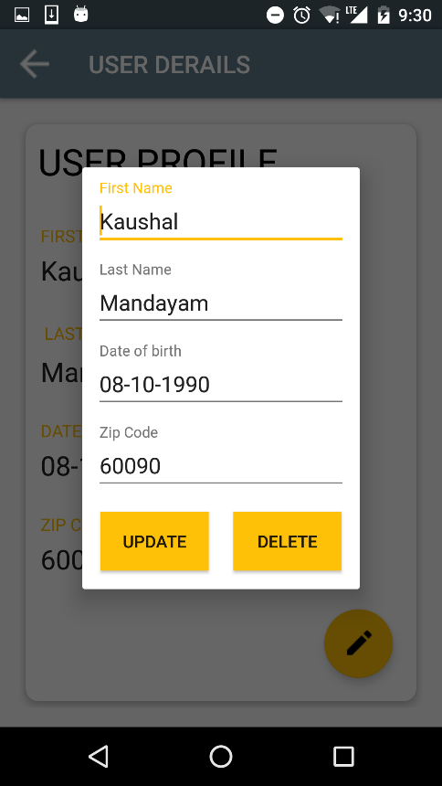

5. Open Detail activity on clicking user card 6. Open edit dialog on clicking floating button

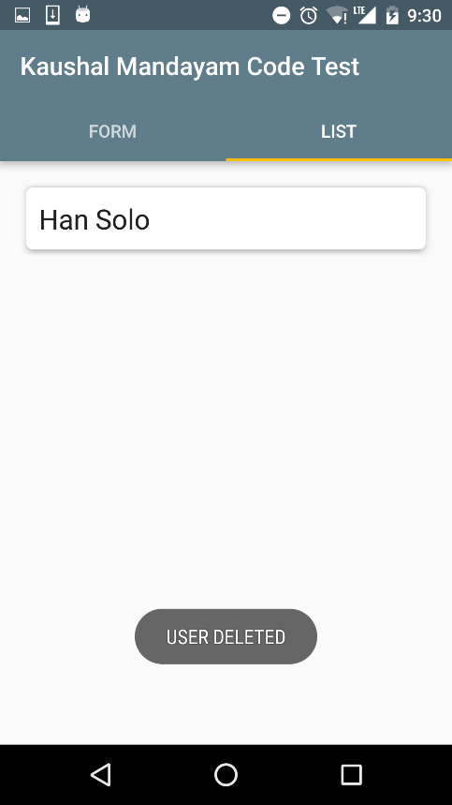 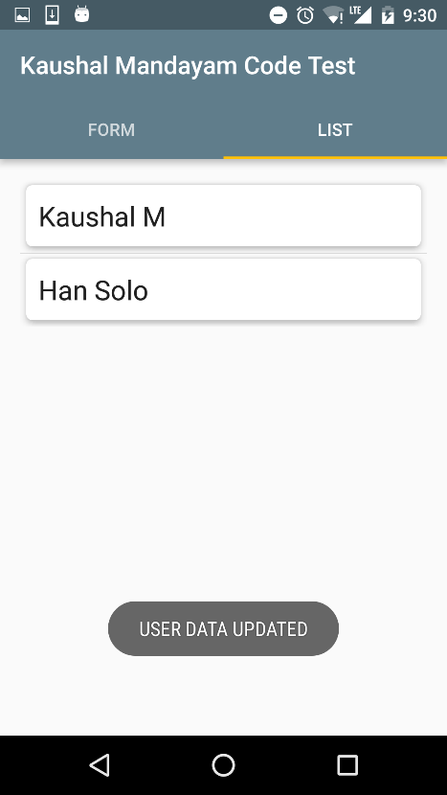

7. Delete user on clicking delete 8. Update user on clicking update

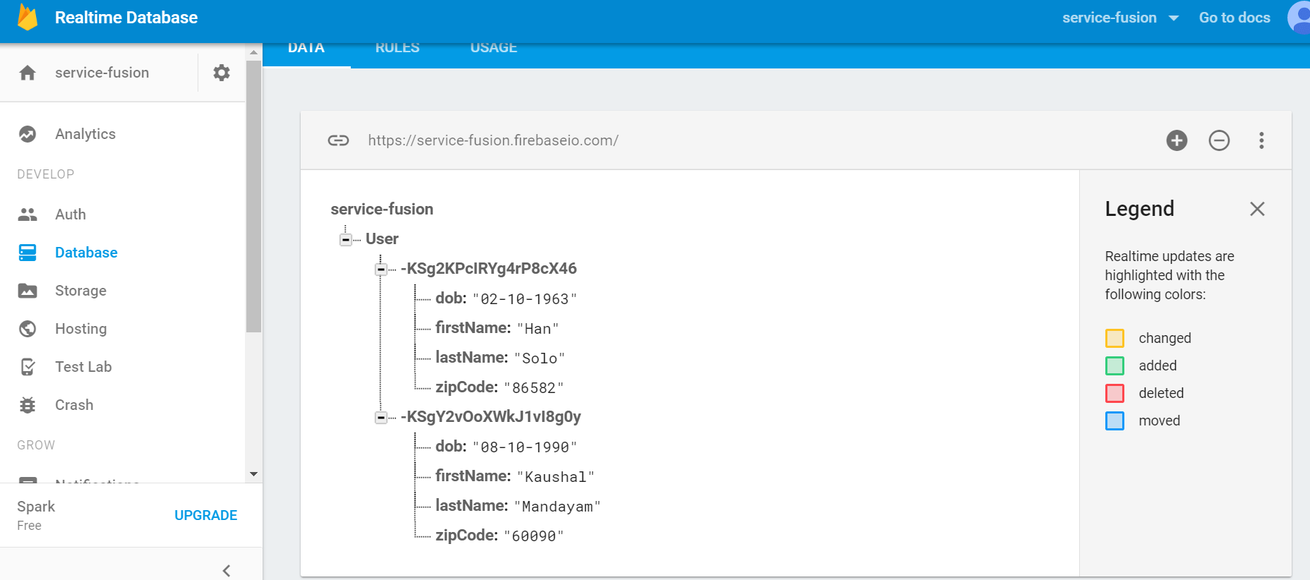

9. Firebese real time database