B.Tech Computer Science Engineering and AI
Database Management Systems (SQL & NoSQL) - Semester III
Case Study 84: RideTogether
Campus Carpool & Ride Sharing Management System
Name: Kaushal Dinesh Rajmandai
Roll No: 150096725111
Program: B.Tech CSE (2025-29), ITM Skills University

1. Problem Statement
RideTogether needs a database for a campus carpool app. Drivers post rides with a fixed number of seats, riders book seats, and the system must never let a ride take more bookings than the vehicle has room for.

2. ER Diagram
Entities are Driver, Rider, Vehicle, Ride and Booking. Primary keys are underlined, foreign keys are dashed and marked (FK). A double line means total participation (a ride must have a driver and a vehicle, a booking must belong to a ride and a rider).
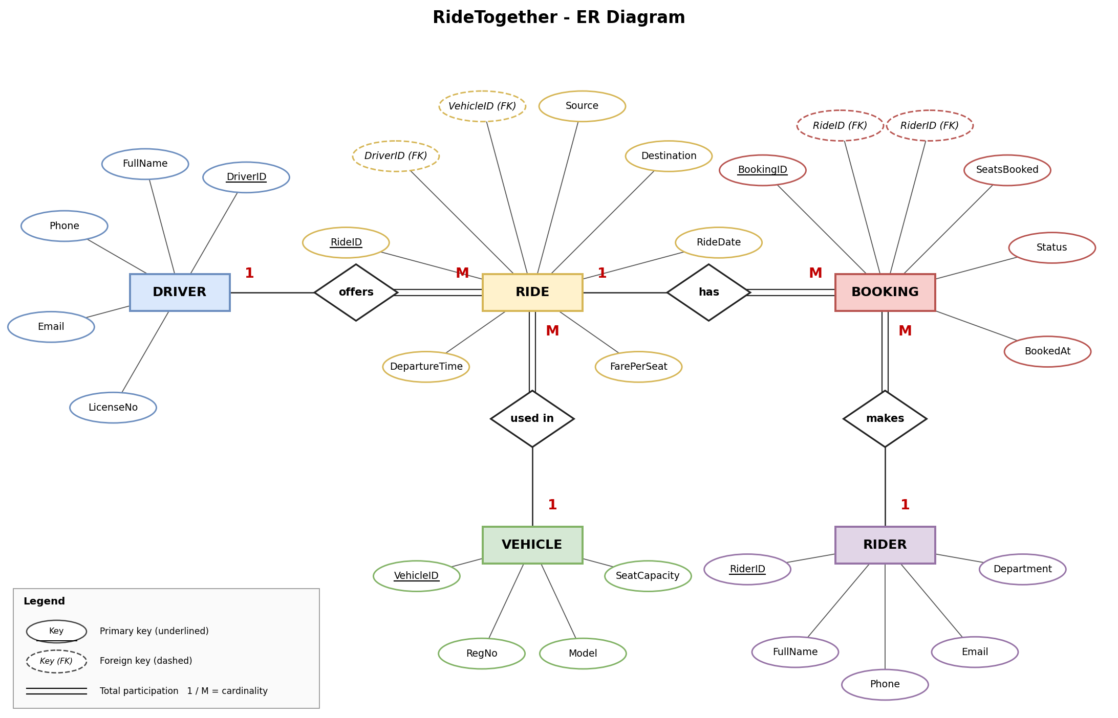

Relationships
- Driver to Ride is 1:M. One driver can offer many rides, each ride has one driver.
- Vehicle to Ride is 1:M. A vehicle can be used for many rides, each ride uses one vehicle.
- Ride to Booking is 1:M. A ride can have many bookings, each booking is for one ride.
- Rider to Booking is 1:M. A rider can make many bookings.
- Rider and Ride are M:N overall, and Booking is the table that resolves it.
Vehicle is not tied to Driver on purpose. A student can borrow a friend's car, so the driver and the vehicle are both recorded on the Ride.

3. Schema Design and Normalization
First version (unnormalized idea): a single Ride table that also stored the vehicle registration number, model and seat capacity on every row.
Problem: the same vehicle details get repeated for every ride it does, and the capacity could be updated in one row and not in another. Vehicle model and capacity depend only on the vehicle, not on the ride, so this breaks 2NF.
Fix: move RegNo, Model and SeatCapacity into a separate Vehicle table and keep only VehicleID in Ride. After this:
- 1NF: every column holds a single value, each table has a primary key.
- 2NF: all non-key columns depend on the whole key (keys are single columns, so no partial dependency).
- 3NF / BCNF: no non-key column depends on another non-key column, and every determinant is a key. Driver details stay in Driver, rider details in Rider.

Tables
Table | Columns | Keys and constraints
Driver | DriverID, FullName, Phone, Email, LicenseNo | PK DriverID. Phone, Email, LicenseNo unique. All NOT NULL.
Rider | RiderID, FullName, Phone, Email, Department | PK RiderID. Phone, Email unique. All NOT NULL.
Vehicle | VehicleID, RegNo, Model, SeatCapacity | PK VehicleID. RegNo unique. CHECK SeatCapacity > 0.
Ride | RideID, DriverID, VehicleID, Source, Destination, RideDate, DepartureTime, FarePerSeat | PK RideID. FK DriverID, FK VehicleID. CHECK FarePerSeat >= 0.
Booking | BookingID, RideID, RiderID, SeatsBooked, Status, BookedAt | PK BookingID. FK RideID, FK RiderID. CHECK SeatsBooked > 0. CHECK Status in (Confirmed, Cancelled, Pending).

4. SQL Scripts
The scripts are included as separate files (run in this order on MySQL 8.0):
- 01_schema.sql - DDL, creates the database and tables
- 02_trigger.sql - seat capacity triggers
- 03_data.sql - sample data (4 drivers, 8 riders, 4 vehicles, 6 rides, 11 bookings)
- 04_queries.sql - the SELECT queries
- 05_trigger_test.sql and 06_trigger_test_ok.sql - trigger tests

DDL
CREATE DATABASE RideTogether;
USE RideTogether;

CREATE TABLE Driver (
DriverID INT AUTO_INCREMENT PRIMARY KEY,
FullName VARCHAR(60) NOT NULL,
Phone VARCHAR(15) NOT NULL UNIQUE,
Email VARCHAR(80) NOT NULL UNIQUE,
LicenseNo VARCHAR(20) NOT NULL UNIQUE
);

CREATE TABLE Rider (
RiderID INT AUTO_INCREMENT PRIMARY KEY,
FullName VARCHAR(60) NOT NULL,
Phone VARCHAR(15) NOT NULL UNIQUE,
Email VARCHAR(80) NOT NULL UNIQUE,
Department VARCHAR(40) NOT NULL
);

-- seating capacity and model live here once, not on every ride (2NF)
CREATE TABLE Vehicle (
VehicleID INT AUTO_INCREMENT PRIMARY KEY,
RegNo VARCHAR(15) NOT NULL UNIQUE,
Model VARCHAR(40) NOT NULL,
SeatCapacity INT NOT NULL,
CHECK (SeatCapacity > 0)
);

CREATE TABLE Ride (
RideID INT AUTO_INCREMENT PRIMARY KEY,
DriverID INT NOT NULL,
VehicleID INT NOT NULL,
Source VARCHAR(60) NOT NULL,
Destination VARCHAR(60) NOT NULL,
RideDate DATE NOT NULL,
DepartureTime TIME NOT NULL,
FarePerSeat DECIMAL(6,2) NOT NULL,
CHECK (FarePerSeat >= 0),
FOREIGN KEY (DriverID) REFERENCES Driver(DriverID),
FOREIGN KEY (VehicleID) REFERENCES Vehicle(VehicleID)
);

CREATE TABLE Booking (
BookingID INT AUTO_INCREMENT PRIMARY KEY,
RideID INT NOT NULL,
RiderID INT NOT NULL,
SeatsBooked INT NOT NULL DEFAULT 1,
Status VARCHAR(10) NOT NULL DEFAULT 'Confirmed',
BookedAt DATETIME NOT NULL DEFAULT CURRENT_TIMESTAMP,
CHECK (SeatsBooked > 0),
CHECK (Status IN ('Confirmed', 'Cancelled', 'Pending')),
FOREIGN KEY (RideID) REFERENCES Ride(RideID),
FOREIGN KEY (RiderID) REFERENCES Rider(RiderID)
);

5. Query Set and Outputs

Q1. Rides with free seats for a given route and date
Vashi to ITM Campus on 6 Oct 2026. The subquery adds up the confirmed seats on each ride and the outer query keeps only rides where that is less than the vehicle capacity.
SELECT r.RideID, r.Source, r.Destination, r.RideDate, r.DepartureTime,
v.SeatCapacity,
v.SeatCapacity - IFNULL((SELECT SUM(b.SeatsBooked)
FROM Booking b
WHERE b.RideID = r.RideID AND b.Status = 'Confirmed'), 0) AS FreeSeats
FROM Ride r
JOIN Vehicle v ON v.VehicleID = r.VehicleID
WHERE r.Source = 'Vashi'
AND r.Destination = 'ITM Campus'
AND r.RideDate = '2026-10-06'
AND v.SeatCapacity > IFNULL((SELECT SUM(b.SeatsBooked)
FROM Booking b
WHERE b.RideID = r.RideID AND b.Status = 'Confirmed'), 0);
Output:
+--------+--------+-------------+------------+---------------+--------------+-----------+
| RideID | Source | Destination | RideDate | DepartureTime | SeatCapacity | FreeSeats |
+--------+--------+-------------+------------+---------------+--------------+-----------+
| 6 | Vashi | ITM Campus | 2026-10-06 | 08:00:00 | 4 | 2 |
+--------+--------+-------------+------------+---------------+--------------+-----------+

Q2. Confirmed bookings vs seat capacity for every ride
Uses COUNT on Booking next to Vehicle.SeatCapacity for each ride.
SELECT r.RideID, r.Source, r.Destination, v.SeatCapacity,
(SELECT COUNT(*) FROM Booking b
WHERE b.RideID = r.RideID AND b.Status = 'Confirmed') AS ConfirmedBookings
FROM Ride r
JOIN Vehicle v ON v.VehicleID = r.VehicleID
ORDER BY r.RideID;
Output:
+--------+------------+-------------+--------------+-------------------+
| RideID | Source | Destination | SeatCapacity | ConfirmedBookings |
+--------+------------+-------------+--------------+-------------------+
| 1 | Vashi | ITM Campus | 4 | 3 |
| 2 | ITM Campus | Vashi | 4 | 1 |
| 3 | Panvel | ITM Campus | 4 | 2 |
| 4 | Thane | ITM Campus | 6 | 1 |
| 5 | Nerul | ITM Campus | 1 | 1 |
| 6 | Vashi | ITM Campus | 4 | 1 |
+--------+------------+-------------+--------------+-------------------+

Q3. Driver participation history
JOIN between Driver and Ride.
SELECT d.DriverID, d.FullName, r.RideID, r.Source, r.Destination, r.RideDate
FROM Driver d
JOIN Ride r ON r.DriverID = d.DriverID
ORDER BY d.FullName, r.RideDate;
Output:
+----------+----------------+--------+------------+-------------+------------+
| DriverID | FullName | RideID | Source | Destination | RideDate |
+----------+----------------+--------+------------+-------------+------------+
| 3 | Amit Patil | 4 | Thane | ITM Campus | 2026-10-06 |
| 4 | Neha Joshi | 5 | Nerul | ITM Campus | 2026-10-06 |
| 1 | Rahul Deshmukh | 1 | Vashi | ITM Campus | 2026-10-05 |
| 1 | Rahul Deshmukh | 2 | ITM Campus | Vashi | 2026-10-05 |
| 2 | Sneha Kulkarni | 3 | Panvel | ITM Campus | 2026-10-05 |
| 2 | Sneha Kulkarni | 6 | Vashi | ITM Campus | 2026-10-06 |
+----------+----------------+--------+------------+-------------+------------+

Q4. Rides and seats filled per driver
Aggregate functions with GROUP BY.
SELECT d.FullName,
COUNT(DISTINCT r.RideID) AS TotalRides,
IFNULL(SUM(b.SeatsBooked), 0) AS SeatsFilled
FROM Driver d
JOIN Ride r ON r.DriverID = d.DriverID
LEFT JOIN Booking b ON b.RideID = r.RideID AND b.Status = 'Confirmed'
GROUP BY d.DriverID, d.FullName;
Output:
+----------------+------------+-------------+
| FullName | TotalRides | SeatsFilled |
+----------------+------------+-------------+
| Rahul Deshmukh | 2 | 5 |
| Sneha Kulkarni | 2 | 5 |
| Amit Patil | 1 | 3 |
| Neha Joshi | 1 | 1 |
+----------------+------------+-------------+

Q5. All bookings with rider and route details
Three table JOIN.
SELECT b.BookingID, ri.FullName AS Rider, r.Source, r.Destination,
r.RideDate, b.SeatsBooked, b.Status
FROM Booking b
JOIN Rider ri ON ri.RiderID = b.RiderID
JOIN Ride r ON r.RideID = b.RideID
ORDER BY b.BookingID;
Output:
+-----------+--------------+------------+-------------+------------+-------------+-----------+
| BookingID | Rider | Source | Destination | RideDate | SeatsBooked | Status |
+-----------+--------------+------------+-------------+------------+-------------+-----------+
| 1 | Aarav Mehta | Vashi | ITM Campus | 2026-10-05 | 1 | Confirmed |
| 2 | Isha Nair | Vashi | ITM Campus | 2026-10-05 | 2 | Confirmed |
| 3 | Karan Shah | Vashi | ITM Campus | 2026-10-05 | 1 | Confirmed |
| 4 | Aarav Mehta | ITM Campus | Vashi | 2026-10-05 | 1 | Confirmed |
| 5 | Pooja Iyer | ITM Campus | Vashi | 2026-10-05 | 1 | Cancelled |
| 6 | Rohan Gupta | Panvel | ITM Campus | 2026-10-05 | 2 | Confirmed |
| 7 | Tanvi More | Panvel | ITM Campus | 2026-10-05 | 1 | Confirmed |
| 8 | Vikram Singh | Thane | ITM Campus | 2026-10-06 | 3 | Confirmed |
| 9 | Ananya Rao | Thane | ITM Campus | 2026-10-06 | 1 | Pending |
| 10 | Isha Nair | Nerul | ITM Campus | 2026-10-06 | 1 | Confirmed |
| 11 | Karan Shah | Vashi | ITM Campus | 2026-10-06 | 2 | Confirmed |
+-----------+--------------+------------+-------------+------------+-------------+-----------+

Q6. Fully booked rides
Rides where confirmed seats have reached capacity.
SELECT r.RideID, r.Source, r.Destination
FROM Ride r
JOIN Vehicle v ON v.VehicleID = r.VehicleID
WHERE v.SeatCapacity <= (SELECT IFNULL(SUM(b.SeatsBooked), 0)
FROM Booking b
WHERE b.RideID = r.RideID AND b.Status = 'Confirmed');
Output:
+--------+--------+-------------+
| RideID | Source | Destination |
+--------+--------+-------------+
| 1 | Vashi | ITM Campus |
| 5 | Nerul | ITM Campus |
+--------+--------+-------------+

6. Constraint Enforcement (Trigger)
A CHECK constraint in MySQL cannot look at other rows, so it cannot count the existing bookings of a ride. That is why the rule is done with a BEFORE INSERT trigger. Before a Confirmed booking goes in, the trigger reads the vehicle capacity for that ride, adds up the seats already confirmed, and raises an error if the new booking would go over the capacity. A second trigger does the same on UPDATE so a Pending booking cannot be switched to Confirmed on a full ride. The simple CHECKs (SeatsBooked > 0, valid Status) sit on the table itself.
Cancelled and Pending bookings do not use up seats, so only Confirmed bookings are counted. Seats are counted with SUM(SeatsBooked) rather than a plain row count, because one booking can hold more than one seat.

-- Blocks a booking if confirmed seats on the ride would go past the
-- vehicle's seat capacity. Runs on insert and on update (e.g. Pending -> Confirmed).

DROP TRIGGER IF EXISTS trg_booking_capacity_ins;
DROP TRIGGER IF EXISTS trg_booking_capacity_upd;

DELIMITER $$

CREATE TRIGGER trg_booking_capacity_ins
BEFORE INSERT ON Booking
FOR EACH ROW
BEGIN
DECLARE cap INT;
DECLARE taken INT;

IF NEW.Status = 'Confirmed' THEN
SELECT v.SeatCapacity INTO cap
FROM Ride r JOIN Vehicle v ON v.VehicleID = r.VehicleID
WHERE r.RideID = NEW.RideID;

SELECT COALESCE(SUM(SeatsBooked), 0) INTO taken
FROM Booking
WHERE RideID = NEW.RideID AND Status = 'Confirmed';

IF taken + NEW.SeatsBooked > cap THEN
SIGNAL SQLSTATE '45000'
SET MESSAGE_TEXT = 'Booking rejected: not enough seats left on this ride';
END IF;
END IF;
END$$

CREATE TRIGGER trg_booking_capacity_upd
BEFORE UPDATE ON Booking
FOR EACH ROW
BEGIN
DECLARE cap INT;
DECLARE taken INT;

IF NEW.Status = 'Confirmed' THEN
SELECT v.SeatCapacity INTO cap
FROM Ride r JOIN Vehicle v ON v.VehicleID = r.VehicleID
WHERE r.RideID = NEW.RideID;

-- exclude this booking's own old row so it isn't counted twice
SELECT COALESCE(SUM(SeatsBooked), 0) INTO taken
FROM Booking
WHERE RideID = NEW.RideID AND Status = 'Confirmed'
AND BookingID <> NEW.BookingID;

IF taken + NEW.SeatsBooked > cap THEN
SIGNAL SQLSTATE '45000'
SET MESSAGE_TEXT = 'Booking rejected: not enough seats left on this ride';
END IF;
END IF;
END$$

DELIMITER ;

Trigger test
Ride 1 is a 4 seater and already has 4 confirmed seats, so another booking is refused:
INSERT INTO Booking (RideID, RiderID, SeatsBooked, Status)
VALUES (1, 5, 1, 'Confirmed');

ERROR 1644 (45000) at line 4: Booking rejected: not enough seats left on this ride
Ride 6 is a 4 seater with 2 seats taken. Booking 2 more works, and then one more is refused:
INSERT INTO Booking (RideID, RiderID, SeatsBooked, Status) VALUES (6, 5, 2, 'Confirmed'); -- ok
INSERT INTO Booking (RideID, RiderID, SeatsBooked, Status) VALUES (6, 7, 1, 'Confirmed'); -- fails

ERROR 1644 (45000) at line 6: Booking rejected: not enough seats left on this ride

7. Outcomes
- A ride cannot take more confirmed seats than the vehicle capacity. The trigger enforces it automatically.
- Riders can find rides with free seats for a route and date using a single subquery (Q1).
- Driver history can be checked with a JOIN between Ride and Driver (Q3).
- Foreign keys make sure every booking points to a real ride and a real rider.

