
SCHOOL OF ARTIFICIAL INTELLIGENCE
23CHY115 |Introduction to Material Informatics
23PHY114 |Computational Mechanics 2
23MAT112 |Mathematics for Intelligent Systems 2

MACHINE LEARNING DRIVEN STRUCTURE-PROPERTY CORRELATION BETWEEN MECHANICAL PROPERTIES OF ALLOYS
(Predicting Phases using Machine Learning)

A Project Report Submitted by BATCH B GROUP10
RISHITHA C - CB.AI.U4AID24109
DIVYA RITHANYA S - CB.AI.U4AID24113
KARTHIKEYA Y - CB.AI.U4AID24163
KAUSHAL S - CB.AI.U4AID24168

Date of Submission: 28.04.2025
FACULTY INCHARGES:

Dr. Kritesh Kumar Gupta Dr. Jithin E.V. Dr. Biswajit Das
TABLE OF CONTENTS
1. | Abstract | 3
2. | Introduction | 3-4
3. | Literature Review | 5-6
4. | Data Description | 6-9
5. | Methodology | 10-12
6. | Evaluation Metric | 12-18
7. | Results | 18-29
8. | Comparison Table | 29-30
9. | Discussion and Insights | 31
10. | Conclusion | 31-32
11. | References | 32-33

ABSTRACT
This study presents a comparative analysis of four supervised machine learning models— applied to a binary classification problem. The objective is to evaluate each model's predictive performance using standard metrics such as accuracy, precision, recall, F1-score, confusion matrix and Feature importance. Through structured experimentation and cross-validation, Neural Networks demonstrated the highest overall accuracy and generalization capability, closely followed by XGBoost. The results highlight how model selection and tuning play a critical role in achieving optimal performance, offering insights into the practical trade-offs between interpretability, training complexity, predictive power and assist in predicting phase stability in novel alloy compositions.

INTRODUCTION
Machine learning has become a cornerstone of modern data-driven applications, enabling systems to learn from data, adapt to new information, and make intelligent decisions. Among the vast array of machine learning algorithms available, we choose four models stand out for their versatility, performance, and wide applicability across classification, regression, ranking tasks and those four models are Support Vector Machines (SVMs), Random Forests, Neural Networks, and XGBoost. Each of these models brings unique strengths and underlying philosophies to the modeling process, making them valuable tools for solving complex problems.
SUPPORT VECTOR MACHINE (SVM)
Support Vector Machines are a class of supervised learning algorithms particularly well-suited for classification problems with clear class separation. Originally developed in the 1990s, SVMs aim to find the optimal hyperplane that maximally separates data points belonging to different classes. By leveraging kernel functions, SVMs can transform data into higher dimensions to handle non-linearly separable datasets, offering strong theoretical guarantees and generalization performance. Their robustness to high-dimensional feature spaces and ability to create complex decision boundaries make SVMs a staple in many practical applications, from text classification to image recognition.

RANDOM FOREST
Random Forest is an ensemble learning algorithm that constructs a multitude of decision trees during training and outputs the mode (classification) or mean prediction (regression) of the individual trees. By averaging multiple trees trained on different subsets of data and features, Random Forest effectively reduces overfitting and improves model stability. Its interpretability, efficiency, and high accuracy make it ideal for datasets with heterogeneous feature types and noise. Furthermore, the algorithm inherently provides insights into feature importance, making it a powerful tool for both predictive modeling and exploratory data analysis.

XGBoost
XGBoost (Extreme Gradient Boosting) is an advanced implementation of the gradient boosting framework, specifically designed for speed and performance. It builds models sequentially, where each new model attempts to correct the errors made by its predecessors. Through techniques such as regularization, tree pruning, and parallel processing, XGBoost achieves remarkable accuracy and efficiency, especially in large-scale structured data scenarios. It has consistently ranked among the top-performing algorithms in machine learning competitions and has become the de facto choice for many industrial and academic applications.

NEURAL NETWORKS
Inspired by the human brain, Neural Networks are a class of algorithms that consist of interconnected layers of nodes (neurons), each performing weighted computations and non-linear transformations. Capable of capturing complex relationships within data, neural networks excel in tasks involving high-dimensional inputs such as images, audio, and text. With the advent of modern optimization techniques and hardware acceleration, neural networks — especially deep learning variants — have become increasingly practical and powerful. Even in relatively shallow architectures, neural networks offer significant flexibility and learning capacity for structured datasets in both classification and regression tasks.

LITERATURE REVIEW

S.No. | RESEARCH PAPERS | AUTHORS & YEAR | SURVEY
1. | Comprehensive data compilation on the mechanical properties of refractory high-entropy alloys | Couzinié, J.P., Senkov, O.N., Miracle, D.B. and Dirras, G., 2018 | - Abstract: Documents mechanical properties of refractory HEAs for structural applications.  - Outcome: Establishes trends in strength, hardness, and toughness of refractory HEAs.  - Gap: Limited exploration of structure-property correlations using computational techniques.
2. | High-entropy alloy: challenges and prospects. | Ye, Y.F., Wang, Q., Lu, J., Liu, C.T. and Yang, Y., 2016 | - Abstract: Reviews challenges and future prospects of HEAs, including stability and applications.  - Outcome: Highlights key factors influencing HEA performance and synthesis.  - Gap: Lacks predictive tools for alloy design and property optimization.
3. | Predicting the formation and stability of single phase high-entropy alloys | King, D.J.M., Middleburgh, S.C., McGregor, A.G. and Cortie, M.B., 2016. | - Abstract: Uses computational methods to predict single-phase stability in HEAs.  - Outcome: Identifies elemental combinations favoring single-phase formation.  - Gap: Computational models are limited in accuracy and need ML-driven improvements.
4. | Machine learning-based prediction of phases in high-entropy alloys: A data article. | Machaka, R., Motsi, G.T., Raganya, L.M., Radingoana, P.M. and Chikosha, S., 2021. | - Abstract: Presents a dataset for machine learning-based phase prediction in high-entropy alloys (HEAs).  - Outcome: Enables data-driven insights into HEA microstructures for improved phase classification.  - Gap: No ML model implementation, only provides dataset.
5. | Database on the mechanical properties of high entropy alloys and complex concentrated alloys | Gorsse, S., Nguyen, M.H., Senkov, O.N. and Miracle, D.B., 2018. | - Abstract: Compiles a database on the mechanical properties of HEAs and complex concentrated alloys.  - Outcome: Provides extensive experimental data for alloy performance analysis.  - Gap: No ML analysis; lacks structure-property correlation.

DATA DESCRIPTION

Dataset Source:
The dataset used in this study is https://drive.google.com/file/d/1ByGGegniYMJ0GUI1c_nWVoHxlIgPRdNx/view?usp=drive_link, which compiles experimental and computational information on High Entropy Alloys (HEAs) and their corresponding phase formations. It includes detailed physicochemical properties and synthesis parameters for a wide range of alloy compositions.

Number of Samples:
The dataset contains 1,420 unique alloy entries, each corresponding to a specific chemical composition and processing route.

Features:
There are 16 input features, comprising both numerical and categorical attributes that describe the compositional and processing characteristics of each alloy. The key features include:
- Numerical Features:
  - Num_of_Elem – Number of elements in the alloy
  - VEC – Valence Electron Concentration
  - Atom.Size.Diff – Atomic Size Difference
  - Elect.Diff – Electronegativity Difference
  - dHmix – Enthalpy of Mixing (ΔH_mix)
  - dSmix – Entropy of Mixing (ΔS_mix)
- Categorical Features:
  - Sythesis_Route – Processing method (e.g., AC, AR, CA)
  - Hot-Cold_Working, Homog_Temp, Homog_Time, Anneal_Temp, Anneal_Time, Quench_Pro – Parameters related to thermal/mechanical treatment
  - Alloy_ID and Alloy – Identification labels
  - References – Source of the data
Target Variable:
Phases – This is the target feature for classification. It contains the primary phase(s) observed for each alloy, such as:
- FCC-SS (Face-Centered Cubic Solid Solution)
- IM (Intermetallic)
- FCC-PLUS-BCC (Mixed)
- BCC-SS (Body-Centered Cubic Solid Solution)
In this study, the classification task is treated as a multi-class problem, with each phase type is encoded into a unique integer value. This approach allows the models to differentiate between multiple distinct phases based on alloy properties.
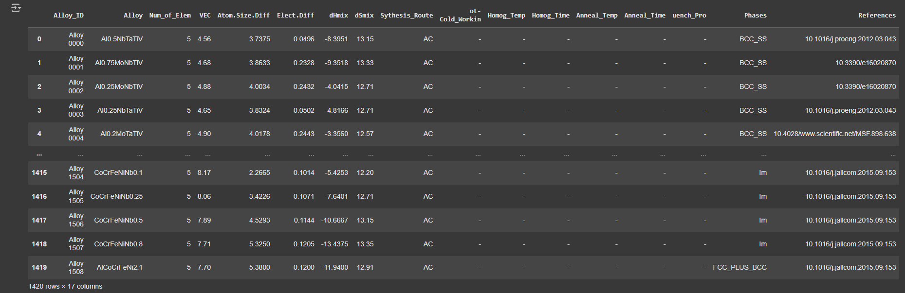
Pre-processing Steps:
To prepare the dataset for machine learning, the following pre-processing pipeline was applied:
- Handling Categorical Variables:
Categorical features—including the target column—were transformed using LabelEncoder and OneHotEncoder, which assigns unique integer codes to each string category across all relevant columns.
- Feature Selection and Cleaning:
Non-predictive identifier columns such as Alloy_ID, Alloy, and References were removed. Missing values in synthesis or processing parameters (e.g., fields with '-') were filled using either domain-specific defaults or appropriate encodings.
- Feature Scaling:
All numerical features were normalized using StandardScaler to ensure consistent input ranges and improve model training efficiency.
- Train-Test Split:
The dataset was split into 80% training and 20% testing sets, using stratified sampling to maintain the original distribution of phase categories across both sets.
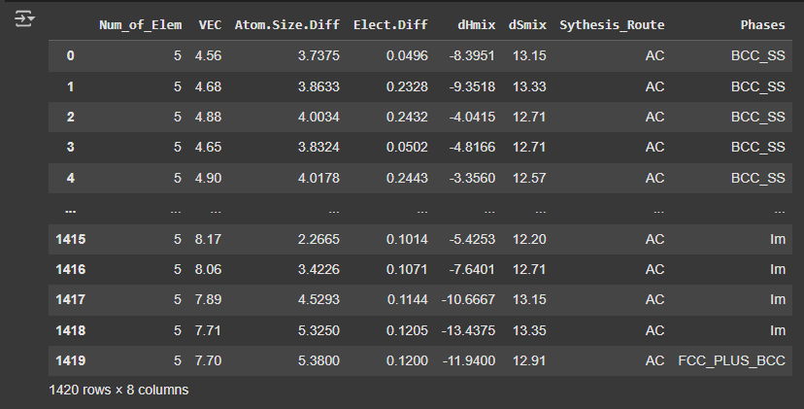
- Class Encoding:
The target classes were label-encoded into multiple integer values to support multi-class classification, allowing the models to learn distinctions among various phase types.
(SVM, XGBoost, Random Forest)
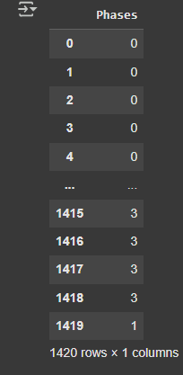
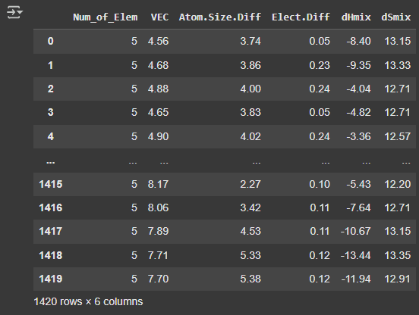
(Neural Networks – MLP Classifier)

METHODOLOGY
This section outlines the machine learning models employed for the classification task, along with the motivation behind selecting each model, pre-processing considerations, and the hyper-parameter tuning strategy adopted.

Support Vector Machine (SVM):

Support Vector Machines are well-suited for classification problems involving high-dimensional data. SVM aims to find the optimal hyper-plane that maximally separates classes, making it effective for multi-class problems with clear boundaries.
Pre-processing:
- Categorical variables were label-encoded.
- Numerical features were standardized using StandardScaler to ensure SVM's sensitivity to feature scaling is addressed.
Hyper-parameters & Tuning:
- Kernel: Radial Basis Function (RBF)
- C: 1.0
Hyper-parameters were selected based on empirical performance.

Random Forest:

Random Forest is a robust ensemble learning technique that builds multiple decision trees and combines their outputs. It is known for its resistance to overfitting and its ability to handle non-linear relationships and both numerical and categorical data.
Pre-processing:
- Standard scaling was applied to ensure consistency, though not strictly required for tree-based models.
- One hot encoder was used for categorical features.

Hyper-parameters & Tuning:
- Number of Estimators: 100 (Default hyper-parameters were used. No manual tuning)

Neural Network (MLPClassifier):
Neural Networks are capable of capturing complex, non-linear patterns in the data through layered representations. Their flexibility makes them powerful for structured classification problems when enough data is available.
Pre-processing :
- All features were scaled using StandardScaler, which is critical for faster and more stable training of neural networks.
- Label encoding was applied for categorical features.
Hyper-parameters & Tuning:
- Architecture: 2 hidden layers (100, 50 neurons respectively)
- Activation Function: ReLU
- Optimizer: Adam
- Epochs and batch size were set using defaults from MLPClassifier.

XGBoost:

XGBoost is an advanced boosting algorithm that often outperforms other models on structured/tabular data due to its ability to capture feature interactions, regularization mechanisms, and gradient boosting efficiency.
Pre-processing:
- Although XGBoost handles unscaled numerical data, StandardScaler was applied to ensure consistency across the pipeline.
- Categorical variables were label-encoded.
Hyper-parameters & Tuning:
- Number of Estimators: 100
- Learning Rate: 0.1
Regularization and early stopping were optionally available but default parameters were initially used.

EVAULATION METRIC:
To comprehensively evaluate the performance of all four machine learning models—Support Vector Machine (SVM), Random Forest, Neural Network (MLPClassifier), and XGBoost—multiple evaluation metrics were used, including training accuracy, testing accuracy, balanced accuracy, and the classification report.
- Training accuracy helps assess how well the model has learned the patterns from the training data.
- Testing accuracy, on the other hand, measures how well the model generalizes to unseen data, making it a critical indicator of real-world performance.
- Balanced accuracy is an extension of traditional accuracy that takes class imbalance into account. It is calculated as the average of recall obtained on each class and is particularly useful when one or more classes are underrepresented in the dataset. Unlike standard accuracy, which can be misleading when classes are imbalanced, balanced accuracy ensures that each class contributes equally to the final metric. This makes it a more reliable indicator of model performance in real-world, skewed datasets.
- The classification report is a comprehensive evaluation metric that provides insights into the performance of a classification model across individual classes. It includes key metrics such as precision (how many predicted positives are actually positive), recall (how many actual positives were correctly identified), and the F1-score, which is the harmonic mean of precision and recall. These metrics help assess not just overall accuracy, but how well the model is performing on each class—especially important in cases of class imbalance..
Using this combination of metrics ensures a robust and fair evaluation across different models, allowing us to identify not only the best-performing algorithm but also the most reliable one in terms of generalization, balance, and per-class performance.

Support Vector Machine (SVM):
Training and testing accuracy
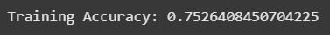
7
Balanced accuracy
Classification Report (Training and testing)
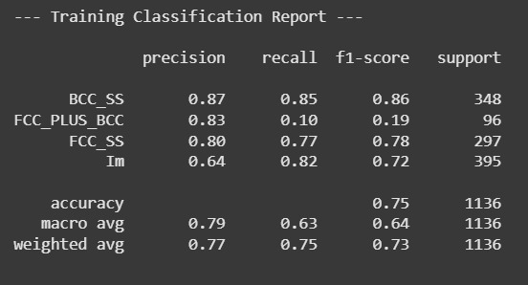
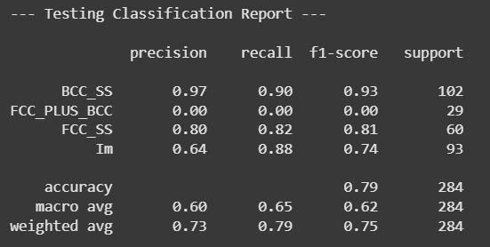

The Support Vector Machine model achieved a training accuracy of 75.26% and a testing accuracy of 78.52%, indicating moderate generalization to unseen data. The balanced accuracy was 61.56%, reflecting challenges in handling class imbalance. The classification reports show that while the model performed well on certain classes like BCC_SS and FCC_SS, it struggled with FCC_PLUS_BCC, achieving very low recall and precision. This suggests that although the SVM model is able to capture patterns in the majority classes, it requires further tuning or class balancing techniques to improve performance on minority or complex phases.

XGBoost:
Training and testing accuracy
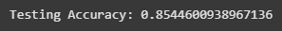
Balanced accuracy
Classification Report (Training and testing)
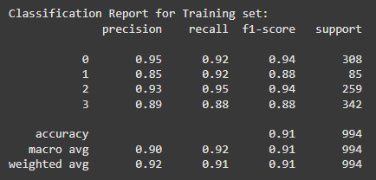
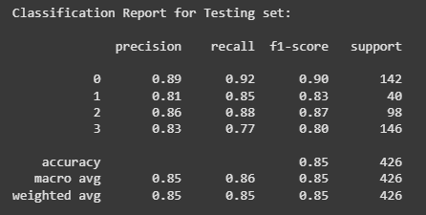
The XGBoost model demonstrated strong overall performance, achieving a training accuracy of 91.44% and a testing accuracy of 85.44%, indicating good generalization with minimal overfitting. The balanced accuracy of 85.60% further confirms that the model performs well across all classes, even when data distribution might not be uniform. The classification reports show consistently high precision, recall, and F1-scores for both training and testing, especially for majority classes. This highlights XGBoost's ability to effectively handle complex patterns and maintain class-wise performance, making it one of the most robust models in this study.

Random forest:
Training and testing accuracy
Balanced accuracy

Classification Report (Training and testing)
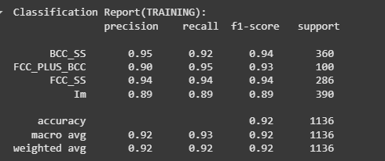
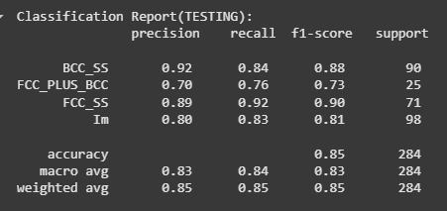
The Random Forest model showed high performance with a training accuracy of 92.08% and a testing accuracy of 84.86%, indicating strong learning capability with moderate generalization. The balanced accuracy of 83.66% highlights its ability to perform well across all classes, especially when dealing with class imbalance. The classification reports reflect consistently high precision, recall, and F1-scores for both sets, with slightly lower performance on the minority class in the testing set. Overall, the model maintains a good trade-off between bias and variance, making it a reliable choice for classification.

Neural Network (MLPClassifier):
Training and testing accuracy
Balanced accuracy
Classification Report (Training and testing)
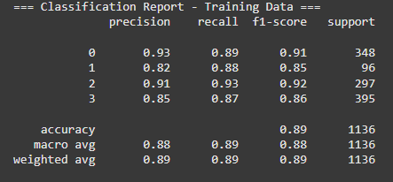
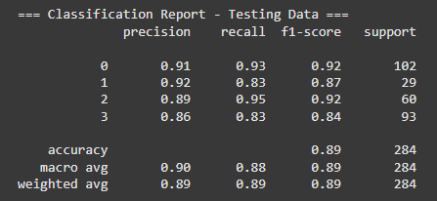
The Multi-Layer Perceptron (MLP) classifier demonstrates consistent performance, achieving a training accuracy of 88.91% and a testing accuracy of 89.08%, indicating good generalization without overfitting. The balanced accuracy of 88.42% further confirms robust performance across all classes. The classification reports show high precision and recall values for both training and testing data, with particularly strong performance in classifying majority classes and minimal drop in minority class performance. Overall, the neural network provides a balanced and stable classification capability suitable for multi-class problems.

RESULTS
To evaluate the performance and generalization capability of the developed models, both training and testing confusion matrices were analyzed. These matrices offer a detailed view of the model's ability to correctly classify each phase category, highlighting strengths in prediction and identifying areas where misclassifications occur.
Furthermore, feature importance visualizations (particularly from tree-based models like Random Forest and XGBoost) were included to provide interpretability by indicating which input features contributed most significantly to the prediction outcomes. This aids in understanding the model’s decision-making process and validates the relevance of engineered features.
The following section presents each models :
- Confusion matrices for both training and testing phases across all models.
- Feature importance plots to interpret model behavior.
- Observations drawn from visual trends and comparative analysis.
These visualizations, combined with the earlier reported metrics (accuracy, balanced accuracy, and classification reports), offer a comprehensive perspective on model robustness and applicability to unseen data.

Support Vector Machine (SVM):
Confusion matrix (Training and testing)
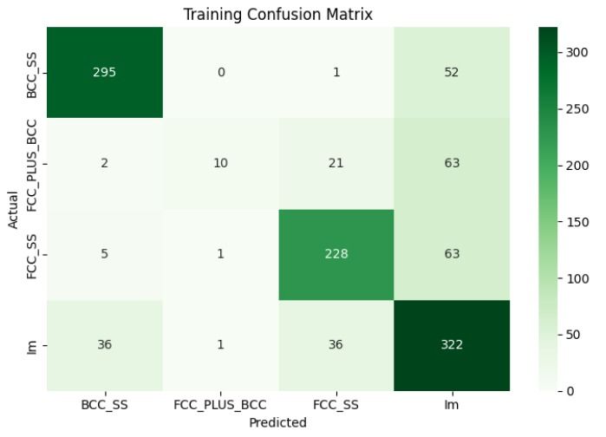
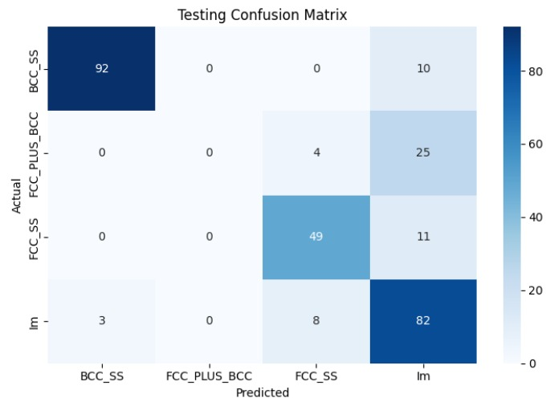
The confusion matrices for training and testing data provide insight into the classifier's behavior across different phases. The BCC_SS and Im phases were classified with high accuracy and consistency, indicating strong model learning and generalization for these dominant classes.
However, the FCC_PLUS_BCC phase was significantly misclassified, with almost no correct predictions in the test set, highlighting issues related to class imbalance or overlapping features. The FCC_SS phase performed moderately well but showed confusion with Im, suggesting a need for improved feature separation.
Overall, the model performs well on the major classes but struggles with minority or closely related phases, indicating opportunities for feature engineering or resampling techniques.
Feature importance
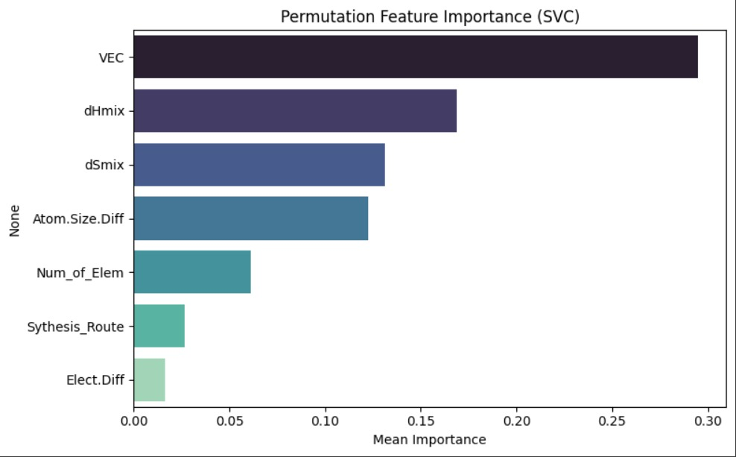

The feature importance plot shows that VEC, dHmix, and dSmix are the most impactful features, indicating their strong influence on phase classification, while features like Elect.Diff and Synthesis Route had minimal effect.

XGBoost:
Confusion matrix (Training and testing)
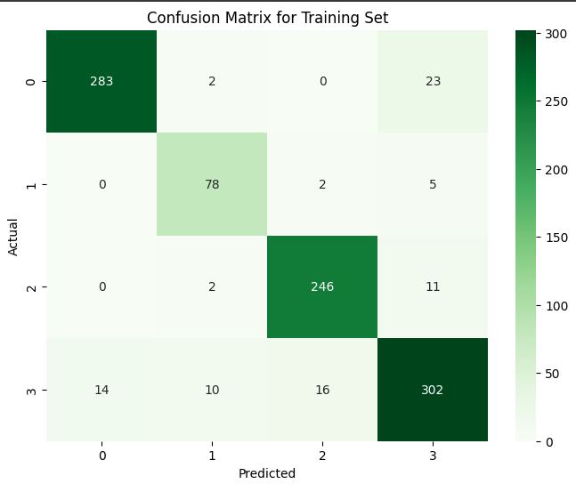
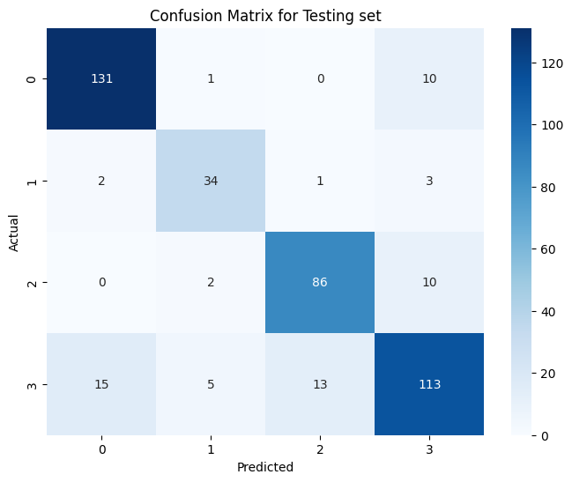
The confusion matrices above illustrate the classification performance on both the training and testing datasets.
Training Set: The model demonstrates strong classification accuracy, with most samples correctly predicted across all classes. For instance, Class 0 and Class 3 achieved high true positive rates (283 and 302 respectively), indicating the model has learned the training patterns well. Misclassifications are relatively minimal, suggesting effective model fitting.
Testing Set: Performance on the testing set also remains strong, though with slightly increased misclassifications, as expected due to generalization. Class 2 and Class 3 are predicted with high accuracy (86 and 113 correct predictions respectively), while some confusion is observed between Class 3 and Class 0 (e.g., 15 Class 3 samples misclassified as Class 0), which could indicate slight overlap in feature space.
Overall, the consistency between training and testing results suggests that the model is neither overfitting nor underfitting significantly.
Feature importance
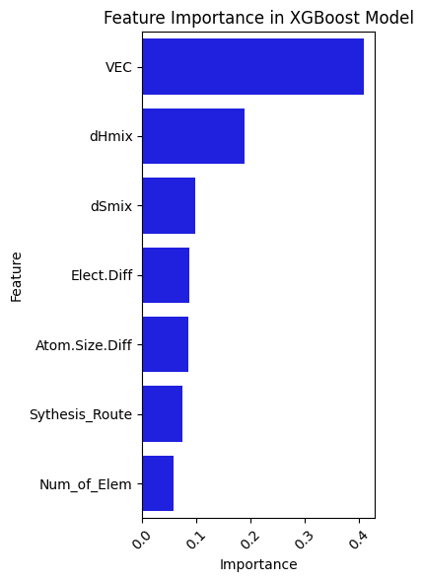

The feature importance plot generated from the XGBoost model indicates that VEC (Valence Electron Concentration), dHmix (Enthalpy of Mixing), and dSmix (Entropy of Mixing) are the most significant contributors to accurate phase classification. Their high importance scores suggest a strong correlation between these thermodynamic and electronic features and the resulting phase stability of the alloy systems.
In contrast, features such as Elect.Diff (Electronegativity Difference), Atom.Size.Diff, Synthesis Route, and Num_of_Elem exhibit lower influence on the model’s predictions. While they contribute marginally, their role may become more prominent in specific alloy families or under certain processing conditions.
This analysis not only supports the physical relevance of VEC and mixing parameters in phase formation but also provides valuable guidance for feature prioritization in future model refinement or material design studies.

Random forest:
Confusion matrix (Training and testing)
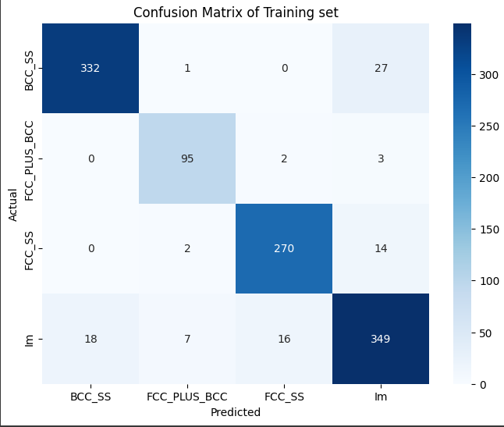
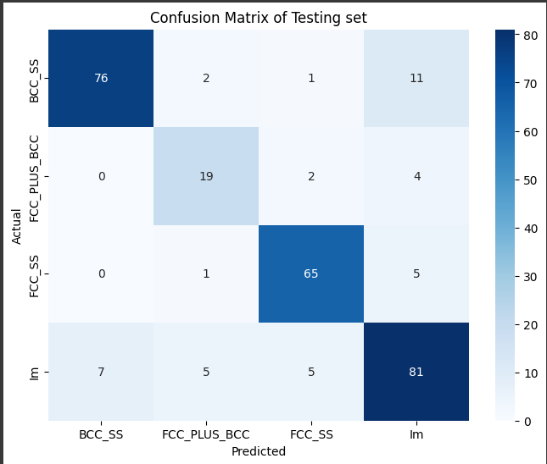
The confusion matrices above present the classification performance of the Random Forest model on both the training and testing datasets.
Training Set: The model demonstrates excellent classification performance on the training data, with high accuracy across all classes. Notably, the BCC_SS and Im classes achieved strong true positive counts (332 and 349, respectively), indicating effective learning. Misclassifications are minimal, suggesting that the model has successfully captured the distinguishing patterns in the data without signs of overfitting.
Testing Set : The model generalizes well to the unseen test data. The Im and FCC_SS classes exhibit strong predictive accuracy (81 and 65 correct classifications, respectively). However, slight confusion is observed in the FCC_PLUS_BCC class, where some instances are misclassified as BCC_SS or FCC_SS, possibly due to overlapping feature distributions. Despite these few errors, overall predictive performance remains robust.
The consistency between the training and testing results highlights the model’s reliability and balanced generalization capability.
Feature importance
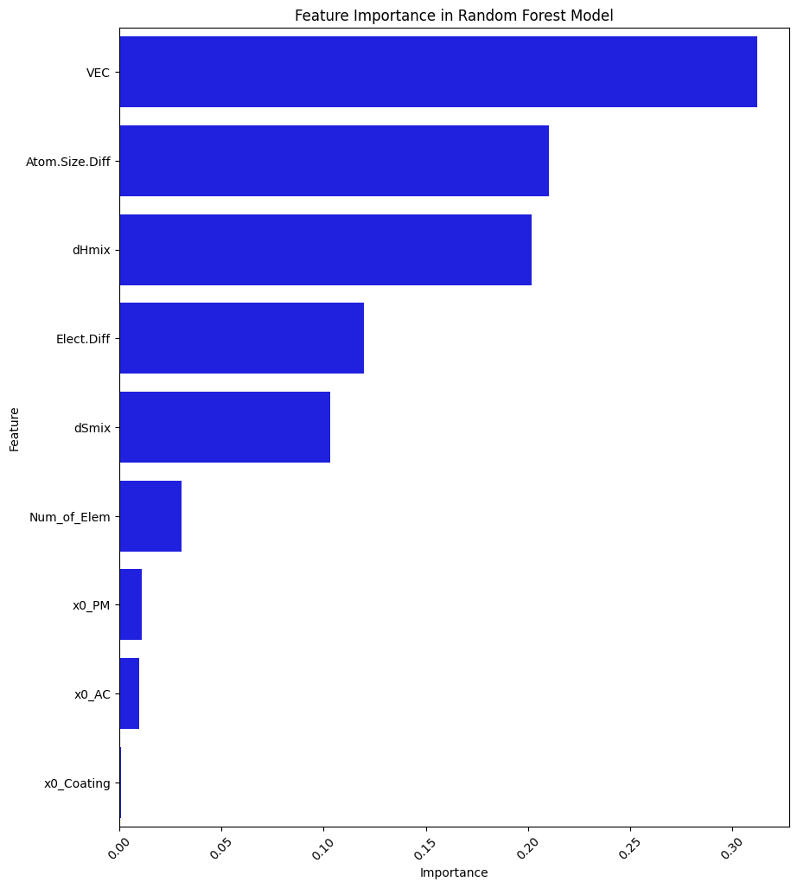

The feature importance plot indicates that VEC is the most dominant factor influencing phase classification in the Random Forest model, followed by Atom.Size.Diff and dHmix. These features significantly contribute to the model's decision-making process. In contrast, variables such as x0_PM, x0_AC, and x0_Coating show minimal impact, suggesting limited relevance in predicting the target phases. This insight can guide future feature selection and model refinement.
Neural Network (MLPClassifier):
Confusion matrix (Training and testing)
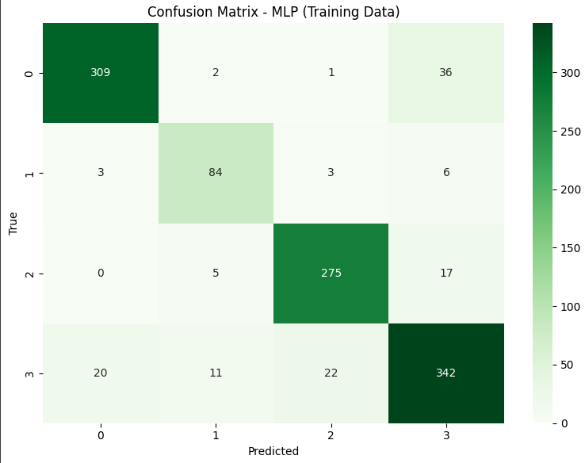
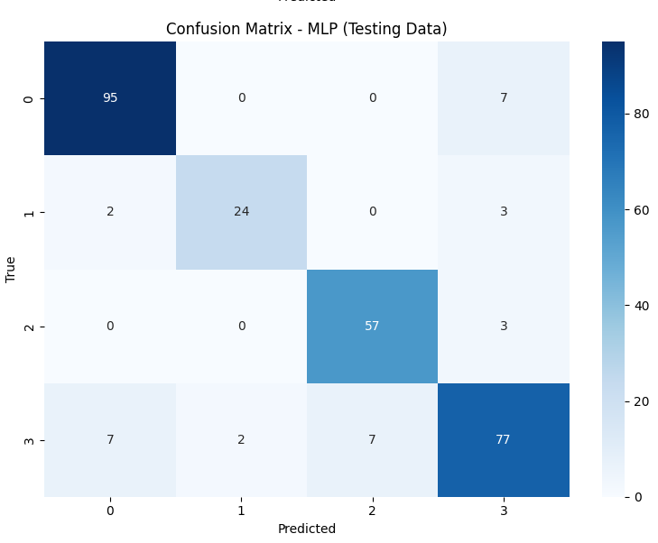

The MLP model performs consistently across training and testing phases, with a balanced accuracy and manageable misclassification levels.
Training Set:The MLP model demonstrates solid learning on the training data. Most classes show high true positive rates, particularly Class 0 and Class 3 (309 and 342 correct predictions respectively). Some misclassifications are present, such as Class 3 being partially confused with Classes 0, 1, and 2, indicating slight overlap. However, overall performance reflects effective learning without severe overfitting.
Testing Set:On the unseen test data, the model maintains good performance. Class 0 and Class 3 are predicted accurately (95 and 77 correct predictions, respectively). A few errors occur across other classes — for example, Class 3 is sometimes misclassified as Class 0 or Class 2. Despite these minor misclassifications, the model generalizes well, suggesting reliable predictive ability.
Feature importance
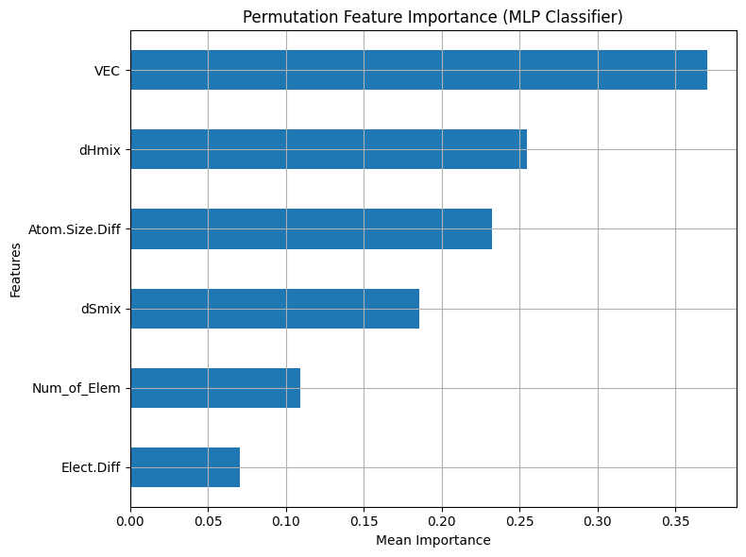

The MLP model relies most heavily on VEC, followed by dHmix and Atomic Size Difference. dSmix also contributes moderately, while Num_of_Elem and Elect.Diff have lower impact on predictions. This highlights VEC and thermodynamic features as key drivers of phase classification.
Phase Distribution
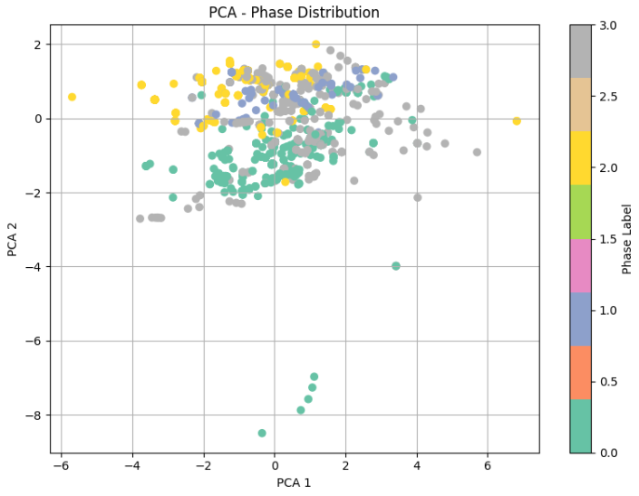
The Principal Component Analysis (PCA) was applied to the scaled dataset (X_scaled) to reduce its dimensionality to two principal components (n_components=2). The resulting PCA-transformed data was visualized in a 2D scatter plot, where: PCA 1 (x-axis) and PCA 2 (y-axis) represent the directions of maximum variance in the data.Points are colored by their corresponding phase labels (y), using the 'Set2' colormap to distinguish different phase categories.
Key Observations:
Dimensionality Reduction:
PCA successfully projects the high-dimensional data onto a 2D plane, preserving the most significant variance patterns.

Phase Clustering:
The scatter plot reveals potential clusters or trends correlated with phase labels, suggesting structured variation in the data.
Color Mapping:
The color gradient helps identify how phase labels distribute across the principal components, highlighting possible relationships between phases and the dominant variance axes.
Interpretation:
Overlapping or distinct clusters may indicate similarities or differences in phase behavior. Sparse or dense regions reflect variability in phase distribution.

COMPARISON TABLES
Here is a consolidated performance comparison of all four models — Random Forest, XGBoost, Neural Network (MLP), and SVM — based on the training/testing accuracy, balanced accuracy, and classification reports.
Model Performance Comparison:
Model | Train  Accuracy | Test  Accuracy | Balanced  Accuracy
  Observations
Random Forest | 0.9208 | 0.8486
  0.8366
  Slight overfitting; performs well overall
XGBoost | 0.9144 | 0.8545 | 0.8560
  Best generalization with stable metrics
Neural Networks | 0.8891 |  | 0.8842 | Most balanced performance; strong generalization
  0.8908
SVM | 0.7526 | 0.7852
  0.6156
  Underperforms on minority class; limited generalization

Class-wise Insights (Test Set):

Class |  |  | MLP: F1-score
  RF: F1-score
  XGB: F1-score
  SVM: F1-score
BCC_SS | 0.91 |  | 0.92
  0.89
  0.93
FCC_PLUS_BCC | 0.73 | 0.77 | 0.87
  0.00
FCC_SS | 0.86 |  | 0.92 | 0.81
  0.91
Im | 0.86 | 0.86 | 0.84 | 0.74

Summary of Model Trade-offs:

Factor | Random Forest | XGBoost | Neural Network | SVM
Accuracy | High | High | Very High | Moderate
Generalization | Moderate | High | Very High | Weak
Speed | Fast | Medium | Slower | Fast
Interpretability | High | Medium | Low | Medium
Class Imbalance Handling | Weak | Good | Good | Poor

DISCUSSION AND INSIGHTS

Best Performing Model:
The Neural Network (MLP) exhibited the highest test accuracy (89.08%) and balanced accuracy (88.42%), with almost equal training performance, indicating excellent generalization and no overfitting. It consistently classified all classes with high precision and recall, especially for minority classes.

Overfitting/ Underfitting Analysis:
- Random Forest showed signs of mild overfitting, with a significant gap between train (92%) and test (84.86%) accuracy.
- XGBoost maintained a healthy balance, with both high test accuracy and balanced accuracy, showing strong generalization.
- Neural Networks demonstrated minimal overfitting, making it a highly robust choice.
- SVM results are expected to provide competitive margins, especially for binary/marginal multiclass splits.

Findings:
Neural Networks slightly outperformed ensemble models despite being more complex and less interpretable. XGBoost proved to be the most efficient trade-off between performance and training time. Class imbalance affected the Random Forest most severely, highlighting the importance of balanced training strategies. Support Vector Machine (SVM), while achieving decent accuracy, struggled particularly with the FCC_PLUS_BCC class due to class imbalance, as seen in its low recall. However, it provided valuable insights through feature importance, with VEC and dHmix emerging as dominant predictors.

CONCLUSION:
This study explored multiple machine learning models—Support Vector Machine (SVM), Random Forest, XGBoost, and Neural Networks—for the classification of phase structures based on composition-based feature vectors. Among these, Neural Networks demonstrated the highest performance, indicating their ability to capture complex patterns despite being less interpretable. XGBoost emerged as the most balanced model in terms of accuracy and computational efficiency, making it suitable for practical applications. Random Forest performance was significantly impacted by class imbalance, underlining the need for balanced datasets or resampling techniques. SVM, while providing moderate performance, offered valuable feature insights, highlighting VEC and dHmix as key discriminative attributes.
The primary limitations of this study include class imbalance, limited dataset size, and the exclusion of ensemble or hybrid approaches that could potentially enhance model robustness.
Future work could involve the use of more sophisticated techniques such as ensemble stacking, deep learning architectures, or the incorporation of additional physical or chemical features to further improve classification accuracy and generalizability.

REFERENCES:
Dataset Source: Machaka, R., Motsi, G. T., Raganya, L. M., Radingoana, P. M., & Chikosha, S. (2021). Machine learning-based prediction of phases in high-entropy alloys: A data article. Data in Brief, 36, 107346.
Scikit-learn Documentation: https://scikit-learn.org/
Géron, A. (2019). Hands-On Machine Learning with Scikit-Learn, Keras & TensorFlow
Pandas Documentation: https://pandas.pydata.org/docs/
McKinney, W. (2010). Data Structures for Statistical Computing in Python. In Proceedings of the 9th Python in Science Conference (pp. 51-56).
NumPy Documentation: https://numpy.org/doc/
Harris, C. R., Millman, K. J., van der Walt, S. J., et al. (2020). Array programming with NumPy. Nature, 585(7825), 357–362.
XGBoost Python API: https://xgboost.readthedocs.io/
Neural Networks (MLPClassifier) Scikit-learn API: https://scikit-learn.org/stable/modules/neural_networks_supervised.html
Random Forest - Scikit-learn API: https://scikit-learn.org/stable/modules/ensemble.html#random-forests
Support Vector Machine (SVM) - Scikit-learn API: https://scikit-learn.org/stable/modules/svm.html

-------X-------

