Satellite optical communication project complete learning guide
This guide explains your existing MATLAB and Simulink research prototype from the beginning. It connects the physical ideas, equations, implementation, saved experiments and results so that you can explain the project in your own words. It describes what was implemented and what the saved evidence supports; it does not treat a simulation as proof of spacecraft readiness.
The central result is that V2 improves detection and exact fault isolation under the tested conditions, while some faults remain ambiguous or physically impossible to repair through pointing. The reported conditional recovery percentage falls, even though average outage falls. Understanding that apparent contradiction is an essential part of understanding this project.
Prepared from the existing source and saved results on 15 October 2026. No project code or previous result was modified, and no simulation was rerun to create this guide. Numerical tables come from the completed comparison batch comparison_20261014_224749_328. Percentages are rounded only for display.

How to use this guide
Read Chapters 1 to 5 first to understand the physical system. Chapters 6 to 11 explain why diagnosis was difficult and how V2 addresses it. Chapters 12 to 18 explain the experiment, metrics, numerical results and graphs. Chapters 19 to 23 explain files, MATLAB commands, limitations and how to present the work.
You do not need to understand every equation immediately. For each equation, first identify the input, the output and the physical meaning. Then follow the numerical example. Questions at the end of major topics let you check your understanding without needing to run MATLAB.
The words “saved result” identify evidence from the existing experiment. The words “illustrative example” identify a teaching example rather than an additional experiment. All figures in the results chapters are the original saved V2 comparison figures.

1 The project in everyday language
Imagine several people communicating with narrow flashlights across a large distance. A receiver sees a strong signal only when a flashlight points accurately toward it. If the received light becomes weak, several explanations are possible: the flashlight points in the wrong direction, the light source has weakened, something blocks the beam, or the instrument reporting its direction is wrong. The same symptom does not automatically reveal the cause.
Your project replaces people and flashlights with a simplified network of satellites and laser communication terminals. The simulation represents the terminal pointing motion, the actuator moving it, angle and rate measurements, received optical power, fault diagnosis, corrective commands and an alternative communication route when a direct link fails.
The main task is to answer three separate questions. First, is something wrong? Second, what kind of fault best explains the measurements? Third, what action can preserve or restore communication? These questions are called detection, isolation and recovery. A method can answer the first correctly while failing at the second or third.
The project is needed because blindly reacting to weak power can be harmful. A pointing adjustment may help a misaligned beam, but it cannot restore power lost through severe attenuation. A correction that was useful during a temporary fault may become harmful after the fault disappears. The software therefore needs to keep checking whether its explanation and its corrective action still make sense.
The implemented V2 method combines physical models with measurement history. It compares measured angle with integrated angular rate, estimates actuator response from commanded and delivered torque, makes small diagnostic pointing movements when appropriate, fits the optical response and removes corrections when new measurements contradict them. The network can route traffic around unavailable links.
Your project is a controlled simulation study, not a deployed satellite system. Its strengths are that the fault truth is known for evaluation, conditions can be repeated and the revised supervisor can be compared against a preserved baseline. Its limitations include a fixed network, simplified traffic, an idealized receiver and unusually informative actuator telemetry.
Understanding check: if a laser link becomes weak, can you immediately conclude that its pointing is wrong? No. Weak power is an observation; pointing error is only one possible explanation.

2 Basic concepts and units

Satellites terminals links and networks
A satellite is a spacecraft. In this model, a satellite is also a node in a graph. A terminal is the modeled optical communication equipment associated with a link. A link is a possible direct connection between two nodes. A route is a sequence of links that carries communication from a source to a destination.
The model uses one effective two-axis terminal for each bidirectional edge. This is a simplification: it does not separately simulate every transmitter and receiver on both ends of a real optical link. A four-node network is therefore a small network of modeled connections, not four full spacecraft digital twins.

Optical communication and pointing
Optical communication carries information using light. Your model concentrates on whether enough optical power reaches the receiver, rather than simulating every optical waveform or communication bit. A narrow laser beam is useful because its energy is concentrated, but small angular errors can move the beam away from the receiving aperture.
Pointing angle describes the direction of the terminal. Angular rate describes how quickly that direction changes. The model has two pointing axes, so angle and rate are vectors with two components. The total pointing error is the vector magnitude, not simply one component.
One radian is an angle unit. One microradian, written µrad, is one millionth of a radian. For small angles, sideways displacement is approximately distance multiplied by angle. At 800 km, 1 µrad corresponds to about 0.8 m, and 20 µrad corresponds to about 16 m. This geometric example explains why microradian changes matter; it is not an additional result from an orbital simulation.

Power torque time and capacity
Power is energy transferred per second, measured in watts. One microwatt, µW, is one millionth of a watt. The default transmitted power is 0.5 W, but the small receiving aperture captures only a tiny fraction of the spread beam. The aligned received power is about 3.906 µW.
Torque is a turning action, measured in newton metres, N m. An actuator converts a command into delivered torque. These are different quantities: an actuator can be weak or slow, so the torque it delivers need not immediately equal the command.
The controller and supervisor use samples separated by 0.02 s, which is 20 ms. The supervisor makes its main scheduled decision checks every 0.1 s. A ten-second simulation contains many time samples; those samples are related through the dynamics and must not be treated as hundreds of independent experiments.
Capacity is the maximum modeled data rate, here 1 Gbit/s for a link. Offered traffic is the requested data rate, here 0.6 Gbit/s. Throughput is the amount successfully carried per second. Latency is the modeled travel and processing time. An outage is a period when service is unavailable under the model's rules.

Measurements noise states and models
A state describes something evolving inside the physical model, such as terminal angle or actuator torque. A measurement is what the supervisor is allowed to observe. A measurement can contain noise or bias. Noise varies from sample to sample; bias is a systematic offset. A fault changes the behavior of the system or a sensor.
A model is a mathematical description of how inputs and states should produce outputs. A residual is the difference between an observation and a model prediction. A large residual says the model and observation disagree; it does not, by itself, identify the reason.
A derivative describes the rate of change. Angular rate is the derivative of angle. An integral accumulates a rate over time. If a terminal rotates at 2 µrad/s for 0.5 s, its angle changes by approximately 1 µrad. The V2 sensor diagnosis uses this connection between angle and rate.
An estimate is a calculated approximation to an unknown quantity. A threshold is a decision boundary. A regression fits unknown model parameters to a set of measurements. A seed initializes a random-number sequence so that noisy trials can be reproduced.
Understanding check: a sensor always reports 5 µrad more than the actual angle. Is that random noise or bias? It is bias. If the error changes irregularly around zero, it is noise.

3 What is actually simulated

Network sizes and graph structure
The retained experiments use 4, 6, 8 and 10 satellites. The topology called mesh in the configuration is a sparse ring with additional opposite-node chords. It is not a complete graph in which every node connects to every other node. The configured networks have 5, 9, 12 and 15 edges respectively.
Node positions and link distances do not evolve through orbital mechanics. The default distance is 800 km. This lets the study focus on diagnosis, terminal control and route availability, but means it does not establish performance under changing intersatellite geometry, acquisition windows or orbital visibility.
The main experiments apply the fault to edge 1. Other edges provide possible alternative routes. Because the affected edge receives the same dynamics and paired noise across network sizes, its diagnostic results are equal across sizes in the saved main comparison. Increasing the number of nodes does not automatically make the local diagnosis problem harder in this setup.

Inputs and time schedule
Each trial starts from a configuration structure. It specifies the satellite count, physical parameters, seed, fault scenario, fault onset and clearance, controller settings, receiver threshold and traffic. The default run lasts 10 s. Evaluation begins at 1 s after a warmup interval. A sudden fault begins at 2 s and ends at 8 s.
The input data are generated within the experiment. They are not downloaded spacecraft telemetry and not a trained machine-learning dataset. prepare_config constructs the graph and reproducible Gaussian measurement-noise arrays. Each edge uses a seed offset, seed plus 1000 times its edge index minus one. Paired V1 and V2 trials use the same conditions and noise inputs.
Fault injection modifies the physical plant or sensor during the scheduled interval. The diagnosis function is deliberately given only permitted measurements and nominal parameters, not the scenario name, true fault label, onset, clearance or severity. The evaluator can use the true fault schedule to score predictions, but the decision method must infer what happened from observations.

Simulink and MATLAB roles
Simulink integrates the terminal dynamics and connects the physical model to the supervisor and logging. V2 uses four separately saved SLX network models, one per network size. MATLAB functions provide the configuration, model equations, supervisory decisions, metric calculation and experiment orchestration.
run_case_v2 loads the appropriate SLX model, places cfg in its model workspace and calls sim. It collects plantLog, decisionLog and estimatorLog, converts them into arrays and computes metrics. The saved report states that the new trial results came from these Simulink runs. This guide reads that existing evidence; it does not claim that another simulation was executed while writing the document.
The overall flow is configuration → Simulink plant → measured signals → V2 estimates and decisions → new reference commands → plant response. Logging runs alongside that loop. After the trial finishes, the evaluator compares predictions with truth and computes communication and control metrics.

4 How received optical power is calculated

Start with beam spreading
The divergence parameter is 20 µrad. The model calculates a beam-width parameter w as distance times divergence. With 800000 m and 20 × 10⁻⁶ rad, w is 16 m. The receiving aperture diameter is 0.10 m, so its radius a is 0.05 m. A small aperture captures only part of the beam.
The nominal aligned power P0 is transmitted power multiplied by the optical efficiency and the aperture-capture factor. The model uses P0 = Pt × η × [1 − exp(−2a²/w²)]. Here Pt is 0.5 W and the optical efficiency η is 0.4. Substitution gives approximately 3.906 µW.
The symbol η is used here for optical efficiency. Later, actuator effectiveness is another gain parameter. They have different physical meanings even if mathematical notation sometimes uses the same Greek letter. In your explanation, say “optical efficiency” or “actuator effectiveness” explicitly.

Include pointing error and power loss
Received power is P = P0 × exp[−2‖θopt‖²/α²] × g × (1 − blocked). The divergence is α, the optical pointing-error vector is θopt, g is the scalar optical power factor, and blocked is either zero or one. The vector norm squared means the sum of the squared errors on both axes.
The exponential term is largest when the pointing error is zero. As pointing error grows, this factor decreases. The total optical error includes physical terminal angle plus an injected boresight offset. A sensor bias does not enter this optical expression directly; it affects what the controller thinks the angle is and can thereby move the physical terminal incorrectly.
For an illustrative calculation, a total error equal to one divergence width gives exp(−2), approximately 0.135. Even without power degradation, the received power becomes about 0.529 µW, below the receiver threshold. This calculation shows how pointing alone can interrupt the link.
The receiver threshold is 1.5 µW. The quality ratio is received power divided by this threshold. The link is available when the ratio is at least one. At 3 µW, the ratio is two; at 0.75 µW, it is one half. This is a threshold receiver model, not a detailed bit-error-rate calculation.

Why some faults cannot be corrected by pointing
The power-loss scenario multiplies power by 0.18. Perfect alignment then gives only 3.906 × 0.18 ≈ 0.703 µW. The combined offset-and-power scenario uses a factor of 0.35, giving at best approximately 1.367 µW. Both are below 1.5 µW.
No pointing command can make the Gaussian alignment factor exceed one. Therefore, correcting the direction cannot restore these two links under the unchanged transmit power and sensitivity. A meaningful response is to diagnose the limitation and use another network route. Claiming physical repair in this situation would be incorrect.
Understanding check: if the maximum possible aligned power is below the receiver threshold, will a better pointing estimate restore the physical link? No. It can improve alignment, but it cannot supply the missing optical power.

5 Terminal dynamics and control

What moves inside the model
Each terminal has eight continuous states: two angles, two angular rates, two delivered-torque values and two integrated control-error values. The implemented plant is a simplified two-axis rotational system. It represents effective terminal motion, not a full three-dimensional spacecraft attitude model with orbital disturbances and reaction-wheel geometry.
The angle derivative is angular rate. The rate derivative is (delivered torque − damping × rate) divided by inertia. Inertia J = 0.002 expresses resistance to changes in rotation, and damping b = 0.004 opposes motion. The actuator torque derivative is (effectiveness × commanded torque − delivered torque) divided by the actuator time constant.
The nominal actuator time constant is 0.08 s. A time constant describes response speed; it is not a fixed delay before the actuator starts moving. A weak actuator has a smaller effectiveness, while a lag fault makes the response slower. These are different dynamic patterns, even if both can cause tracking errors.
Torque commands are limited to ±2 × 10⁻⁶ N m per axis. The rate limit is 120 µrad/s. These constraints matter because a diagnostic action or correction cannot demand unlimited physical motion. The model also prevents outward acceleration at the rate limit and includes an antiwindup rule for the integral state when commanded torque saturates.

Feedback control in simple terms
The reference is the angle the controller is asked to follow. The measured angle is what the sensor reports. Their difference is the tracking error. Feedback control observes that error and changes actuator torque to reduce it. If the sensor is biased, a controller can correctly follow its measured error while moving the real terminal to the wrong direction.
The default controller is sliding mode control, SMC. Its sliding variable combines measured angular rate and angle error: s = measured rate + λ × error, with λ = 8. The control law includes damping compensation, an error-related dynamic term and a bounded restoring term involving sat(s/φ). The boundary-layer parameter φ is 8 × 10⁻⁶ in sliding-variable units, and the switching gain K is 80 × 10⁻⁶. Since s combines rate with λ times angle, φ should not be confused with the optical divergence angle.
The saturation function clips its argument between −1 and +1. Compared with an ideal sign switch, it softens the change close to zero. The resulting torque command is itself clipped to the actuator limit. The practical idea is to push the combined angle-and-rate error toward zero without commanding unlimited torque.
The code also contains a PID branch: commanded torque is based on proportional angle error, derivative rate feedback and accumulated error. The default gains are kp = 64, kd = 14 and ki = 8. The presence of this branch does not mean the V2 comparison changed to PID. The primary compared configuration retains SMC.

Controller and supervisor are different
The low-level controller turns a reference angle into torque. The supervisor decides whether the reference should include a fault correction or a diagnostic probe. Keeping these roles separate is useful: V2 primarily revises diagnosis and supervision while retaining the existing physical terminal plant and control setup.
Do not describe the main implementation as a neural network or a learned classifier. Its diagnosis uses physical models, regression and decision thresholds. Also, scheduled decisions every 0.1 s are not evidence of a formally developed event-triggered or self-triggered control law. A title from a reference presentation does not change what the project actually implements.

6 Fault classes and why detection is easier than isolation
Code | Class | Injected change
0 | Healthy | No injected fault
1 | Pointing | Optical offset [23, 10] µrad
2 | Actuator effectiveness | Effectiveness reduced to 0.25
3 | Actuator lag | Time constant multiplied by 6, to 0.48 s
4 | Optical power loss | Power factor 0.18
5 | Blockage | Received power forced to zero
6 | Sensor bias | Angle bias [23, 10] µrad
7 | Uncertain prediction | No injected truth class; evidence insufficient
8 | Combined | Optical offset plus power factor 0.35

The normal scenario has no injected fault. The seven faulty scenarios modify different parts of the model. Each main fault is temporary, active from 2 s to just before 8 s, and is applied to the first edge. Code 7 is a possible diagnosis, “uncertain,” rather than a physical fault injected by the experiment.
Detection asks whether the predicted label is nonzero. Isolation asks whether that label is exactly the correct physical class. Suppose the true class is pointing and the output is uncertain. The detector has noticed an abnormal condition, so it receives detection credit. It has not identified pointing, so it receives no exact-isolation credit.
This explains why high detection accuracy can coexist with low isolation accuracy. A detector that says “something is wrong” for nearly every fault may detect reliably without distinguishing causes. Your original results, approximately 72.06% detection and 9.48% exact isolation, were therefore not contradictory.

Pointing offset versus sensor bias
A boresight offset changes the relationship between terminal angle and beam direction. Even if the angle sensor is correct, the optical beam can be misaligned. A sensor bias changes the reported angle; the controller may then move the terminal incorrectly because it trusts the wrong report.
Both can reduce optical power. Looking only at a single power measurement cannot generally tell them apart. However, this model also supplies an independently measured rate channel. Its time history gives information about actual movement. That additional information lets V2 identify a change in angle-sensor bias under the stated calibration assumptions.

Gain versus lag and darkness ambiguity
Actuator effectiveness is about how much torque is eventually delivered for a command. Actuator lag is about how quickly torque changes. A constant command observed only after settling may reveal gain but little about response speed. Time-varying commands and delivered-torque history allow a better distinction.
When received power is effectively zero, several causes remain consistent with the measurements: blockage, an extinguished transmitter or sufficiently severe attenuation. The modeled test may label its injected cause as blockage, but the supervisor is not entitled to use that truth label. V2 deliberately reports uncertain in this situation. Its zero exact blockage isolation is therefore an unresolved observability limitation, not a result to hide.
Understanding check: why is “uncertain” useful? It prevents a confident but unsupported explanation. It is useful only if its frequency and costs are reported honestly, not removed from the denominator.

7 What was wrong with the original diagnosis
The audit found that the old classifier could uniquely output only the power-loss class among the nonzero physical classes. It could not uniquely label pointing, actuator gain, actuator lag, sensor bias or the combined fault. This structural limitation alone made a high exact-isolation score impossible.
Power isolation was about 66.3%, while the other six fault classes had zero exact isolation. The mean across seven equally exposed fault classes was therefore approximately 66.3% divided by seven, or 9.48%. This is a direct explanation of the reported low score, rather than speculation that the numerical thresholds were merely a little inaccurate.
The actuator gate was scaled to maximum torque, while the informative torque signals were much smaller. Consequently, genuine actuator changes were often missed. The optical scan and correction were also latched after a decision, so later measurements could fail to remove an explanation that had become false.
Applying an old correction after a temporary fault clears can create a new pointing error. For example, a correction that offsets a +23 µrad boresight shift becomes an unnecessary −23 µrad command when the shift vanishes. The physical plant then moves away from alignment despite the original fault having ended.
Another weakness was applying a pointing correction when the fitted best-case optical power was still below receiver sensitivity. Such a correction could consume effort and create clearance problems without being capable of restoring the link.
The V2 response was not to redefine accuracy or remove difficult classes. It was to use the available time histories more effectively, require informative fits, keep uncertain cases uncertain, check whether recovery is physically feasible and continually test whether a correction remains valid.

8 How V2 estimates sensor bias

Reconstruct movement from independent rate
V2 initializes a kinematic angle estimate from the measured angle and then integrates the independent measured angular rate. The trapezoidal update adds dt times the average of the previous and current rate. It approximates the area under the rate-versus-time curve more accurately than assuming one endpoint rate for the whole interval.
For an illustrative example, suppose the previous rate is 1 µrad/s, the new rate is 3 µrad/s and dt is 0.02 s. Their average is 2 µrad/s, so the estimated angle increases by 0.04 µrad. This calculation repeats at each sample.
The difference between the encoder angle and the integrated-rate angle is a bias innovation. V2 smooths this with a half-old, half-new filter: the new bias estimate is 0.5 times its previous estimate plus 0.5 times the current difference. Filtering reduces the effect of sample noise, while retaining a fast response to a large jump.
If the magnitude exceeds 3 µrad, the bias flag is raised. The main injected sensor fault is [23, 10] µrad, much larger than the nominal angle-noise scale of 0.08 µrad. This is one reason the saved sensor-bias result is strong; it is not evidence that arbitrarily small biases would be detected equally well.

Why the correction sign makes sense
The controller tracks measured angle. If measured angle equals true angle plus bias, asking it to track a reference equal to the estimated bias makes the true angle approach zero. That is why the reference correction contains a positive bias estimate. An optical boresight offset instead needs a negative physical-angle correction, so the combined expression is bias estimate minus optical-offset estimate.

What the method cannot infer
Initialization assumes an adequately calibrated starting measurement. A constant unknown bias already present at initialization becomes part of the integrated-angle reference and is not identified by this change-detection mechanism. Rate integration can also drift over long durations.
The rate channel must carry independent information. If rate were calculated by differentiating the same biased encoder, an encoder jump could enter both channels and the comparison could lose the ability to distinguish bias from real movement. The revision tests include an observation-level example demonstrating this dependency.

9 How V2 distinguishes actuator weakness from slowness
The actuator model says that delivered-torque rate equals a coefficient times commanded torque minus another coefficient times delivered torque. V2 fits these two coefficients over a recent 0.8 s window. Finite differences approximate torque derivatives, and a midpoint torque approximates torque within an interval.
Call the fitted coefficients β1 and β2. The estimated actuator time constant is 1/β2, and effectiveness is β1/β2. The reason is algebra: the physical model has command coefficient effectiveness/time constant and delivered-torque coefficient 1/time constant. Recovering the two coefficients therefore separates the two physical effects.
The method needs at least 15 history samples and rejects fits with poor conditioning or excessive residual. Conditioning measures whether the input patterns contain enough distinct information to estimate the coefficients separately. A nearly constant or zero signal may provide too little information, even if a numerical least-squares routine returns numbers.
The implemented conditioning gate is 2 × 10⁻⁴ and the relative-error gate is 0.5, together with parameter-range checks. An estimated effectiveness below 0.65 indicates a gain fault. An estimated time constant above 1.8 times the nominal value indicates lag. If both indicate conflicting actuator faults, the diagnosis becomes uncertain rather than forcing one class.
These are model-specific gates. They are not universal spacecraft thresholds. Sample-and-hold dynamics and finite-difference approximations bias parameter estimates, so the numerical estimate should not be described as an exact identification of hardware parameters.
The plant exposes delivered torque, which is especially helpful. Real hardware may not provide equally accurate torque telemetry. Therefore, the observed actuator-isolation improvement depends on an informative measurement channel and sufficient excitation. The final results also show a regression: actuator scenarios acquire some healthy-period false alarms after V2 begins detecting those faults.

10 Active optical diagnosis

Why deliberately move the terminal
A single weak-power value may be explained by either misalignment or attenuation. If the terminal makes a small known movement and the power changes systematically with direction, that response reveals information about the beam's alignment. This is active diagnosis: take an action to learn about the cause, rather than only watching passively.
V2 checks an optical model residual. When it is sufficiently large and the signal is not dark, it can begin a bounded coordinate probe in the +x, −x, +y and −y directions. The maximum nominal probe amplitude is 6 µrad, with 0.5 s dwell per phase. An estimated torque bound must remain below the configured actuator limit.
The maximum nominal four-phase sequence lasts 2 s, but a usable fit can stop the probe earlier. Fit attempts start after 1.4 s. Samples too close to phase transitions are excluded using a phase-age threshold of 0.12 s. The worked pointing trial used 1.4 s of active probing.
The probe has a cost. It moves the optical direction and can alter service quality while information is collected. Bounded movement is not proof of globally optimal experimentation or formal spacecraft safety. The recorded probe duration and control metrics help make that cost visible.

Turn the optical model into a regression
The unknown optical-offset vector is δ and the scalar power factor is g. The model is P = P0 g exp[−2‖q + δ‖²/α²], where q is the kinematic angle estimate. Taking the natural logarithm converts the multiplication into addition. Expanding the squared vector gives a constant term, a term linear in q and a known quadratic term.
Move the known quadratic term to the measured side: z = ln(P/P0) + 2‖q‖²/α². Fit z to a constant plus qx/α and qy/α. The fitted slopes reveal offset direction, while the intercept, corrected for the offset magnitude, reveals power loss. Specifically, δ is minus the two slopes multiplied by α/4; g is exp(intercept + 2‖δ‖²/α²).
This is why probing can distinguish pointing from attenuation: pointing produces a directional gradient, while scalar attenuation changes the overall power scale. Both estimates being abnormal supports the specifically modeled combined offset-and-power class.

Accept information only when the fit supports it
The optical fit requires enough non-dark samples, adequate conditioning, a small residual and plausible parameters. The code requires at least 20 usable samples, a conditioning measure of at least 10⁻⁴, log-model RMSE below 0.08, offset standard-error checks below 2 µrad, fitted gain between 0.02 and 1.5 and offset magnitude below 60 µrad.
These checks reduce unsupported fits but are not a fully calibrated probability of correctness. A successful least-squares fit means the observations are sufficiently compatible with this simplified model, not that every possible alternative physical cause has been excluded.
The optical-offset flag uses a 4 µrad threshold. The power-loss flag uses fitted gain below 0.8. The combined class is assigned only when both flags are present without conflicting sensor or actuator evidence. Arbitrary combinations of many simultaneous faults are not solved by this limited class definition.
During a probe, for a dark link or when an unexplained residual remains without a valid fit, the output can be uncertain. Those uncertain samples are retained in the reported metrics.

11 Removing stale corrections and verifying service

A diagnosis must remain testable
V2 continually predicts received power using the current kinematic angle, fitted offset and fitted power gain. It compares this prediction with the measured power using a logarithmic ratio. If the absolute log ratio exceeds 0.35 on two consecutive scheduled decision checks, the stored optical fit is invalidated.
The method removes the optical offset correction, resets the fitted gain, clears restoration status and enters a 0.6 s cooldown state. The recorded rollback action is action 5. The supervisor does not need to know that the scheduled fault ended at 8 s; contradictory measurements trigger the rollback.
Two checks reduce reaction to a single noisy measurement, but they introduce a finite delay. The physical terminal then still needs time to move. Therefore, post-clearance outage can shrink without becoming zero for every scenario. In the worked pointing trial, 1.24 s of post-clearance outage remains.
Sensor correction follows the estimated sensor bias and falls when the bias estimate falls. This is distinct from optical-fit invalidation, although both prevent applying corrections indefinitely after their supporting evidence disappears.

Check whether pointing can restore service
V2 applies an optical-offset correction only if the estimated aligned power is at least 1.05 times receiver sensitivity. The five-percent margin is a model decision rule, not a guarantee. If best-case power is too low, the supervisor retains the diagnosis while avoiding a futile pointing correction.
The correction vector is limited to 35 µrad. The reference includes the correction, any probe and a small nominal sinusoidal movement; its overall magnitude is bounded again. This prevents unbounded commands even if estimates are imperfect.

Three meanings of success
Physical-link restoration means the impaired link becomes available. Network continuity means the source can still communicate through some available route. Diagnostic success means the label is correct. These can occur independently. A correctly identified severe power fault may remain physically unavailable while traffic successfully reroutes.
The supervisor marks measured availability verified after a 0.5 s hold above sensitivity. The evaluator separately checks physical availability using the simulated plant output. The original recovery metric requires sustained restoration before the injected fault clears. The extra post-clearance metric checks what happens after clearance. Neither should be silently substituted for the other.
Understanding check: if traffic is rerouted successfully while the broken link stays down, did the terminal recover? No. Network service continued, but the physical link was not repaired.

12 How network communication is calculated
The routing function searches the graph of operational edges using shortest-path logic. The modeled source and destination are nodes 1 and 2. Alternative links are already established; the model does not simulate acquisition time for bringing a backup optical connection into operation.
The cost of a link includes propagation time, processing time and packet serialization time. Propagation is distance divided by the speed of light. Processing contributes 0.0001 s per link. Serialization is packet size divided by link capacity, using 12000 bits and 10⁹ bit/s.
At 800 km, propagation is about 2.669 ms; processing adds 0.1 ms and serialization adds 0.012 ms. A longer route adds more such hop costs. The recorded average latency can lie between one-hop and multi-hop values because a route changes during the run.
If a route exists, throughput is the smaller of offered traffic and capacity, here 0.6 Gbit/s. Packet-delivery ratio is throughput divided by offered traffic, so it is one in this simplified service model. Without a route, throughput is zero and latency is undefined.
This is fluid traffic accounting, not packet-by-packet simulation. It has no detailed queue evolution, congestion interaction, retransmission protocol or optical bit-error process. A packet-delivery ratio of 100% therefore means the modeled offered flow had a route with sufficient capacity; it does not establish real communication reliability.

13 How the experiment was produced

The matched comparison
The main comparison contains 4 sizes × 8 scenarios × 5 seeds = 160 trials per method, giving 320 comparison records for V1 and V2 together. The seeds are 101, 202, 303, 404 and 505. Seeds 101 and 202 match the historical shared set; 303, 404 and 505 were held out from pilot tuning according to the saved report.
Of the 160 V1 trials, 64 were reused from saved historical results. Another 96 V1 trials were run with the unchanged baseline implementation for the additional seeds. All 160 V2 trials were new for that comparison. Thus 256 main simulations were newly executed, while the comparison contains 320 records. These counts answer different questions and should not be confused.
The original larger experiment had 448 trials across four sizes, eight scenarios, seven baseline methods and two seeds. The headline V1-versus-V2 table compares the historical proposed method with its revision. A separate saved table retains the shared-seed comparison with all historical baseline methods; those methods should not be relabeled as 160-trial five-seed comparisons.
Four-node shared-seed comparison, seeds 101 and 202 only. Mean ± trial SD including scenario variation.
Saved method label | Detection % | Isolation % | Link outage s
threshold | 80.69 ± 28.94 | 0.00 ± 0.00 | 3.75 ± 3.00
residual | 80.69 ± 28.94 | 0.00 ± 0.00 | 3.75 ± 3.00
pid | 82.36 ± 29.30 | 0.00 ± 0.00 | 3.75 ± 3.00
smc | 80.69 ± 28.94 | 0.00 ± 0.00 | 3.75 ± 3.00
no_active | 80.69 ± 28.94 | 0.00 ± 0.00 | 3.75 ± 3.00
no_recovery | 72.06 ± 24.92 | 9.48 ± 24.09 | 3.75 ± 3.00
proposed | 72.06 ± 24.92 | 9.48 ± 24.09 | 3.58 ± 3.10
revised_v2 | 96.47 ± 4.52 | 71.38 ± 31.31 | 2.73 ± 2.90

The method names above are labels from this project's saved baseline study, not a claim to represent all published state-of-the-art algorithms. The no_active and no_recovery labels identify ablations that remove a capability to examine its effect. The pid and smc labels identify controller-oriented comparisons; threshold and residual identify simpler diagnostic baselines. The exact enabled combinations are selected in supervisor_sfun.m, so a label should not be interpreted as a complete algorithm specification by itself. The proposed row is the preserved V1 method; revised_v2 is the revised method evaluated on the shared seeds.
The SD in this historical comparison is across trials that mix scenarios, as the CSV column name states. It includes differences between easy and difficult scenarios and is not the same as the five-seed SD of scenario means used in the main V1-versus-V2 table. These tables should not be merged as if their uncertainty measures were identical.
The preservation report records that 1426 protected original files were hash-verified. The original metric implementation, original SLX models and completed results were retained. New model names and new result folders prevent overwriting baseline evidence.

Repetition and variability
For the overall table, metrics are averaged across scenarios within each seed, then the mean and sample standard deviation are computed across five seed-level values. The standard deviation describes spread among these repeated noisy trials. It is not a confidence interval and not proof of future performance.
An SD displayed as 0.000% can occur because discrete decisions were identical across the tested seeds or because variation is below the displayed precision. It does not mean the system is universally deterministic or immune to noise. The physical outage duration can vary slightly even when a rounded diagnostic score does not.
Paired conditions help comparison: if V1 and V2 receive the same noise realization and fault schedule, a difference is less likely to be caused merely by a different random input. However, the experiment still covers a limited set of models, seeds and fault amplitudes.

Additional checks
The saved stress batch includes 24 paired runs: two methods, two sizes, three scenarios and two seeds. It shifts faults to 2.7–6.7 s and increases angle noise to 0.2 µrad. The scenarios are pointing, sensor and combined; the sizes are 4 and 10; seeds are 707 and 808. V2 verified post-clearance restoration in all 12 V2 stress runs.
Nine revision tests passed in the saved execution. They cover truth exclusion, uncertain dark links, rejection of uninformative fits, stale-correction removal, Simulink outputs for all four sizes, pointing recovery, sensor-change diagnosis, the infeasible combined-power case and the independent-rate assumption. The Simulink size test uses short runs, while the experiment batch supplies the longer performance evidence.
Passing these checks shows the tested behaviors occurred. It does not exhaust every fault combination, prove numerical robustness in every environment or certify a flight system.

14 Every major metric explained

First establish the denominator
The evaluation interval is 1 ≤ t < 10 s, sampled every 0.02 s, giving 450 samples per trial. A sudden fault is active for 2 ≤ t < 8 s, giving 300 faulty samples and 150 healthy samples. A normal trial has 450 healthy samples and no faulty samples. Diagnostics concern edge 1.
True positive, TP, means a fault is present and a nonzero label is predicted. True negative, TN, means the system is healthy and label zero is predicted. False positive, FP, means healthy but predicted abnormal. False negative, FN, means faulty but predicted healthy. An uncertain label counts as abnormal, so it contributes to TP during a fault and FP during healthy time.
Metric | Calculation | Question
Binary accuracy | (TP + TN) / all evaluated samples | Was healthy versus faulty decided correctly?
Precision | TP / (TP + FP) | How many alarms correspond to actual faults?
Recall | TP / (TP + FN) | How much fault exposure was detected?
False alarm rate | FP / (FP + TN) | How much healthy time was flagged?
False negative rate | FN / (FN + TP) | How much fault time was missed?
Exact isolation | Exact fault matches / actual fault samples | Was the precise physical class correct?
Uncertainty | Class 7 samples / all evaluated samples | How often was diagnosis uncertain?
Multiclass accuracy | All exact matches / all evaluated samples | Were healthy and fault labels both exact?

Accuracy asks how often the binary healthy-or-faulty decision is correct. Precision asks how often an alarm corresponds to a real fault. Recall asks how much of the actual fault exposure was detected. False-alarm rate asks how much healthy exposure was incorrectly flagged. These denominators differ, so the percentages should not be interchanged.
Exact isolation asks a harder question: during actual fault time, how often was the exact physical class correct? It excludes healthy time and gives no credit for uncertainty or a wrong nonzero label. Overall multiclass accuracy instead includes correct healthy samples in its denominator, so it is not the same as exact fault isolation.
The uncertainty rate uses all evaluation samples. For example, 70 uncertain samples in a 450-sample run give 15.56%. The same 70 samples occupy 23.33% of its 300-sample fault window. A percentage must always be read with the denominator stated.
Undefined ratios remain NaN. A normal run has no fault samples, so fault recall and isolation are undefined. A run with no positive predictions has undefined precision. Treating these as zero or one would change the meaning of the aggregate. The report averages finite values and identifies finite-trial counts in the tables.

Binary detection versus exact class scores
A per-scenario binary score asks whether abnormalities were detected while that scenario was tested. A one-versus-rest class score asks whether a particular exact class was correctly selected across all scenarios. For class pointing, true positives require predicted pointing and true pointing; uncertain does not count as pointing.
One-versus-rest accuracy can be misleading when a class is rare. In the balanced eight-scenario, five-seed four-node set, each physical fault class occupies 1500 of 18000 evaluated samples. A classifier that never predicts that class can still achieve 91.67% one-versus-rest accuracy by rejecting it everywhere, while its recall is zero. Precision, recall, support and confusion counts are essential context.

Macro averages versus pooled counts
A macro average first computes a metric for each trial or scenario and then averages the ratios. A pooled metric first adds TP, TN, FP and FN across runs and then computes the ratio. These can differ because the denominators differ across scenarios and because some ratios are undefined.
For example, the normal trial contributes 450 healthy samples, while each faulty trial contributes 150 healthy samples. A pooled false-alarm rate weights that healthy exposure accordingly, whereas a macro scenario average gives each scenario's defined rate equal weight. Both can be useful, but they answer different aggregation questions. The headline comparison preserves the original macro definitions; pooled results are separately labeled in the saved tables.

Timing control and communication metrics
Diagnosis time is the delay from fault onset to the first nonzero prediction. It is not the time to an exact isolated class. A rapid uncertain alarm can produce a short diagnosis time while an optical fit is still being collected.
RMS pointing error is the square root of the average squared two-axis optical error magnitude. It describes typical error with extra weight on large deviations. Maximum pointing error is the largest magnitude. The settling metric checks when the error remains below 2 µrad for the remainder of the fault window.
Control effort sums squared commanded torques over time and has units N² m² s. It is not electrical energy. Total variation sums absolute changes in command, showing how much commands fluctuate. Saturation duration counts time at the command limit. Command-delivery RMS measures disagreement between requested and delivered torque.
Affected-link availability measures the first edge only. Network-wide link availability averages across edges and time, so many healthy links can conceal one poor link. Link outage sums unavailable affected-edge samples times dt. Network outage sums time with zero flow throughput. A healthy alternative route can make network outage zero despite substantial link outage.
Average latency is calculated over reachable samples. An outage does not become an enormous latency value; it is excluded as undefined. Therefore, always read latency alongside outage and throughput. A low average latency alone cannot prove uninterrupted communication.

Recovery eligibility and hold time
The original physical-recovery metric is defined only when the impaired link suffers an outage during the fault window. It then requires a sustained 0.5 s available interval before fault clearance. The implementation checks both endpoints, corresponding to 26 samples over 25 sampling intervals. A run without an initial outage is not a successful recovery; recovery is undefined because there was nothing to recover from.
Recovery time is measured from the first fault-window outage to the start of the qualifying available interval. Confirmation arrives only after the hold interval has elapsed. It is not measured from the first diagnosis, and it is not the total outage across the complete evaluation period.
Unnecessary recovery attempts count specific action-3 transitions during healthy time, rather than every correction sample. Active-probe duration sums samples with a nonzero probe flag. Post-clearance outage, false alarms and restoration verification are supplementary measures; they do not replace the original pre-clearance recovery requirement.

15 Overall saved results and their meaning
Metric | V1 mean ± SD | V2 mean ± SD
Detection accuracy % | 72.056 ± 0.000 | 96.533 ± 0.122
Binary precision % | 79.883 ± 0.000 | 98.229 ± 0.093
Binary recall % | 71.190 ± 0.000 | 95.762 ± 0.213
False alarm rate % | 33.417 ± 0.000 | 2.983 ± 0.149
False negative rate % | 28.810 ± 0.000 | 4.238 ± 0.213
Exact isolation % | 9.476 ± 0.000 | 71.524 ± 0.213
Uncertainty % | 44.361 ± 0.000 | 14.167 ± 0.000
Conditional recovery % | 40.000 ± 0.000 | 25.000 ± 0.000
Affected link outage s | 3.582 ± 0.005 | 2.725 ± 0.002
Post clearance outage s | 0.599 ± 0.004 | 0.152 ± 0.003
Post clearance false alarms % | 50.125 ± 0.000 | 4.475 ± 0.224
Post clearance verified % | 71.429 ± 0.000 | 100.000 ± 0.000
Multiclass accuracy % | 36.056 ± 0.000 | 82.394 ± 0.122
Network link availability % | 92.040 ± 0.011 | 93.944 ± 0.006
Network outage s | 0.000 ± 0.000 | 0.000 ± 0.000
Throughput Mbit per s | 600.000 ± 0.000 | 600.000 ± 0.000
Reachable latency ms | 3.885 ± 0.001 | 3.622 ± 0.001
Execution runtime s | 0.610 ± 0.159 | 0.601 ± 0.031
Active probing s | 1.000 ± 0.000 | 0.525 ± 0.000

Source: overall_original_metrics.csv. Post-clearance verification excludes normal trials; conditional recovery excludes trials with no fault-window outage. Display precision does not change the stored values.
These are the saved four-node macro results, mean ± sample SD across five seed means. Diagnostic values are the same across network sizes in this experiment because the impaired-edge signals are paired and independent of the extra healthy edges. They should not be presented as four independent confirmations of a harder diagnosis problem.
Detection increases by about 24.48 percentage points, and exact isolation increases by about 62.05 percentage points. Say percentage points when subtracting percentages: 96.53% minus 72.06% is approximately 24.48 percentage points, not a 24.48% relative increase.
The lower uncertainty rate means V2 spends less time unable to assign a class. The remaining uncertainty is not discarded from the accuracy calculation. Some is expected during informative probes, and much of the blockage fault remains uncertain because the measurements do not uniquely identify its cause.
The affected-link outage average decreases from about 3.582 s to 2.725 s, a reduction of approximately 0.857 s. Post-clearance outage decreases from about 0.599 s to 0.152 s. These averages mix scenarios: they do not mean every pointing case clears within 0.152 s. The worked pointing run alone has 1.24 s post-clearance outage, while other scenarios contribute zero or very small values.

Why recovery drops from 40 percent to 25 percent
For each network size there are 40 trials per method. V1 has 25 eligible outage cases and recovers in 10; V2 has 20 eligible cases and recovers in 5. V2 prevents five sensor-fault outages altogether, so those cases no longer enter its eligible recovery denominator. There are no newly introduced fault-window outages in the reported cohort comparison.
The recovered count also changes: 10 becomes 5. The correct explanation is not merely that a denominator changed. V2 prevents a set of cases that V1 had to recover from, and the remaining outage cohort is more difficult. The original conditional metric must still be reported as a decrease. Report the recovered, eligible and prevented counts alongside it, rather than claiming recovery percentage improved.
Three major optical fault types remain physically unavailable for the six-second injected interval: pure power loss, blockage and the combined severe-power case. Their best available diagnosis does not supply missing power. This is why improved isolation cannot automatically produce a high physical-recovery percentage.

Regressions that must remain visible
The actuator-effectiveness scenario's healthy-window false-alarm rate rises from 0% to about 4.667%, with SD 1.491 percentage points. The lag scenario rises from 0% to 4.000%. V2 detects actuator faults that V1 often missed, but finite estimation and clearance delays now create some healthy-period alarms.
The overall false-alarm rate nevertheless falls strongly because other large baseline errors are reduced. Both statements can be true. An honest presentation includes the overall improvement and these per-scenario regressions.

16 Results by fault class and network size
Per scenario binary detection percentages for V2, mean ± SD across five trials at four nodes.
Scenario | Accuracy % | Precision % | Recall % | False alarms %
normal | 100.00 ± 0.00 | — | — | 0.00 ± 0.00
pointing | 98.44 ± 0.00 | 98.03 ± 0.00 | 99.67 ± 0.00 | 4.00 ± 0.00
effectiveness | 88.89 ± 0.99 | 97.36 ± 0.80 | 85.67 ± 1.49 | 4.67 ± 1.49
lag | 89.56 ± 0.00 | 97.74 ± 0.00 | 86.33 ± 0.00 | 4.00 ± 0.00
power | 98.44 ± 0.00 | 98.03 ± 0.00 | 99.67 ± 0.00 | 4.00 ± 0.00
blockage | 99.56 ± 0.00 | 99.67 ± 0.00 | 99.67 ± 0.00 | 0.67 ± 0.00
sensor | 98.93 ± 0.10 | 98.75 ± 0.15 | 99.67 ± 0.00 | 2.53 ± 0.30
simultaneous | 98.44 ± 0.00 | 98.03 ± 0.00 | 99.67 ± 0.00 | 4.00 ± 0.00

Per scenario isolation, uncertainty, recovery and affected-link outage for the same trials.
Scenario | Isolation % | Uncertain % | Recovery % | Outage s
normal | — | 0.00 ± 0.00 | — | 0.000 ± 0.000
pointing | 76.33 ± 0.00 | 15.56 ± 0.00 | 100.00 ± 0.00 | 3.800 ± 0.020
effectiveness | 85.67 ± 1.49 | 0.00 ± 0.00 | — | 0.000 ± 0.000
lag | 86.33 ± 0.00 | 0.00 ± 0.00 | — | 0.000 ± 0.000
power | 76.33 ± 0.00 | 15.56 ± 0.00 | 0.00 ± 0.00 | 6.000 ± 0.000
blockage | 0.00 ± 0.00 | 66.67 ± 0.00 | 0.00 ± 0.00 | 6.000 ± 0.000
sensor | 99.67 ± 0.00 | 0.00 ± 0.00 | — | 0.000 ± 0.000
simultaneous | 76.33 ± 0.00 | 15.56 ± 0.00 | 0.00 ± 0.00 | 6.000 ± 0.000

Normal operation has no exact-isolation percentage because there is no actual fault. Pointing, power and combined scenarios share probe-related delay before exact labels become available. Their high binary detection and lower exact isolation reflect the interval spent saying “uncertain” while collecting information.
Sensor isolation is approximately 99.67% because the large transient bias is distinguishable from independent rate history under this model. This performance must be qualified by the initially calibrated sensor and independent rate assumptions. It is not evidence that an unknown initial bias or a correlated sensor failure is equally identifiable.
Actuator gain and lag have lower binary detection than the optical scenarios, and the gain case varies more across seeds. Their estimation requires a time window and enough excitation. Zero outage in these scenarios means that these configured faults did not necessarily interrupt the optical link, even though a meaningful actuator fault was present.
Blockage has high detection and zero exact isolation. The supervisor can recognize a dark link without being able to uniquely distinguish blockage from other dark-link causes. The 66.67% uncertainty rate corresponds to the six-second fault interval out of the nine-second evaluation interval.
Exact class one-versus-rest percentages for V2, mean ± SD across seeds at four nodes.
Exact class | Accuracy % | Precision % | Recall % | False alarms %
healthy | 96.53 ± 0.12 | 94.27 ± 0.27 | 97.61 ± 0.12 | 4.24 ± 0.21
pointing | 97.86 ± 0.00 | 97.45 ± 0.00 | 76.33 ± 0.00 | 0.18 ± 0.00
effectiveness | 98.61 ± 0.12 | 97.36 ± 0.80 | 85.67 ± 1.49 | 0.21 ± 0.07
lag | 98.69 ± 0.00 | 97.74 ± 0.00 | 86.33 ± 0.00 | 0.18 ± 0.00
power | 97.86 ± 0.00 | 97.45 ± 0.00 | 76.33 ± 0.00 | 0.18 ± 0.00
blockage | 91.67 ± 0.00 | — | 0.00 ± 0.00 | 0.00 ± 0.00
sensor | 99.87 ± 0.01 | 98.75 ± 0.15 | 99.67 ± 0.00 | 0.12 ± 0.01
Uncertain | 85.83 ± 0.00 | 0.00 ± 0.00 | — | 14.17 ± 0.00
simultaneous | 97.86 ± 0.00 | 97.45 ± 0.00 | 76.33 ± 0.00 | 0.18 ± 0.00

Support across five seeds: healthy 7500 samples, each physical fault class 1500 samples, uncertain truth 0 samples. Uncertain one-versus-rest precision is zero because no true uncertain class exists; this is separate from treating uncertainty as a binary alarm.
The table above asks the exact-class, one-versus-rest question across the full four-node dataset. It is different from the per-scenario binary-detection table. A dash means an undefined ratio, not zero. Uncertain is shown separately as a prediction category because there is no true physical uncertain class to supply recall support.
All retained sizes, mean ± SD across five seed means. Diagnostic scores are shared across sizes; network availability and latency are shown separately.
Nodes | Method | All link availability % | Affected outage s | Latency ms
4 | V1 | 92.040 ± 0.011 | 3.582 ± 0.005 | 3.885 ± 0.001
4 | V2 | 93.944 ± 0.006 | 2.725 ± 0.002 | 3.622 ± 0.001
6 | V1 | 95.578 ± 0.006 | 3.582 ± 0.005 | 4.989 ± 0.003
6 | V2 | 96.636 ± 0.003 | 2.725 ± 0.002 | 4.464 ± 0.002
8 | V1 | 96.683 ± 0.004 | 3.582 ± 0.005 | 4.989 ± 0.003
8 | V2 | 97.477 ± 0.002 | 2.725 ± 0.002 | 4.464 ± 0.002
10 | V1 | 97.347 ± 0.004 | 3.582 ± 0.005 | 4.989 ± 0.003
10 | V2 | 97.981 ± 0.002 | 2.725 ± 0.002 | 4.464 ± 0.002

The size table keeps all four required networks. The local fault-diagnosis task does not gain new independent fault interactions when extra healthy nodes are added. Network-average availability increases partly because the same impaired edge is averaged together with more healthy edges. This is a denominator effect in the network-wide measure, not better physical repair of the first edge.
Route latency and runtime can change with graph size and available paths. The four-versus-ten comparison therefore evaluates the implemented topology and computational workload, but it does not establish scaling to large constellations with simultaneous correlated faults, traffic competition or changing orbits.

17 Reading every saved comparison figure

Figure 1 Matched scalability
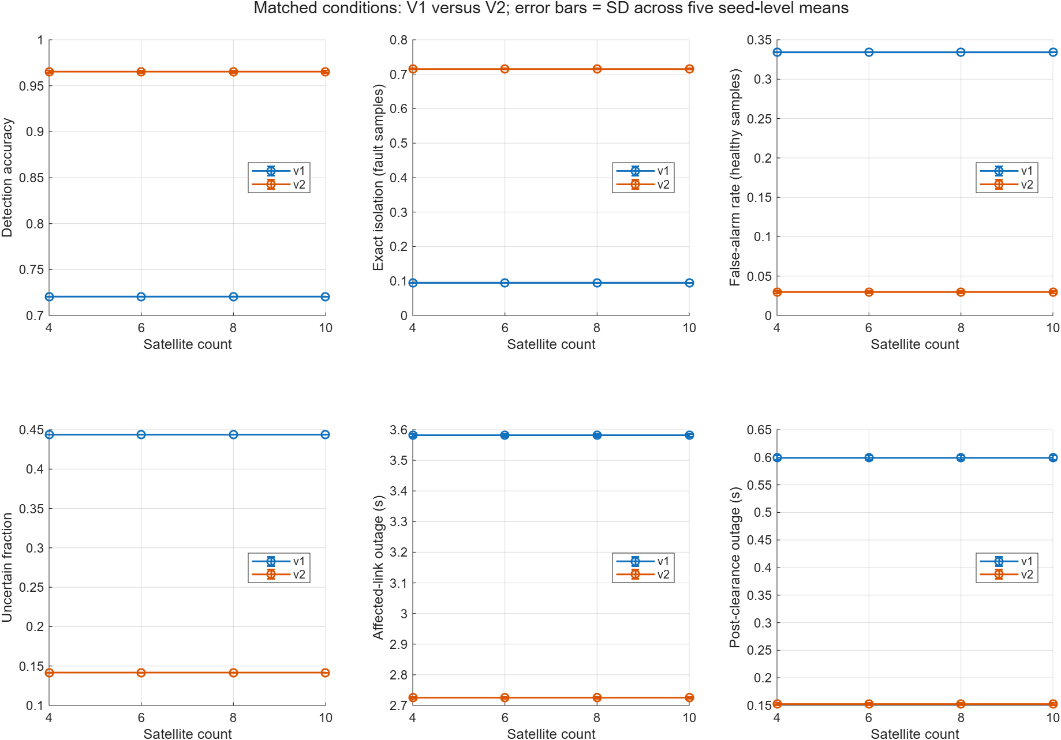
Original saved figure • matched_scalability.png
Read the horizontal axis as the number of satellites. The six panels show detection accuracy, exact isolation, false-alarm rate, uncertainty, affected-link outage and post-clearance outage. Larger detection and isolation values are better; smaller false-alarm, uncertainty and outage values are generally better when considered together. The diagnostic axes show fractions: 0.965 means 96.5%. Error bars are SD across five seed-level means, not arbitrary measurement tolerances.
Nearly flat diagnostic curves are expected because the first edge is subjected to the same fault and noise conditions across sizes. Do not interpret flat curves as a proof that diagnosis remains equally easy for any constellation. If network-average link availability rises, remember that more healthy edges are included in the average. Compare affected-link outage separately.
The important comparison is paired V1 versus V2 at each retained size. Use the numerical tables when quoting exact values; figure resolution and rounded tick labels are not a substitute for the underlying CSV data.

Figure 2 Per scenario diagnostics
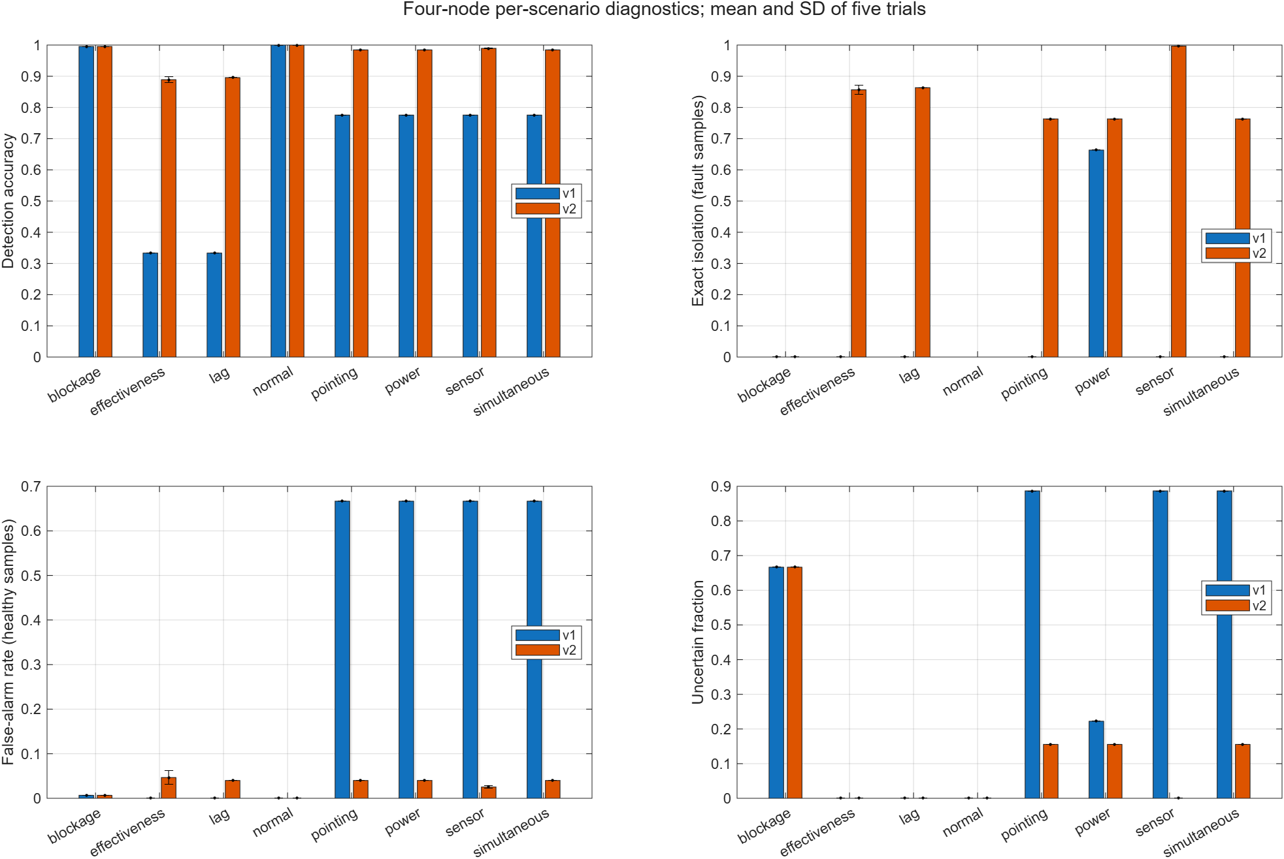
Original saved figure • per_scenario_diagnostics.png
This figure separates the fault classes so that one overall percentage does not hide weak classes. Compare detection with exact isolation. A tall detection bar and a short isolation bar mean the system notices something wrong but often cannot name the exact cause.
The blockage result is the clearest example: abnormality is detected, but the exact blockage label is not justified by the permitted measurements. Sensor-bias changes benefit strongly from the independent rate comparison. Optical classes incur an information-collection interval before a fitted label becomes available.
Use uncertainty alongside exact isolation, rather than treating uncertainty as a correct physical label. The actuator false-alarm regression should be discussed even if its bars are visually smaller than the improvements elsewhere.

Figure 3 Clearance and recovery traces
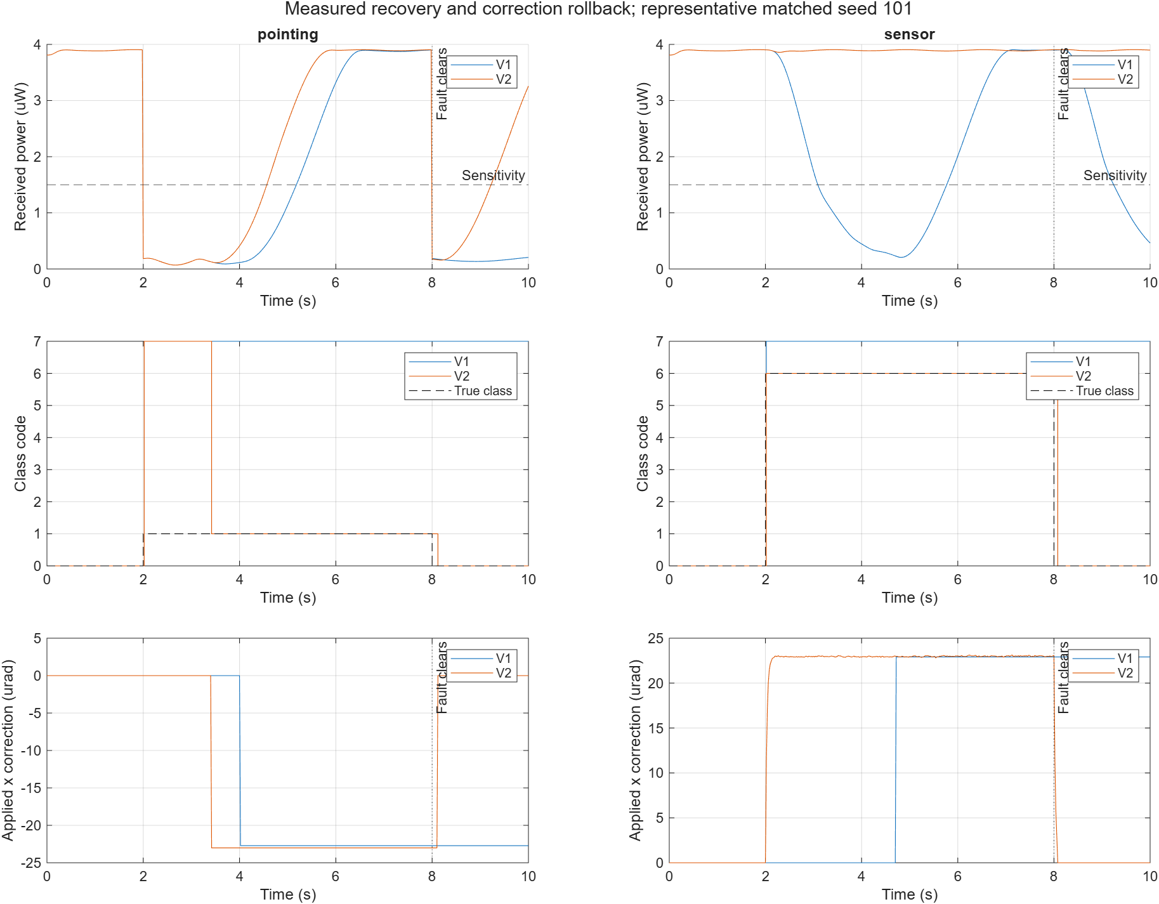
Original saved figure • clearance_and_recovery.png
These time traces show how signals evolve, rather than only their final averages. The fault begins at 2 s and clears at 8 s in the main experiment. Read the received-power trace against receiver sensitivity, and compare corrections and labels before, during and after the fault.
A useful correction during the fault can become stale after 8 s. V2's predictive validation and rollback address that behavior. The sensor case illustrates how a correction can follow a bias change without waiting for a generic optical scan to determine every cause. The figure supports understanding of representative runs, while the repeated-trial tables support average comparisons.
Do not infer that V2 has zero clearance delay. Rollback requires contradictory observations and the physical terminal must respond. A trace is the best place to show the remaining transient instead of concealing it behind a small across-scenario average.

Figure 4 Confusion matrices
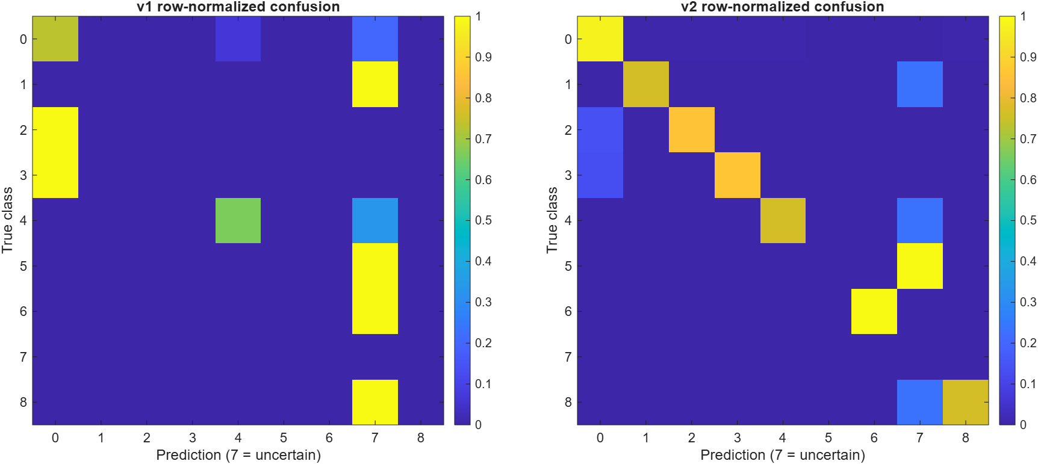
Original saved figure • confusion_matrices.png
Rows represent the actual class and columns represent the predicted class. A diagonal cell is an exact match. Off-diagonal cells show which labels were confused. The healthy row shows false alarms when entries appear in nonzero prediction columns. The uncertain column shows cases where the supervisor declined a unique label.
These displayed matrices are row-normalized: a color value of 0.8 means 80% of samples from that actual class were assigned to the corresponding prediction column. The raw per-trial confusion arrays contain counts; the plotting code pools the four-node counts and divides by each row total. Row 7 has no actual-class support because uncertain is only a prediction category. Yellow indicates a larger fraction and dark purple a smaller fraction in this saved color scale. Interpret each diagonal cell with its class support rather than assuming that color alone establishes overall accuracy.
The baseline's inability to emit most unique physical classes appears as missing diagonal success for those faults. V2 adds meaningful diagonal entries for pointing, actuator and sensor classes while retaining an uncertain blockage column. That is the correct pattern for the stated observability limitation, not a reason to relabel uncertain outputs as blockage.

18 A complete real trial from input to output
This chapter uses the saved n4_pointing_v2_seed101 trial. It is an actual completed record from MATLAB R2026a Update 2, not a newly invented numerical example. The JSON and MAT files share that identifier.

Step 1 Configure and initialize
The configuration selects four satellites, the pointing scenario and seed 101. Default physics, limits, traffic and timing remain in place. The first edge receives a temporary [23, 10] µrad optical offset between 2 and 8 s. The controller is SMC, the simulation lasts 10 s and the metric window starts at 1 s.
Simulink loads the four-node V2 network model, initializes physical states and integrates the terminal equations. The supervisor receives measured angle, measured rate, measured power, commanded torque, delivered torque and reference history. It does not receive the scheduled fault interval as a decision input.

Step 2 Observe and diagnose
At onset, the optical model and measurements become inconsistent. The first nonzero diagnosis appears after 0.02 s. This is an alarm delay, not exact identification after 0.02 s. The supervisor uses an active optical probe for a total of 1.4 s, gathers enough directional information and estimates the offset.
Because the aligned power is sufficient in a pure pointing fault, an offset correction can physically restore the link. The terminal takes time to move, and the evaluator finds a qualifying pre-clearance recovery with recovery time 2.58 s measured from the first outage. Sustained availability is checked over the required hold interval.

Step 3 Handle clearance
When the injected offset clears, an old offset correction would be wrong. V2 detects inconsistency, removes stale optical compensation and verifies restoration. The saved post-clearance outage is still 1.24 s, so the result is an improvement mechanism with a remaining transient, not instantaneous perfect recovery.

Step 4 Count diagnostic outcomes
There are 300 actual fault samples. Of these, 229 are correctly labeled pointing, 70 are uncertain and one is labeled healthy. There are 150 healthy samples: 144 correctly healthy and six incorrectly labeled pointing. Therefore TP = 299, TN = 144, FP = 6 and FN = 1.
Accuracy = (299 + 144) / 450 = 98.44%. Precision = 299 / 305 = 98.03%. Recall = 299 / 300 = 99.67%. False-alarm rate = 6 / 150 = 4.00%. Exact isolation = 229 / 300 = 76.33%. Uncertainty = 70 / 450 = 15.56%. Overall multiclass accuracy = (229 + 144) / 450 = 82.89%.
This single arithmetic example explains why the same run has 98.44% detection accuracy but 76.33% exact isolation. The 70 uncertain fault samples count as detected faults, but not as correctly isolated pointing faults. None were removed to make the percentages look better.

Step 5 Interpret service and physical behavior
Affected-link outage is 3.82 s across the nine-second evaluation period. Affected-link availability is 57.56%. With five edges, network-average link availability is 91.51%, because the other edges remain available. This demonstrates why averaging over links can hide the severity of the impaired edge.
Network outage is zero, throughput is 600 Mbit/s and packet-delivery ratio is one. Alternative routing preserves the modeled flow despite the physical link outage. Average reachable-route latency is approximately 3.961 ms.
RMS optical pointing error is approximately 15.73 µrad and maximum error is 28.40 µrad. The settling metric is 3.72 s after onset. Torque saturation duration is zero. Squared-torque effort is about 6.35 × 10⁻¹⁴ N² m² s, and command-delivery RMS is about 3.68 × 10⁻⁸ N m. These describe control behavior; they are not energy-consumption measurements.
The recorded wall-clock runtime is about 0.850 s, while simulated time is 10 s. A simulation can run faster or slower than the physical time it represents. Runtime is machine- and software-dependent and is not a spacecraft response time.

Step 6 Store and aggregate
The MAT file stores full configuration and time-series arrays. The JSON stores compact metadata, metrics and extra counts. The trial contributes to the pointing-scenario statistics, the seed-level averages and the overall table. The original graph files summarize several such results; they are not screenshots of a hardware test.

19 How the important code files work together
All paths in this chapter are relative to the existing project root, outputs/Satellite_Optical_Recovery in the workspace. The downloaded clean package has the same essential project structure. A file can be necessary without being a command you should run by itself.
File or folder | Main role
matlab/configuration/default_config.m | Default physical, control, network and experiment parameters
prepare_config.m and make_network.m | Complete configuration, construct edges and seed noise
matlab/optical_channel/optical_power.m | Gaussian pointing loss, capture factor and receiver availability
simulink/terminal_kernel.m | Physical dynamics, controller and measurement outputs
fault_input.m | Apply the configured fault to the physical or sensing model
revisions/v2/setup_v2.m | Set MATLAB paths for the existing revision
revisions/v2/run_case_v2.m | Execute one Simulink case and compute its results
revisions/v2/supervisor_v2.m | Sample observations and maintain per-edge estimator history
revisions/v2/v2_nominal.m | Whitelist nominal parameters allowed into diagnosis
revisions/v2/v2_decision_step.m | Decide class, probe, correction, rollback and verification
revisions/v2/v2_actuator_fit.m | Fit actuator effectiveness and response time
revisions/v2/v2_optical_fit.m | Fit optical offset and scalar attenuation
matlab/metrics/compute_metrics.m | Unchanged original metric definitions
revisions/v2/v2_extra_metrics.m | Supplementary counts and post-clearance measures
revisions/v2/run_v2_suite.m | Run matched repeated comparison cases
revisions/v2/plot_v2_comparison.m | Summarize saved trials and export the four figure files
revisions/v2/models | Separate V2 SLX models for 4, 6, 8 and 10 satellites
revisions/v2/tests/test_revision_v2.m | Nine tests checking specific revision behaviors

default_config creates the starting structure. prepare_config fills in network edges and reproducible noise. run_case_v2 chooses a model name based on satellite count, loads it, assigns cfg to the model workspace and executes sim. The model calls its terminal dynamics and the supervisor throughout the simulated time interval.
The terminal kernel generates both physical truth and measured signals. supervisor_v2 extracts the permitted sensor view, updates history and calls v2_decision_step for each edge. The decision function calls the actuator and optical fits, updates its state, selects labels and actions and produces the new reference.
compute_metrics evaluates the completed run using the unchanged original definitions. v2_extra_metrics adds denominator counts, multiclass accuracy and post-clearance measures. run_v2_suite manages repeated cases and matched baselines. plot_v2_comparison reads completed results and creates summaries and figures.

The plant log Y
Each edge contributes 26 columns. Columns 1–2 contain reference; 3–4 true terminal angle; 5–6 optical error; 7–8 true rate; 9–10 sliding variable; 11–12 commanded torque; 13–14 delivered torque; 15 saturation flag; 16 true received power; 17 quality ratio; 18 true availability; 19–20 measured angle; 21–22 measured rate; 23 measured power; and 24–26 the actuator effectiveness, lag factor and optical power factor used by the plant.
For edge j, its first column is 26 × (j − 1) + 1. The first-edge formulas in the plotting example therefore use columns 16 and 23 directly. True fault factors and physical states can be logged for evaluation without being permitted as diagnosis inputs. These two uses must remain separate.

The decision and estimator logs
Each edge contributes eight decision columns: predicted label, uncertainty flag, action, true label for evaluation, correction x, correction y, probe flag and availability. After all edge blocks, four columns record throughput, latency, packet-delivery ratio and hop count. Missing-route latency is encoded in the log and handled when metrics are computed.
Each V2 edge also contributes 16 estimator columns: two kinematic-angle values, two bias estimates, two optical-offset estimates, optical gain, actuator effectiveness, actuator time constant, actuator class, actuator residual, optical conditioning, optical residual, actuator conditioning, mode and verified-restoration status.
The internal supervisor state has 30 values per edge and a rolling measurement history. It keeps previous rate, fitted parameters, mode, mismatch count, update times and verification timers. These are memory for the algorithm, not extra physical truth sensors.

Saved file roles
A .m file contains MATLAB code. A .slx file contains the Simulink model. A .mat file holds structured numerical data and time histories. A .json file holds a compact readable trial summary. A .csv file holds a comparison table. A .png file is a saved figure image. Documentation explains assumptions and results, while status files record completed work.
run_case_v2 refuses to overwrite an existing completed MAT trial in its target folder. The suite can create a new batch or resume missing cases in an existing batch. This protects results, but the safest beginner workflow is to inspect saved data first and run a new single case only when needed.

20 MATLAB commands for opening results and running the core model

Set the correct folder and paths
Your earlier error occurred while MATLAB was in the configs subfolder and default_config was not on the search path. A helper function is not found merely because another file calls it. The project root and setup procedure must add the required directories.
The following commands use the extracted package location you previously showed. If you extracted elsewhere, change only the root line to the folder containing revisions and the project setup files. Do not paste a new function definition into the Command Window to repair a missing search path.
root = 'C:\Users\rishi\Downloads\Satellite_Optical_Recovery_Final';
cd(root)
addpath(fullfile(root,'revisions','v2'))
setup_v2
which default_config -all
which run_case_v2 -all

Both which commands should resolve to files in your intended project. If they do not, stop and check the extracted folder rather than recreating functions. If start_v2 is present at the package root, it is a convenience setup entry point; setup alone does not run the complete comparison or display all saved results.

View existing graphs without rerunning experiments
batch = fullfile(root,'revisions','v2','results', ...
'comparison_20261014_224749_328');
names = {'matched_scalability','per_scenario_diagnostics', ...
'clearance_and_recovery','confusion_matrices'};
for k = 1:numel(names)
I = imread(fullfile(batch,'figures',[names{k} '.png']));
figure('Name',names{k},'Visible','on');
image(I); axis image off
end
T = readtable(fullfile(batch,'tables', ...
'overall_original_metrics.csv'));
disp(T)

This displays existing figure images inside MATLAB. It does not rerun a simulation, and the lines are pixels rather than editable plotted data. The saved plot_v2_comparison implementation creates and exports figures and closes them, so it should not be described as a guaranteed interactive figure viewer.

Plot saved numerical data directly in MATLAB
S = load(fullfile(batch,'raw','n4_pointing_v2_seed101.mat'));
r = S.r;
figure('Name','Saved pointing trial','Visible','on');
plot(r.t,1e6*r.Y(:,16),'LineWidth',1.5); hold on
plot(r.t,1e6*r.Y(:,23),'LineWidth',1);
yline(1e6*r.config.sensitivity,'--','Receiver threshold');
xlabel('Time (s)'); ylabel('Received power (uW)'); grid on
legend('True simulated power','Measured power','Location','best');
figure('Name','Saved diagnosis','Visible','on');
stairs(r.t,r.D(:,1),'LineWidth',1.5); hold on
stairs(r.t,r.D(:,4),'--','LineWidth',1);
xlabel('Time (s)'); ylabel('Class code'); grid on
legend('Predicted class','True class','Location','best');
disp(r.metrics)
disp(r.extra)

These are native MATLAB plots made from saved arrays. You can zoom and inspect the data without recomputing the experiment. The first plot uses the first edge's physical and measured power. The second compares its predicted and actual labels; the actual label is shown for evaluation only.

Run one new core experiment when you choose
c = default_config(4);
c.scenario = 'pointing';
c.seed = 101;
r = run_case_v2(c,[],'v2');
figure('Visible','on');
plot(r.t,1e6*r.Y(:,16),'LineWidth',1.5); hold on
yline(1e6*c.sensitivity,'--','Receiver threshold');
xlabel('Time (s)'); ylabel('Received power (uW)'); grid on
disp(r.metrics)

This command calls the Simulink model and creates a new result in MATLAB memory. Passing an empty save folder avoids overwriting saved files. MATLAB and Simulink must be available with the required model dependencies. You can choose 6, 8 or 10 as the satellite count because those V2 models are retained.
Use open_system('SatelliteOpticalNetwork_4_v2') to inspect the configured model after setup. Use test_v2 to run the revision checks if you intentionally want to execute tests. run_v2_suite runs or resumes the larger comparison and is not needed merely to see results. run_v2_stress executes the separate stress cases. Read each function's arguments before choosing a destination folder.
Do not run every helper file individually. Files such as v2_optical_fit and terminal_kernel expect arguments supplied by the experiment and Simulink. Their role is similar to parts of an engine: the top-level runner coordinates them. The base_experiment helper returning default_config(4) is not the full simulation or plotting workflow.

21 Where results are stored and how to trace a claim
The main completed comparison is revisions/v2/results/comparison_20261014_224749_328. Its raw folder contains individual trial MAT and JSON files. Its tables folder contains overall, per-scenario, exact-class, pooled, size-comparison, held-out, paired-difference and recovery-cohort tables. Its figures folder contains the four graphs reproduced here.
The stress results are in revisions/v2/results/stress_20261014_225450_080. The original saved baseline batch is results/run_20261014_185235_444. V2_COMPARISON_REPORT.md summarizes the execution and outcomes. docs/METRIC_AUDIT_AND_IDENTIFIABILITY.md explains denominators and observability assumptions. V2_STATUS.json records completion status.
To verify a headline number, start with overall_original_metrics.csv and check the metric, implementation, satellite count and aggregation. For a weak class, use per_scenario_metrics.csv and exact_class_one_vs_rest.csv. For denominator questions, use pooled_detection_with_denominators.csv and the trial's extra counts. For a graph, trace its data back to these tables or the saved raw trial.
For a particular run, the filename identifies size, scenario, method and seed. n4_pointing_v2_seed101 means four satellites, pointing fault, V2 method, seed 101. Its JSON gives the compact metrics, while its MAT lets you recreate time plots and independently inspect the signal history.
This guide is a learning explanation of the preserved project. It does not replace the raw evidence or certify that every file in a downloaded archive has been executed on your own computer. The saved execution records describe the recorded environment and runs.

22 What you can honestly claim
You can say that the project implements and evaluates a model-based fault-diagnosis and recovery supervisor for a simplified multi-satellite optical network in MATLAB and Simulink. Under matched simulated conditions, V2 improves binary detection, exact isolation and average outage compared with the preserved V1 proposed method.
You can explain the implemented contributions as using independent rate history to detect transient sensor bias, delivered-torque dynamics to distinguish actuator effectiveness and lag, bounded optical probes to separate offset and power loss, and continued model validation to discard stale corrections. These are concrete implementation contributions within this prototype.
You cannot yet call those ideas globally novel without a careful literature comparison showing what existing methods do and what is specifically new. A successful implementation or a high percentage does not establish research novelty. The project also does not demonstrate real-world reliability, radiation tolerance, flight qualification or performance with real satellite telemetry.
Remaining limitations include the fixed sparse topology, a single impaired edge in the main comparison, the effective symmetric terminal representation, no changing orbital geometry, ideal delivered-torque telemetry, short trials, a threshold receiver, fluid traffic and a limited set of five main seeds. More healthy edges do not test correlated multifault conditions.
Initial unknown sensor bias remains ambiguous without calibration. Dark-link cause remains unresolved. Actuator regression is affected by discretization and excitation. Probe actions have service cost. Post-clearance transients remain. The conditional recovery statistic falls and actuator false alarms increase in some scenarios. These are part of the result, not footnotes to remove.
Reasonable future work would test longer runs for rate-integration drift, a wider range of fault sizes and noise, imperfect torque telemetry, correlated sensor errors, multiple faulty edges and time-varying geometry. Additional independent optical or transmitter-health measurements could help distinguish dark-link causes. These are proposed extensions, not completed experiments.

23 Explaining the project to your professor

A clear opening explanation
“My project studies fault diagnosis and communication recovery in a simulated network of optical satellite links. A weak laser signal can come from different causes, so detecting low power alone does not identify the fault. I use angle, independent angular rate, optical power and actuator torque history to distinguish modeled causes. When passive measurements are insufficient, the supervisor makes bounded pointing probes. It also checks whether an old correction remains valid and removes it after contradictory measurements. I evaluate both physical link restoration and network service through alternative routes.”
Follow this with the experimental scope: four network sizes, eight scenarios and five seeds per method. State that the main comparison uses Simulink plant simulations and preserves the baseline metric definitions. Then present the headline improvement and immediately explain the recovery denominator and unresolved blockage class.

Questions you should be ready to answer
Why is received power low? It can result from pointing error, power degradation, blockage or sensor-driven mispointing. The project diagnoses causes using additional measurements and time history.
What is active diagnosis? It is a deliberate bounded action designed to reveal information. Here, small directional pointing probes reveal how received power changes with angle, allowing offset and power scale to be estimated.
Why use rate history? A transient encoder bias can change measured angle without corresponding physical rotation. Independently measured rate helps identify that inconsistency, provided initial calibration and independence hold.
Why is detection accuracy higher than isolation? An uncertain alarm counts as detecting an abnormal condition, but it is not an exact fault label. The worked trial shows the arithmetic with 299 detected fault samples and only 229 exact matches.
Why is blockage isolation zero? The available observations cannot uniquely separate blockage from other near-zero-power causes. The supervisor reports uncertainty instead of using hidden fault truth.
Why did recovery percentage fall? Its denominator includes only runs that first suffer an outage. V2 prevents five sensor outages per size, changing the eligible cohort. The recorded counts are 10/25 for V1 and 5/20 for V2, with five prevented cases and zero newly introduced fault-window outages. Report all of these facts.
Why can network outage be zero when a link fails? Traffic can use an already established alternative path. That preserves modeled communication but does not repair the failed optical link.
Why are diagnostic curves flat across network sizes? The impaired edge has the same paired local conditions. Extra healthy edges affect network averages and routes but do not create a new local diagnosis challenge.
Did you change the metric to improve accuracy? The original compute_metrics definitions were preserved and historical proposed runs were recomputed for equality in the saved audit. Additional metrics are labeled separately.
Is this artificial intelligence? It is an automated model-based inference and control prototype. It does not use a trained neural network in the implemented V2 method. Describe the actual algorithms instead of relying on a broad label.
What remains unsolved? Dark-link cause identification, unknown initial sensor bias, realistic telemetry limitations, wider operating conditions, remaining clearance delay and reliable behavior under richer network and fault models.

Final understanding exercise
Explain the following chain without reading the equations: a pointing fault lowers optical power; the supervisor detects an inconsistency; bounded probes reveal a directional offset; a feasible correction changes the reference; the controller moves the terminal; the link is checked for sustained availability; when the fault clears, the prediction becomes inconsistent and stale correction is removed; raw signals and truth are then used to compute fixed metrics.
Next explain why the same sequence cannot physically repair severe power loss. Finally, use the real pointing-trial counts to calculate detection, exact isolation and uncertainty yourself. If you can explain those three items, you understand the central reasoning of this project rather than only memorizing its headline percentages.

Appendix Source and verification notes
The explanation was checked against default_config.m, the metric and identifiability audit, run_case_v2.m, v2_decision_step.m, the revision tests, the saved comparison report and the completed trial JSON. Parameter and signal descriptions follow the existing terminal, optical and supervisor implementation inspected for this project. The tables in this guide are generated from the saved CSV files, not reconstructed from bar heights.
The four embedded figures are matched_scalability.png, per_scenario_diagnostics.png, clearance_and_recovery.png and confusion_matrices.png from the completed main comparison. The worked numerical example is raw/n4_pointing_v2_seed101.json and its matching MAT file. Historical execution statements are attributed to the saved report; this document creation did not execute new MATLAB or Simulink trials.
Abbreviations: SMC means sliding mode control; PID means proportional integral derivative control; RMS means root mean square; RMSE means root mean square error; SD means sample standard deviation; TP, TN, FP and FN are the four binary diagnostic counts; PDR means packet-delivery ratio. “Macro” means averaging separate scores, while “pooled” means combining counts before calculating a score.

Appendix Equations to read with the explanations
These editable equations collect the main relationships discussed in the guide. Angle and torque symbols represent two-axis quantities where appropriate. The text chapters explain their physical meaning and assumptions.
$$w = dα, a = D/2$$
$$P₀ = Pₜη [1 − exp(\frac{−2a²}{w²})]$$
$$P = P₀g exp(\frac{−2‖θopt‖²}{α²}) (1 − blocked)$$
$$dθ/dt = ω, \frac{dω}{dt} = \frac{aτ − bω}{J}$$
Here aτ denotes delivered torque to avoid confusing it with aperture radius a. The actuator equation below uses u for commanded torque, eₐ for actuator effectiveness and τₐ for the actuator time constant.
$$\frac{daτ}{dt} = \frac{eₐu − aτ}{τₐ}$$
$$e = yθ − r, s = yω + λe$$
$$u_raw = b yω − Jλ yω − JK sat(s/φ)$$
$$qₖ = qₖ₋₁ + \frac{Δt}{2}(ωₖ₋₁ + ωₖ)$$
$$δ = −\frac{α}{4}[βₓ, βᵧ], g = exp(β₀ + \frac{2‖δ‖²}{α²})$$
$$Accuracy = \frac{TP + TN}{TP + TN + FP + FN}$$
$$Precision = \frac{TP}{TP + FP}, Recall = \frac{TP}{TP + FN}$$
$$False alarm rate = \frac{FP}{FP + TN}$$
Percentages multiply these ratios by 100. Exact isolation divides exact physical fault matches by all actual fault samples; uncertainty divides uncertain predictions by all evaluation samples. Neither definition discards uncertain predictions.

