**PROJECT SYNOPSIS**

**Machine Intelligence**

**Customer Segmentation in the Banking Sector using clustering algorithms**

**BACHELOR OF TECHNOLOGY- V Sem CSE**

## **Department of Computer Science & Engineering**

SUBMITTED BY

**Batch No:-**

Student name 1: Kaushal Suresh SRN: PES1UG20CS201

Student name 2: Keshav MN SRN: PES1UG20CS207

Student name 3: Kiran SS SRN: PES1UG20CS212



## **PES UNIVERSITY**

## **(Established under Karnataka Act No. 16 of 2013)**

## **100 Feet Ring Road, BSK III Stage, Bengaluru-560085**

**Abstract and Scope**

Customer segmentation is one of the most crucial areas of knowledge-based marketing. Understanding customers and putting them into the center of a business plan is indispensable for growing companies. It is a proven and efficient method of differential management that has been widely used in various fields. By providing different types of customers with specific services to meet their heterogeneous needs, companies achieve profit growth and other objectives. Some ways to segment customers are demographic, psychographic, behavioral, geographic, and firmographic segmentation.

The aim of the study is to investigate different data analytics algorithms using a dataset of bank customers. Different customer segmentation algorithms that exist can be classified into types such as centroid-based (like K-Means), density-based (like DBSCAN, OPTICS) or hierarchical (Agglomerative Clustering, BIRCH). It also provides proof of concept of how data analytics can be used in customer segmentation.

Customer segmentation has a high scope in the market sector because of the following reasons:

1. Measurability - We want to identify members of the segments on the basis of some common characteristics or behavior pattern, such as lifestyle, etc.
2. Accessibility - Even if the segment is identified, it should be within our reach through suitable means of communication and distribution.
3. Market Responsiveness-  The identified segment must respond favorably to our marketing efforts.
4. Effective Demand- The segment may respond favorably. But it must have sufficient buying power.
5. Adequate potential- Marketers should develop segmentation strategies only for substantial segments.

**Feasibility Study**:

1. The adoption of mass production where automatically segmented.
2. Each product or service was tailored to the needs of the buyer who had ordered it.
3. The aim of mass production was to standardize products to achieve greater production efficiency and lower product cost.
4. This would lead to the lowest costs and create the largest potential market.
5. It is said that today Never Follow the Crowd.
6. The economic theory of pure competition assumes that all buyers are alike and consumer behavior is unidimensional.
7. Marketers recognize the importance of heterogeneous demand. They are interested in subdividing or segmenting the market.
8. Each segment can be a group of people with similar or homogeneous demand and enterprises can offer tailor-made marketing mix for each market or subdivision.
9. A marketing segment is a meaningful buyer group having similar wants. Segmentation is a customer-oriented marketing strategy.
10. Varied and complex buyer behavior is the root cause of customer segmentation.

**Design Approach/ Methodology/ Planning of work**:

* The data set obtained is passed to the pre-processing stage where duplicates and null rows are dropped. The datatype of columns is converted to the required datatype for pre-processing.
* The refined data set is then used to classify the customers into different categories by un-supervised learning through algorithms like K-Means, DBSCAN, HAC, OPTICS and BIRCH.
* The resultant clusters can be visualized through scatter plots, and can be compared with the help of their respective [Silhouette](https://towardsdatascience.com/silhouette-coefficient-validating-clustering-techniques-e976bb81d10c) scores.

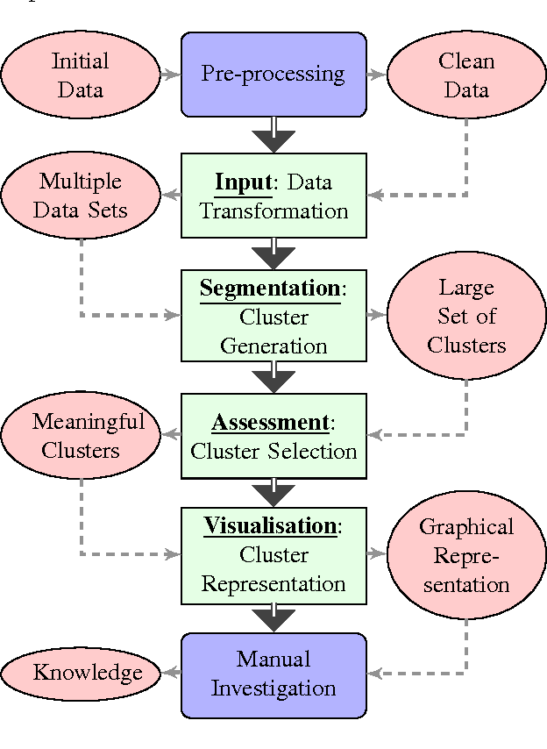

### References

Base paper: U. Sayan, M. Demirdag, G. Yuceturk and S. M. Yalcinkaya, "A Review of Customer Segmentation Methods: The Case of Investment Sector," 2022 IEEE 5th International Conference on Big Data and Artificial Intelligence (BDAI), 2022, pp. 200-204, doi: 10.1109/BDAI56143.2022.9862801.

The study has acquired and preprocessed data along with a comparison of the clustering algorithms in order to choose the best fits for segmenting individual investors. They have used Partitioning-based, Hierarchical-based, Density-based, Grid-based and Model-based algorithms.