

**Name : Kaushal Pravin Tare**

**SE 3 C**

**Roll No. :50**

**Experiment No 3:** Evaluation of postfix Expression using stack ADT

**Aim:** Implementation of Evaluation of Postfix Expression using stack ADT

**Objective:**

1. Understand the use of stack
2. Understand importing an ADT in an application program
3. Understand the instantiation of stack ADT in an application Program
4. Understand how the member function of an ADT are accessed in an application program

**Theory:**

Consider the expression: exp = **“2 3 1 * + 9 -“**

* + Scan **2**, it’s a number, So push it into stack. Stack contains ‘2’.

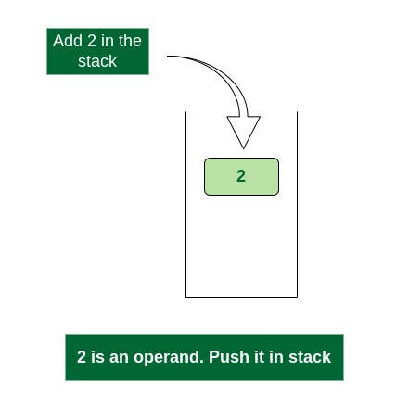

*Push 2 into stack*

3, again a number, push it to stack, stack now contains ‘2 3’ (from bottom to top)

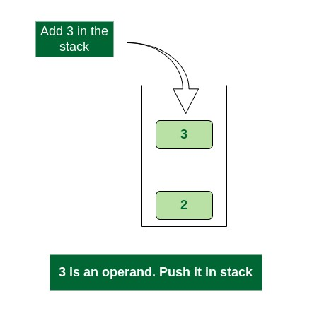

*Push 3 into stack*

* + Scan 1, again a number, push it to stack, stack now contains ‘2 3 1’

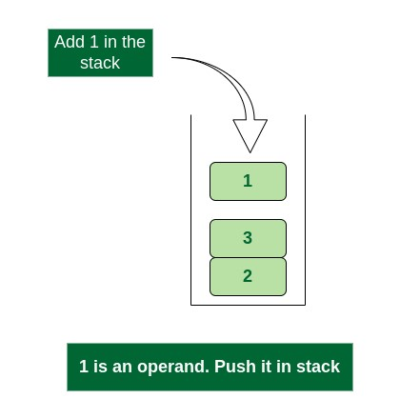

*Push 1 into stack*

*, it’s an operator. Pop two operands from stack, apply the * operator on operands. We get 3*1 which results in 3. We push the result 3 to stack. The stack now becomes ‘2 3’.

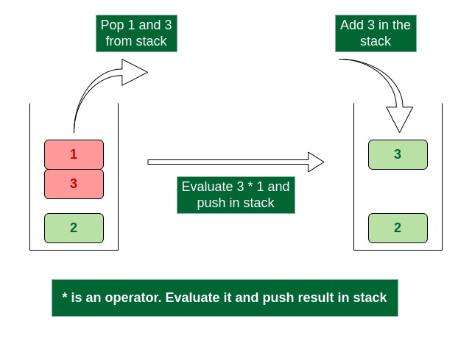

*Evaluate * operator and push result in stack*

* + Scan +, it’s an operator. Pop two operands from stack, apply the + operator on operands. We get 3 + 2 which results in 5. We push the result 5 to stack. The stack now becomes ‘5’.

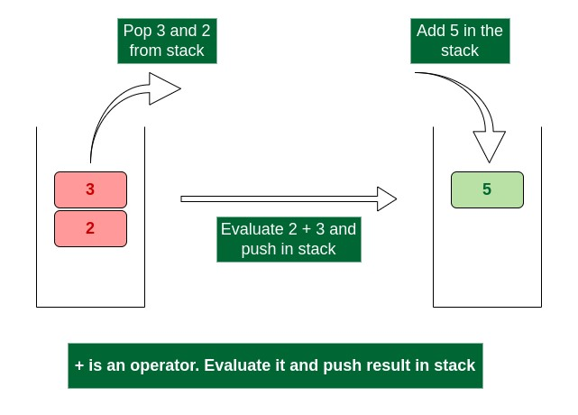

*Evaluate + operator and push result in stack*

9, it’s a number. So we push it to the stack. The stack now becomes ‘5 9’.

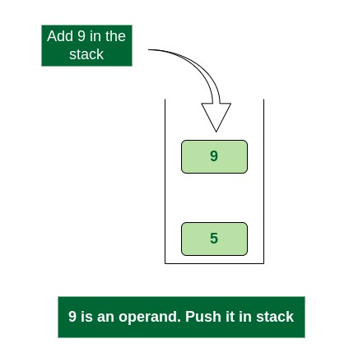

Push 9 into stack

* + Scan -, it’s an operator, pop two operands from stack, apply the – operator on operands, we get 5 – 9 which results in -4. We push the result -4 to the stack. The stack now becomes ‘-4’.

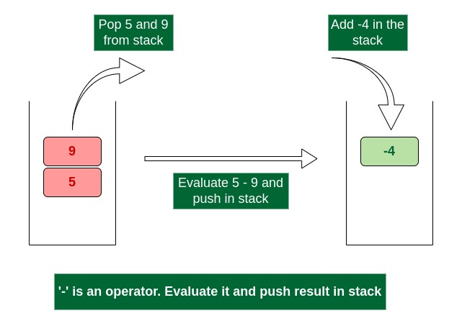

*Evaluate ‘-‘ operator and push result in stack*

* + There are no more elements to scan, we return the top element from the stack (which is the only element left in a stack).

So the result becomes **-4**.

**Algorithm:**

**Step 1:** If a character is an operand push it to Stack **Step 2:** If the character is an operator Pop two elements from the Stack.

Operate on these elements according to the operator, and push the result back to the Stack **Step 3:** Step 1 and 2 will be repeated until the end has reached.

**Step 4:** The Result is stored at the top of the Stack, return it

**Step 5**: End

**Code :**

#include<stdio.h>

#include<conio.h>

#include<ctype.h>

int stack[20];

int top = -1;

void push(int x)

{

stack[++top]=x;

}

int pop()

{

return stack[top--];

}

int main()

{

char exp[20];

char *e;

int n1,n2,n3,num;

printf("enter the expression:");

scanf("%s",exp);

e=exp;

while(*e!='\0')

{

if(isdigit(*e))

{

num=*e-48;

push(num);

}

else

{

n1=pop();

n2=pop();

switch(*e)

{

case'+':

{

n3=n1+n2;

break;

}

case'-':

{

n3=n2-n1;

break;

}

case'*':

{

n3=n1*n2;

break;

}

case'/':

{

n3=n2/n1;

break;

}

}

push(n3);

}

e++;

}

printf("the result of the expression is %s=%d\n\n",exp,pop());

getch();

return 0;

}

|  |  |
| --- | --- |
|  |  |

|  |
| --- |
|  |

0utput:

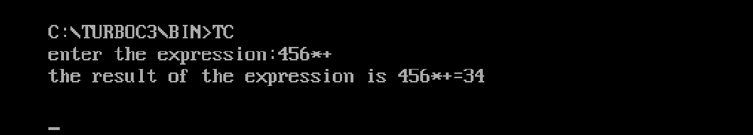

**Conclusion :**

To evaluate a postfix expression we can use a stack. Iterate the expression from left to right and keep on storing the operands into a stack. Once an operator is received, pop the two topmost elements and evaluate them and push the result in the stack again.