Taskify
Task Submission Document — Task 1

1. Task Overview
Taskify is a full-stack, containerized task management web application built to match a custom UI design (split-screen login/sign-in page and a project dashboard). It was built end-to-end across the following layers:
- Frontend: Static HTML + Tailwind CSS (compiled at build time) + vanilla JavaScript, served by Nginx
- Backend: Node.js + Express REST API, with JWT authentication and bcrypt password hashing
- Database: PostgreSQL 16
- Orchestration: Docker Compose (three services — frontend, backend, db — with healthchecks and a persistent volume)
The application has no seeded/demo data — every user registers their own account (name, job role, email, password), and all data (tasks, assignments, team members, logged hours) is created and managed by the logged-in user through the UI.

2. Features Implemented
- Authentication: registration (with manually-declared name & role), login, JWT-protected API, logout
- Dashboard: real-time greeting for the logged-in user, task cards with editable progress bars
- Task creation: inline "+ Add Task" form — auto-calculates "days left" from the due date
- Tasks Progress chart: real weekly bar chart driven by a "+ Log Hours" control; all 7 days always render, with 0-hour days shown as empty columns
- Assignments: inline "+ Add" form, checkbox toggle for completion, live completed/total counter
- Calendar / current-date display: reads the real system date — always reflects the actual current day
- Team members (Batchmates): add/remove team members manually (name + role)
- Track: editable list of every task with a live progress slider and delete
- Projects: tasks automatically grouped by category with aggregate progress per group
- Reports: real aggregate analytics (total tasks, average progress, assignments completed, hours logged, progress by category) computed server-side
- Settings: edit profile (name/role) and change password, both backed by real API endpoints
- Support: in-app usage guide

3. Tech Stack & Architecture
Layer | Technology
Frontend | HTML5, Tailwind CSS 3 (build-time compiled), vanilla JavaScript
Web server | Nginx (serves static frontend, reverse-proxies /api to backend)
Backend | Node.js 20, Express 4
Auth | JSON Web Tokens (jsonwebtoken), bcryptjs password hashing
Database | PostgreSQL 16
Containerization | Docker (multi-stage builds), Docker Compose v2

4. Project Structure
taskify/
├── docker-compose.yml
├── .env.example
├── backend/
│ ├── Dockerfile (multi-stage: deps -> production)
│ ├── server.js
│ ├── db/ (init.sql, pool.js)
│ ├── middleware/auth.js (JWT verification)
│ └── routes/ (auth.js, tasks.js, assignments.js, users.js, reports.js)
└── frontend/
├── Dockerfile (multi-stage: Tailwind build -> nginx)
├── nginx.conf (reverse-proxies /api to backend)
└── public/ (index.html, dashboard.html, css/, js/)

5. Commands Used

5.1 Local setup
git clone https://github.com/kaushanikoner20-hub/taskify.git
cd taskify
cp .env.example .env

5.2 Build and run with Docker Compose
docker compose up --build

5.3 Verify containers are healthy
docker ps

5.4 Access the application
- Web app: http://localhost:3000
- Backend API health check: http://localhost:4000/api/health

5.5 Stop the application
docker compose down

6. Environment Variables / Configuration
Variable | Purpose
POSTGRES_DB / POSTGRES_USER / POSTGRES_PASSWORD | PostgreSQL credentials
JWT_SECRET / JWT_EXPIRES_IN | Token signing secret and expiry
FRONTEND_PORT (default 3000) | Host port mapped to Nginx
BACKEND_PORT (default 4000) | Host port mapped to the Express API

7. API Endpoints
Method | Endpoint | Auth | Description
POST | /api/auth/register | No | Create account (name, email, password, role)
POST | /api/auth/login | No | Log in, returns JWT + user
GET | /api/auth/me | Yes | Current user profile
PATCH | /api/auth/me | Yes | Update name/role
POST | /api/auth/change-password | Yes | Change password
GET/POST | /api/tasks | Yes | List / create tasks
PATCH/DELETE | /api/tasks/:id | Yes | Update / delete a task
POST | /api/tasks/progress-log | Yes | Log hours for today
GET/POST | /api/assignments | Yes | List / create assignments
PATCH | /api/assignments/:id/toggle | Yes | Toggle completion
GET/POST | /api/users/batchmates | Yes | List / add team members
DELETE | /api/users/batchmates/:id | Yes | Remove a team member
GET | /api/reports/summary | Yes | Aggregate analytics

8. Screenshots
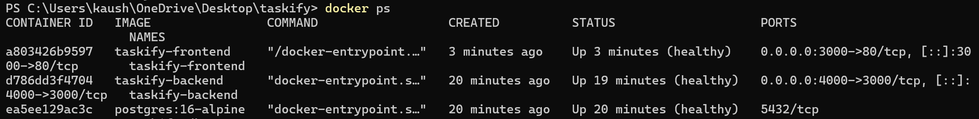
docker ps — all three containers healthy (frontend, backend, db)
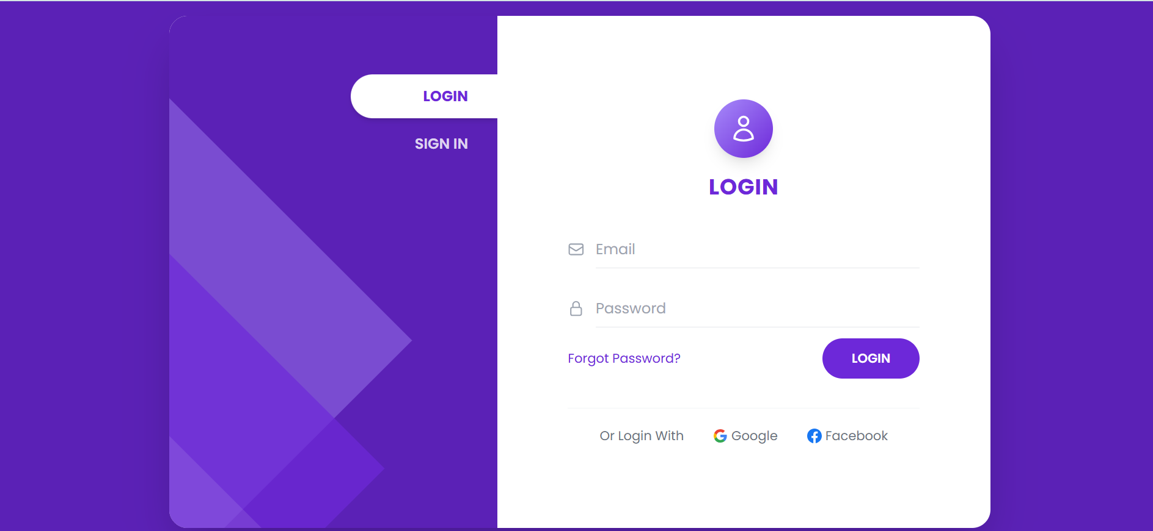
Login page
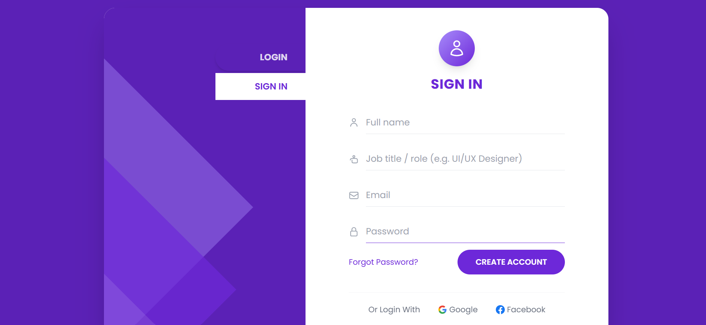
Sign In / registration page — Full name, Job title / role, Email, Password
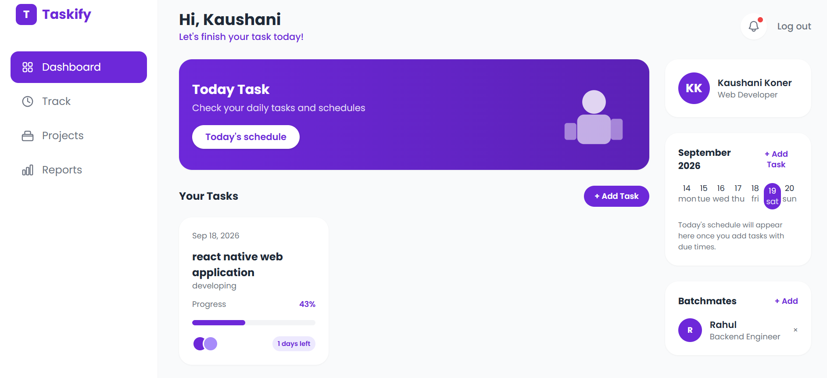
Dashboard — logged in as Kaushani, task card, calendar, batchmates
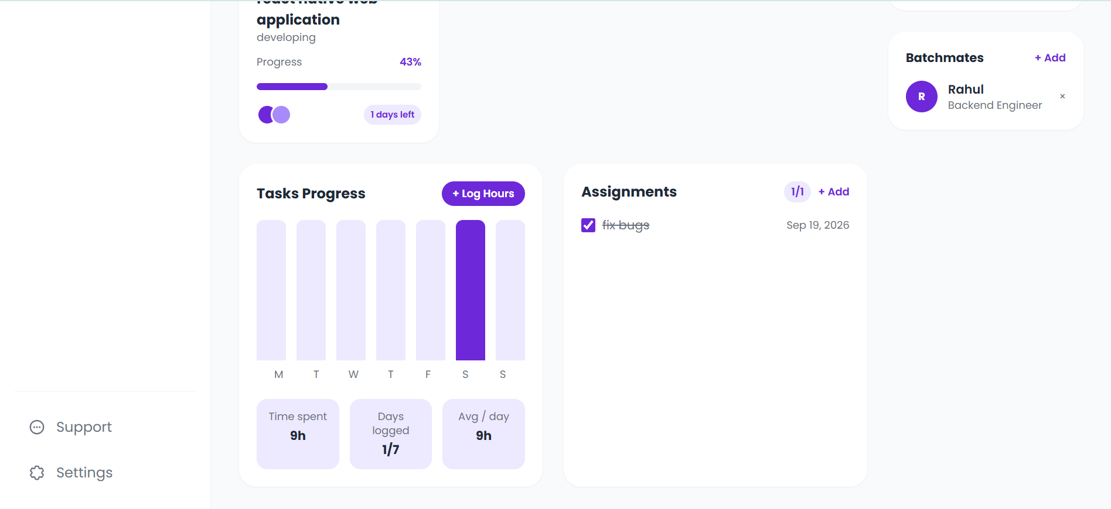
Dashboard (scrolled) — Tasks Progress chart, Assignments, Batchmates
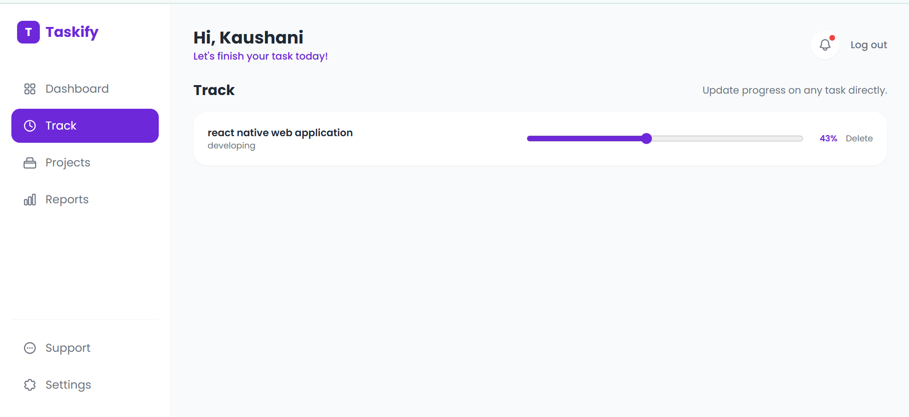
Track — editable task progress slider
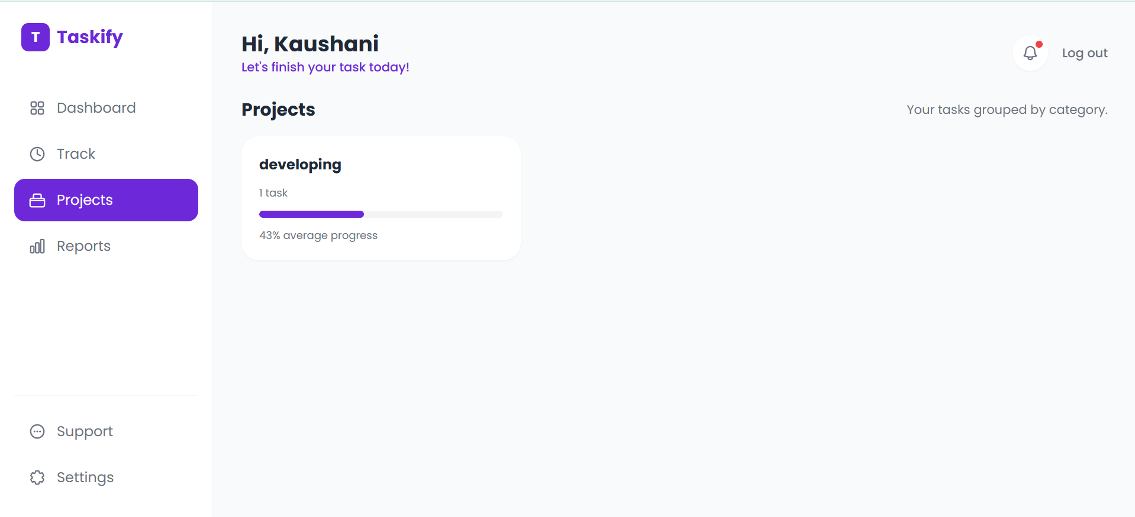
Projects — tasks grouped by category
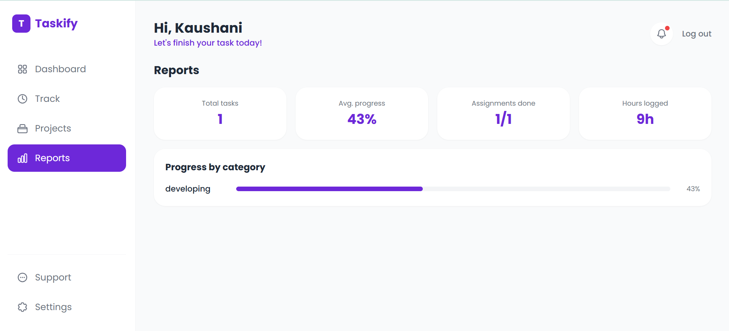
Reports — real aggregate analytics
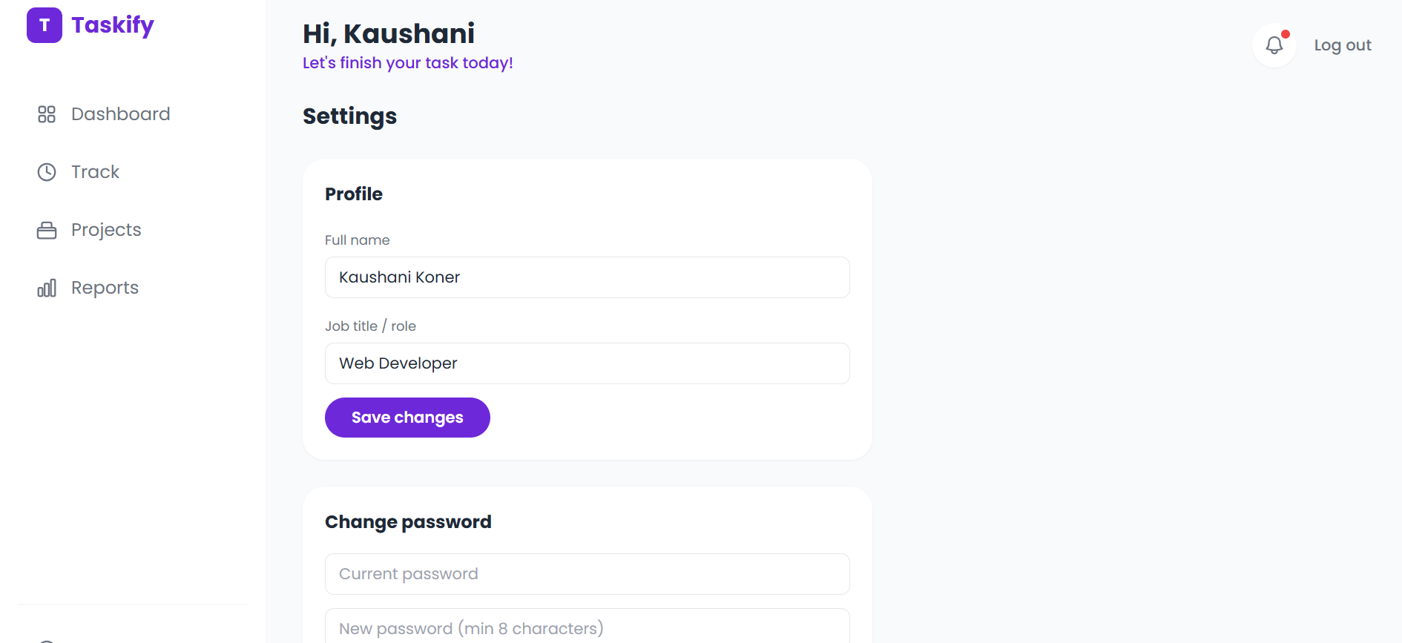
Settings — profile edit and change password
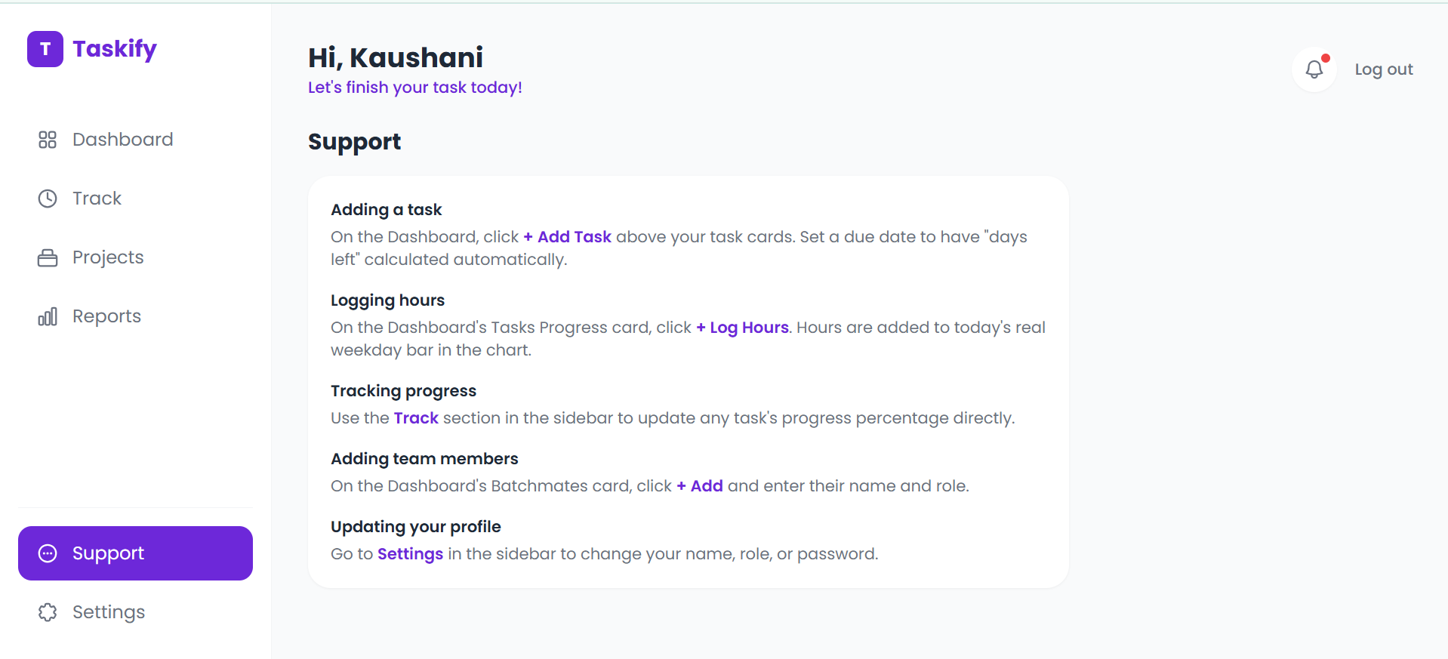
Support — in-app usage guide

9. Links

GitHub Repository
https://github.com/kaushanikoner20-hub/taskify

Deployed Endpoint
Not deployed publicly — runs locally via: docker compose up --build

10. Reproducibility Notes
A reviewer should be able to reproduce this by running the exact commands in Section 5 against the linked repository, with no manual file edits beyond copying .env.example to .env. On first login, use the "SIGN IN" tab to register a new account — there is no seeded demo account by design.
Debugging note: the taskify-frontend container initially reported "unhealthy" despite the application working correctly. The healthcheck command was failing with "wget: can't connect to remote host: Connection refused." Root cause: docker-compose.yml defined its own healthcheck for the frontend service using wget against "localhost" - and a Compose-level healthcheck always overrides whatever HEALTHCHECK instruction is written inside the image's Dockerfile, so editing the Dockerfile alone had no effect. The fix was applied in docker-compose.yml itself: the frontend healthcheck now uses curl against 127.0.0.1 explicitly (avoiding a separate, unrelated IPv6-loopback resolution quirk in Alpine-based images). All three containers now report healthy, as shown in the screenshot above.

