Taskify CI/CD Pipeline
Task Submission Document — Task 2

1. Goal
Create an automated CI/CD pipeline that builds, tests, and optionally deploys the containerized Taskify application (built in Task 1).

2. Requirements Traceability
Requirement | Status | How it's met
GitHub Actions workflow(s) for build and test | Met | backend-test job (real Postgres service container) + docker-build job (frontend & backend, matrix)
Deploy to Docker Hub | Met | docker-build job pushes both images on push to main, tagged latest + commit SHA
Deploy to remote host (optional) | Met | deploy job present; runs and exits cleanly until DEPLOY_HOST/USERNAME/SSH_KEY secrets are added
Status badge in README | Met | CI/CD badge added near the top of README.md, shows live passing status
.github/workflows/*.yml in repo | Met | backend/.github/workflows/ci-cd.yml committed to main
Workflow run screenshots + explanation | Met | 9 screenshots included in Section 7 below

3. Tools & Technologies
- GitHub Actions — pipeline orchestration
- Docker Buildx — multi-stage image builds with layer caching (type=gha)
- Docker Hub — container image registry
- PostgreSQL 16 (GitHub Actions service container) — real database for backend tests
- Node.js built-in test runner (node:test) + Supertest — backend API tests

4. Pipeline Architecture

Pull request → main
Pull Request
-> backend-test (real Postgres service container)
-> docker-build (frontend + backend, build only, no push)
-> integration-test (docker compose up --build, health checks)
-> Result shown on the PR

Push → main (or manual workflow_dispatch)
Push to main
-> backend-test
-> docker-build (frontend + backend, build AND push to Docker Hub)
-> integration-test
-> deploy (optional) (SSH deploy if secrets configured, else skips cleanly)

5. Jobs Implemented
Job | Triggers | Purpose
backend-test | push, pull_request, workflow_dispatch | Runs 8 API tests against a real disposable Postgres instance
docker-build | push, pull_request, workflow_dispatch | Builds frontend + backend images (matrix); pushes to Docker Hub only on main
integration-test | push, pull_request, workflow_dispatch | Runs the full docker compose stack and verifies both health endpoints respond
deploy | push to main, workflow_dispatch | Optional SSH deploy; skips gracefully if DEPLOY_* secrets are absent

6. Key Commands

Trigger a run
git push origin main
# or, from the GitHub UI: Actions tab -> CI/CD -> Run workflow

Pull the published images
docker pull kaushanikoner20/taskify-backend:latest
docker pull kaushanikoner20/taskify-frontend:latest

Run backend tests locally
cd backend && npm install && npm test

7. Screenshots
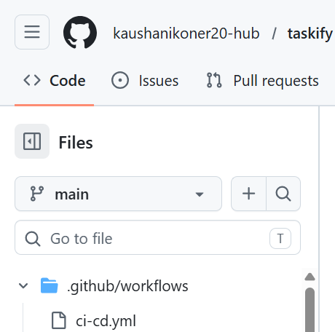
1. Repository file tree — .github/workflows/ci-cd.yml present on main
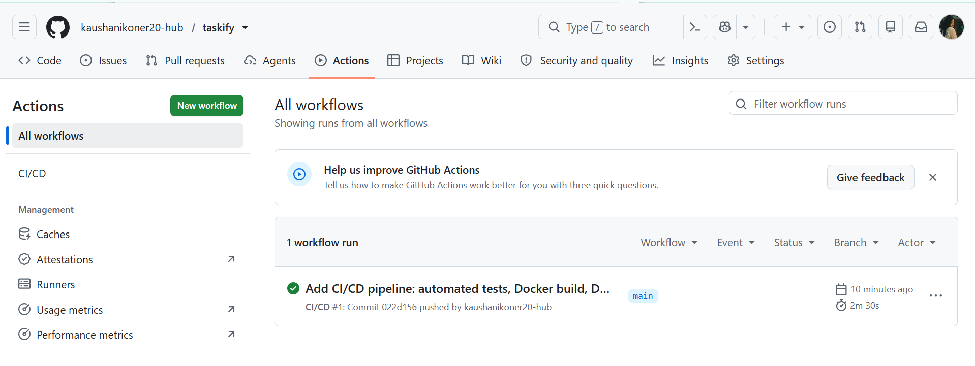
2. Actions tab — CI/CD workflow, successful run listed
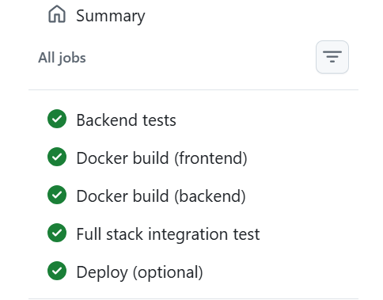
3. Full workflow run summary — all 5 jobs passing
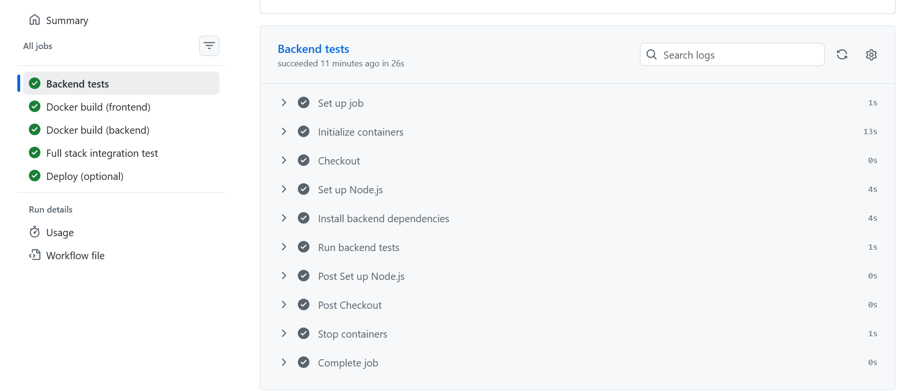
4. Backend tests job — expanded steps, succeeded in 26s
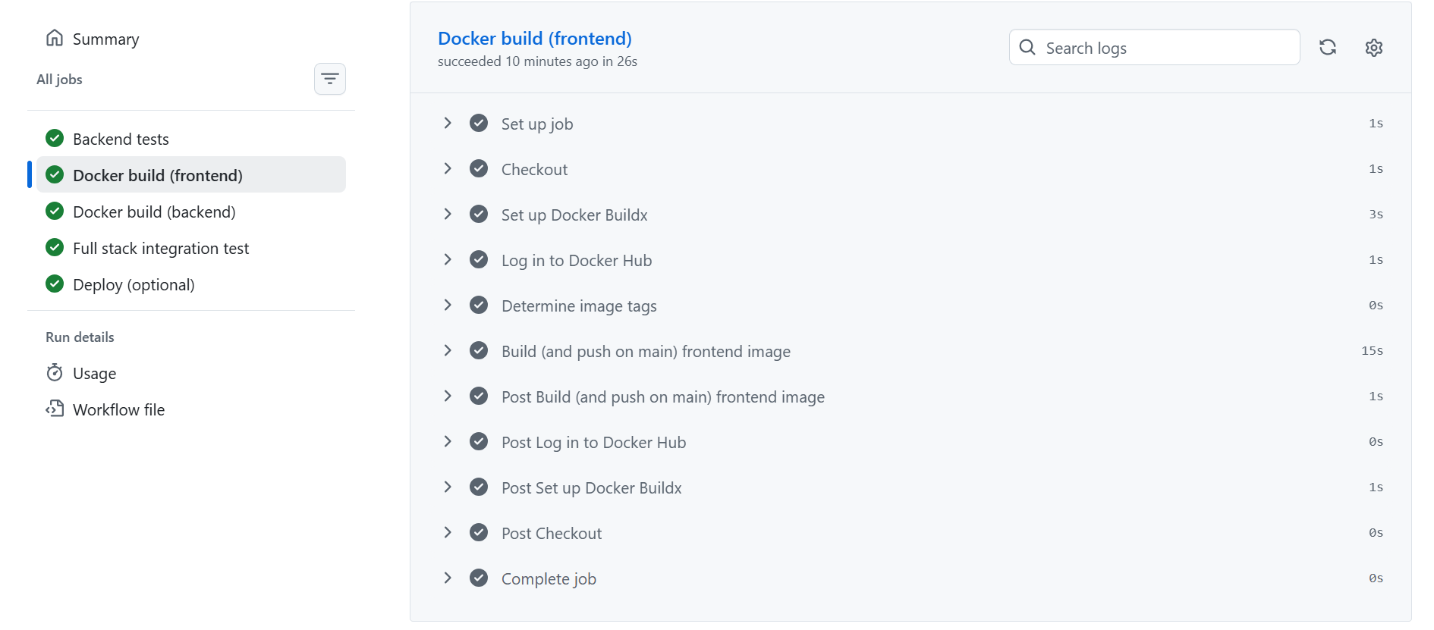
5. Docker build (frontend) job — expanded steps, image built and pushed
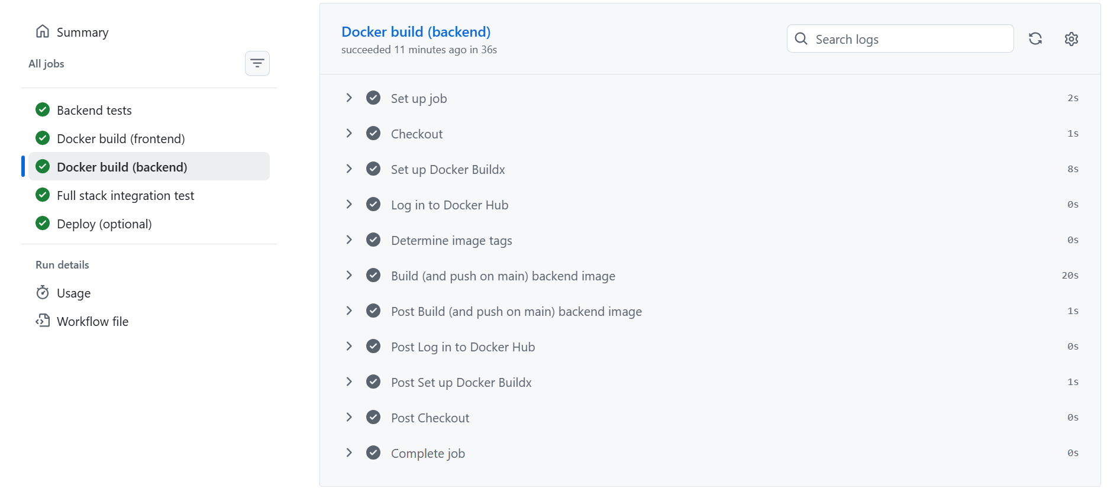
6. Docker build (backend) job — expanded steps, image built and pushed
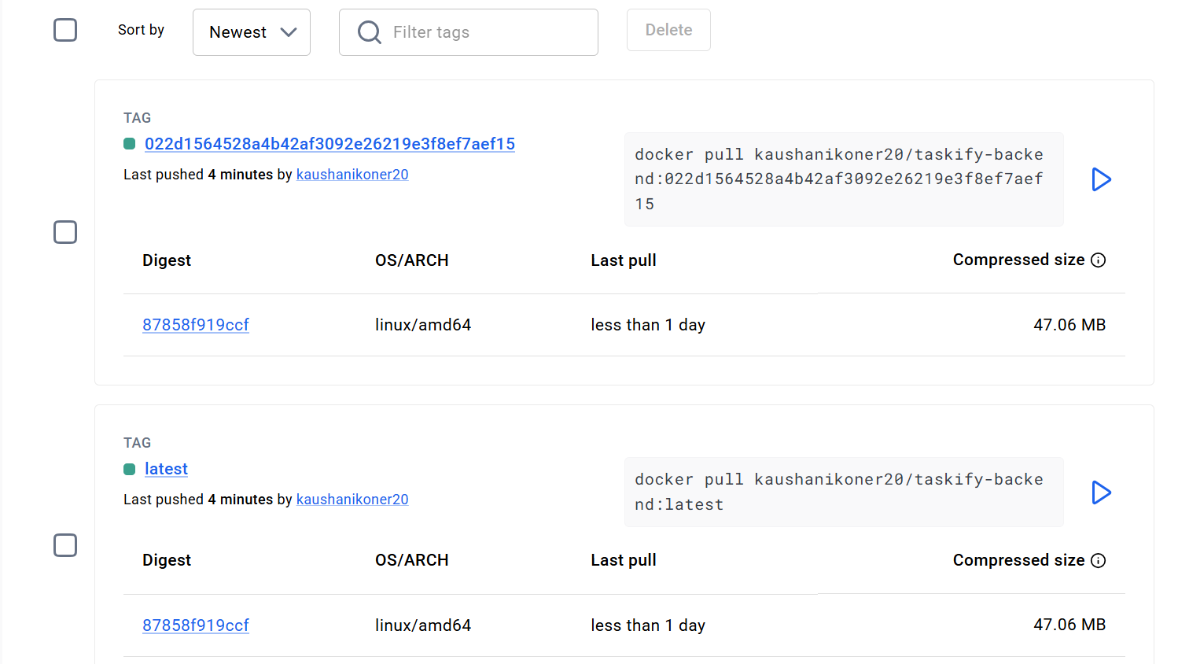
7. Docker Hub — taskify-backend repository, latest + commit-SHA tags
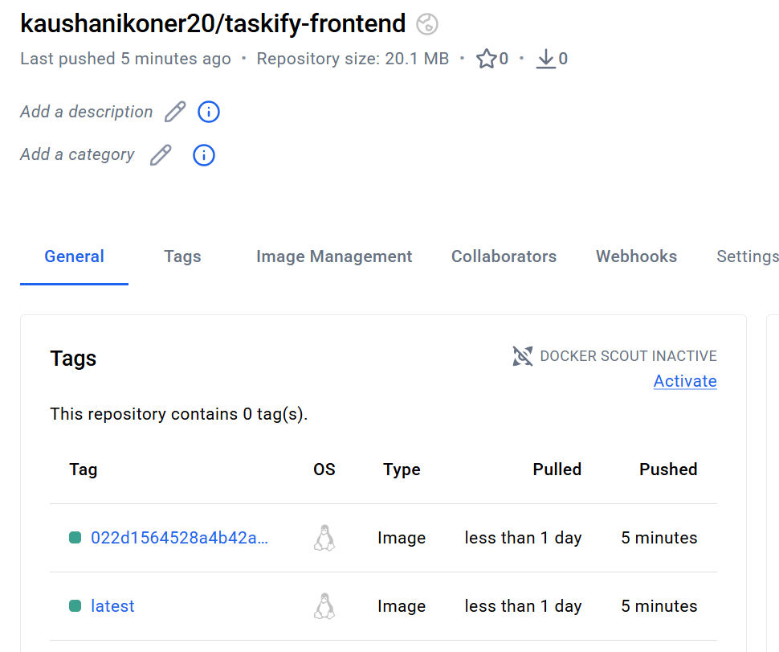
8. Docker Hub — taskify-frontend repository, both tags pushed
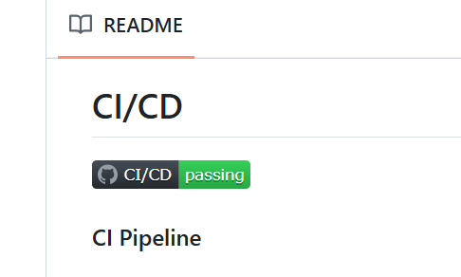
9. README.md on GitHub — CI/CD badge rendering "passing"

8. Links

GitHub Repository
https://github.com/kaushanikoner20-hub/taskify

Workflow file
https://github.com/kaushanikoner20-hub/taskify/blob/main/.github/workflows/ci-cd.yml

Docker Hub Images
hub.docker.com/r/kaushanikoner20/taskify-backend
hub.docker.com/r/kaushanikoner20/taskify-frontend

Deployed Endpoint
No remote deployment endpoint is provisioned for this project (no server available). The deploy job is implemented, wired, and verified to run successfully end-to-end — it correctly detects that DEPLOY_HOST/DEPLOY_USERNAME/DEPLOY_SSH_KEY secrets are not set and exits cleanly rather than failing, as shown in the "Deploy (optional)" job in Screenshot 3. Docker Hub is the actual CD destination for this deliverable, per the assignment's stated options ("Docker Hub + remote host").

9. Notes on the Test Suite
The backend-test job is not a placeholder. It runs 8 real tests (Node's built-in test runner + Supertest) against a genuine, disposable PostgreSQL 16 instance spun up as a GitHub Actions service container - not a mock or in-memory substitute. Coverage includes:
- Registration input validation (missing fields rejected)
- Duplicate email rejection
- Password hash never returned in API responses
- Incorrect password rejected on login
- JWT authentication enforcement on protected routes
- Task creation and retrieval
- Regression test: the weekly progress chart's API response always returns all 7 weekdays, even for a brand-new user with no logged hours - this is a real bug that shipped and was fixed earlier in this project
- Reports aggregation reflecting actual created data

