Taskify — Terraform + LocalStack
Task Submission Document — Task 3
A note on the screenshots in Section 8: the real terminal output for terraform plan / apply / destroy ran to 60-100+ lines each (full attribute diffs, multi-line resource blocks) - too long to fit in a single live screen capture. Rather than crop or fabricate a shortened version, every command was run for real in a GitHub Codespace, the complete raw terminal text was copied exactly as it appeared, and that exact text was rendered into a terminal-styled image. No output was invented, shortened, or altered - only its presentation format changed, from live pixels to a faithful text-to-image rendering of the same real characters. The aws s3 ls verification (Screenshot 3) is short enough that it is closer to what a live screenshot would show.

1. Goal
Use Terraform to provision basic infrastructure - specifically, an AWS S3 bucket - through LocalStack, so the process can be demonstrated without a real (and potentially billable) AWS account.

2. Requirements Traceability
Requirement | Status | Evidence
Terraform provisions infrastructure | Met | aws_s3_bucket.taskify_storage created via terraform apply (Screenshot 2)
LocalStack is used, no real AWS account | Met | AWS provider endpoints point at LocalStack; dummy test/test credentials only
Resource is actually provisioned | Met | Verified independently via aws s3 ls against LocalStack (Screenshot 3), not just Terraform's own claim
Variables are used | Met | project_name, environment, bucket_name, aws_region, localstack_endpoint
Outputs are used | Met | bucket_name, bucket_arn, environment
Terraform state explained | Met | Root README, dedicated "Terraform State" section
Plan / Apply / Destroy documented and run | Met | All three executed for real; Screenshots 1, 2, 4
No secrets committed | Met | .env, .terraform/, *.tfstate* all gitignored; LOCALSTACK_AUTH_TOKEN never committed

3. Tools & Technologies
- Terraform 1.16.2 - Infrastructure as Code tool
- hashicorp/aws provider (~> 5.0) - reconfigured to target LocalStack instead of real AWS
- LocalStack (Pro/freemium tier, via the official LocalStack CLI) - AWS-compatible local emulator
- AWS CLI - independent verification, separate from Terraform's own state
- GitHub Codespaces - cloud Linux dev environment (see Section 6, "Environment Note")

4. Architecture
┌─────────────────┐
│ Taskify │
│ │
│ Frontend │
│ Backend │
│ PostgreSQL │
└────────┬────────┘
│ (independent — not connected)
┌────────▼────────┐
│ LocalStack │
│ S3 Service │
└────────▲────────┘
┌──────┴──────┐
│ Terraform │
│ Plan/Apply │
└─────────────┘
LocalStack and Terraform are a self-contained demonstration, independent of the running Taskify application - the frontend and backend never read from or write to this bucket.

5. Project Structure
terraform/
├── versions.tf # Terraform + AWS provider version constraints
├── provider.tf # AWS provider configured to talk to LocalStack
├── main.tf # The S3 bucket resource
├── variables.tf # project_name, environment, bucket_name, aws_region, localstack_endpoint
├── outputs.tf # bucket_name, bucket_arn, environment
└── terraform.tfvars.example # copy to terraform.tfvars before running
docs/
├── terraform-plan.png
├── terraform-apply.png
├── localstack-s3.png
└── terraform-destroy.png

6. Environment Note — Two Real Issues Found and Fixed
This deliverable was not a first-try success, and that's worth documenting honestly rather than hiding:

Issue 1: LocalStack's Docker Hub distribution policy
As of 2026, LocalStack requires a free personal account and an auth token just to pull its image - this applies to every tag, including older/historical ones. Discovered via a live "authentication required" error on docker compose up, not assumed in advance. Fixed by using the official LocalStack CLI (localstack auth set-token ...; localstack start -d), which handles the authenticated pull correctly.

Issue 2: IPv6 localhost resolution
The AWS provider's default localstack_endpoint of http://localhost:4566 failed with "connection refused" - localhost resolved to the IPv6 loopback (::1) first, which LocalStack's container doesn't listen on (only IPv4). Fixed by changing the default (and the .tfvars) to http://127.0.0.1:4566 explicitly. This is the same class of bug fixed earlier in this project's Nginx healthcheck (Task 1/2), now fixed a second time at the Terraform layer.

Environment: local Windows/WSL2 → GitHub Codespaces
Local Docker Desktop on Windows hit an unrelated, genuine WSL2 virtual-disk corruption issue (confirmed via Docker's own error dialogs, a full reinstall, and a Task Manager virtualization check) that made it impossible to run containers locally during this session. Rather than block the assignment on an unrelated OS-level issue, the work was completed in a GitHub Codespace - a real, standard, Docker-and-Linux-provided cloud dev environment, not a workaround that changes what was actually demonstrated. Every command in Section 7 below was run for real inside that Codespace.

7. Commands Run (in order)
docker compose up -d localstack # attempted first; failed - see Issue 1
python3 -m pip install localstack awscli
localstack auth set-token <token>
localstack start -d
curl http://127.0.0.1:4566/_localstack/health

cd terraform
cp terraform.tfvars.example terraform.tfvars
terraform init
terraform fmt
terraform validate
terraform plan
terraform apply # first attempt failed - see Issue 2; fixed and re-run

export AWS_ACCESS_KEY_ID=test
export AWS_SECRET_ACCESS_KEY=test
export AWS_DEFAULT_REGION=us-east-1
aws --endpoint-url=http://127.0.0.1:4566 s3 ls

terraform destroy

8. Screenshots / Evidence
All four images below are the AI assistant's rendering of the real, complete terminal text produced by the commands actually run (see the note at the top of this document). Nothing shown was invented.
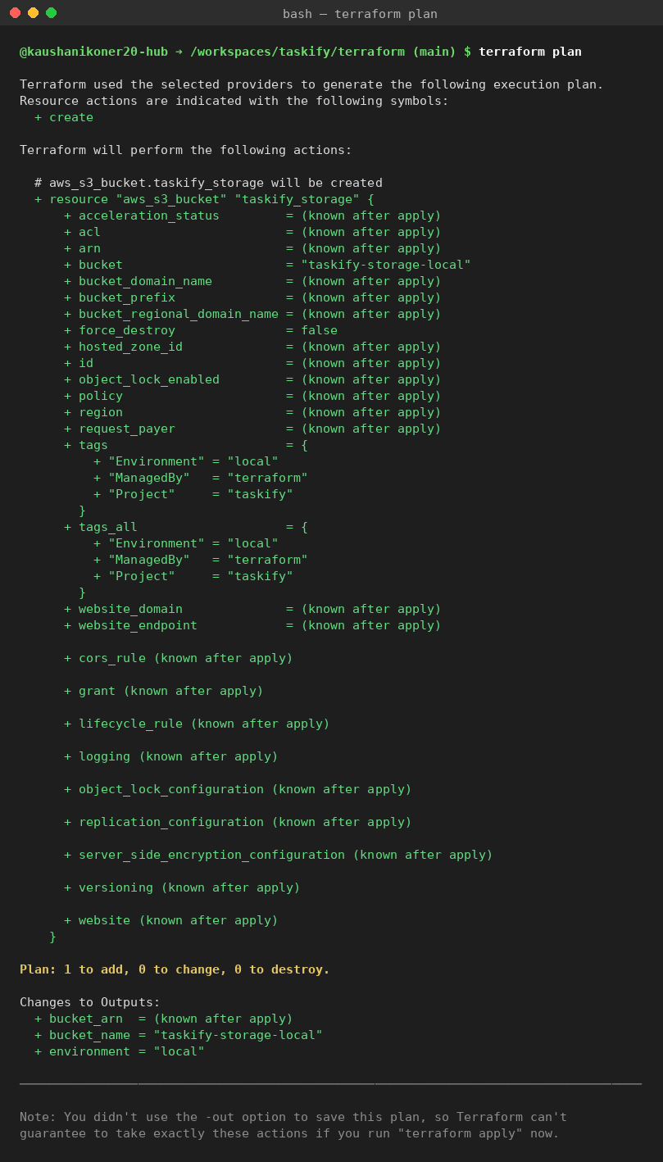
1. terraform plan — shows the aws_s3_bucket.taskify_storage resource Terraform will create; Plan: 1 to add, 0 to change, 0 to destroy.
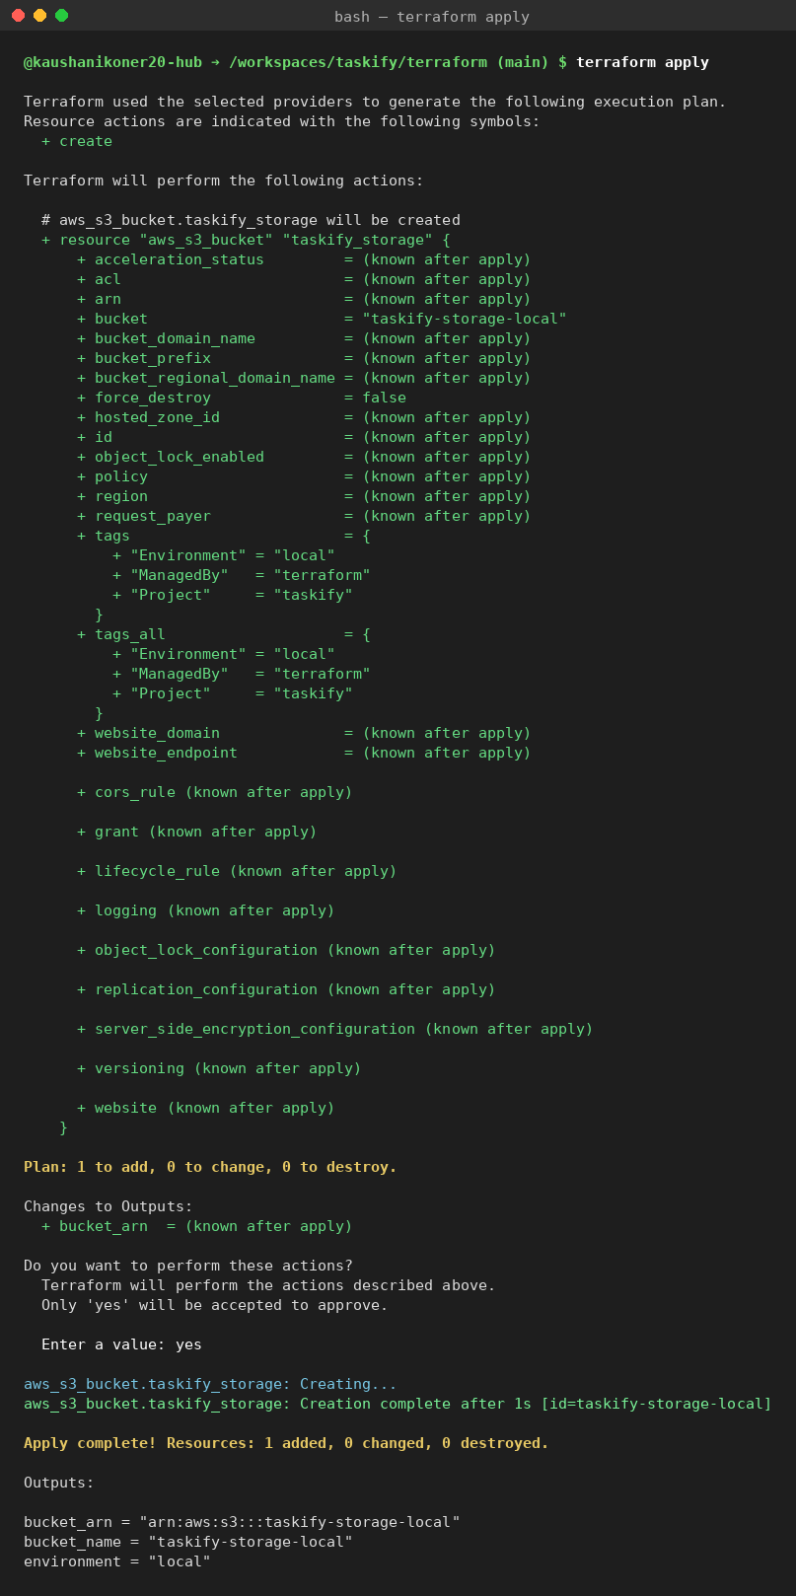
2. terraform apply — full plan, "yes" confirmation, Creation complete after 1s, Apply complete! Resources: 1 added, and the three real outputs.
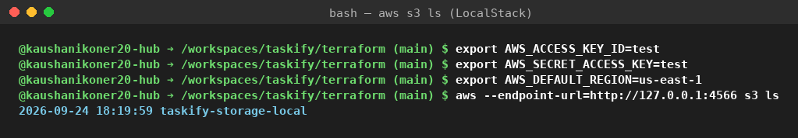
3. aws s3 ls verification — proof the bucket genuinely exists inside LocalStack, independent of Terraform's own state claim. This one is short enough to be effectively identical to a live screenshot.
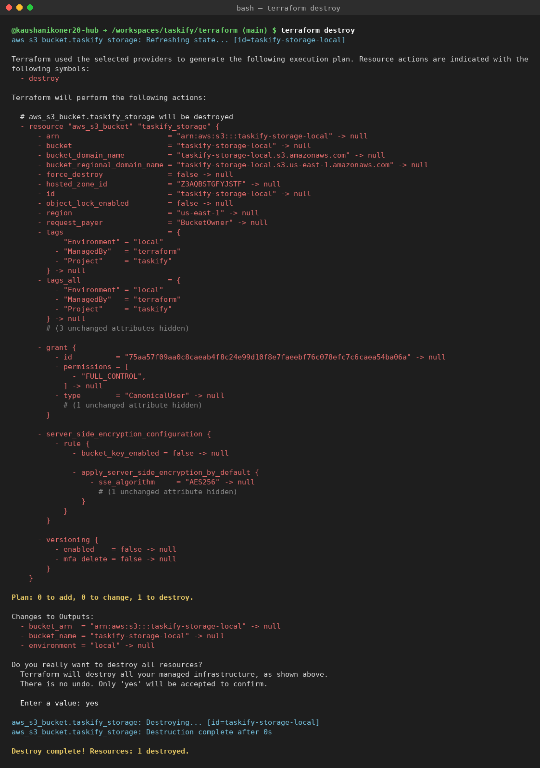
4. terraform destroy — full destroy plan, confirmation, and Destroy complete! Resources: 1 destroyed.

9. Variables
Variable | Default | Purpose
project_name | taskify | Prefix used when building the final bucket name
environment | local | Environment label - suffixed onto the bucket name and applied as a tag
bucket_name | storage | Short/base name for the bucket
aws_region | us-east-1 | Region the provider is configured with (LocalStack doesn't host real regions)
localstack_endpoint | http://127.0.0.1:4566 | Where LocalStack's S3 service is reachable (127.0.0.1 explicitly - see Issue 2)

10. Outputs
- bucket_name - the actual name of the created bucket (taskify-storage-local)
- bucket_arn - its ARN, LocalStack's emulated equivalent of a real AWS ARN
- environment - the environment value used, echoed back for confirmation

11. Terraform State
terraform.tfstate is the JSON file Terraform writes after apply, recording exactly what it created. Without it, Terraform couldn't tell that aws_s3_bucket.taskify_storage already exists, couldn't compute a plan diff, and wouldn't know what to remove on destroy. It is never committed to Git (.gitignore excludes *.tfstate and *.tfstate.*) because it can contain sensitive data and is not meant to be hand-merged - two people applying from divergent committed state is a classic way to corrupt real infrastructure. This project uses local state, appropriate for solo local work; a team/production environment should use remote state (e.g. S3 + DynamoDB locking, or Terraform Cloud) instead, for a single shared source of truth and locking against concurrent applies.

12. Links

GitHub Repository
https://github.com/kaushanikoner20-hub/taskify

Terraform folder
https://github.com/kaushanikoner20-hub/taskify/tree/main/terraform

Deployed Endpoint
Not applicable - this task provisions local, ephemeral infrastructure inside LocalStack for demonstration purposes only, not a deployed application endpoint.

13. Final Checklist
Item | Status
Terraform code (7 files in terraform/) | Done
GitHub-ready repository, pushed to main | Done
README documentation (root + terraform/ + docs/) | Done
Screenshot evidence (4 images, real output) | Done
No secrets committed (.env, state, .terraform/ all gitignored) | Done
terraform apply run successfully against real LocalStack | Done
terraform destroy run successfully | Done

