Game Design Document

Fill up the following document

1. Write the title of your project.

Infinity runner

1. What is the goal of the game?

Overcome the obstacles and reach the finish line

1. Write a brief story of your game.

There will a boy named Jimmy he has to go to his school from his home

But there are many obstacles in the way so jimmy has to cross all the obstacles to reach his school . His school is the finish line and his home is the starting point.

1. Which are the playing characters of this game?

* Playing characters are the ones who respond to the user based on the input from the user.
* Cars, monkeys, dinos, wizards, etc., are the playing characters in the game.

|  |  |  |
| --- | --- | --- |
| Number | Character Name | What can this character do? |
| 1 | Jimmy | Run infinitely |
| 2 |  |  |
| 3 |  |  |
| 4 |  |  |
| 5 |  |  |
| 6 |  |  |
| 7 |  |  |
| 8 |  |  |

1. Which are the Non-Playing Characters of this game?

* Non-Playing characters are the ones that don't have an action or behavior when the user interacts with the game.
* Hurdles, stones, bananas, coins, etc., are non-playing characters in the game.

|  |  |  |
| --- | --- | --- |
| Number | Character Name | What can this character do? |
| 1 | Broken bridge | Jimmy has to cross his first obstacle the broken bridge |
| 2 | The forest | Jimmy has to cross the forest his second obstacle |
| 3 |  |  |
| 4 |  |  |
| 5 |  |  |
| 6 |  |  |
| 7 |  |  |
| 8 |  |  |

Draw your imagination of this game. What does this game look like?

* Draw the game either on your computer or on paper.
* Add images of the game scenes to show each of the playing and non-playing characters at least once.

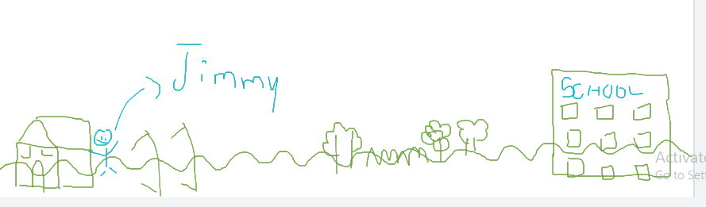

How do you plan to make your game engaging?