ineuron assignment 2

Python

kaushik

1.What are the two values of the Boolean data type? How do you write them?

**Ans** : The two values of the Boolean data type are **True(means 1)** and **False(means 0)**.

# **how to write the boolean values in python**

bool_a=True

print ("the true data types are", bool_a ,'and its class is ',type(bool_a) , 'and its numeric values', int(bool_a))

bool_b=False

print ("the true data types are", bool_b ,'and its class is ',type(bool_b),'and its numeric values', int(bool_b))

the true data types are True and its class is <class 'bool'> and its numeric values 1

the true data types are False and its class is <class 'bool'> and its numeric values 0

2. What are the three different types of Boolean operators?

**Ans** : The three different types of Boolean operators are given below

**Comparison Operator**

**Equal to** (operator type is comparison & operator sign is ==)

**Example** :

**#comparison operator**

x = 5

y = 8

print("x == y:", x == y)

x == y: False

**Logical Operator**

**and** (operator type is logical & operator sign is and)

True if both are true

Example :

#**Logical Operators**

print((9 > 7) and (2 < 4))

True

**Logical Operator**

**or** (operator type is logical & operator sign is or)

True if at least one is true.

Example:

#Logical Operators

print ((8 == 8) or (6!= 6))

True

**Logical Operator**

**not** (operator type is logical & operator sign is not)

True only if false

#Logical Operators

print(not(3 <= 1))

True

3. Make a list of each Boolean operator's truth tables (i.e. every possible combination of Boolean values for the operator and what it evaluate ).

**Ans :**

**== Truth Table**

|  |  |  |  |
| --- | --- | --- | --- |
| X | == | Y | Returns |
| **True (1)** | **==** | **True (1)** | **True(1)** |
| **True(1)** | == | **False(0)** | **False(0)** |
| **False(0)** | == | **True(1)** | **False(0)** |
| **False(0)** | == | **False(0)** | **True(1)** |
|  |  |  |  |

**AND Truth Table**

|  |  |  |  |
| --- | --- | --- | --- |
| X | and | Y | Returns |
| **True (1)** | **and** | **True (1)** | **True(1)** |
| **True(1)** | **and** | **False(0)** | **False(0)** |
| **False(0)** | **and** | **True(1)** | **False(0)** |
| **False(0)** | **and** | **False(0)** | **False(0)** |
|  |  |  |  |

**OR Truth Table**

|  |  |  |  |
| --- | --- | --- | --- |
| X | or | Y | Returns |
| **True (1)** | **or** | **True (1)** | **True(1)** |
| **True(1)** | **or** | **False(0)** | **True(1)** |
| **False(0)** | **or** | **True(1)** | **True(1)** |
| **False(0)** | **or** | **False(0)** | **False(0)** |
|  |  |  |  |

**NOT Truth Table**

|  |  |  |
| --- | --- | --- |
| not | X | Returns |
| **Not** | **True (1)** | **False (0)** |
| **Not** | **False (0)** | **True (1)** |

4. What are the values of the following expressions?

**Ans :**

(5 > 4) and (3 == 5) = expression is False.

not (5 > 4) = expression is False.

(5 > 4) or (3 == 5) = expression is True.

not ((5 > 4) or (3 == 5)) = expression is False.

(True and True) and (True == False) = expression is False.

(not False) or (not True) = expression is True.

5. What are the six comparison operators?

**Ans** : The six comparison operators are given below.

|  |  |  |
| --- | --- | --- |
| Operator Name | Meaning | Example |
| == | Equal to | x = 5  y = 8  print("x == y:", x == y)  x == y: False |
| != | Not Equal to | x = 5  y = 8  print("x != y:", x != y)  x != y: True |
| < | Less than | x = 5  y = 8  print("x < y:", x < y)  x < y: True |
| > | Greater than | x = 5  y = 8  print ("x > y:", x > y)  x > y: False |
| <= | Less than or equal to | x = 5  y = 8  print("x <= y:", x <= y)  x <= y: True |
| >= | Greater than or equal to | x = 5  y = 8  print("x >= y:", x >= y)  x >= y: False |

6. How do you tell the difference between the equal to and assignment operators? Describe a condition and when you would use one.

**Ans :**

**= sign indicates assignment operator where == sign indicates equal to operator.**

**= assign values from right side operands to the left side operand**

**== checks if the value of two operands are equal or not equal.**

**One use case is given below:**

# assignment operator

# in assignment operator i just assign the value of a

a = 5

print ("Print the value of a", a)

# equal to operator

# equal to operator checks the both variable(operands) values and

# on that basis it can print the result with the if else conditions

a = int(input("Enter the value of a"))

b = int(input("Enter the value of b"))

if a == b:

   print("Value are matched")

else :

   print("Value are not matched")

7. Identify the three blocks in this code:

spam = 0

if spam == 10:

print('eggs')

if spam > 5:

print('bacon')

else:

print('ham')

print('spam')

print('spam')

**Ans :**

spam = 0

if spam == 10:

print('eggs') # indent increased, block A

if spam > 5: # block A

print('bacon') # still block A, indent increased, block B inside block A

else: # still block A, indent decreased, block B ended in line above

print('ham') # still block A, indent increased, block C inside block A

print('spam') # still block A, indent decreased, block C ended in line above

print('spam') # indent decreased, block A ended in line above

8. Write code that prints Hello if 1 is stored in spam, prints Howdy if 2 is stored in spam, and prints Greetings! if anything else is stored in spam.

**Ans:**

# different different condition different prints as in output

#first spam initialization

spam=0;

#if value 1 is stored in spam then prints Hello

if spam==1:

print("Hello")

#if 2 is stored in spam then prints Howdy

elif spam==2:

print("Howdy")

# if anything stored is spam then prints Greetings

else :

print("Greetings!")

Screenshot :

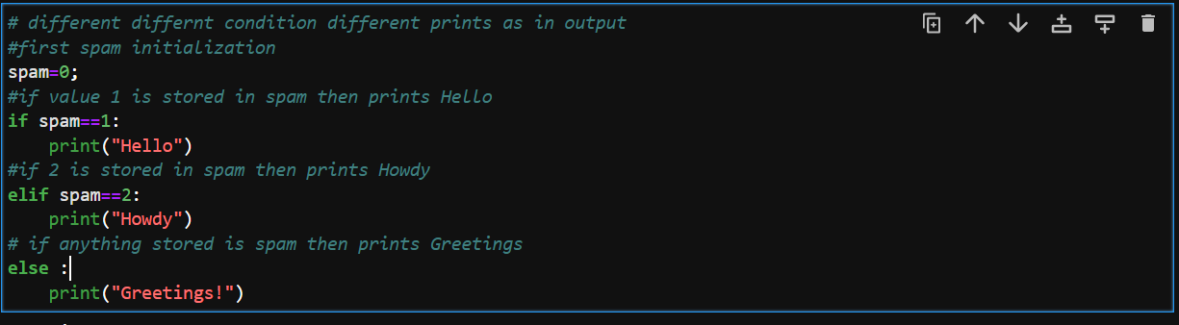

Now test with different case

Case 1 if spam is 1:

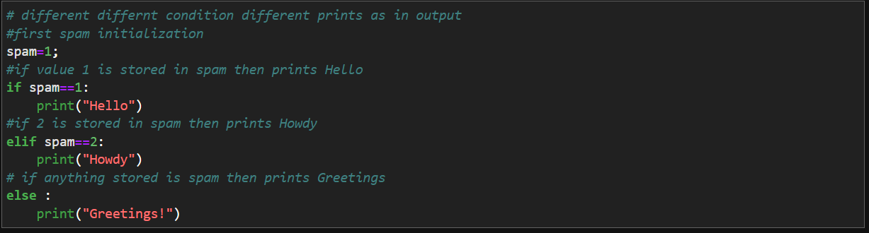

Output “Hello”

Case 2 if spam is 2:

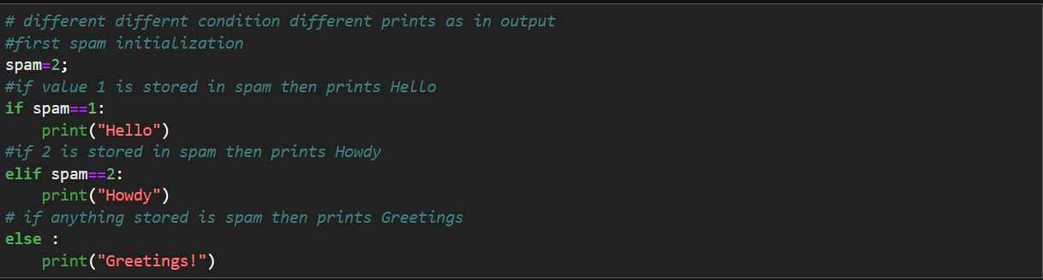

Output “Howdy”

Case 3 if spam is ineuron

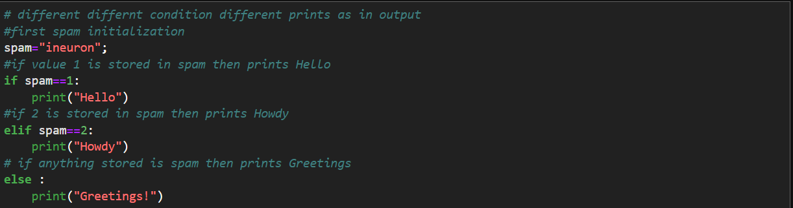

Output “Greetings!”

9.If your programme is stuck in an endless loop, what keys you’ll press?

**Ans :** to stop an infinite loop we can press : ctrl + c

10. How can you tell the difference between break and continue?

**Ans** : in simple words we can say that break statement stops the entire process of the loop where continue statement only stops the current iteration of the loop.

Screenshot for break statement :

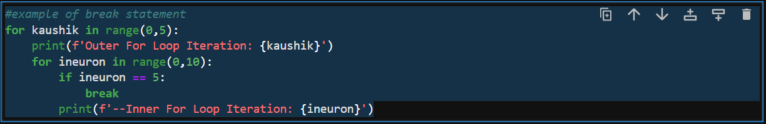

Screenshot for another break statement :

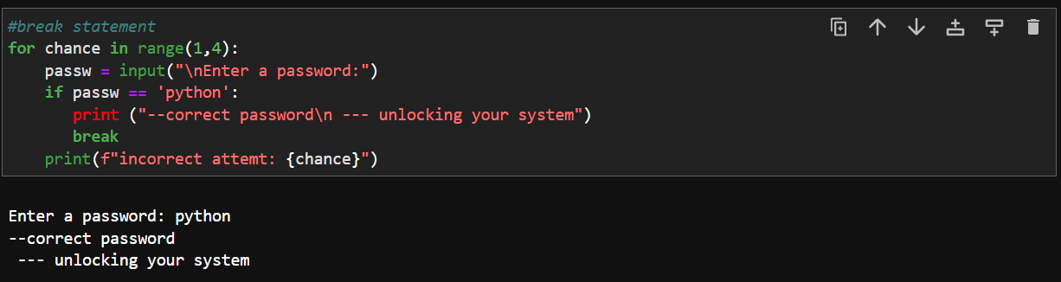

Screenshot for continue statement:

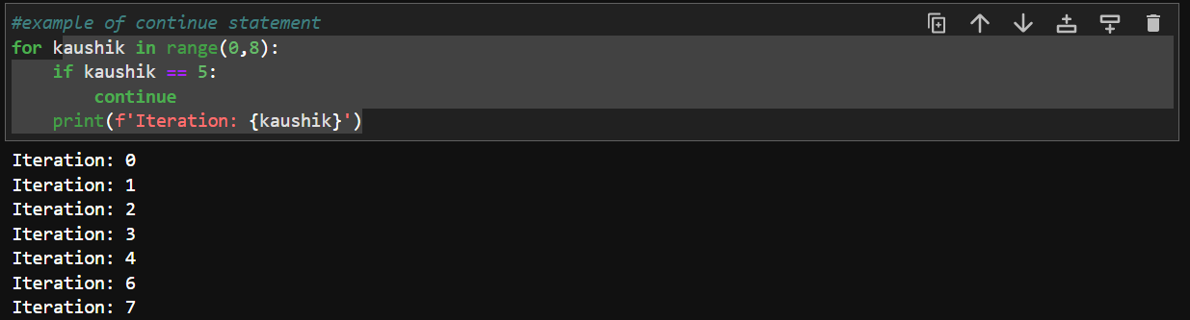

11. In a for loop, what is the difference between range(10), range(0, 10), and range(0, 10, 1)?

**Ans** : there is no difference between above conditions, all are printed upto range 10 ( from 0 to 9)

There different conditions screenshot is given below:

Case 1 range(10):

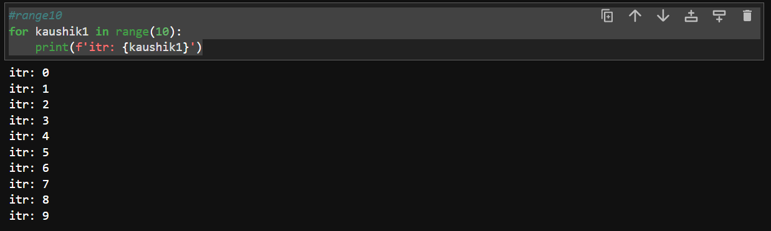

Case 2 range(0,10):

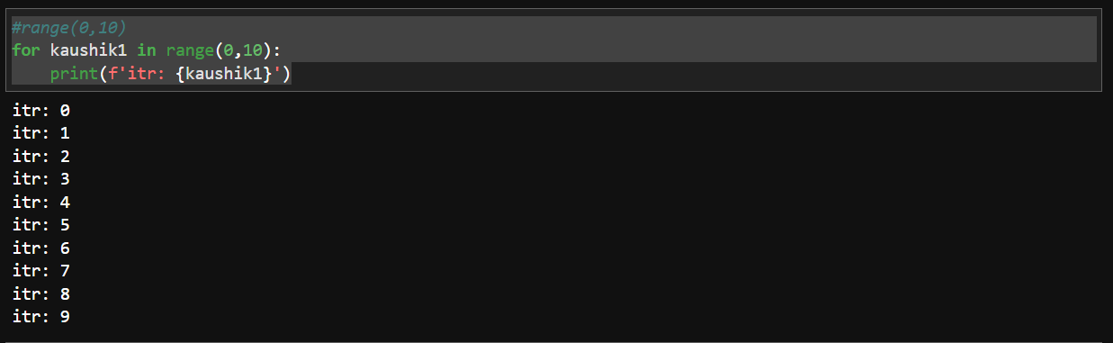

Case 3 range(0,10,1):

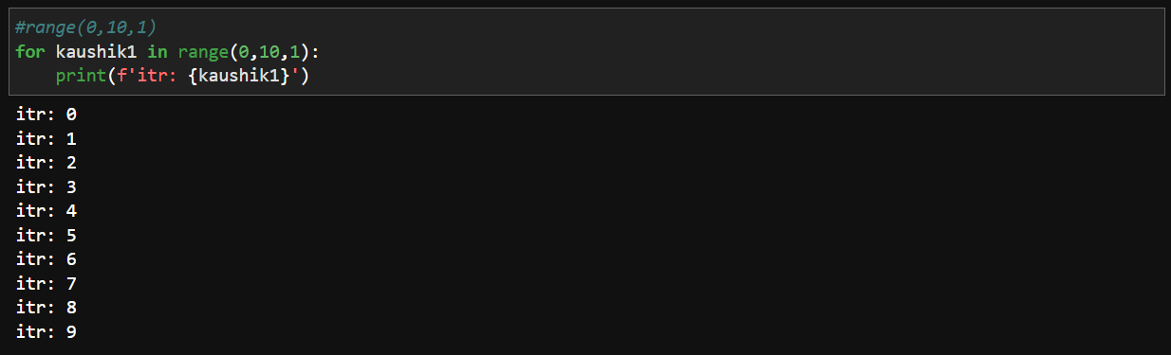

12. Write a short program that prints the numbers 1 to 10 using a for loop. Then write an equivalent program that prints the numbers 1 to 10 using a while loop.

**Ans:**

Prints the numbers 1 to 10 using a for loop.

Code:

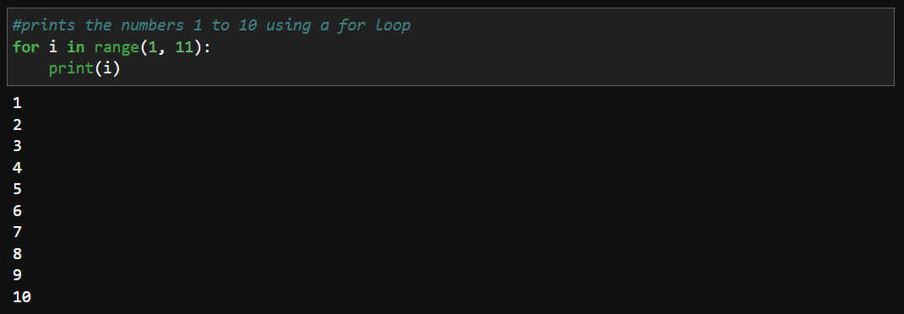

Prints the numbers 1 to 10 using while loop.

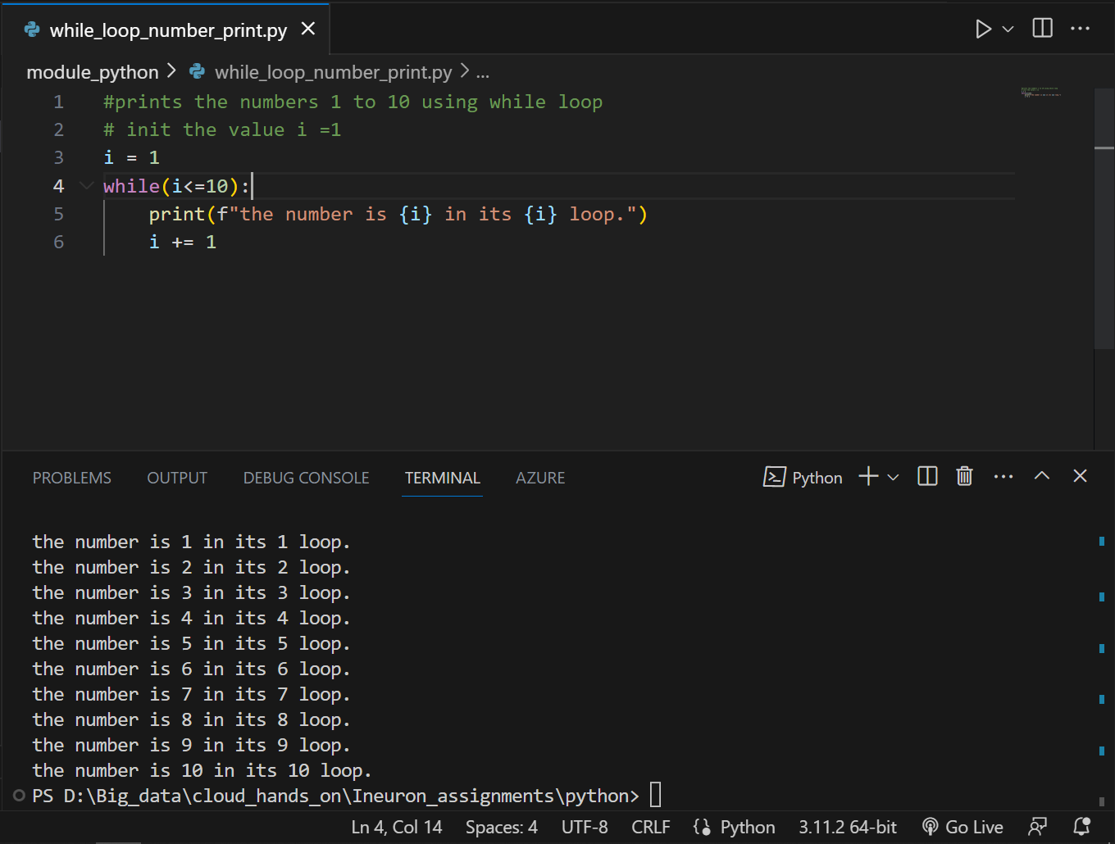

13. If you had a function named bacon () inside a module named spam, how would you call it after importing spam?

**Ans :**

Inside spam.py

# creating bacon func with parameter

def bacon(name):

  print(f"welcome to python world, {name}")

Inside call.py

# calling spam module inside call.py file

# And from that spam module calling the func bacon with params

import spam

spam.bacon("kaushik")

out put :

welcome to python world, kaushik!

