Kaushik Dey

Kaushikdey1984@yahoo.com

docker installation & various commands

Docker commands

Step 1 : Install Docker in Linux ec2 instance.

[ec2-user@ip-172-31-37-157 ~]$ sudo -i

[root@ip-172-31-37-157 ~]# docker -version

-bash: docker: command not found

[root@ip-172-31-37-157 ~]# yum install docker -y

[root@ip-172-31-37-157 ~]# docker --version

Docker version 20.10.23, build 7155243

[root@ip-172-31-37-157 ~]#

[root@ip-172-31-37-157 ~]# docker version

When we add this command, it ask for Dameon Running? So, we must add Dameon,

[root@ip-172-31-87-143 ~]# systemctl status docker

[root@ip-172-31-87-143 ~]# systemctl start docker

[root@ip-172-31-87-143 ~]# systemctl status docker

[root@ip-172-31-87-143 ~]# systemctl enable docker

[root@ip-172-31-87-143 ~]# docker version

Client:

Version: 20.10.23

API version: 1.41

Go version: go1.18.9

Git commit: 7155243

Built: Tue Apr 11 22:56:36 2023

OS/Arch: linux/amd64

Context: default

Experimental: true

Server:

Engine:

Version: 20.10.23

API version: 1.41 (minimum version 1.12)

Go version: go1.18.9

Git commit: 6051f14

Built: Tue Apr 11 22:57:17 2023

OS/Arch: linux/amd64

Experimental: false

containerd:

Version: 1.6.19

GitCommit: 1e1ea6e986c6c86565bc33d52e34b81b3e2bc71f

runc:

Version: 1.1.4

GitCommit: 5fd4c4d144137e991c4acebb2146ab1483a97925

docker-init:

Version: 0.19.0

GitCommit: de40ad0

[root@ip-172-31-87-143 ~]# history

DOCKER HUB REGISTRATION

Link : <https://hub.docker.com/_/ubuntu>. After Sign up you will be able to see this pages. I have signed in via iimdatascience1@gmail.com.

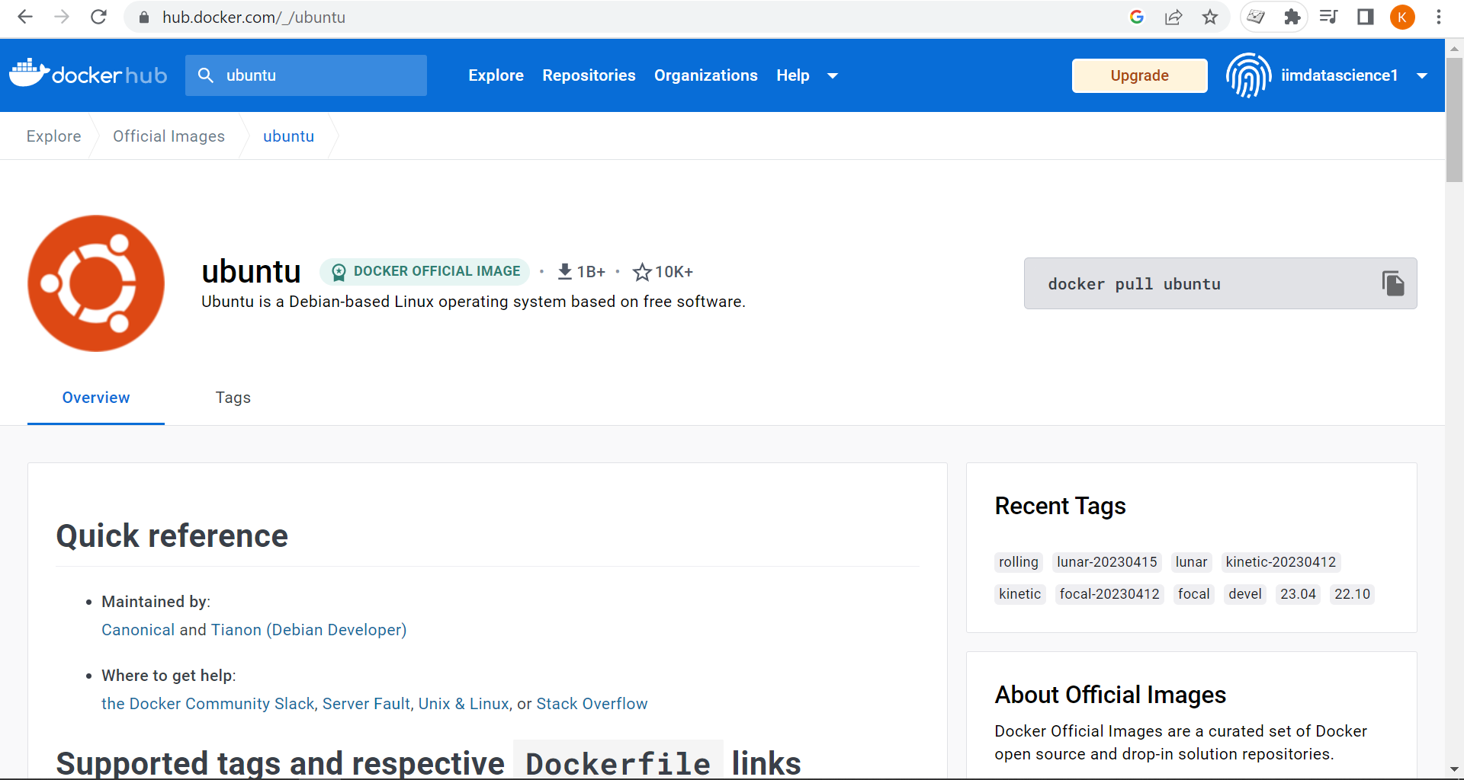

[root@ip-172-31-87-143 ~]# docker images

REPOSITORY TAG IMAGE ID CREATED SIZE

[root@ip-172-31-87-143 ~]# docker ps

(showing only running containers)

CONTAINER ID IMAGE COMMAND CREATED STATUS PORTS NAMES

[root@ip-172-31-87-143 ~]# docker ps -a

(showing all types of containers, running or not running)

CONTAINER ID IMAGE COMMAND CREATED STATUS PORTS NAMES

[root@ip-172-31-87-143 ~]# docker pull ubuntu

(only pull the images not runing)

[root@ip-172-31-87-143 ~]# docker run ubuntu

Unable to find image 'ubuntu:latest' locally

latest: Pulling from library/ubuntu

2ab09b027e7f: Pull complete

Digest: sha256:67211c14fa74f070d27cc59d69a7fa9aeff8e28ea118ef3babc295a0428a6d21

Status: Downloaded newer image for ubuntu:latest

[root@ip-172-31-87-143 ~]# clear

[root@ip-172-31-87-143 ~]# docker images

REPOSITORY TAG IMAGE ID CREATED SIZE

ubuntu latest 08d22c0ceb15 7 weeks ago 77.8MB

[root@ip-172-31-87-143 ~]# docker ps

CONTAINER ID IMAGE COMMAND CREATED STATUS PORTS NAMES

[root@ip-172-31-87-143 ~]# docker ps -a

CONTAINER ID IMAGE COMMAND CREATED STATUS PORTS NAMES

044b0fc95d57 ubuntu "/bin/bash" 2 minutes ago Exited (0) 2 minutes ago dazzling_swanson

[root@ip-172-31-87-143 ~]# docker pull centos

Using default tag: latest

latest: Pulling from library/centos

a1d0c7532777: Pull complete

Digest: sha256:a27fd8080b517143cbbbab9dfb7c8571c40d67d534bbdee55bd6c473f432b177

Status: Downloaded newer image for centos:latest

docker.io/library/centos:latest

[root@ip-172-31-87-143 ~]# docker images

REPOSITORY TAG IMAGE ID CREATED SIZE

ubuntu latest 08d22c0ceb15 7 weeks ago 77.8MB

centos latest 5d0da3dc9764 19 months ago 231MB

[root@ip-172-31-87-143 ~]# docker ps -a

CONTAINER ID IMAGE COMMAND CREATED STATUS PORTS NAMES

044b0fc95d57 ubuntu "/bin/bash" 5 minutes ago Exited (0) 4 minutes ago dazzling_swanson

[root@ip-172-31-87-143 ~]# docker run centos

[ec2-user@ip-172-31-87-143 ~]$ sudo -i

[root@ip-172-31-87-143 ~]# docker run -it centos bash

[root@4c0cc4af0e5a /]# ls

bin etc lib lost+found mnt proc run srv tmp var

dev home lib64 media opt root sbin sys usr

[root@4c0cc4af0e5a /]# cat /etc/*release*

CentOS Linux release 8.4.2105

Derived from Red Hat Enterprise Linux 8.4

NAME="CentOS Linux"

VERSION="8"

ID="centos"

ID_LIKE="rhel fedora"

VERSION_ID="8"

PLATFORM_ID="platform:el8"

PRETTY_NAME="CentOS Linux 8"

ANSI_COLOR="0;31"

CPE_NAME="cpe:/o:centos:centos:8"

HOME_URL="https://centos.org/"

BUG_REPORT_URL="https://bugs.centos.org/"

CENTOS_MANTISBT_PROJECT="CentOS-8"

CENTOS_MANTISBT_PROJECT_VERSION="8"

CentOS Linux release 8.4.2105

CentOS Linux release 8.4.2105

cpe:/o:centos:centos:8

[root@4c0cc4af0e5a /]# ls

bin etc lib lost+found mnt proc run srv tmp var

dev home lib64 media opt root sbin sys usr

[root@4c0cc4af0e5a /]# exit

exit

[root@ip-172-31-87-143 ~]# docker run centos sleep 20

[root@ip-172-31-87-143 ~]# docker run -d centos sleep 20

(container run in detach mode)

16f661294d1afcc4c5ae3be3b4d5cae5eb43273ebff3c441e4afc092fb77ce90

[root@ip-172-31-87-143 ~]#

[root@ip-172-31-87-143 ~]# docker rm 6efc10a0510f

(Remove the containers from local machine)

[root@ip-172-31-87-143 ~]# docker rm 6efc 4bfc 2de4

(Remove Multiple containers from local system)

[root@ip-172-31-87-143 ~]# docker rmi centos

Error response from daemon: conflict: unable to remove repository reference "centos" (must force) - container 7d2b27881316 is using its referenced image 5d0da3dc9764

[root@ip-172-31-87-143 ~]#

[root@ip-172-31-87-143 ~]# docker stop e0bdc119b578

e0bdc119b578

(Stop the containers from local system)

[root@ip-172-31-87-143 ~]# docker ps

(To check any containers are running or not)

CONTAINER ID IMAGE COMMAND CREATED STATUS PORTS NAMES

[root@ip-172-31-87-143 ~]# docker run -d centos sleep 50

[root@ip-172-31-87-143 ~]# docker inspect 74a21c<container id>

(Inspect inside the container)

[

{

"Id": "74a21c30e7629ffb8793ba1175597b58e5f79c0f9f956958a14346e06a37f1b6",

"Created": "2023-05-02T18:07:36.825874193Z",

"Path": "sleep",

"Args": [

"50"

],

"State": {

"Status": "running",

"Running": true,

"Paused": false,

"Restarting": false,

"OOMKilled": false,

"Dead": false,

"Pid": 2822,

"ExitCode": 0,

"Error": "",

"StartedAt": "2023-05-02T18:07:37.312491925Z",

"FinishedAt": "0001-01-01T00:00:00Z"

},

"Image": "sha256:5d0da3dc976460b72c77d94c8a1ad043720b0416bfc16c52c45d4847e53fadb6",

"ResolvConfPath": "/var/lib/docker/containers/74a21c30e7629ffb8793ba1175597b58e5f79c0f9f956958a14346e06a37f1b6/resolv.conf",

"HostnamePath": "/var/lib/docker/containers/74a21c30e7629ffb8793ba1175597b58e5f79c0f9f956958a14346e06a37f1b6/hostname",

"HostsPath": "/var/lib/docker/containers/74a21c30e7629ffb8793ba1175597b58e5f79c0f9f956958a14346e06a37f1b6/hosts",

"LogPath": "/var/lib/docker/containers/74a21c30e7629ffb8793ba1175597b58e5f79c0f9f956958a14346e06a37f1b6/74a21c30e7629ffb8793ba1175597b58e5f79c0f9f956958a14346e06a37f1b6-json.log",

"Name": "/sweet_rhodes",

"RestartCount": 0,

"Driver": "overlay2",

"Platform": "linux",

"MountLabel": "",

"ProcessLabel": "",

"AppArmorProfile": "",

"ExecIDs": null,

"HostConfig": {

"Binds": null,

"ContainerIDFile": "",

"LogConfig": {

"Type": "json-file",

"Config": {}

},

"NetworkMode": "default",

"PortBindings": {},

"RestartPolicy": {

"Name": "no",

"MaximumRetryCount": 0

},

"AutoRemove": false,

"VolumeDriver": "",

"VolumesFrom": null,

"CapAdd": null,

"CapDrop": null,

"CgroupnsMode": "host",

"Dns": [],

"DnsOptions": [],

"DnsSearch": [],

"ExtraHosts": null,

"GroupAdd": null,

"IpcMode": "private",

"Cgroup": "",

"Links": null,

"OomScoreAdj": 0,

"PidMode": "",

"Privileged": false,

"PublishAllPorts": false,

"ReadonlyRootfs": false,

"SecurityOpt": null,

"UTSMode": "",

"UsernsMode": "",

"ShmSize": 67108864,

"Runtime": "runc",

"ConsoleSize": [

0,

0

],

"Isolation": "",

"CpuShares": 0,

"Memory": 0,

"NanoCpus": 0,

"CgroupParent": "",

"BlkioWeight": 0,

"BlkioWeightDevice": [],

"BlkioDeviceReadBps": null,

"BlkioDeviceWriteBps": null,

"BlkioDeviceReadIOps": null,

"BlkioDeviceWriteIOps": null,

"CpuPeriod": 0,

"CpuQuota": 0,

"CpuRealtimePeriod": 0,

"CpuRealtimeRuntime": 0,

"CpusetCpus": "",

"CpusetMems": "",

"Devices": [],

"DeviceCgroupRules": null,

"DeviceRequests": null,

"KernelMemory": 0,

"KernelMemoryTCP": 0,

"MemoryReservation": 0,

"MemorySwap": 0,

"MemorySwappiness": null,

"OomKillDisable": false,

"PidsLimit": null,

"Ulimits": [

{

"Name": "nofile",

"Hard": 65536,

"Soft": 32768

}

],

"CpuCount": 0,

"CpuPercent": 0,

"IOMaximumIOps": 0,

"IOMaximumBandwidth": 0,

"MaskedPaths": [

"/proc/asound",

"/proc/acpi",

"/proc/kcore",

"/proc/keys",

"/proc/latency_stats",

"/proc/timer_list",

"/proc/timer_stats",

"/proc/sched_debug",

"/proc/scsi",

"/sys/firmware"

],

"ReadonlyPaths": [

"/proc/bus",

"/proc/fs",

"/proc/irq",

"/proc/sys",

"/proc/sysrq-trigger"

]

},

"GraphDriver": {

"Data": {

"LowerDir": "/var/lib/docker/overlay2/84652d3275145b9a82b0bd04e95c38b007c96577f3c0066e6c4f92a6b9c9e9a0-init/diff:/var/lib/docker/overlay2/42da92aecc0ccf72d8290bafb588135470c093de154749566efc9d8e4b3cb773/diff",

"MergedDir": "/var/lib/docker/overlay2/84652d3275145b9a82b0bd04e95c38b007c96577f3c0066e6c4f92a6b9c9e9a0/merged",

"UpperDir": "/var/lib/docker/overlay2/84652d3275145b9a82b0bd04e95c38b007c96577f3c0066e6c4f92a6b9c9e9a0/diff",

"WorkDir": "/var/lib/docker/overlay2/84652d3275145b9a82b0bd04e95c38b007c96577f3c0066e6c4f92a6b9c9e9a0/work"

},

"Name": "overlay2"

},

"Mounts": [],

"Config": {

"Hostname": "74a21c30e762",

"Domainname": "",

"User": "",

"AttachStdin": false,

"AttachStdout": false,

"AttachStderr": false,

"Tty": false,

"OpenStdin": false,

"StdinOnce": false,

"Env": [

"PATH=/usr/local/sbin:/usr/local/bin:/usr/sbin:/usr/bin:/sbin:/bin"

],

"Cmd": [

"sleep",

"50"

],

"Image": "centos",

"Volumes": null,

"WorkingDir": "",

"Entrypoint": null,

"OnBuild": null,

"Labels": {

"org.label-schema.build-date": "20210915",

"org.label-schema.license": "GPLv2",

"org.label-schema.name": "CentOS Base Image",

"org.label-schema.schema-version": "1.0",

"org.label-schema.vendor": "CentOS"

}

},

"NetworkSettings": {

"Bridge": "",

"SandboxID": "472e647c8ccdb2ea5c8e49270fa60294aefd59bd755872b0aa8f60ded9e9f42f",

"HairpinMode": false,

"LinkLocalIPv6Address": "",

"LinkLocalIPv6PrefixLen": 0,

"Ports": {},

"SandboxKey": "/var/run/docker/netns/472e647c8ccd",

"SecondaryIPAddresses": null,

"SecondaryIPv6Addresses": null,

"EndpointID": "5a8c9b062bebcc7b55ac9e04844625548961ad4adfdabade0f196fa79a345338",

"Gateway": "172.17.0.1",

"GlobalIPv6Address": "",

"GlobalIPv6PrefixLen": 0,

"IPAddress": "172.17.0.2",

"IPPrefixLen": 16,

"IPv6Gateway": "",

"MacAddress": "02:42:ac:11:00:02",

"Networks": {

"bridge": {

"IPAMConfig": null,

"Links": null,

"Aliases": null,

"NetworkID": "92d90f66cf3db5667487a30863bde4e7786829f0203d6ff59219e286eb671fad",

"EndpointID": "5a8c9b062bebcc7b55ac9e04844625548961ad4adfdabade0f196fa79a345338",

"Gateway": "172.17.0.1",

"IPAddress": "172.17.0.2",

"IPPrefixLen": 16,

"IPv6Gateway": "",

"GlobalIPv6Address": "",

"GlobalIPv6PrefixLen": 0,

"MacAddress": "02:42:ac:11:00:02",

"DriverOpts": null

}

}

}

}

]

[root@ip-172-31-87-143 ~]#

[root@ip-172-31-87-143 ~]# docker images

REPOSITORY TAG IMAGE ID CREATED SIZE

nginx latest 6efc10a0510f 2 weeks ago 142MB

ubuntu latest 08d22c0ceb15 7 weeks ago 77.8MB

centos latest 5d0da3dc9764 19 months ago 231MB

[root@ip-172-31-87-143 ~]# docker history centos

IMAGE CREATED CREATED BY SIZE COMMENT

5d0da3dc9764 19 months ago /bin/sh -c #(nop) CMD ["/bin/bash"] 0B

<missing> 19 months ago /bin/sh -c #(nop) LABEL org.label-schema.sc… 0B

<missing> 19 months ago /bin/sh -c #(nop) ADD file:805cb5e15fb6e0bb0… 231MB

[root@ip-172-31-87-143 ~]#