Kaushik Dey

Kaushikdey1984@yahoo.com

continuous integration with jenkins

Jenkins build pipeline

Step1 : Create Pipeline view using DevCompile and QAUnitTest.

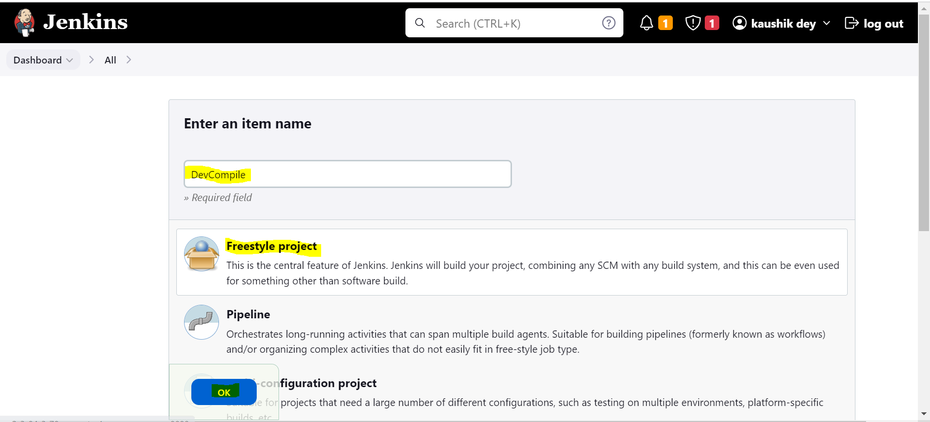

Step 2 : After creating the free style project we must add our git repository , in my case using this following

git repo : <https://github.com/edureka-git/DevOpsClassCodes.git> ( public repo )

credentials None.

After that apply the changes.

In later stages we can also add our branches.

Step 3 : now we can concentrate on build steps , in this case please choose **Invoke top-level Maven targets.** Thescreenshot is given below.

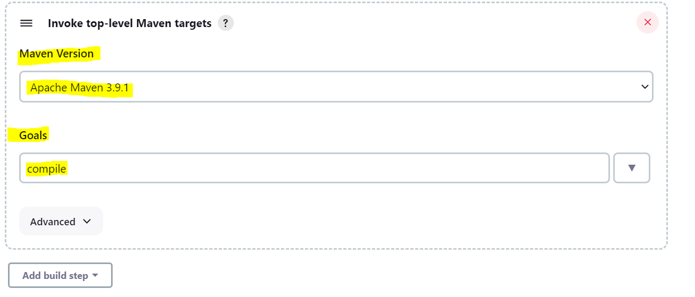

**Note :** In first time MVN is not installed in the Jenkins workspace , first we have to install it via global configuration, the screenshot is given below.

First navigate to Global Tool Configuration from Managed Plugins

And then

Step 4 : Create QAunitTest project and provide the same SCM path and execute it after DevCompile Action by setting build.

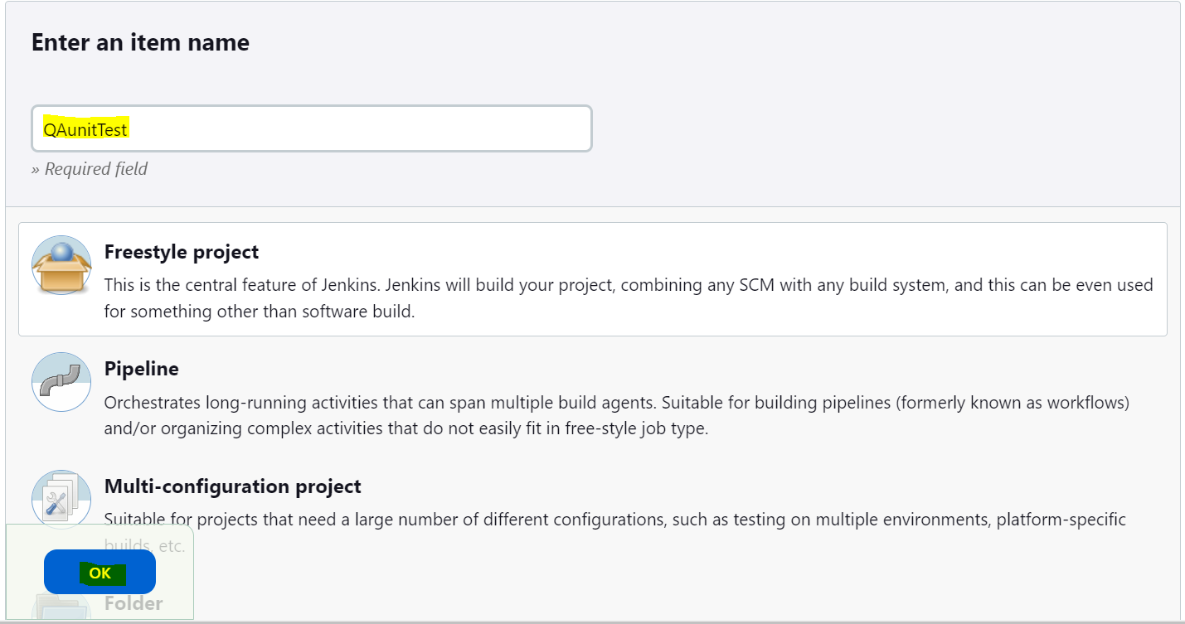

Step 5 : Check Junit plugins are present or not, the screenshot is given below.

Step 6 : Configure DevCompile project and set post-build action as QAUnitTest.

Step 7 :

* Go to Jenkins Dashboard and click on the “+” button. That button is for adding a view.
* You will be redirected to the following screen.
* Give the View name and Select the build Pipeline View radio button, and press OK.

Screenshot 1 :

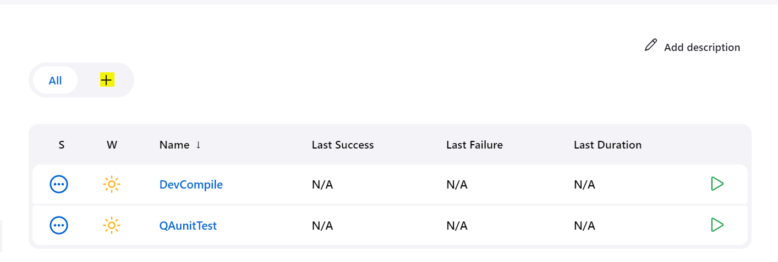

Screenshot 2: before going to the new view we have to install build pipeline plugins, so all jobs should be showing as in pipeline interface, the screenshot is given below.

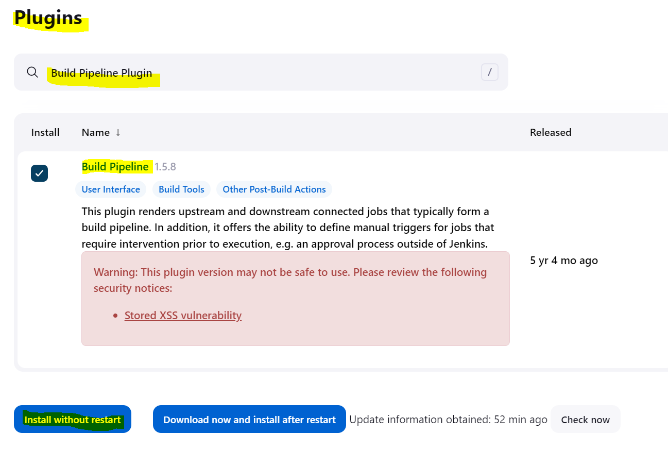

* Now we can check that plugins are installed or not, if it is installed it should be present in installed plugins. The screenshot is given below.

Screenshot 3 :

Step 8 : Now we have to configure build pipeline view.

Screenshot 1:

Screenshot 2:

Screenshot 3:

Then click on OK button to proceeds.

Step 9 : our jobs ( Upstream and downstream) done successfully. We can see the following output.

Step 10 : we can see the console output of this two jobs , the screen shot is given below.

Screenshot1 : This is my build no.5 and the console output is that. (DevCompile). Also noticed that **Triggering a new build of QAUnitTest**

Screenshot2 : This is my build no.5 and the console output is that. (QAUnitTest)

Step 11: Now we can see the pipeline view of this job, just click on demo_execution_1. The screenshot is given below.

Conclusion: Successfully build the pipeline with upstream and downstream the project.