Kaushik Dey

Kaushikdey1984@yahoo.com

hands on with jenkins components

Devops Tools

First, we just copy the Jenkins URL :

<http://ec2-54-166-207-152.compute-1.amazonaws.com:8080/view/all/newJob>

**Step 1** : click on Manage Jenkins . its very important place where we can do our administration work over Jenkins , the screenshot is given below.

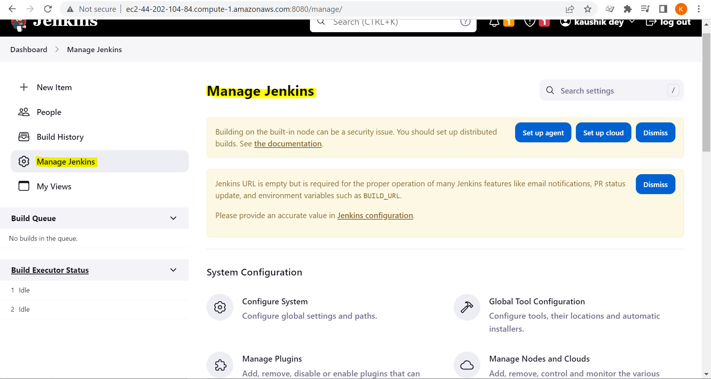

Step 2: very import under manage Jenkins is **System Configuration**

Step 3 : we have installed , available plugins , the screenshot is given below.

Step 4 : now we have to see the **user management** under managed plugins, the screenshot is given below. ( this user creation is not recommended , but it is one of the way that we can create our users here )

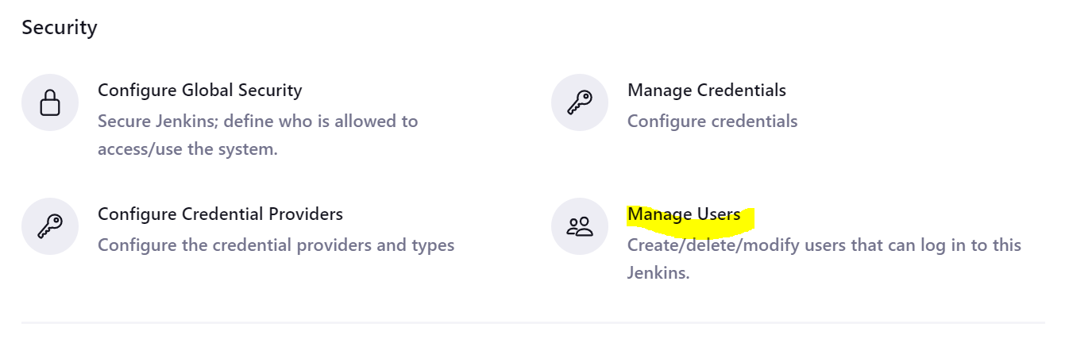

Now we can create user , the following screenshot is given below.

Step 5 : next another important concept is that configuare system. The screen shot is given below.

**Note : Important concept is that number of executors : here we set 5 executors , the screenshot is given below.**

**So, when we create the job that time also we can see the 5 build executor status. The screenshot is given below.**

Step 7 : we have manage nodes and clouds option, the screenshot is given below.

Step 8: now we have created our own free style project by clicking the new Item. The screenshot is given below. ( create jenkins jobs)

Freestyle project means we have to manually configure the components.

Pipeline projects .

In real time we can know that pipeline project is recommended.

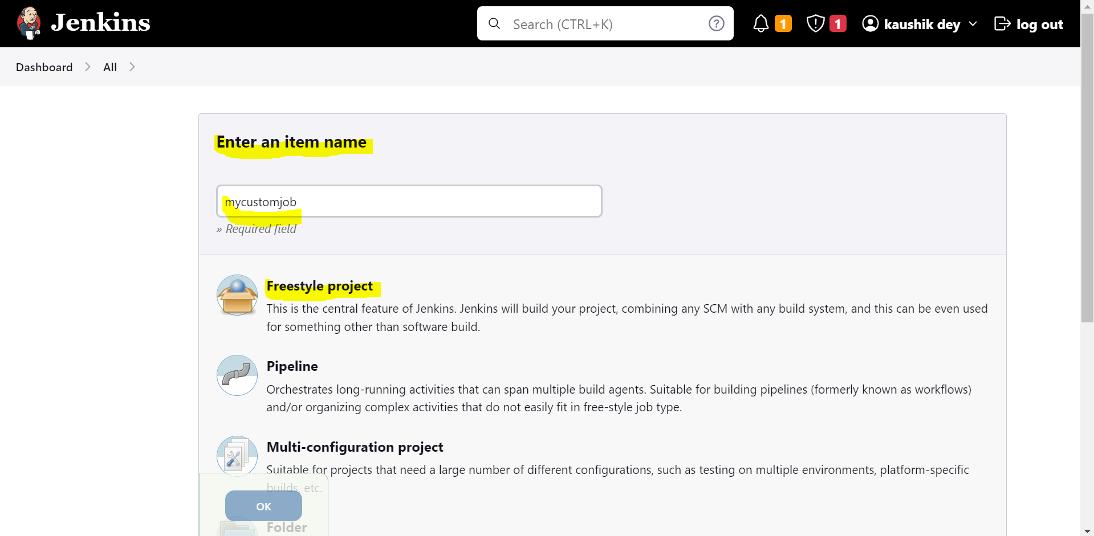

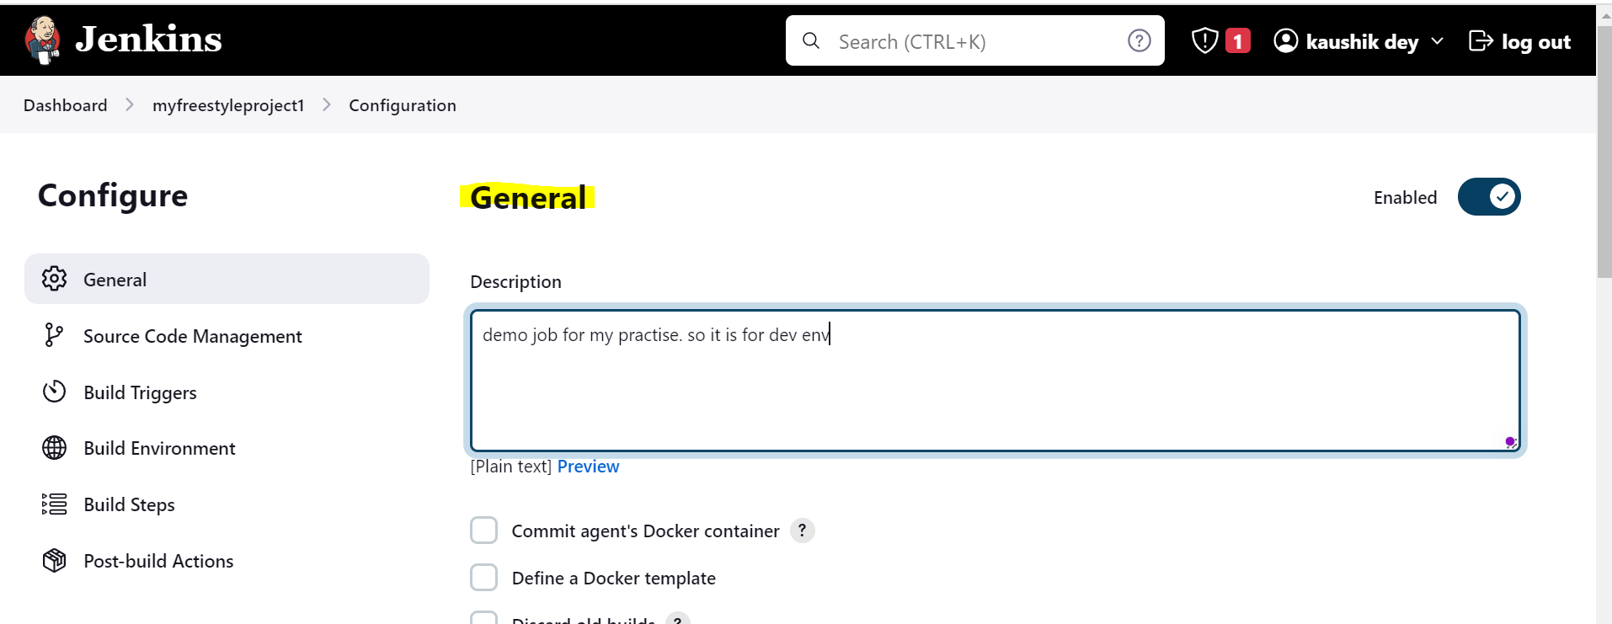

**Now we must configure the build steps. ( Important steps )**

The execute Shell command with code is given below.

* Open execute shell command and write simple echo command and click on Apply button.
* Now go to the job board and see the effects.
* Now we can see the console output and the jenkins workspace details.

Now we can run this jobs, the screenshot is given below. Click in the Build Now option.

Now we can see from the workspace details where jenkins are installed.

Written the normal script. ( build script for shell )

echo "Hello"

echo "hello team" >> file1.txt

echo "jenkins-${JOB_NAME}-${BUILD_NUMBER}"

echo "user defined var- ${envi}"

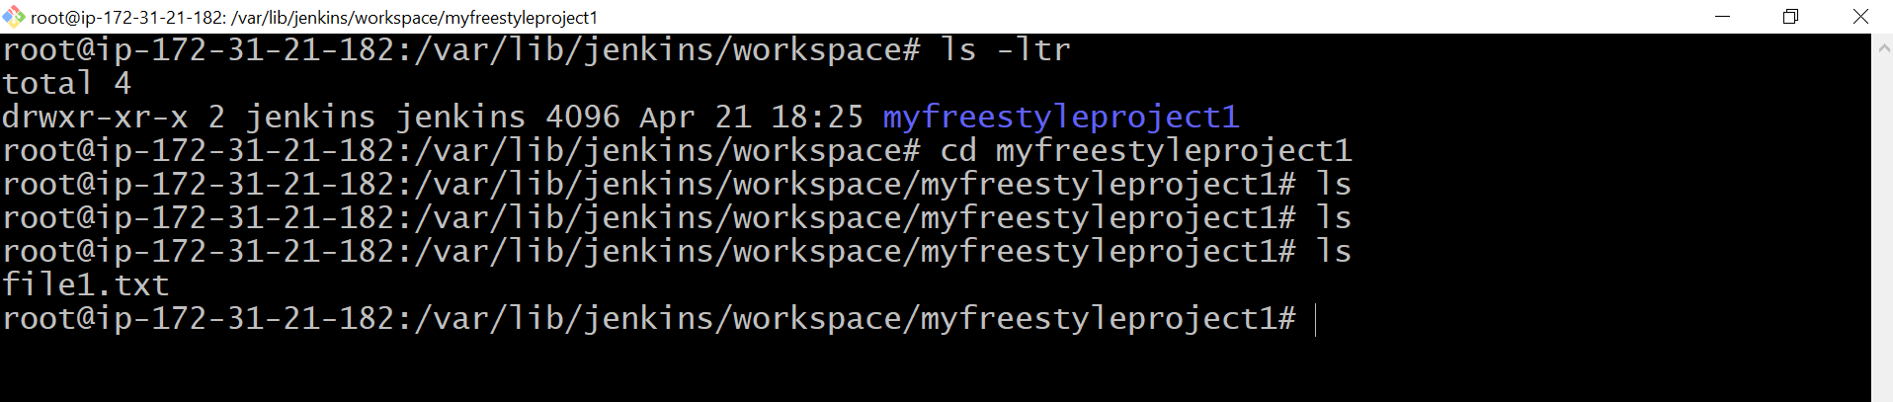

Step 9 : Now we have concentrated on variables, **( Environment variable and user defined variable)**

The link is : http://ec2-54-166-207-152.compute-1.amazonaws.com:8080/env-vars.html/

Step 10 : now we can again modify our existing job again. The screenshot is given below.

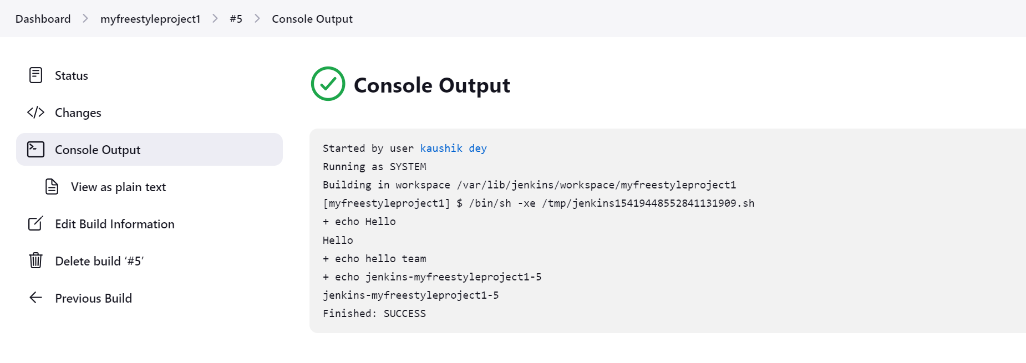

Step 11 : Now we can go with user defined variable.

Please check on This project is parameterized.

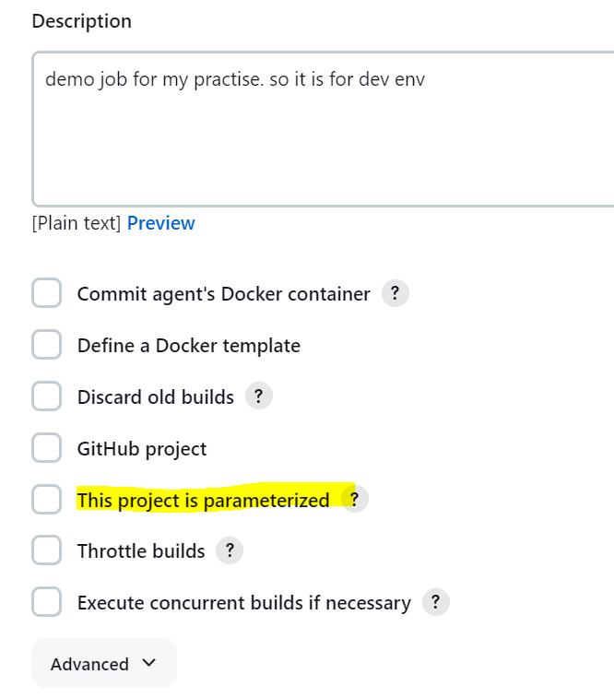

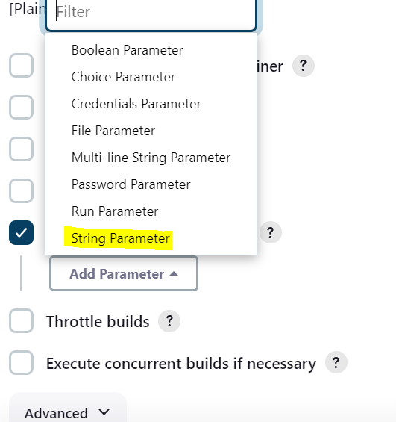

In this case we are taking three parameter ( Name, Default Value and Description ).

**Please note : After saving this job ( with parameterized build ) we can see that build option now change to build with paramenter, the screenshot is given below.**

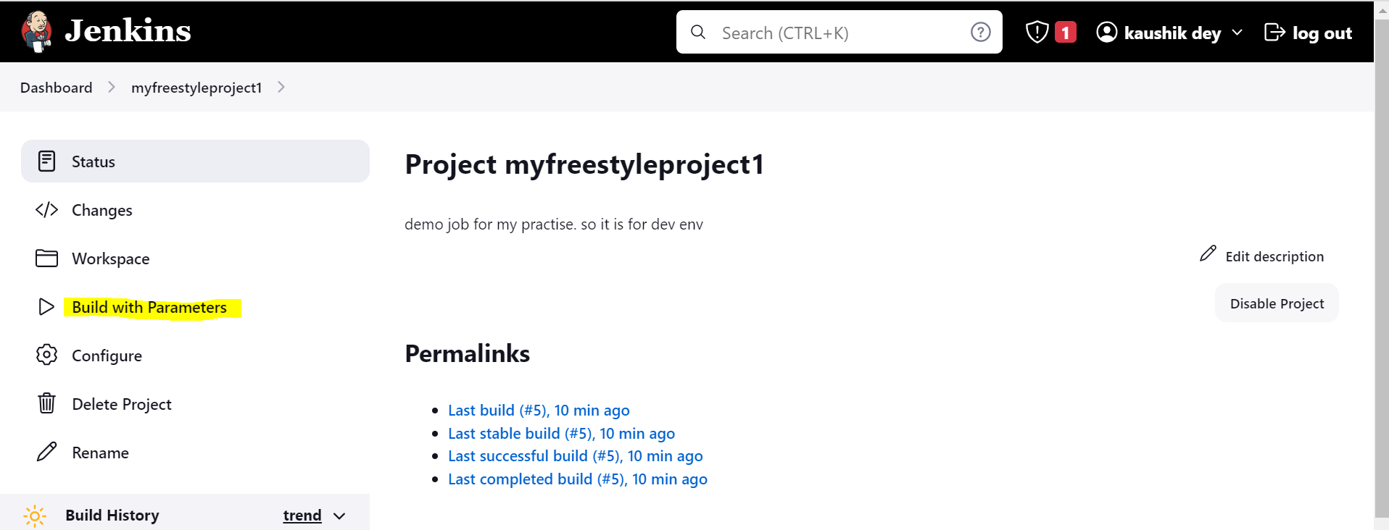

In my case I have changed the value , QA to UAT ( in the runtime ) , the screenshot is given below.

For this demo the following commands line are provided, the list is given below.

1 sudo apt-get update -y

2 sudo apt install openjdk-11-jre -y

3 curl -fsSL https://pkg.jenkins.io/debian-stable/jenkins.io-2023.key | sudo tee /usr/share/keyrings/jenkins-keyring.asc > /dev/null

4 echo deb [signed-by=/usr/share/keyrings/jenkins-keyring.asc] https://pkg.jenkins.io/debian-stable binary/ | sudo tee /etc/apt/sources.list.d/jenkins.list > /dev/null

5 apt-get update

6 java --version

7 apt-get install jenkins

8 jenkins --version

9 cd /var/lib/jenkins

10 ls

11 cd secrets

12 ls

13 cat initialAdminPassword

14 cd

15 cd /var/lib/jenkins/

16 ls

17 cd plugins

18 ls

19 history

20 ls

21 cd ..

22 ls

23 cd users

24 ls

25 cd kaushikbhai_12703125140721037793

26 ls

27 ls -ltr

28 cat config.xml

29 clear

30 cd

31 cd /var/lib/jenkins/

32 ls

33 ls -ltr

34 cd workspace

35 clear

36 ls -ltr

37 cd myfreestyleproject1

38 ls

39 cat file1.txt

40 ls

41 cd ..

42 ls

43 cd ..

44 ls -ltr

45 cd jobs

46 ls

47 cd myfreestyleproject1

48 ls

49 cd builds

50 ls -ltr

51 history