Impact Assessment of Covid-19 on universalisation of School Education System in Gujarat

The study proposes to focus on the impact assessment of covid-19 on universalisation of school education system in Gujarat.

Aim/objectives

To assess the present situation and the essential factors related to school education in Gujarat To review the existing conceptual framework and scholarly view proposed in this area.

To study the impact of covid-19 on learning outcomes To study impact of covid-19 on equity outcomes

To study adequacy of existing infrastructure

The proposed study intends to bring out a comprehensive analysis of Impact of covid-19 on school education system in Gujarat.

School education is a subject of the Concurrent List and that state-level leadership is crucial for improving outcomes in a cost effective manner.

The study is proposed to measure the overall effectiveness, quality and efficiency of Gujarat school education system.

The study will measure the efficiency of school education system and its cost- benefit analysis The enrolment status of Gujarat compared to other states of India

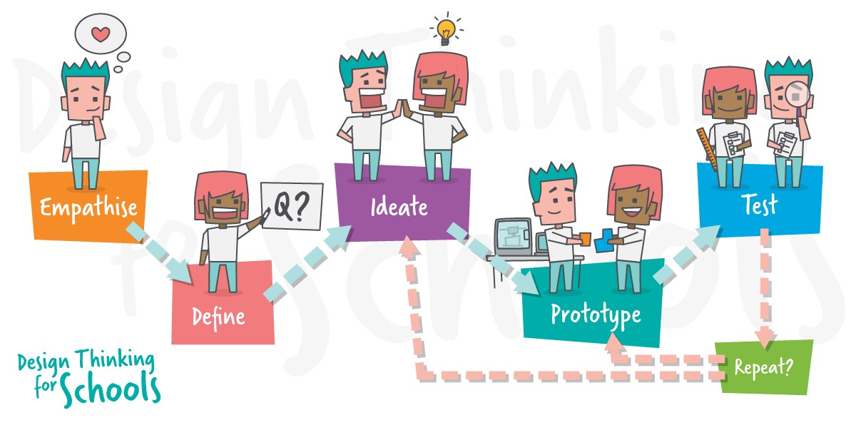

Whether there is significant cost of covid-19 on school education system in Gujarat Hypotheses:

There is no significant relationship between covid-19 and performance on equity outcome domain There is no significant relationship between covid-19 and performance on access outcome domain

There is no significant relationship between covid-19 and performance on infrastructure and Facilities outcome domain

There is no significant relationship between covid-19 and performance on learning outcome domain

The study will be using both primary and secondary sources for this study. For this study data will be collected by using survey method with the help of questionnaire as well as interview schedule.

Secondary sources will be taken from annual reports, review of studies, articles and various publications and analyzed. For this study combination of quantitative data as well as qualitative data will be used.

Secondary sources: UDISE+, National Achievement Survey, NCERT, Mid Day Meal, PFMS, Shagun Portal etc.

Relevance of Proposed study in policy planning:

The study is relevant for policy makers to measure impact of covid-19 on school education system in Gujarat.

Relevance of Proposed study in Society:

The study is important in the present scenario because even though RTE Act 2009 complement SDG however substantial change is still needed.

Covid-19 crisis has challenged the key questions of “why”, “what”, “how”, “who”, and “when” of education

Broadly identified challenges with e-learning are accessibility, affordability, flexibility, learning pedagogy, life-long learning and educational policy

The level of academic performance of the students is likely to drop for the classes held for both year-end examination and internal examination due to reduced contact hour for learners and lack of consultation with teachers when facing difficulties in learning/understanding

Depending on the duration of the lockdown, postponement or cancellation of the entire examination assessment might be a grim possibility

Thank you