1. <https://ap1.ca.analytics.ibm.com/bi/?perspective=dashboard&pathRef=.my_folders%2FCustomerLoyaltyProgram_dashboard&action=view&mode=dashboard&subView=model0000018281dc6c16_00000000>

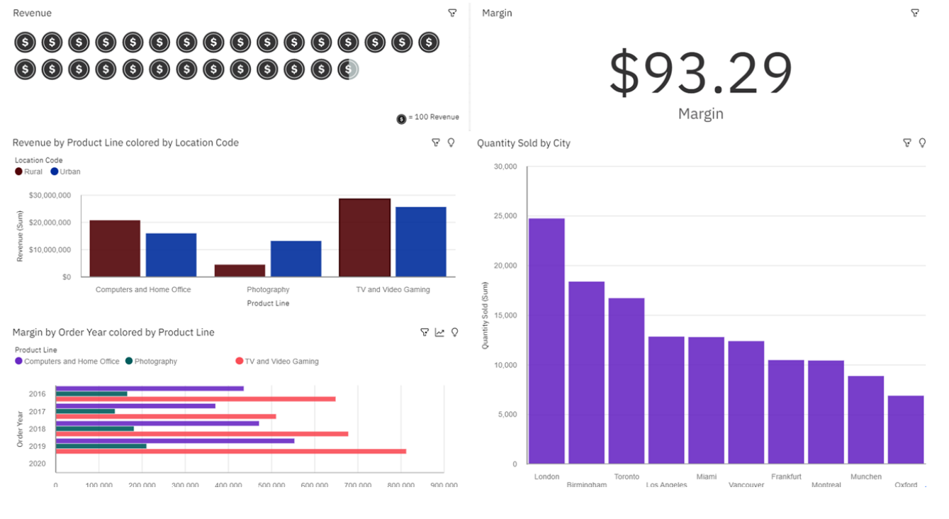

1. <https://ap1.ca.analytics.ibm.com/bi/?perspective=dashboard&pathRef=.my_folders%2FSimple_dashboard_for_lat_long&action=view&mode=dashboard&subView=model0000018281fa649c_00000000>

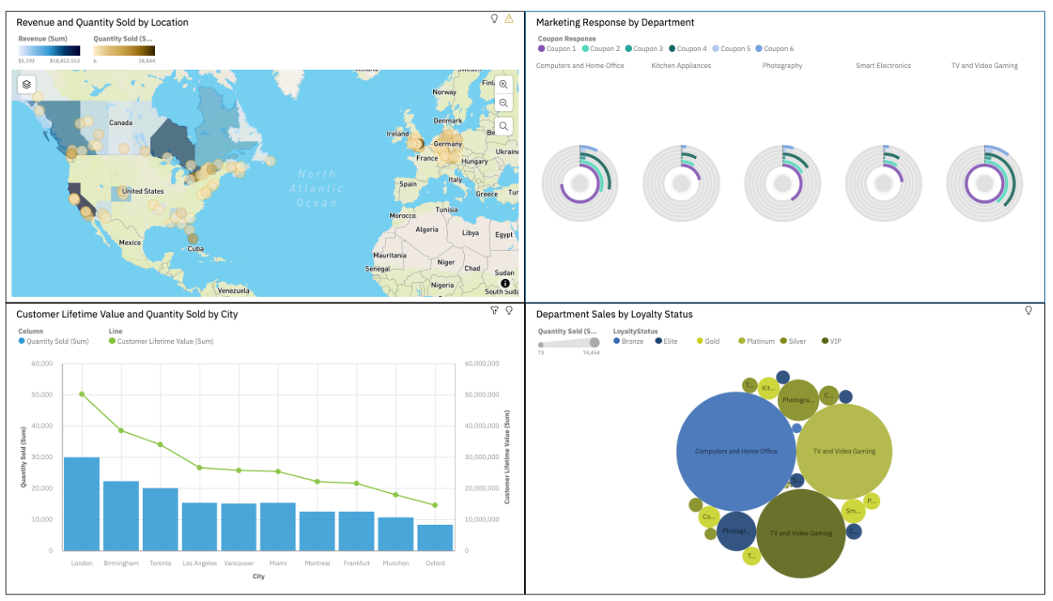

1. 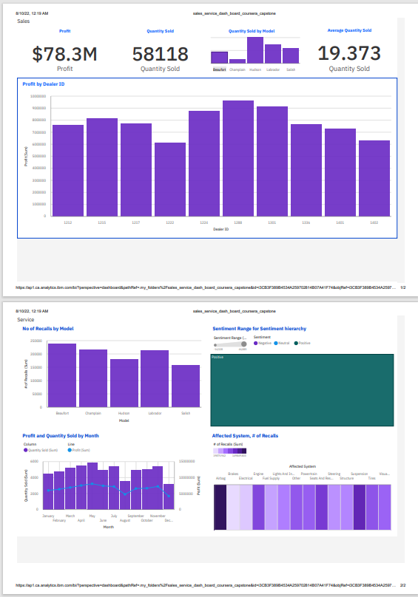<https://ap1.ca.analytics.ibm.com/bi/?perspective=dashboard&pathRef=.my_folders%2Fsales_service_dash_board_coursera_capstone&action=view&mode=dashboard&subView=model0000018283cb6761_00000001>