In this example I just used my google sheet as a primary data source and that has to be connected with FiveTran to Snowflake.

https://docs.snowflake.com/en/user-guide/ecosystem-partner-connect.html

1. <https://app.snowflake.com/ap-southeast-1/kd90882/#/partner-connect>

1. Then choose FiveTran as my partner connect ( Database, warehouse and system password given)

1. This Launch icon automatically redirects to FiveTran Account with following url and screenshots:

<https://fivetran.com/dashboard/warehouse> ( Connectors, Transformation and Destination is selected here)

1. Now go to Connectors and add one data connector. ( Click on Add Connector Button)

1. <https://fivetran.com/dashboard/add-connector> and screenshot where we can add our database (Mysql, Redshift, GoogleSheet)

1. Choose Google Sheet from the **Search all sources with following screenshots.**

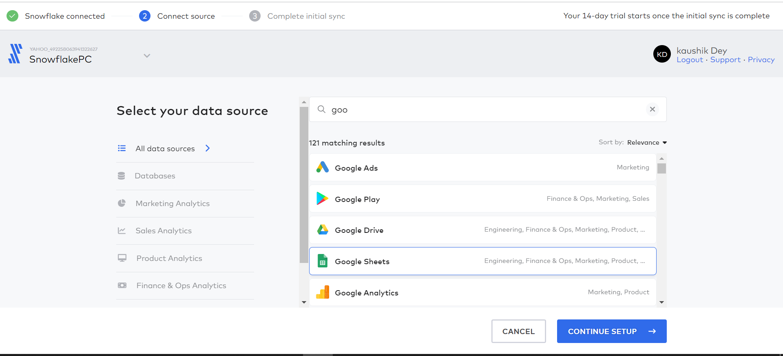

1. Now we have to click on Continue setup button for next step of my google Sheet.
2. <https://fivetran.com/integrations/google_sheets?groupId=alighted_afforded&unsaved=false&testing=false> with Following ScreenShots.

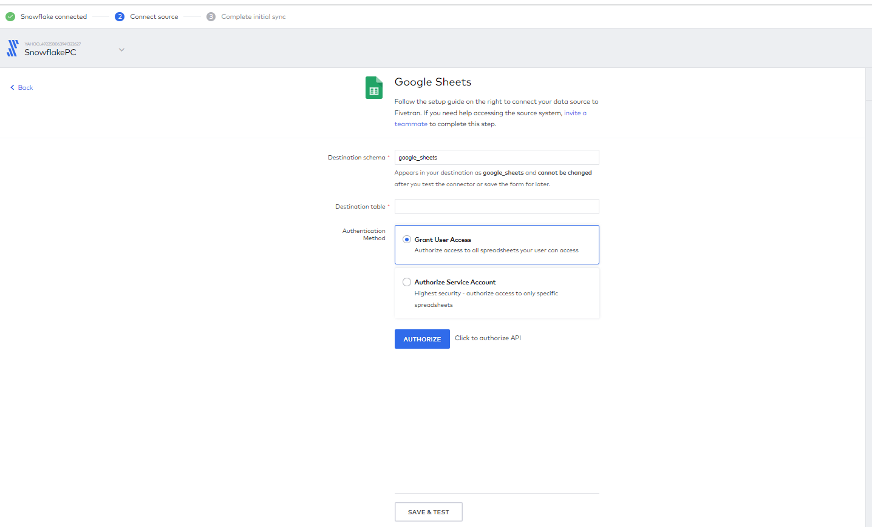

1. Now setup your Google Sheet, In My case I have created small dummy data in google sheet from my personel account.

**In My case Destination schema is : dummydataloadexcel and**

**table is : final_data_performance**

**And Authorized your userAccess.**

**Now I got the message in** five-tran that Authentication Succeeded

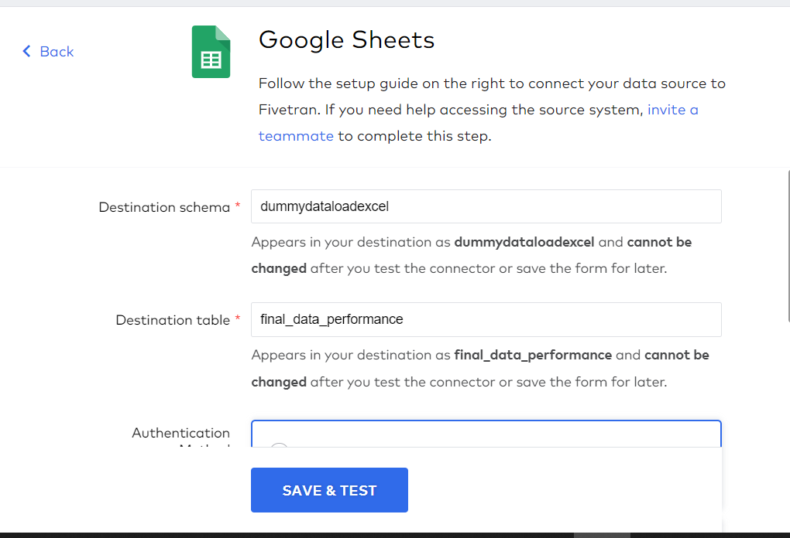

1. Now we have to add our dummy google sheet with data with its namedrangeOptions.

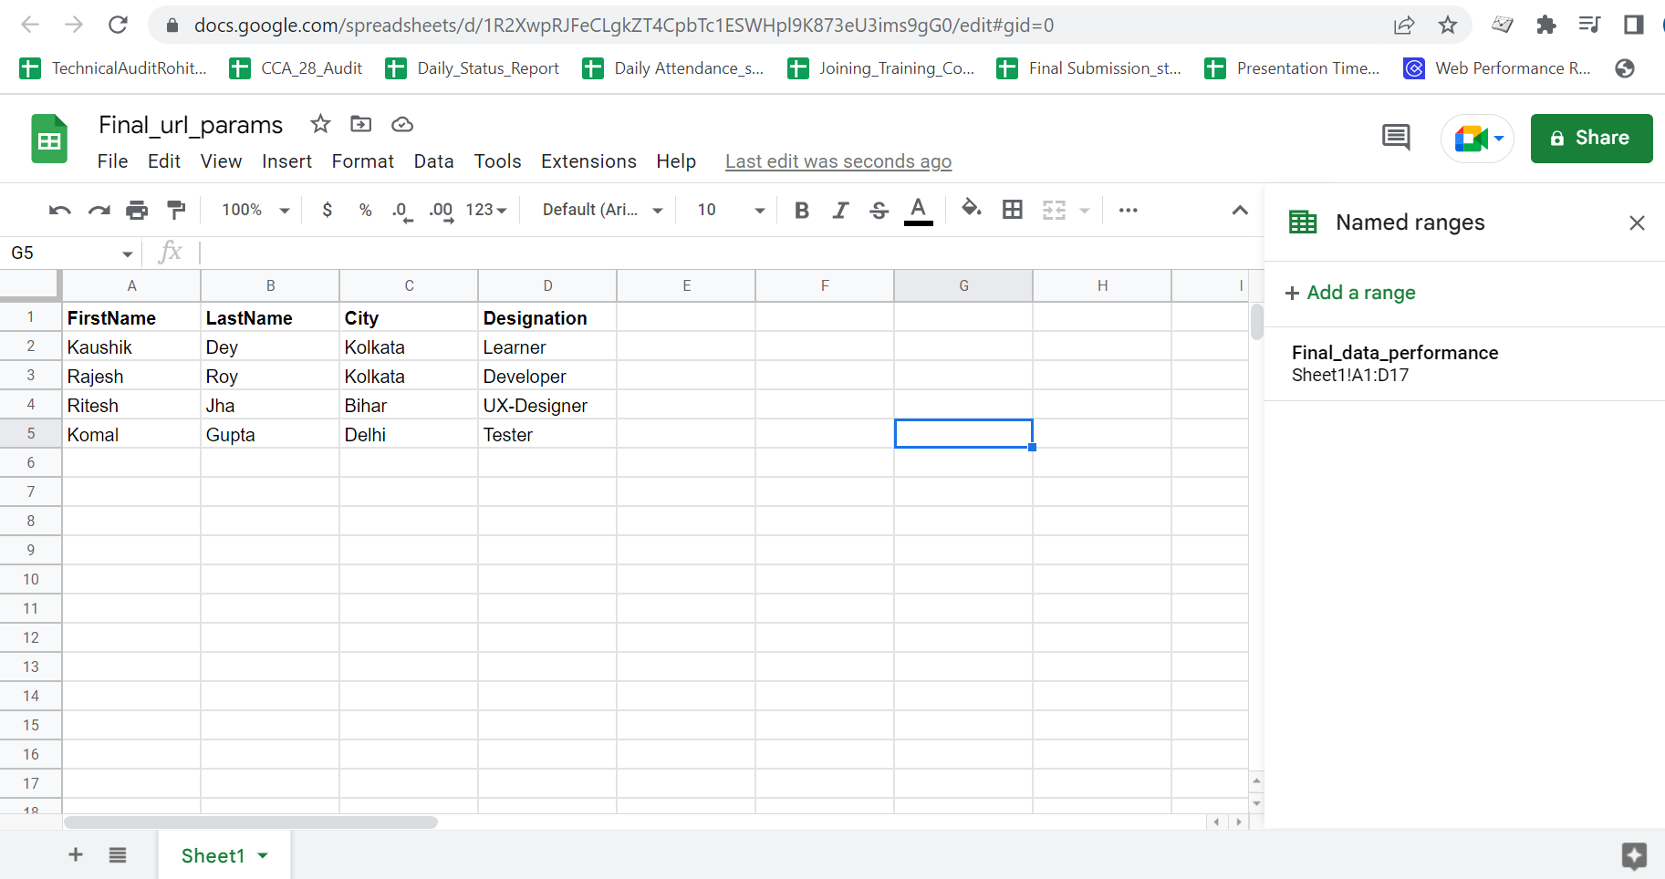

This above Dummy data uploaded into snowflake via fivetran.

<https://docs.google.com/spreadsheets/d/1R2XwpRJFeCLgkZT4CpbTc1ESWHpl9K873eU3ims9gG0/edit#gid=0> ( Google Sheet Link)

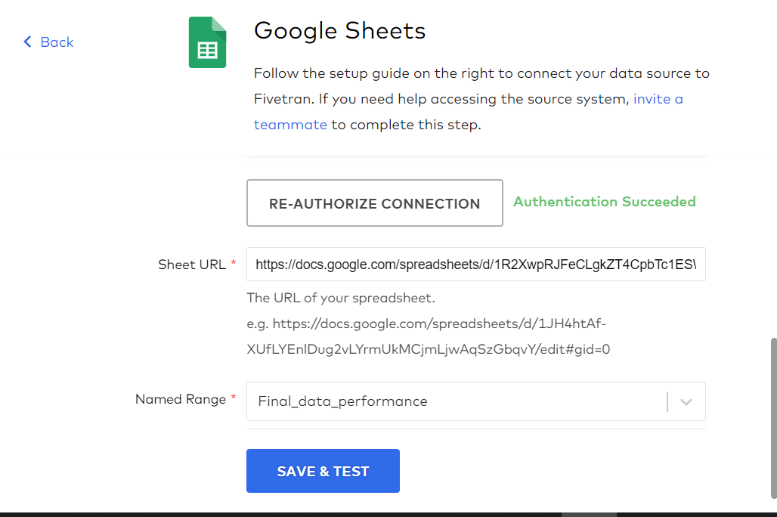

Now Click on Save & test button for Google Sheet Validation.

1. [**https://fivetran.com/integrations/google_sheets/oauth2/return?code=4%2F0AfgeXvvnCIrcnnjpHBWQPjrqHBFuDfB6YRcPzr9yY1ezFN6tMKPY9b4CU10nQe8bJzOo-Q&scope=https%3A%2F%2Fwww.googleapis.com%2Fauth%2Fspreadsheets.readonly&unsaved=false&testing=false**](https://fivetran.com/integrations/google_sheets/oauth2/return?code=4%2F0AfgeXvvnCIrcnnjpHBWQPjrqHBFuDfB6YRcPzr9yY1ezFN6tMKPY9b4CU10nQe8bJzOo-Q&scope=https%3A%2F%2Fwww.googleapis.com%2Fauth%2Fspreadsheets.readonly&unsaved=false&testing=false)

**with following screenshots.**

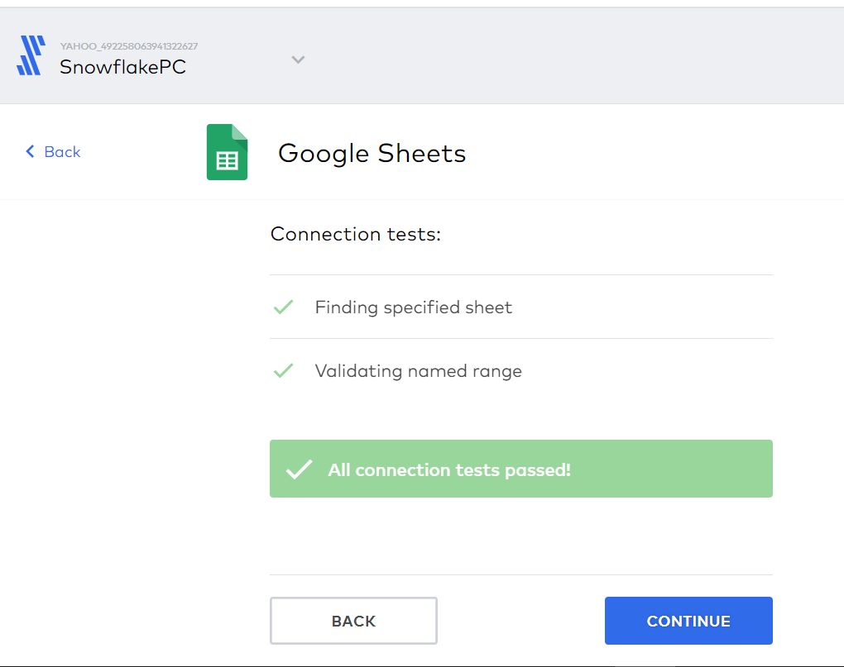

**Now we have to Continue for next process.**

1. **Now we have to sync my data with following options.**
2. **https://fivetran.com/dashboard/connectors/google_sheets/dummydataloadexcel.final_data_performance/schema/select-sync-mode 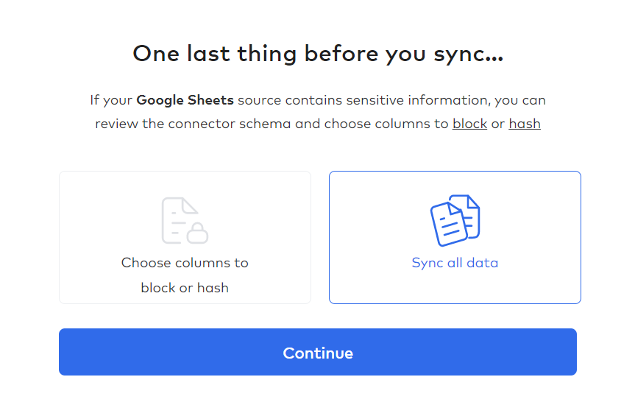 with following Messages.**
3. Your connector is ready to sync source data to your destination! Syncing may take time depending on how large your data set is. Your 14-day trial will begin after any connector you add completes an initial sync.

**URL :** [**https://fivetran.com/dashboard/connectors/google_sheets/dummydataloadexcel.final_data_performance/status?requiredGroup=alighted_afforded**](https://fivetran.com/dashboard/connectors/google_sheets/dummydataloadexcel.final_data_performance/status?requiredGroup=alighted_afforded)

**ScreenShots:**

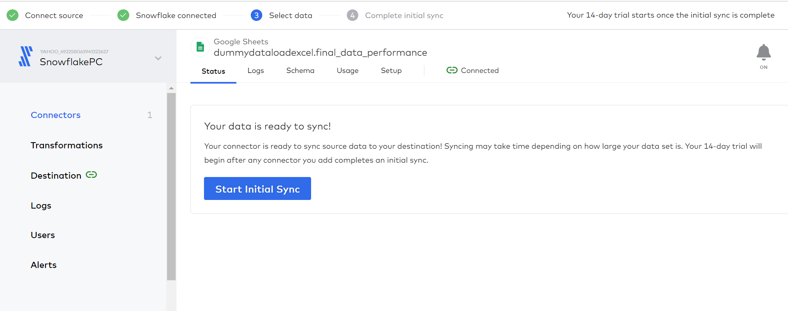

1. **Now we have to start Initial Sync button.**

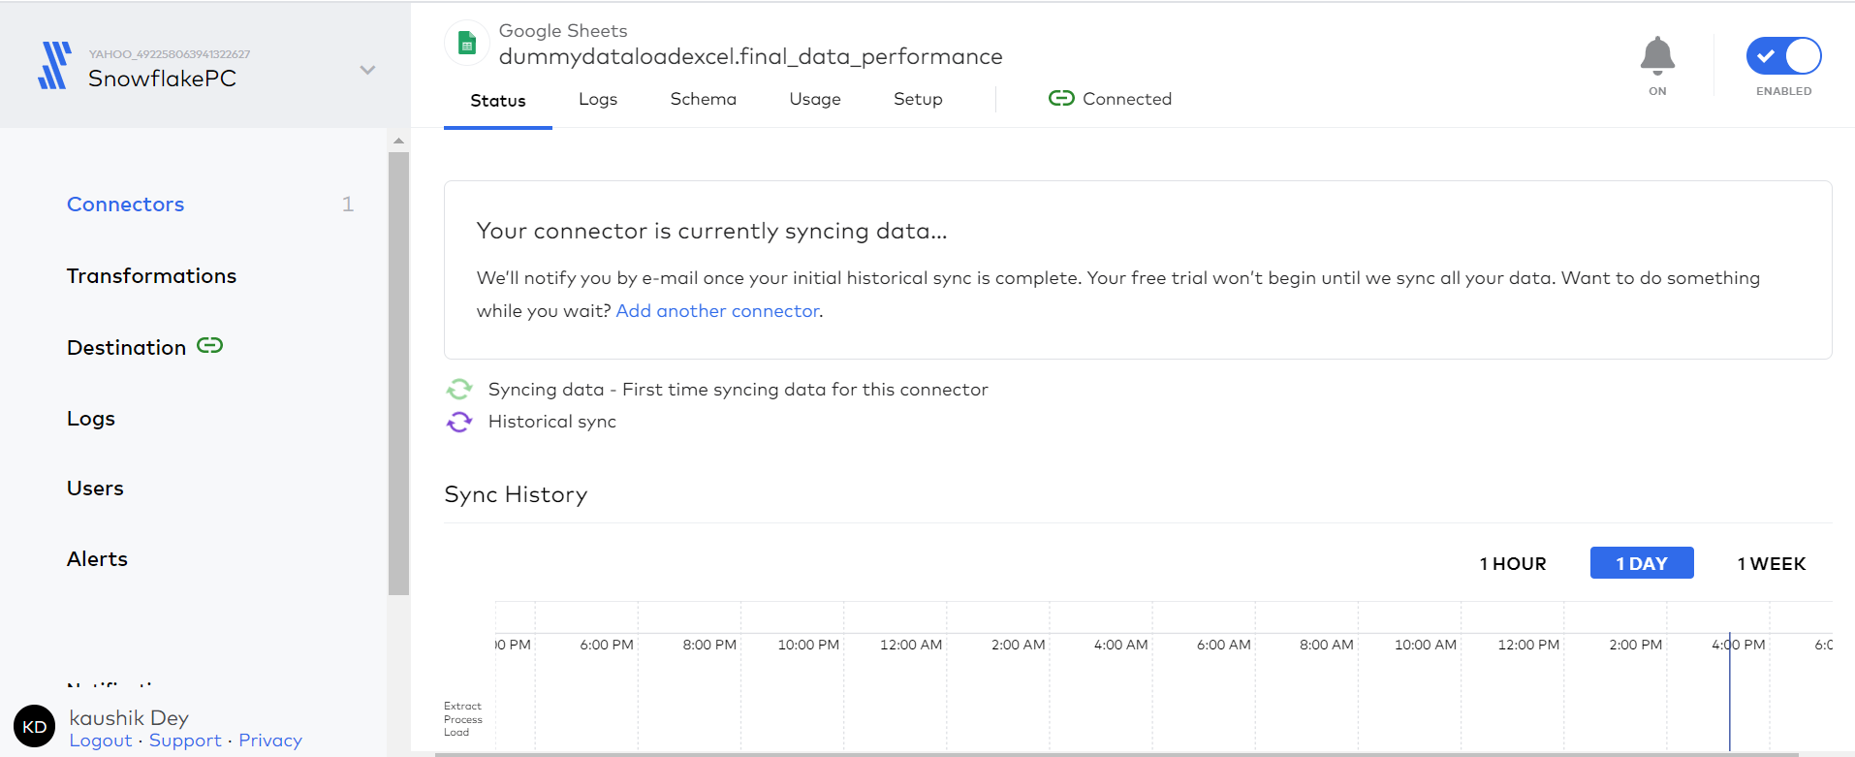

**With extra screenshots.**

1. **Now if I will go to snowflake account to check the data is showing there or not .**

[**https://app.snowflake.com/ap-southeast-1/kd90882/w4DSeNBxkUqm#query**](https://app.snowflake.com/ap-southeast-1/kd90882/w4DSeNBxkUqm#query)

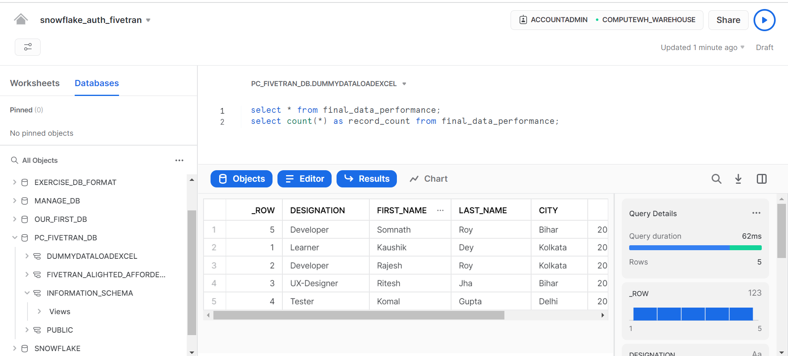

**So, we can see the data what we have added in that google sheet it will show in our snowflake account. Following information is required for that.**

**Database Name : PC_FIVETRAN_DB**

**SCHEMA NAME : DUMMYDATALOADEXCEL**

**TABLE NAME : final_data_performance;**

**The Following queries we can perform to check.**

**select * from final_data_performance;**

**select count(*) as record_count from final_data_performance;**

1. **For sync we can trigger sync button in fivetran environment also.**

**Finally our data is synced with my connectors.**

[**https://fivetran.com/dashboard/connectors/google_sheets/dummydataloadexcel.final_data_performance/status?requiredGroup=alighted_afforded**](https://fivetran.com/dashboard/connectors/google_sheets/dummydataloadexcel.final_data_performance/status?requiredGroup=alighted_afforded) **[Five Tran console]**

[**https://app.snowflake.com/ap-southeast-1/kd90882/w4DSeNBxkUqm#query**](https://app.snowflake.com/ap-southeast-1/kd90882/w4DSeNBxkUqm#query) **[SnowFlake]**