|  |
| --- |
|  |

|  |
| --- |
| **Patient Diagnosis Report** |
| SQL Queries |
|  |
|  |
|  |
| **Kaushik Dey** |
|  |
|  |

Description

The data analyst of a hospital wants to store the patient diagnosis reports with the details of the doctors and the patients for good medical practice and continuity of care.

**Objective:**

The database design helps to retrieve, update, and modify the patient’s details to keep track of the patient's health care routine.

**Task to be performed:**

* Write a query to create a **patients table** with the fields such as date, patient id, patient name, age, weight, gender, location, phone number, disease, doctor name, and doctor id.

CREATE TABLE Patient_Diagnosis_Report.patients (

date DATE NOT NULL,

pid varchar(45) NOT NULL,

p_name varchar(45) NOT NULL,

age INT NOT NULL,

weight INT NOT NULL,

gender varchar(45) NOT NULL,

location varchar(45) NOT NULL,

phone_no INT NOT NULL,

disease varchar(45) NOT NULL,

doctor_name varchar(45) NOT NULL,

doctor_id INT NOT NULL,

PRIMARY KEY(pid));

* Write a query to **insert** values into the **patients table**.

INSERT INTO Patient_Diagnosis_Report.patients

(date,pid,p_name,age,weight,gender,location,phone_no,disease,doctor_name,doctor_id)

VALUES

('2019-06-15','AP2021','Sarath','67','76','Male','chennai','5462829','Cardiac','Mohan','21'),

('2019-02-13','AP2022','John','62','80','Male','banglore','1234731','Cancer','Suraj','22'),

('2018-01-08','AP2023','Henry','43','65','Male','Kerala','9028320','Liver','Mehta','23'),

('2020-02-04','AP2024','Carl','56','72','Female','Mumbai','9293829','Asthma','Karthik','24'),

('2017-09-15','AP2025','Shikar','55','71','Male','Delhi','7821281','Cardiac','Mohan','21'),

('2018-07-22','AP2026','Piysuh','47','59','Male','Haryana','8912819','Cancer','Suraj','22'),

('2017-03-25','AP2027','Stephen','69','55','Male','Gujarat','8888211','Liver','Mehta','23'),

('2019-04-22','AP2028','Aaron','75','53','Male','Banglore','9012192','Asthma','Karthik','24');

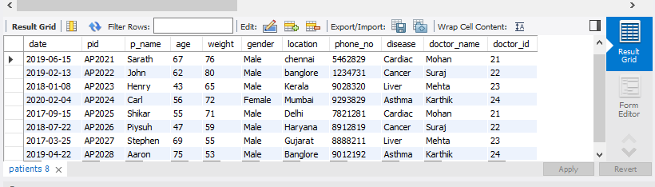

* Write a query to display the **total number of patients** in the table.

select count(*) as total_number_of_patients from Patient_Diagnosis_Report.patients;

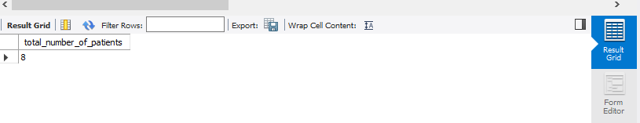

* Write a query to display the patient id, patient name, gender, and disease of the patient whose **age is maximum**.

select pid, p_name, gender, disease, max(age) as max_age from Patient_Diagnosis_Report.patients;

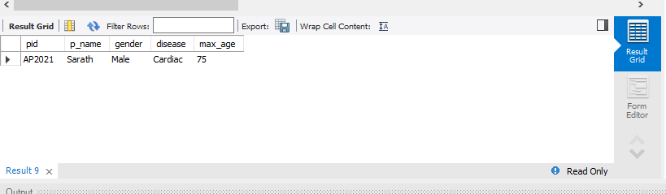

* Write a query to display patient id and patient name with the **current date**.

select pid, p_name, now() as curent_date from Patient_Diagnosis_Report.patients;

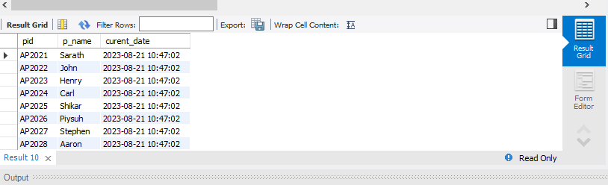

* Write a query to display the **doctor’s name** in **uppercase**.

select UCASE(doctor_name) as upperCase_Doctor_name from

Patient_Diagnosis_Report.patients;

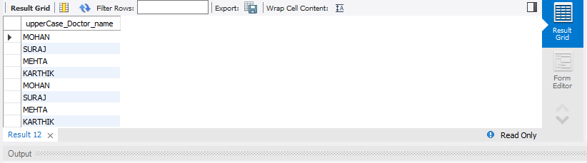

* Write a query to display the patient’s name along with the **length of their name.**

select p_name, length(p_name) as length_of_patient_name from

Patient_Diagnosis_Report.patients;

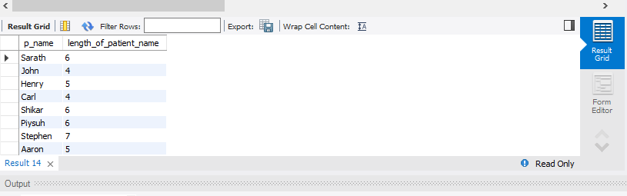

* Write a query to display the patient’s name, and the **gender** of the patient must be mentioned as **M or F**.

select p_name, mid(gender,1,1) as Gender from Patient_Diagnosis_Report.patients;

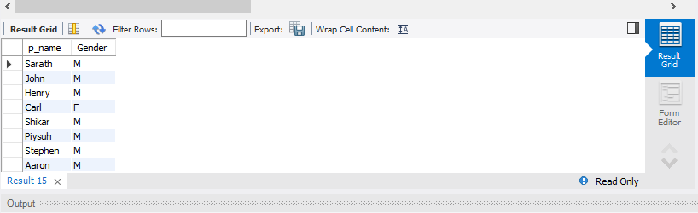

* Write a query to **combine the names of the patient** and the doctor in a new column.

select p_name, doctor_name, concat(p_name, ' ', doctor_name) as patient_doctor_name from

Patient_Diagnosis_Report.patients;

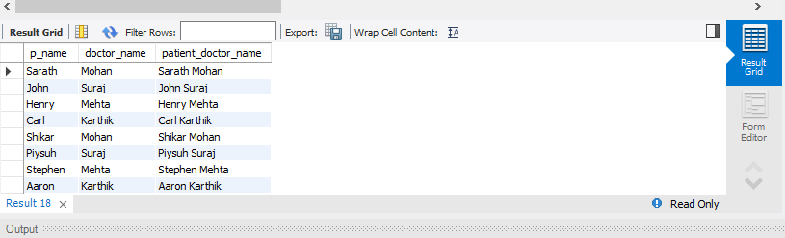

* Write a query to display the patients’ age along with the **logarithmic value** (base 10) **of their age**.

select age, log10(age) as log_age from Patient_Diagnosis_Report.patients;

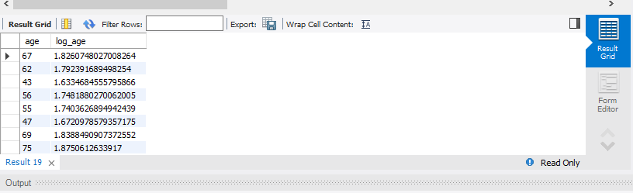

* Write a query to **extract the year** from the given date in a separate column.

select *, year(date) as year_extraction from Patient_Diagnosis_Report.patients;

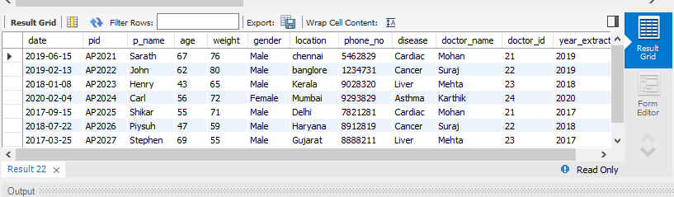

* Write a query to return **NULL** if the **patient’s name and doctor’s name are similar** else returns the **patient’s name**.

select nullif(p_name,doctor_name) as conditional_name from Patient_Diagnosis_Report.patients;

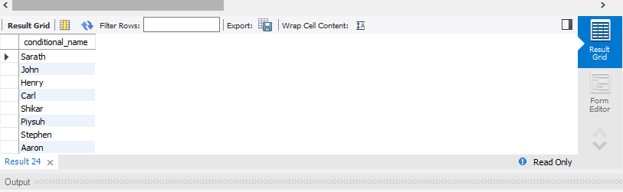

* Write a query to return**Yes** if the **patient’s age is greater than 40** else return **No**.

select age,if(age>40,'Yes','No') as agegreater_40 from

Patient_Diagnosis_Report.patients;

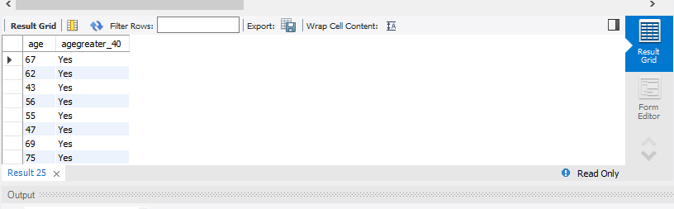

* Write a query to display the **doctor’s duplicate name** from the table.

select doctor_name, count(*) occurences from Patient_Diagnosis_Report.patients GROUP BY

doctor_name HAVING COUNT(*)>1;

