Digital Elevator Controller with Priority Handling

Group Members:
B. Kaushik Reddy – 24ECB0B11
B. Karthik – 24ECB0B12
Ch. Vishnu Vardhan– 24ECB0B13
OBJECTIVES :
The main objective of this project is to design and implement an intelligent, FPGA-based Digital Elevator Controller using Verilog HDL that efficiently manages elevator movement across multiple floors with priority-based request handling.
The system aims to:
- Control elevator operations such as movement, direction, and door actions automatically.
- Handle multiple floor requests simultaneously using a priority selection algorithm to determine the nearest target floor.
- Provide real-time floor indication through a 7-segment display interface.
- Demonstrate modular hardware design using Verilog HDL and FPGA implementation for real-time embedded control applications.

BLOCK DIAGRAM :
Elevator _top
(connects inputs, FSM, and selector)

Target _selector
Determines next target floor from requests

Elevator_ fsm
Main Control Logic (Finite State Machine)

SUBMODULES
IDLE
Waits for new requests from car_req or hall_up/down

NEXT VALID=1

PICK_TARGET
Calls target_selector to choose next_target floor based on direction and pending_reqs

TARGET= CURRENT FLOOR

DOOR_OPEN | | MOVING |
| Opens doors at | |Moves elevator|
| current floor | |up/down one step |

step pulse
door timer expired

DOOR_CLOSE
| Close doors, |
| check new reqs|

Implementation

Hardware and Software Requirements
Hardware:
- Nexys-4 DDR FPGA Development Board (Xilinx Artix-7)
- On-board 7-Segment LED Display – for displaying the current floor number
- On-board Push Buttons and Switches – for car and hall requests
- Clock and Reset Inputs – for FSM timing and system initialization
Software:
- Xilinx Vivado Design Suite – for simulation, synthesis, and FPGA programming
- Verilog HDL – for module-level digital design and hardware description
- ModelSim / Vivado Simulator – for functional verification and waveform analysis

Functional Description
The Digital Elevator Controller is implemented using a modular Verilog HDL design consisting of three main modules:
- elevator_fsm – Handles motion control, door operation, and state transitions.
- target_selector – Determines the next floor to service based on current direction and pending requests.
- elevator_top – Integrates all submodules and interfaces with the display system.

Input Interface:
- Car Requests (car_req): 4-bit input representing internal elevator button requests (floors 0–3).
- Hall Up (hall_up) and Hall Down (hall_down): 3-bit inputs each, representing floor calls from outside the elevator.
- Clock (clk) and Reset (reset): Used to synchronize FSM transitions and initialize system state.
All requests are latched into a pending request register and held until the requested floor is reached.

Processing Logic:
- The Finite State Machine (FSM) transitions between five main states:
IDLE → PICK_TARGET → MOVING → DOOR_OPEN → DOOR_CLOSE → IDLE
- The Target Selector Module dynamically determines the nearest valid floor based on the current floor and motion direction.
- A step counter generates periodic pulses (step_pulse) that simulate real-time elevator motion from one floor to the next.
- The system supports bidirectional motion with motor_up and motor_down control signals.

Output and Display:
- The current floor number is output in binary and converted to BCD using a binary_to_bcd converter (Double Dabble Algorithm).
- Door and motor status signals (door_open, motor_up, motor_down) can also be visualized during simulation.

Operational Summary
- System Initialization: Elevator starts at floor 0 in the IDLE state.
- Request Handling: Any car or hall call sets a bit in pending_reqs.
- Target Selection: The next floor is chosen using the target_selector logic based on direction.
- Movement: Elevator moves floor-by-floor until the target is reached.
- Door Operation: The door opens and closes automatically at the target floor.
- Next Request Check: FSM checks for more requests; if none, returns to IDLE.
Modules Description :

1. elevator_top
- The top-level module that integrates all submodules including the FSM, target selector, BCD converter, and display driver.
- Connects input signals such as car_req, hall_up, and hall_down to the controller.
- Manages overall elevator control, display interfacing, and system synchronization through the clock and reset inputs.
- Ensures proper signal flow between the FSM, selector, and output display.

2. elevator_fsm
- Implements the Finite State Machine (FSM) that governs elevator operation.
- Handles five primary states:
IDLE → PICK_TARGET → MOVING → DOOR_OPEN → DOOR_CLOSE → IDLE
- Controls the elevator’s motion, door operation, and state transitions based on current requests and position.
- Generates output signals:
  - motor_up and motor_down – control the direction of movement.
  - door_open – activates door open duration.
  - current_floor – tracks current floor level.
- Includes step counter logic to simulate real-time movement delay between floors.

3. target_selector
- Implements the priority handling and target selection logic.
- Determines the nearest valid floor request based on:
  - Current floor position
  - Direction of motion (dir_up)
  - Pending request bits (reqs)
- Provides outputs:
  - target – the next destination floor.
  - valid – indicates if a valid request exists.
- Ensures efficient and fair servicing of multiple pending requests.

4. binary_to_bcd
- Converts the binary floor value (current_floor) into a 4-digit BCD format suitable for display.
- Uses the Double Dabble Algorithm to convert 16-bit binary input to BCD digits (ones, tens, hundreds, thousands).
- Pads unused higher digits with zeros to maintain a consistent display format.

5. step_counter_logic
- Generates a periodic step_pulse that simulates floor-to-floor travel timing.
- Controlled by a programmable parameter STEP_LIMIT to vary motion speed in simulation.
- Ensures smooth elevator movement between floors during the MOVING state.

6. request_latch_logic
- Combines all car and hall button requests into a single pending request register.
- Uses logical OR operation to merge multiple input sources:
pending_reqs = car_req | hall_up | hall_down
- Maintains each request until the corresponding floor is reached and serviced.
- Updates dynamically after each completed trip.

7. Simulation Testbench (tb_elevator_fast)
- Provides simulated input patterns for car and hall requests to verify system performance.
- Monitors FSM states, motor direction, door status, and floor position in waveform view.
- Validates correct state transitions, timing behavior, and request servicing logic.

Error Handling
- Invalid Requests:
If no valid pending request exists, the FSM remains in the IDLE state until a new call is detected.
- Direction Conflicts:
The target selector logic resolves up/down direction conflicts by prioritizing current direction before switching.
- Floor Limits:
Elevator motion is constrained within valid floor indices (0–3) to prevent overflow or underflow.
- Reset Condition:
On reset activation, all registers and outputs are cleared, returning the elevator to floor 0 (idle) safely.

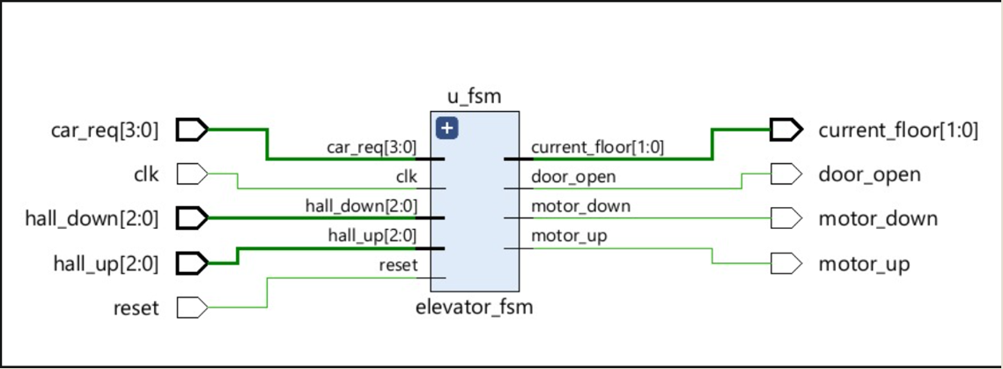
OUTPUT WAVEFORM: 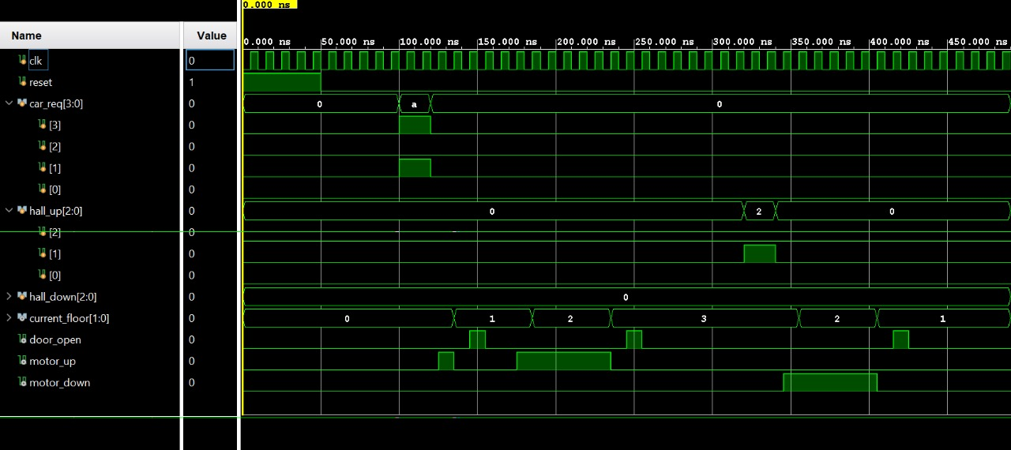
RESULT :
The Digital Elevator Controller with Priority Handling was successfully designed, implemented, and verified through both simulation and FPGA testing. The system effectively demonstrates the capability of hardware-based control logic to manage multi-floor elevator operations with accurate motion control, intelligent request handling, and real-time display output. The project validates the use of Verilog HDL and FPGA technology for implementing efficient, modular, and scalable embedded control systems.

