**Business Intelligence**

**IMAT5264**

**P2656623**

**21/05/2021**

**East Midlands Candy Assignment**

(Word count:3032)

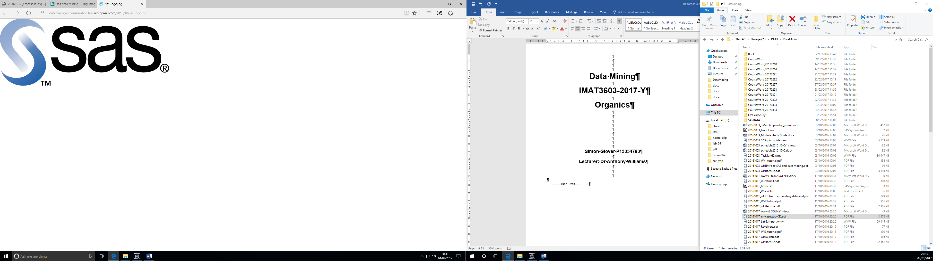

**Table of contents**

Contents

Forecasting 3

Overview of Forecasting techniques. 3

Challenges 3

Key Points East Midlands Candy should consider. 3

Forecasting Data 4

Identifying the sales pattern of the products. 5

Forecasting the performance of the 4th Year. 6

Optimization and linear programming. 16

Increasing the profit of popcorn production with Linear Programming. 16

Allocating Human Resources using Linear Programming. 17

SAS BI 17

Data preparation: Information Map Studio 18

Using SAS BI to display Total Sales with respect to Customer & Product type. 19

Using SAS BI to display Total Sales of each product to the different customer. 20

Legal, Ethical and Privacy issues 22

Conclusion 22

References 22

Other References 22

# Forecasting

The act of analyzing and mining data in order to predict what will happen in the future is known as forecasting. Forecasting is usually done with the help of a business intelligence tool like SAS Information Map Studio. Forecasting can provide critical data to any business, regardless of industry.

# Overview of Forecasting techniques.

Business forecasting uses tools and techniques to predict the changes occurring in a business (like sales, cost of production, profit, loss and so on). The aim of business forecasting is to develop better strategies based on these predictions which helps us to eliminate potential loss or failure that can happen to the business.

# Challenges

While setting up the Business Intelligence platform for EMC there could be a number of challenges the company could face. Some of them are:

* As this department is new the data processed will be from scratch and the accuracy of the prediction could be low.
* The forecast accuracy of the method is highly associated with the forecast error of the method. As we are calculating the forecast error for the 1st time there could be slight variations in the output. This could also affect the other forecasting errors as well.

# Key Points East Midlands Candy should consider.

* EMC Should have a proper understanding of the historical data to be able to make proper decisions.
* The decision EMC takes from the analysis could be bad data is not properly interpreted.
* A user could incorrectly use the application and provide false data, resulting in poor decision-making.
* There can be data leaks in some business intelligence applications that could get the data into wrong hands.

# Forecasting Data

**Product A: Chocolate Bar**

|  |  |  |  |  |
| --- | --- | --- | --- | --- |
| **Year** | **Winter** | **Spring** | **Summer** | **Autumn** |
| 1 | 9.5 | 9.3 | 9.4 | 9.6 |
| 2 | 9.8 | 9.7 | 9.8 | 10.5 |
| 3 | 9.9 | 9.7 | 9.6 | 9.6 |

The above table depicts the shows the sales of Chocolate bar in the different seasons.

**Product B: Children’s treats**

|  |  |  |  |  |
| --- | --- | --- | --- | --- |
| **Year** | **Winter** | **Spring** | **Summer** | **Autumn** |
| 1 | 14.2 | 31.8 | 33.0 | 6.8 |
| 2 | 15.4 | 34.8 | 36.2 | 7.4 |
| 3 | 14.8 | 38.2 | 41.4 | 7.6 |

The above table depicts the shows the sales of Children’s treats in the different seasons.

|  |  |  |  |  |
| --- | --- | --- | --- | --- |
| **Year** | **Winter** | **Spring** | **Summer** | **Autumn** |
| 1 | 11.4 | 12.6 | 13.0 | 12.8 |
| 2 | 13.8 | 14.0 | 14.8 | 15.2 |
| 3 | 15.6 | 15.8 | 16.2 | 16.6 |

**Product C: Adult Mint bar**

The above table depicts the shows the sales of Adult Mint bar in the different seasons.

The above three tables show the number of sales made for the 3 products (Chocolate bar, Children’s treats, and Adult Mint bar) in a particular year.

# Identifying the sales pattern of the products.

**Product A: Chocolate Bar**

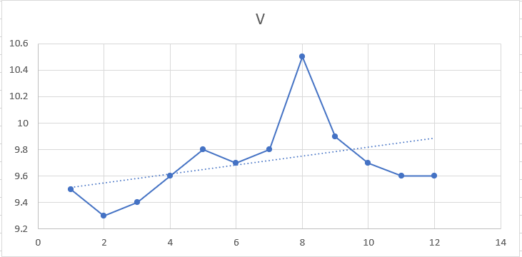

The above graph represents the time series plot of the sales of Chocolate bars.

From the above graph we can see that the sales of Product A is not follow any sort of trend over the time period given. We can see that there is a spike in sales during the 8th period which is the “Autumn” season of the 2nd year.

**Product B: Children’s treats**

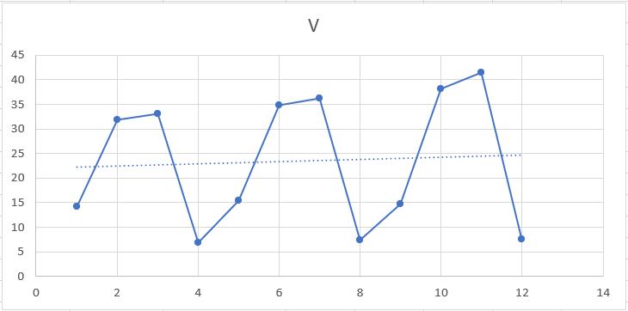

The above graph represents the time series plot of the sales of Children’s treats.

From the above graph we can see that the sales of Product B is following a trend over the time period given. We can see that there is a seasonal trend being followed by the sales as the sales goes up and dips over the different seasons.

**Product C: Adult Mint bar**

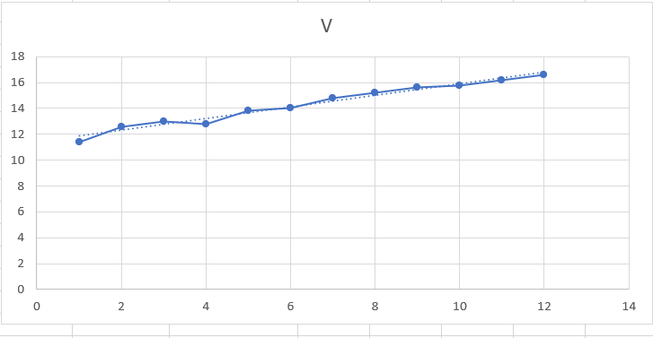

The above graph represents the time series plot of the sales of Adult Mint bar.

From the above graph we can see that the sales of Product C is not following a seasonal trend. We can see that the sales of this product is going up slowly over the given time period. The sales of Product C do not follow any trend.

# Forecasting the performance of the 4th Year.

**Product A: Chocolate Bar**

For this product forecasting without trend is used

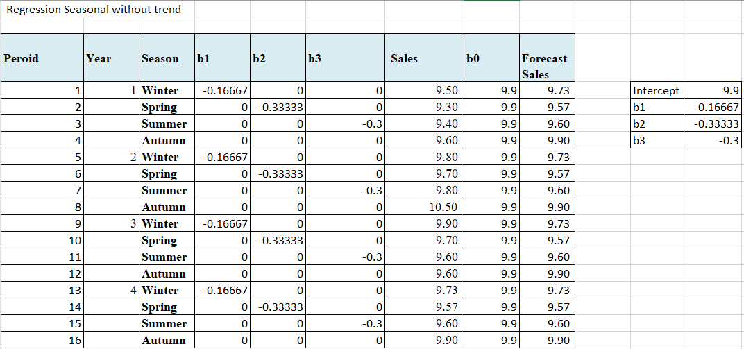

Table used for finding b0 b1 b2 and b3 using regression.

From the above table b0 = 9.9, b1 = -0.166666667, b2 = -0.333333333, b3 = -0.3

Model: 𝒚𝒕 = 𝒃𝟎 + 𝒃𝟏𝑸𝒕𝒓𝟏𝒕 + 𝒃𝟐𝑸𝒕𝒓𝟐𝒕 + 𝒃𝟑𝑸𝒕𝒓𝟑t

Where t is the time period which ranges from 1 to16.

The above graphs show depicts the given value (in blue) and the forecasted value (in orange). From the graph we can see that the forecasted line follows a seasonal trend. This could be an indicator that this product may follow a seasonal trend.

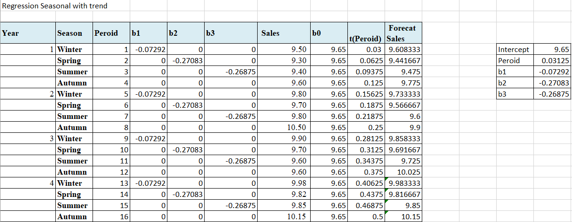

Table used for finding b0 b1 b2, b3, t using regression.

From the above table b0 = 9.65, b1 = -0.07292, b2 = -0.27083, b3 = -0.26875, t = 0.03125

Model: 𝒚𝒕 = 𝒃𝟎 + 𝒃𝟏𝑸𝒕𝒓𝟏𝒕 + 𝒃𝟐𝑸𝒕𝒓𝟐𝒕 + 𝒃𝟑𝑸𝒕𝒓𝟑t+ **Peroid(t)**

Where t is the time period which ranges from 1 to16.

The above graphs show depicts the given value (in blue) and the forecasted value (in orange). From the graph we can see that the forecasted line follows a seasonal trend. This could be an indicator that this product may follow a seasonal trend.

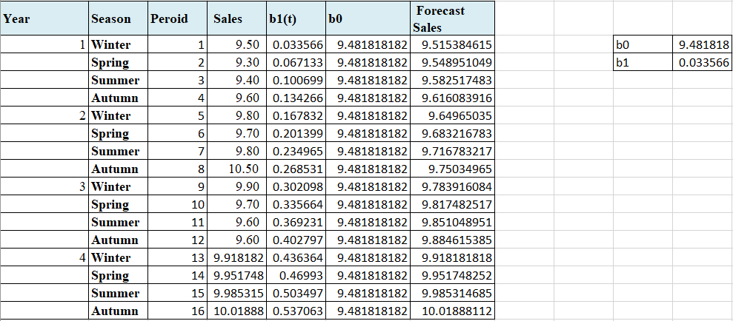

Table used for finding b0 b1 b2 and b3 using regression.

From the above table b0 = 9.481818, b1 = -0.033566

Model : 𝒚𝒕 = 𝒃𝟎 + 𝒃𝟏t

Where t is the time period which ranges from 1 to16.

The above graphs show depicts the given value (in blue) and the forecasted value (in orange). From the graph we can see that the forecasted line follows a Linear Trend.

The Mean Squared error of the above models are:

|  |  |  |
| --- | --- | --- |
| **Regression Seasonal without trend** | **Regression Seasonal with trend** | **Linear Trend Projection** |
| 6.78% | 5.74% | 7.16% |

From the above three calculations we can see that Regression Seasonal with trend has the least Mean Squared Error. Thus, this is the best model for Product A.

**Product B: Children’s treats**

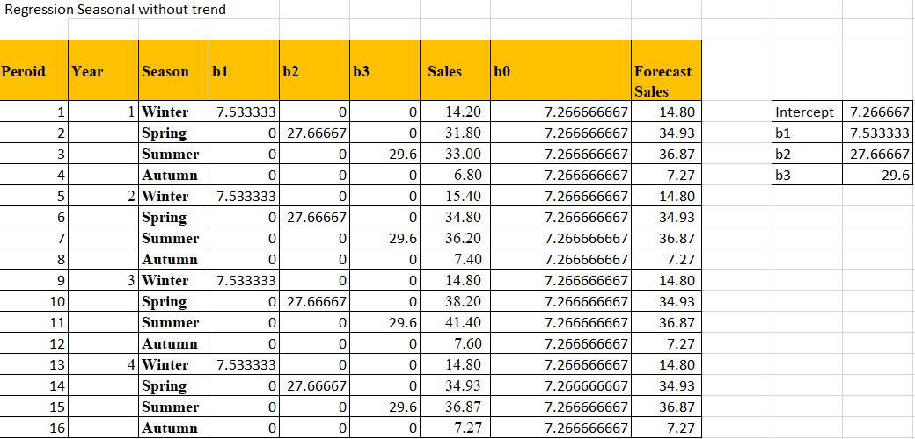

Table used for finding b0 b1 b2 and b3 using regression.

From the above table b0 = 7.266667, b1 = 7.533333, b2 = 27.66667, b3 = 29.6

Model : 𝒚𝒕 = 𝒃𝟎 + 𝒃𝟏𝑸𝒕𝒓𝟏𝒕 + 𝒃𝟐𝑸𝒕𝒓𝟐𝒕 + 𝒃𝟑𝑸𝒕𝒓𝟑t

Where t is the time period which ranges from 1 to16.

The above graphs show depicts the given value (in blue) and the forecasted value (in orange). From the graph we can see that the forecasted line follows a seasonal trend. This could be an indicator that this product may follow a seasonal trend. In the forecasted value we can see that there is a hike in performance in the beginning and see a dip at the end.

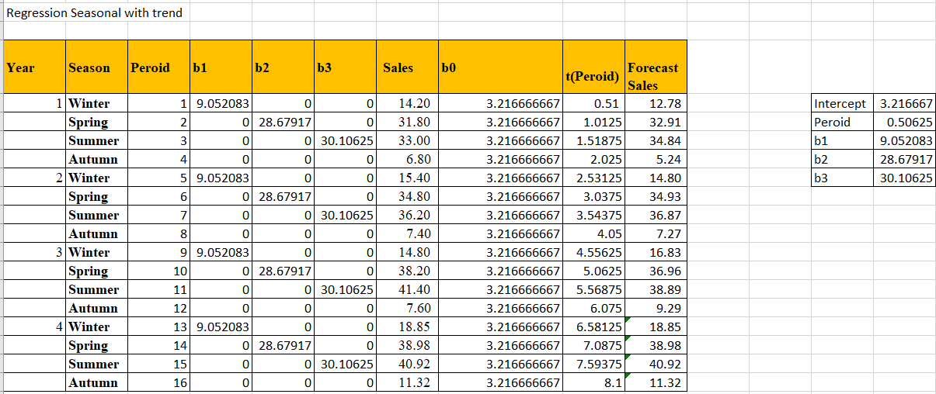

Table used for finding b0 b1 b2, b3, t using regression.

From the above table b0 = 3.216667, b1 = 9.052083, b2 = 28.67917, b3 = 30.10625, t = 0.50625

Model : 𝒚𝒕 = 𝒃𝟎 + 𝒃𝟏𝑸𝒕𝒓𝟏𝒕 + 𝒃𝟐𝑸𝒕𝒓𝟐𝒕 + 𝒃𝟑𝑸𝒕𝒓𝟑t+ **Peroid(t)**

Where t is the time period which ranges from 1 to16.

The above graphs show depicts the given value (in blue) and the forecasted value (in orange). From the graph we can see that the forecasted line follows a seasonal trend. This could be an indicator that this product may follow a seasonal trend. I can see a similar pattern to the previous regression but with this regression the forecasted values are much more similar to the given values.

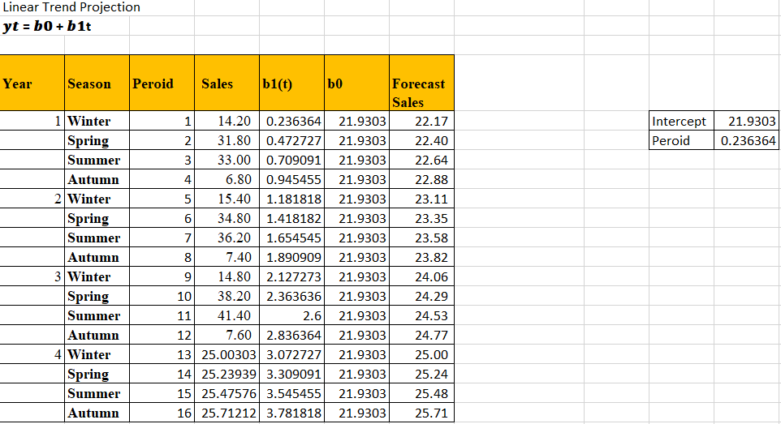

Table used for finding b0 b1 b2 and b3 using regression.

From the above table b0 = 21.93, b1 = 0.236364

Model : 𝒚𝒕 = 𝒃𝟎 + 𝒃𝟏t

Where t is the time period which ranges from 1 to16.

The above graphs show depicts the given value (in blue) and the forecasted value (in orange). From the graph we can see that the forecasted line follows a Linear Trend. This could be an indication that this model is not suitable for this product.

The Mean Squared error of the above models are:



From the above three calculations we can see that Regression Seasonal with trend has the least Mean Squared Error. Thus, this is the best model for Product B.

**Product C: Adult Mint bar**

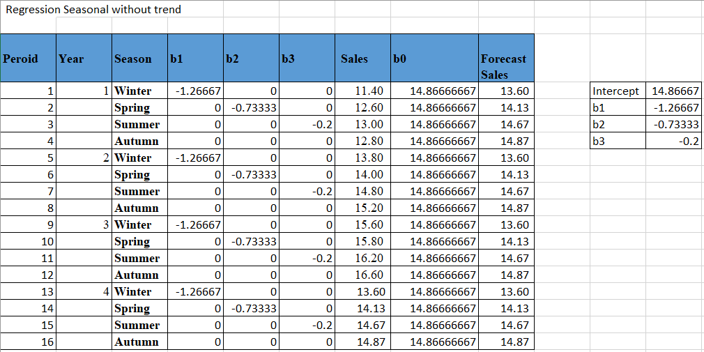

Table used for finding b0 b1 b2 and b3 using regression.

From the above table b0 = 14.86667, b1 = -1.26667, b2 = -073333, b3 = -0.2

Model : 𝒚𝒕 = 𝒃𝟎 + 𝒃𝟏𝑸𝒕𝒓𝟏𝒕 + 𝒃𝟐𝑸𝒕𝒓𝟐𝒕 + 𝒃𝟑𝑸𝒕𝒓𝟑t

Where t is the time period which ranges from 1 to16.

The above graphs show depicts the given value (in blue) and the forecasted value (in orange). From the graph we can see that the forecasted line follows a seasonal trend. This could be an indicator that this product may follow a seasonal trend. Even though the given values show a linear growth, the forecasted line seems to be seasonal.

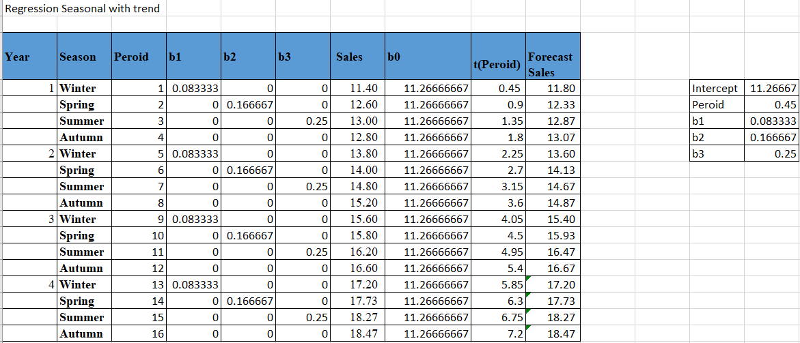

Table used for finding b0 b1 b2, b3, t using regression.

From the above table b0 = 11.26667, b1 = 0.083333, b2 = 0.166667, b3 = 0.25, t = 0.45

Model : 𝒚𝒕 = 𝒃𝟎 + 𝒃𝟏𝑸𝒕𝒓𝟏𝒕 + 𝒃𝟐𝑸𝒕𝒓𝟐𝒕 + 𝒃𝟑𝑸𝒕𝒓𝟑t+ **Peroid(t)**

Where t is the time period which ranges from 1 to16.

The above graphs show depicts the given value (in blue) and the forecasted value (in orange). From the graph we can see that the forecasted line follows a seasonal trend. This could be an indicator that this product may follow a seasonal trend. I can see a similar pattern to the previous regression but with this regression the forecasted values are much more like the given values.

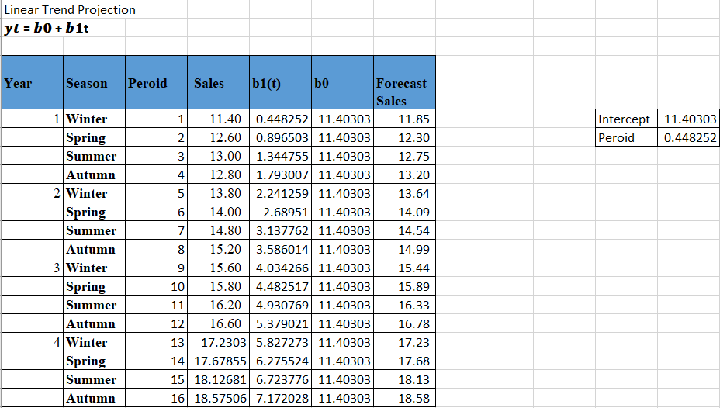

Table used for finding b0 b1 b2 and b3 using regression.

From the above table b0 = 11.40303, b1 = 0.448252

Model : 𝒚𝒕 = 𝒃𝟎 + 𝒃𝟏t

Where t is the time period which ranges from 1 to16.

The above graphs show depicts the given value (in blue) and the forecasted value (in orange). From the graph we can see that the forecasted line follows a Linear Trend. The given values were also following a linear trend. The predictions are also like the given values. This could be a indicator that this product follows a linear projection model.

The Mean Squared error of the above models are:



From the above three calculations we can see that Regression Seasonal with trend has the least Mean Squared Error. Thus, this is the best model for Product C.

# Optimization and linear programming.

East Midlands Candy can use linear programming to aid in decision making. This can be achieved by using the historical data of the company and forecasting different models that in turn helps in choosing the right model for the optimum growth in sales.

To achieve this objective, the linear programming model would be:

MAX **Z = b1x1 + b2x2 + b3x3**

Where x1 = chocolate bar, x2 = children’s treats, x3 = adult mint bar and b1, b2, b3 are the profit each of them makes respectively.

The above equation is used to solve the linear programming using simplex method with tools like Microsoft Excel. The uncontrollable variables are market cost of material and financial capacity.

# Increasing the profit of popcorn production with Linear Programming.

|  |  |
| --- | --- |
| b1 | b2 |
| 0.5 | 0.8 |

|  |  |  |
| --- | --- | --- |
|  | STD | DLX |
| Sugar | 0.3 | 0.4 |
| Colour | 0.008 | 0.015 |
| Cinema | 0.3 | 0 |

Max **Z = b1std + b2dlx**

Where std = standard popcorn and dlx = deluxe popcorn and b1 and b2 are their respective profits.

The Constraints are:

K11std + K12dlx <= Q1

K21std + K22dlx <= Q2

Where K11 & K12 are the amount of sugar used for Standard and Deluxe respectively, K21 & K22 are the colour used for Standard and Deluxe respectively.

Q1 & Q2 are the maximum quantity of sugar and colour available per week.

**Decision variables:** std and dlx

**Result Variables:** Z (Total Profit)

**Objective function:** Z = 0.5std + 0.8dlx

**Uncontrollable Variables:**

Sugar: 0.3std + 0.4dlx <= 40000

Colour: 0.008std + 0.015dlx <= 48

# Allocating Human Resources using Linear Programming.

|  |  |  |  |  |  |  |  |  |  |
| --- | --- | --- | --- | --- | --- | --- | --- | --- | --- |
| **Time Period** | 1 | 2 | 3 | 4 | 5 | 6 | 7 | 8 |  |
| 9:00-12:00 | 1 |  |  |  |  |  |  | 1 | 32 |
| 12:00-15:00 | 1 | 1 |  |  |  |  |  |  | 24 |
| 15:00-18:00 |  | 1 | 1 |  |  |  |  |  | 20 |
| 18:00-21:00 |  |  | 1 | 1 |  |  |  |  | 28 |
| 21:00-24:00 |  |  |  | 1 | 1 |  |  |  | 12 |
| 0:00-3:00 |  |  |  |  | 1 | 1 |  |  | 4 |
| 3:00-6:00 |  |  |  |  |  | 1 | 1 |  | 2 |
| 6:00-9:00 |  |  |  |  |  |  | 1 | 1 | 10 |

The above table is used for the formulation of equation for finding the minimum number of workers required. I have assigned a value Time period for each shift. The total adds up to 8. The above seen dummy variables are used for the linear programming of the data and obtaining a minimum number of workers required.

**Equation:**

Min P = 32p1 + 24p2 + 20p3 + 28p4 + 12p5 + 4p6 + 2p7 + 10p8

**Constraints:**

p1 + p2 + p3 + p4 + p5 + p6 + p7 + p8 <= 24

The equation above shows the required number of workers in each shift represented by px where x ranges from 1 to 8. P is the minimum number of workers that would be enough to fill the shift.

# SAS BI

I am creating a business intelligence application for the sales department. 2 information delivery portals are used. They are:

1. IDP1- This portal is used to display the total sales with respect to Product Category and Customer Type.
2. IDP2- This portal is used to display the total sales of each product with respect to the Customer and produce graphs for further analysis.

# Data preparation: Information Map Studio

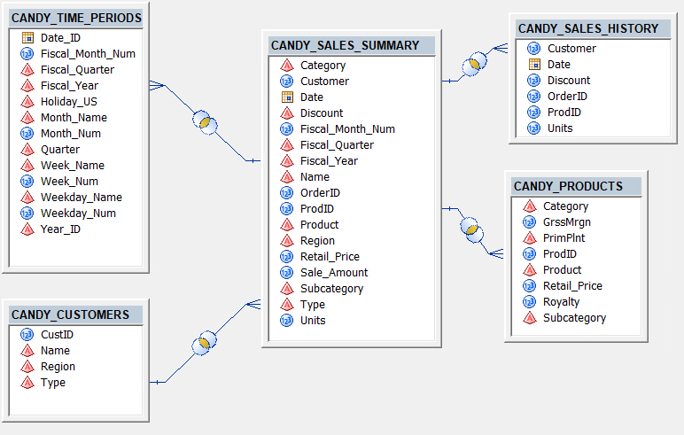

The above image shows how the tables are joined to each other in information map studio.

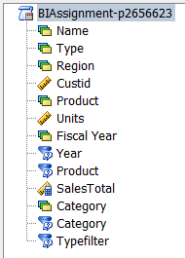

The Image above shows all the variables and filters used for creating the Information Delivery Portal.

I am mainly using the filters Year Category (Product Group) and Typefilter. A Variable SalesTotal has also been created which holds the value of Sum of Sale Amount.

This is the final set of data I will be using in SAS Web report Studio to create web reports.

# Using SAS BI to display Total Sales with respect to Customer & Product type.

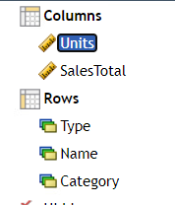

The above variables are used to display The Sales Totals of different types of Customers.

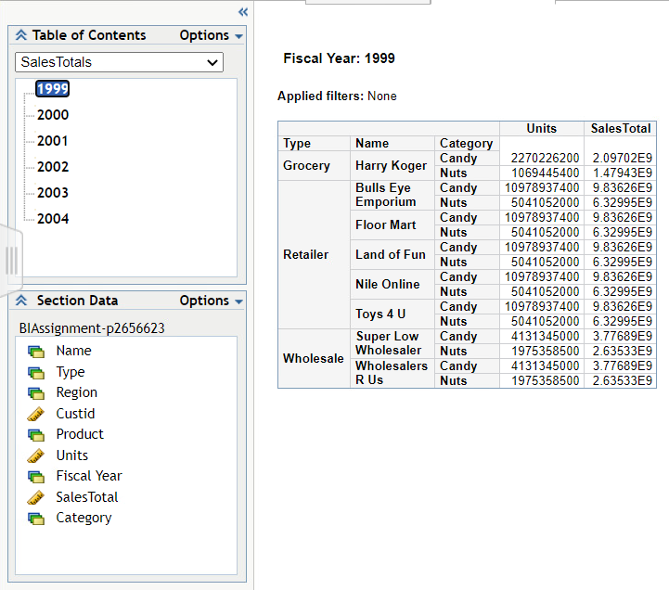

We get the above application in the information delivery portal. The table has been broken with Year. From the Table of contents, we can select the year which in turn displays the Type, Name of customer, Product Category, Units and Total Sales.

We can see the data for individual Customer Type and Product Type.

# Using SAS BI to display Total Sales of each product to the different customer.

In this section we are going to display an IDP with total sales of each product with respect to the customer. Different charts are also displayed using the tabular data.

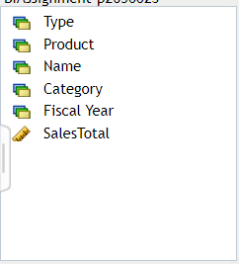

The above variables are used for this portal.

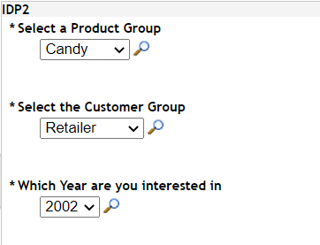

Initially when the data is viewed a prompt table pops up asking the user to select the Product Group, Customer Group and Year. According to the selections made by the user the data is displayed.

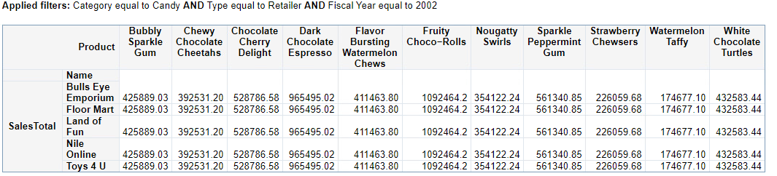

The above table is displayed in the information delivery portal. Here we can see the total sales of each product. This particular table displays the Sales totals of where category is equal to ‘Candy’, Type of customer is equal to ‘Retailer’ and the Year is 2002.

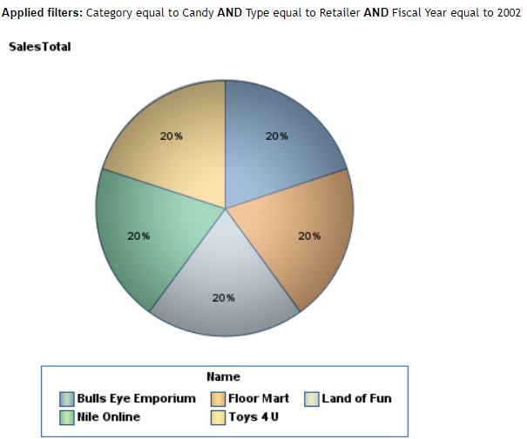

The above pie chart shows the percentage Sales total of each customer with type ‘Retailer’.

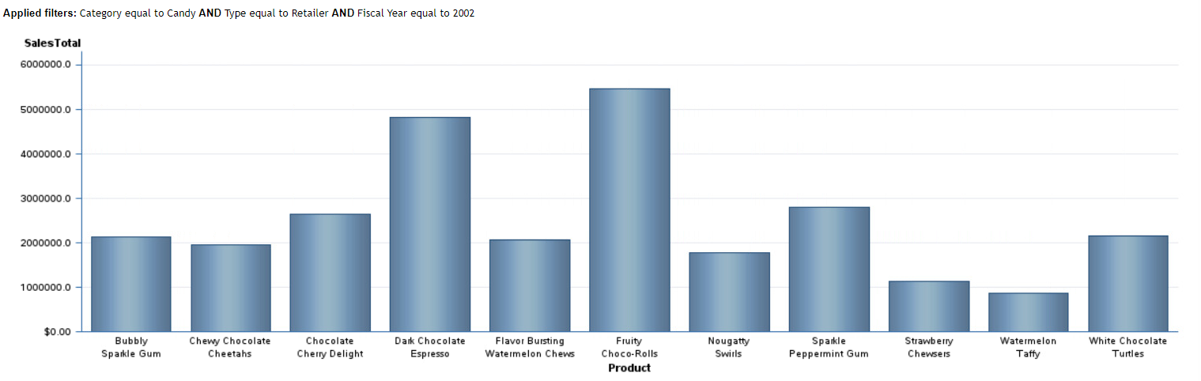

The above bar graph shows how total sales of each product with product group ‘Candy’, Customer type ‘Retailer’ and Year is ‘2002’.

This BI application can be used to get the total sales value using Product Group, Customer Group, and year. In the information any low-level IT user can access these records and get a meaningful insight using this application.

# Legal, Ethical and Privacy issues

When using a Business Intelligence application, EMC should consider the legal, ethical, and privacy consequences. EMC must address the issue of reliability; for example, a user could incorrectly use the application and provide false data, resulting in poor decision-making.

The EU's General Data Protection Regulation (GDPR), which was enacted to protect users, is a push for data privacy. It focuses on data protection regulations for businesses and consumers. Employees at EMC must be trained to be discreet when compiling and using classified information gathered during the course of the company's operations.

Since it involves personal interest, the nuances and ethical questions are a major concern. Codes of behaviour for the use of business intelligence applications should be developed by EMC.

# Conclusion

From this activity we were able to conclude that the best model for Product A, B and C is regression seasonality with trend. I was able to come up with this conclusion as the Mean forecast error of the 3 types of regression I did on the 3 Products, was the lowest for Regression seasonality with trend. The graphs of the forecast values of the 3 products also exhibited a seasonality trend. I also defined equations for linear programming for the 3 products.

Then we discussed how to Maximize the profit on standard and deluxe popcorn by creating an equation to find the maximum profit that can be obtained with the available supplies. Further, I also formulated an equation for Minimizing the required staff across the 8 time periods.

The I started with SAS Information Map Studio for preparing the data and creating filters to use the data on SAS Web Report Studio. Then I created a 2 web reports; 1) that displays total sales with respect to Customer type and product type. 2) that displays totals sales of each product with respect to the customer.

Once this is done 2 pages are created in the information delivery portal that displays the 2 above created web reports.

# References

IMAT5264 2021 Lecture slides and video by Dr Caroline Khene and Mr Alexander Mee, De Montfort University, Leicester United Kingdom.

# Other References

[https://youtu.be/hDsychjSwdU](https://eur03.safelinks.protection.outlook.com/?url=https%3A%2F%2Fyoutu.be%2FhDsychjSwdU&data=04%7C01%7CP2656623%40my365.dmu.ac.uk%7C446b20421fac47531e3708d91d2a5b10%7C4f78c0e3d2504ddfbb1c15d3145697cc%7C1%7C0%7C637572890017486028%7CUnknown%7CTWFpbGZsb3d8eyJWIjoiMC4wLjAwMDAiLCJQIjoiV2luMzIiLCJBTiI6Ik1haWwiLCJXVCI6Mn0%3D%7C1000&sdata=W38t4awkqshFhmLRCj%2BFYdgliATSeIEKFixINceEHCE%3D&reserved=0)

[http://faculty.sfasu.edu/fisherwarre/lp_solver.html](https://eur03.safelinks.protection.outlook.com/?url=http%3A%2F%2Ffaculty.sfasu.edu%2Ffisherwarre%2Flp_solver.html&data=04%7C01%7CP2656623%40my365.dmu.ac.uk%7C1f349fe432e34296617a08d91d5836e5%7C4f78c0e3d2504ddfbb1c15d3145697cc%7C1%7C0%7C637573086973975436%7CUnknown%7CTWFpbGZsb3d8eyJWIjoiMC4wLjAwMDAiLCJQIjoiV2luMzIiLCJBTiI6Ik1haWwiLCJXVCI6Mn0%3D%7C1000&sdata=UqTffisQwFewJFnIVv1w509e51MTe9i3b0n3IiS6BJk%3D&reserved=0)