**Mechatronic Systems Laboratory**

**Report on**

**Manipulator Robot**

**Pick and Place Task**

**WS 2020/21**

**Group 14**

**1537943 Chaithanya Tenneti**

**1536199 Kaushik Goud Chandapet**

**1522044 Nishanth Iruthayaraj**

**1533846 Sai Radha Krishna Vangaveeti**

**1536988 Venkata Sai Tarak Padarthi**

**Date: 31.01.2021**

**Objective:**

Implementation of the motion control of a manipulator robot to achieve a pick-and-place sequence of motion.

**Inverse Kinematics:**

The motion of this 2-DOF manipulator robot (θ1 and θ2) can be controlled using two motors Motor B and Motor C whereas the gripper action can be controlled using Motor A.

Assuming the Origin at the base of the robot (exactly below the Motor C) with X axis pointing outward, Y axis pointing to the right and Z-axis to the top when looked from the Front side of the robot.

Using Graphical method and performing Inverse Kinematics, we can deduce the formulae for the θ1 and θ2 from the given position of the gripper in rectangular co-ordinates X, Y, Z.

The inverse kinematics of manipulator robot is found by the following expressions

y

x

θ1

α

*Gripper*

*Motor C*

Fig 1: Top view of manipulator robot

$$α=\tan^{-1} \left(\frac{y}{x}\right)$$

$$θ_{1}={90}^{ 0}+α$$

$$θ_{1} = {90+tan}^{-1}\left({\begin{aligned}y \\ -\end{aligned} \atop x}\right)$$

*Motor C*

*Motor B*

x

z

y

θ1

θ2

35˚

*l*4

*l*3

*l*2

*l*1

*base*

Fig 2: Front view of manipulator robot

$$z= base+ l_{1}+l_{2}\sin{45}- l_{4}+ l_{3}sin⁡(35-θ_{2})$$

$$θ_{2}=35-\sin^{-1}\left(\frac{z+l_{4}-base-l_{1}-l_{2}\sin{45} }{l_{3}}\right)$$

Calculating station Co-ordinates:

$$Station A=\left(0, -118, 70\right)$$

$$Station B=\left(118, 0, 0\right)$$

$$Station C=\left(0, 118, 0\right)$$

Considering the angle $θ_{2}$ when the link $l_{3}$ is parallel to the ground, we get Y co-ordinate for station A with respect to Origin.

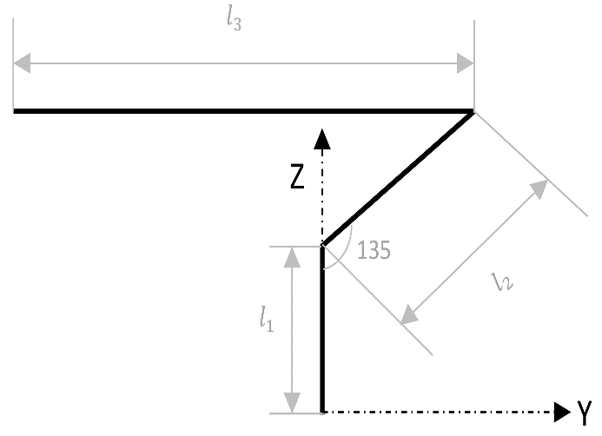

Fig 3: Cropped view of manipulator robot

$$y= l_{3}- l_{2}*\sin{45} ≈ 118$$

The X co-ordinate is *zero* and the Z co-ordinate is ‘70’ (elevation of station A) for station A.

Similarly, we get the Station B and Station C co-ordinates as $\left(118, 0, 0\right)$ and $\left(0, 118, 0\right)$ respectively.

**Program implementation:**

The task can be divided into three behaviors – Homing, Picking and Placing

***Homing*** – We take the robot arm to a position where both the touch sensors are active(touching) and reset the encoder values of the motor B and motor C making θ1 and θ2 to be equal to zero.

*Function call: homing()*

***Picking*** – We take the robot arm to the given station, close the gripper to hold the object and then bring back elbow to the initial position (θ2=0).

*Function call: pick(stationA)*

***Placing*** – We take the robot arm to the given station, open the gripper to release the object and then bring back elbow to the initial position (θ2=0).

*Function call: place(stationA)*

As motors are coupled through Gear Boxes, using Gear ratio formula between motor C (encoder values) θmC and the link 1 angle θ1, we get,

$$N_{1}* θ_{1}= N_{mC}* θ_{mC}$$

$$θ_{mC}=θ_{1}* \frac{N_{1}}{N_{mC}}$$

$$θ_{mC}=θ_{1}* \frac{36}{12}$$

$$θ_{mC}={3θ}_{1}$$

Similarly for motor B (encoder values) θmB and the elbow angle θ2,

*Program Sequence:*

homing();% Reset to position where touch sensors are active

% and reset the encoder reading values to zero

% Sequence start

pick(stationC); % Move to StationC and Close the gripper

place(stationA); % Move to StationA and Open the gripper

pick(stationA);

place(stationB);

pick(stationB);

place(stationC);

% Sequence end

**References :**

1. MATLAB Support Package for LEGO MINDSTORMS EV3 Hardware

<https://de.mathworks.com/help/supportpkg/legomindstormsev3io/>

1. Building Instructions for LEGO MINDSTORMS EV3 Robot Arm