VESPER vs SkillOpt — Slide Contents
Three ready-to-use slide contents for the prior-art review. Slide 1 is written as paragraphs; the key difference in each paragraph is set in red and should stay red on the slide.
Knox AI · SRI-Bangalore · prepared against SkillOpt v0.2.0 (Microsoft, July 2026) — arXiv 2605.23904 · github.com/microsoft/SkillOpt

SLIDE 1 — Difference from Closest Prior Art (side-by-side)
Slide title: Difference from Closest Prior Art — SkillOpt (Microsoft)

Diagram — place across the top of the slide
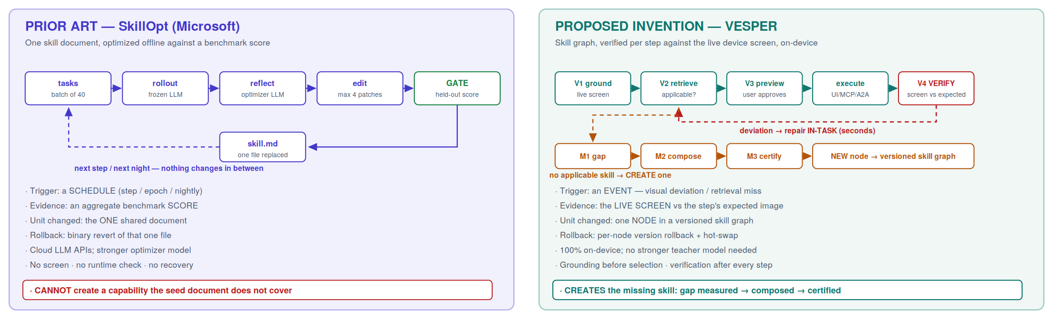

Side-by-side table — one row, two columns
PRIOR ART: SkillOpt (Microsoft, 2026) | PROPOSED INVENTION: VESPER (Knox AI, SRI-B)
SkillOpt treats a single natural-language skill document (.md) as the trainable state of a frozen LLM agent. An optimizer model reads scored rollouts from a batch of benchmark tasks and proposes bounded add / delete / replace text edits to that one document; a candidate edit is accepted only if it strictly improves a held-out validation score, and the deployed artifact is a single best_skill.md loaded into the frozen agent's context. The update is triggered by a schedule — a training step, an epoch boundary, or a nightly cycle — and is driven by an aggregate benchmark score, so the system learns that the document got better or worse overall but not which instruction was wrong. Rollback is a binary revert of that one file, and the whole loop runs on cloud LLM APIs with a separate, usually stronger optimizer model.  There is no screen, no device action, no per-step verification and no runtime recovery — and because it can only reword what the seed document already covers, SkillOpt cannot create a capability it was never given. | VESPER holds skills as step-granular procedures inside a versioned dependency graph, where every step carries an image of what success is supposed to look like. At runtime it grounds the live screen before any skill is selected, retrieves only skills whose preconditions actually hold on that screen, previews the plan for the user, then executes and compares the resulting screen against that step's expected image. The update is triggered by an event — a visual deviation, a retrieval miss, or a user correction — and is driven by localized physical evidence: which step, the actual screen, the expected screen. A failure is repaired inside the running task in seconds and consolidated afterwards into a new version of a single graph node, which can be rolled back on its own while every other skill keeps running. Everything runs on the device.  The ground truth is the live screen rather than a benchmark score, every step is verified before the next one runs, the task is repaired while it is still running — and when retrieval finds no applicable skill, the gap is measured as an embedding delta and a new skill is hypothesised, composed from certified primitives, validated in a sandbox and deployed.

BOTTOM STRIP — one-line main difference (red)
SkillOpt improves a skill that already exists, scored by a benchmark number, on a schedule, in the cloud. VESPER decides which skill applies to the screen in front of the user, proves every step against that screen in real time, repairs the task while it is still running, and creates the skill when none exists — all on the device.

SLIDE 2 — Prior Art Comparison
Slide title: Prior Art Comparison
Prior Art Reference | Difference between invention and prior art
SkillOpt — Microsoft Research  Text-space optimizer for self-evolving agent skills (incl. SkillOpt-Sleep nightly consolidation)  arXiv 2605.23904 · github.com/microsoft/SkillOpt  v0.1.0 Jun-2026 · v0.2.0 Jul-2026 · MIT licence | SkillOpt optimizes the text of one existing skill document for a frozen LLM. Its update is triggered by a schedule (training step, epoch, or nightly cycle), driven by an aggregate held-out benchmark score, applied as bounded text patches to that single file, and rolled back by reverting the file. It runs on cloud LLM APIs and has no screen, no device execution, no per-step verification and no runtime recovery.  The proposed invention differs on five points. (1) Trigger: the update is initiated by a live event — a per-step visual deviation, a retrieval miss, or a user correction — not by a schedule. (2) Evidence: it is driven by localized physical evidence (the executed step, the actual screen, the expected screen), not by an aggregate score. (3) Unit: it updates one node inside a versioned skill-dependency graph, allowing per-capability rollback and hot-swap, not one shared document. (4) Latency: it repairs the failing task in-session within seconds and consolidates afterwards, rather than improving only at the next scheduled cycle. (5) Creation: when no skill is applicable it measures the capability gap as an embedding delta and synthesizes, certifies and deploys a new skill — SkillOpt has no mechanism to detect or build a missing capability. All of this executes on-device.

SLIDE 3 — Prior Art Landscape & Similarity Assessment
Slide title: Prior Art Landscape & Similarity Assessment
Patent / Owner | Technology | What it does | Why proposed invention is different | Similarity with VESPER
Microsoft Research  SkillOpt (open-source, MIT)  arXiv 2605.23904  Jun–Jul 2026 | Text-space optimizer for agent skills; frozen model, no weight training | Trains one Markdown skill document through rollout → reflect → bounded edit → held-out validation gate, with a textual learning rate, slow update and optimizer memory; exports best_skill.md for a frozen agent. SkillOpt-Sleep adds a nightly offline consolidation cycle staged for human adoption. | Schedule-triggered and score-driven, editing one shared document in the cloud; rollback is a single-file revert.  The proposed invention is event-triggered by per-step visual evidence from the live device screen, updates one node in a versioned skill graph with per-capability rollback, repairs the task in-session, and — critically — creates a new certified skill when retrieval finds none. SkillOpt has no screen, no runtime verification and no capability-creation mechanism. Fully on-device. | MEDIUM  Overlap is limited to validation-gated skill updating (our F3 / F4).  No overlap on F1 gap-driven genesis, F2 formal composition, V1 visual grounding, V2 live-screen applicability, V4 per-step verification, or on-device operation.

Notes before presenting
1. Similarity is deliberately MEDIUM, not LOW.
Claiming low similarity is not defensible — SkillOpt's held-out validation gate genuinely overlaps our F3 (validation before deployment), and its learning-rate schedule, slow update and meta-skill memory genuinely overlap our F4 (bounded self-improvement). Stating MEDIUM and then showing precisely which pillars survive — F1 gap-driven genesis, F2 formal composition, V1 visual grounding, V2 live-screen applicability, V4 per-step verification and on-device operation — is a far stronger position with a reviewer than overclaiming and being corrected.
2. Only the SkillOpt row is included, as requested.
Rows for the other prior-art families — corrective / Self-RAG, AppAgent-class GUI agents, Voyager-class skill-learning agents, and OCR tooling — are drafted and available in VESPER-vs-SkillOpt.md if the reviewer asks for the wider landscape. The GUI-agent family is the one most likely to be raised next, since it is the closest prior art on the execution side.
3. Formal patent-number sweep is still pending.
SkillOpt is open-source and published rather than patented, so it is cited by paper and repository. Actual patent numbers must come from the formal sweep with counsel before claim drafting.
Recommended one-line framing for the review:
“SkillOpt is the strongest published work on making one skill document better. VESPER is about deciding which skill applies to the screen in front of the user, proving each step against that screen, and building the skill when none exists. The overlap is real in F3 / F4 and we have narrowed those claims accordingly.”

