Visual Recovery of Damaged Barcodes
Complete Technical Design: a Top-3 Decoder + Dynamic Multimodal RAG, Model-Agnostic by Construction
Every stage, every formula, every failure branch — with multi-digit damage carried end to end

1. What We Start With, and What We Will Achieve

1.1 Assets already in hand
- A neural decoder used as a black box: for a damaged crop it returns the top-3 full-string predictions with a confidence score each — nothing more is assumed. This makes the system model-agnostic: any top-k barcode decoder, including a commercial one, can sit in this slot.
- The Knox Dynamic RAG stack (SQLite/Room structured store, FTS/BM25 sparse index, USearch-HNSW dense index, RRF fusion k=60, mismatch-driven re-retrieval), production-proven for skill routing on Android.
- RTMDet-tiny detection: barcode localization, corner quad, deskew — already working.

1.2 The precise goal
Given a scan whose barcode cannot be decoded by classical readers (ZXing/ZBar fail) and where the top-3 predictions are unreliable (checksum failures, low confidence, disagreement among the beams), output exactly one of:
- VERIFIED PAYLOAD — the true string, with both mathematical proof (check digit / Reed–Solomon parity) and contextual proof (member of the current operational context), auto-accepted;
- SHORTLIST — 2–3 verified-plausible candidates rendered as products for a one-tap human decision;
- WARNING — “this item does not belong here” (wrong shipment / wrong patient / mis-routed part), which is itself valuable output.
Quantified target: recover a large fraction (target ≥70% at moderate-to-severe damage; to be measured) of classically-unreadable scans with zero silent wrong-item errors, at ≤150 ms added latency on the recovery path, and zero added latency on clean scans.

2. The Problem, Stated Precisely

2.1 Notation
y* = true payload, string of length L over alphabet Σ (EAN-13: L=13 digits)
x = photographed crop of the damaged code (plus wide_crop of the label/packaging)
B = {(b1,c1),(b2,c2),(b3,c3)} = top-3 predicted strings with confidences
A = active set: payloads possible in the current context (|A| = 10 … 10^4)

2.2 What the barcode's own structure gives us
EAN-13 check digit (exact formula). Number the 12 data digits d₁…d₁₂ left to right. Compute S = (d₁+d₃+d₅+d₇+d₉+d₁₁) + 3·(d₂+d₄+d₆+d₈+d₁₀+d₁₂). The check digit is d₁₃ = (10 − S mod 10) mod 10. One wrong digit always breaks it; it is a detector, not a corrector.
Reed–Solomon (2D codes). A symbol with n−k parity codewords corrects any combination of e codeword errors and f erasures with 2e + f ≤ n−k. Example: a 24×24 ECC-200 DataMatrix carries 24 data + 24 parity codewords → standard decoding fixes up to 12 unknown-position errors; if damage positions are known (erasures), up to 24 codewords are recoverable — double. In this design, erasure positions come from image-level damage analysis (Stage 1b), not from any decoder internals.

2.3 The GS1 structure that matters (and is usually ignored)
EAN-13 payloads are not uniform random strings: digits 1–3 are a country prefix (890 = India), digits 4–9 a company prefix, digits 10–12 the item reference, digit 13 the check. Consequence: within one manifest, same-brand items share up to 9 leading digits — the discriminating information is concentrated in roughly digits 10–12. This drives which damage is easy and which is hard (Section 6).

3. Why Top-3 Predictions Are Mathematically Insufficient
This section is the reason the system must exist; make it concrete.

3.1 One damaged digit — top-3 usually suffices
If exactly one position is unreadable with ~3 plausible characters, the three highest-scoring full strings typically enumerate those alternatives, and the check digit eliminates the wrong ones (a single-digit change always breaks it). Top-3 + checksum ≈ solved. This is why single-digit examples make the problem look easier than it is.

3.2 Multiple damaged digits — combinatorial explosion
With d damaged positions and ~a plausible characters at each, the plausible-string space has a^d members. Top-3 predictions cover exactly 3 of them:
Damaged positions d | Plausible strings (a=3) | Covered by top-3 | Chance the truth is in the top-3
1 | 3 | 3 | ≈ 1.00
2 | 9 | 3 | ≈ 0.33–0.6
3 | 27 | 3 | ≈ 0.11–0.35
4 | 81 | 3 | ≈ 0.04–0.2

So under multi-digit damage the true payload is usually NOT among the top-3 predictions at all. No reranking of the three strings can fix an answer that is missing from the list. The candidate set must come from somewhere else — the active context set A. And crucially, the system must be able to reach candidates the decoder never proposed.
Key point: The three beams are not the hypothesis space — they are three samples from it. What the beams DO reliably tell us, even as a black box, is WHERE they agree (trusted digits) and WHERE they disagree (damaged digits). That agreement structure, not any internal probability, is what we mine.

3.3 Why the context makes the trusted digits sufficient — the counting argument
Suppose the beams agree on L−d positions (trusted) and disagree on d (damaged). A candidate from the active set is “consistent” if it matches every trusted digit. For an active set of N payloads whose varying digits (Section 2.3: usually ~3–5 item-reference digits within one manifest) number v, the expected count of consistent candidates when dₑ of those v varying digits are damaged is approximately:
E[#consistent] ≈ N · 10^(−(v − d_e)) (digits outside v match via the shared prefix anyway)
Active set N | v (varying digits) | d_e damaged among them | E[#consistent] | Meaning
200 | 4 | 0–1 | ≤ 0.2 | unique or empty → near-deterministic recovery
200 | 4 | 2 | ≈ 2 | small ambiguity → visual arbitration decides
200 | 4 | 3–4 | 20–200 | underdetermined → arbitration + human tap
30,000 | 5 | 1 | ≈ 3 | retail catalog: still small → arbitration
30,000 | 5 | 3 | ≈ 3,000 | must narrow by priors/packaging first

This is the honest capability envelope: recovery is near-certain while the trusted digits still pin the item down within the context; it degrades predictably as damage eats the discriminating digits; and in the hard region the system’s job is to (a) squeeze extra bits from the image (render-and-compare, packaging), and (b) fail safely into a one-tap human choice instead of guessing.

4. The Complete Pipeline — Every Stage, With Code
Running example carried through all stages — a two-digit-damage case where the top-1 prediction is wrong; Section 6 then shows the same machinery on 3-digit damage where the truth appears in no beam.
True payload y* = 8901030865268 (Dove Soap 100g; EAN-13)
Check-digit verification of y*: odd sum = 8+0+0+0+6+2 = 16;
even sum = 9+1+3+8+5+6 = 32; S = 16 + 3·32 = 112; 112 mod 10 = 2; check = 10−2 = 8 ✓
Damage: positions 11 and 12 (the '2' and the '6') are torn.
Decoder output (black box):
b1: 8901030865288 conf 0.61 check: S=16+3·34=118 → check=2 ≠ 8 ✗
b2: 8901030865268 conf 0.58 check ✓ (= y*, ranked SECOND)
b3: 8901030865788 conf 0.44 check: S=21+3·34=123 → check=7 ≠ 8 ✗

Stage 0 — Offline: build the dynamic multimodal memory
record = {
payload: '8901030865268', symbology: EAN13,
name: 'Dove Soap 100g', tags: {PO:4521, dock:7, pallet:'PL-09', cat:'personal care'},
img_pack: embedding(photo of packaging), # E_pack
img_code: embedding(rendered clean barcode), # E_code (trained encoder, Stage 3)
ngrams: char 3-grams of payload + name # sparse index terms
}
Triggered by a context event (truck assigned, wristband scanned, route downloaded, work order opened). Indexing: tags → SQLite; ngrams → FTS/BM25; E_pack, E_code → HNSW. Wider tiers (site catalog, organisation) are pre-registered so widening at scan time is a filter flip, not an indexing job. This is the Knox stack verbatim; only the record schema is new.

Stage 1 — Read (black box) and take the fast path when possible
quad = RTMDet(frame); crop = rectify(frame, quad); keep wide_crop
B = Decoder(crop) # top-3 strings + confidences, nothing else
if b1.checksum_ok and c1 > θ_fast: ACCEPT(b1); return # clean scans exit here

Stage 1b — Uncertainty from beam agreement + image damage analysis
No per-position probabilities are available or needed. Two cheap analyses replace them:
# (i) BEAM AGREEMENT: align b1,b2,b3 position by position
trusted = { t : b1[t]=b2[t]=b3[t] } # all beams agree
damaged = all other positions
alt[t] = { (b_i[t], c_i) : i=1..3 } # alternatives seen at t,
# weighted by beam confidence
consensus = pattern with '?' at damaged positions # e.g. '89010308652??'
# (ii) IMAGE DAMAGE MAP: no model internals — pure image analysis on the crop:
M = regions with low stroke contrast ∪ specular glare ∪ occlusion/tear edges
(gradient-energy + saturation heuristics; for 2D, mapped to module grid)
Worked example: b1/b2/b3 agree on positions 1–10 and the check digit’s neighbourhood pattern, disagree at 11–12 → consensus ‘8901030865 ? ? 8’, with alternatives alt[11]={2 (0.61+0.58), 7 (0.44)}, alt[12]={8 (0.61), 6 (0.58), 7→(from b3) 8 (0.44)}. The damaged-position set from beam disagreement and the image damage map M typically coincide — when they do not, their union is used (conservative).
Key point: Model-agnostic by construction: everything downstream consumes only (top-3 strings, confidences, consensus pattern, image damage map). Swap in any decoder — including a vendor SDK — and the system still runs. This is itself a selling point: the RAG layer upgrades decoders it cannot even see inside.

Stage 2 — Build the multimodal query
# TEXT: n-grams from the consensus pattern
hard terms: all 3-grams fully inside trusted regions ('890','901',…,'086','865')
soft terms: 3-grams crossing damaged positions, one per alternative in alt[t],
weighted by (sum of confidences of beams containing that character)
wildcard pattern: '8901030865??8' # for exact pattern matching in SQL
# VISUAL: q_code = E_code(crop); q_pack = E_pack(wide_crop) if packaging visible
# CONTEXT: filters/priors {dock 7, PO 4521, pallet-in-progress, last-5-scans}
The essential property: the true payload matches the wildcard consensus pattern and all hard trigrams even when it appears in no beam — the damaged positions are wildcards, so the query never commits to the beams’ wrong guesses there. Alternatives merely add boost when a beam happened to contain the right character.

Stage 3 — Multimodal retrieval + RRF fusion
L_patt = SQL: payload LIKE '8901030865__8' within active set # wildcard match
L_text = BM25(hard + soft terms, active_ngrams) # fuzzy, weight-aware
L_code = HNSW_search(q_code, E_code index) # damage-invariant code embedding
L_pack = HNSW_search(q_pack, E_pack index) # only if packaging visible
L_ctx = prior_rank(tags) # pallet / next stop / next serial / basket
score(r) = Σ_lists 1/(60 + rank_list(r)); C = top-m, m ≤ 50
The trained code embedding, precisely: an encoder f trained with a contrastive objective (InfoNCE): positives = (damaged render, clean render) of the same payload under our degradation pipeline; negatives = different payloads, with hard negatives mined from single-digit neighbours. Off-the-shelf embeddings fail here because all barcodes look alike; f is optimized so payload identity, not stroke texture, dominates. Its ablation (swap f for CLIP/DINO features) must show a large recall gap — a measured contribution.
Example outcome over the 200-record active set:
C1: 8901030865268 Dove Soap 100g (pattern ✓, all hard trigrams, code-emb near, pallet)
C2: 8901030865299 Dove Shampoo 180ml (pattern ✗ at check digit, text near-miss, pallet)
C3: 8901030812345 Pears Soap 75g (pallet prior only)

Stage 4 — Visual arbitration: render-and-compare
With a black-box decoder, the primary arbiter is analysis-by-synthesis: every candidate can be rendered as a perfect code and tested against the surviving pixels directly — no model internals required.
R = render(candidate, symbology) # ideal binary image
R' = warp(R, H_quad) # into photo geometry via detector quad
v(y) = NCC( binarize(crop)⊙(1−M), R'⊙(1−M) ) # agreement on undamaged regions only
v(C1)=0.96 v(C2)=0.41 v(C3)=0.12
Why this decides even multi-digit damage: the bars encoding a digit occupy a specific region; C1 and C2 differ in their rendered bars at positions 11–13, and whatever fragments survive there agree with exactly one of them. A secondary, cheap signal is beam-consistency: how well the candidate matches the consensus at trusted positions (must be 100%) and whether its characters at damaged positions appear in alt[t] (boost, not requirement). Final score: s(y) = α·log v(y) + β·beam_consistency(y) + γ·log RRF(y).
Optional upgrade (not required): if the decoder does expose a scoring mode, an exact likelihood P(candidate|image) can be added as a fourth term. The mainline design deliberately does not depend on it.
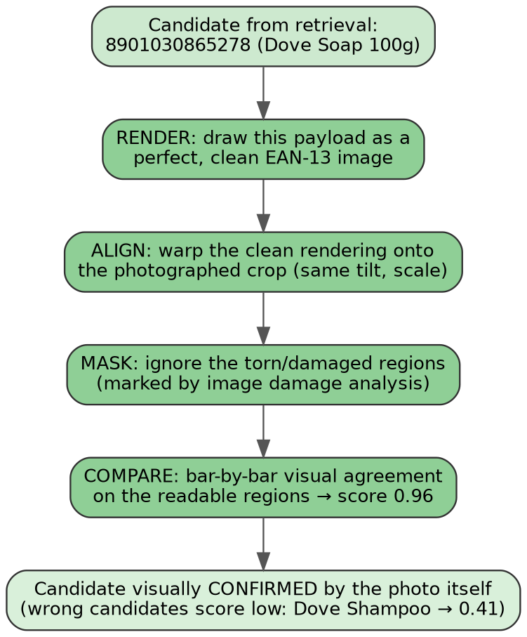
Figure 1 — Render-and-compare: render the candidate, warp to the photo, mask damaged regions (from image analysis), score bar-by-bar agreement on what is visible. Right answer 0.96; one-digit sibling 0.41.

Stage 5 — Verification: mathematics + membership
math_ok(y): EAN-13 → check-digit formula holds
2D → RS erasure-decode with M's module positions; parity must reconstruct
world_ok(y): y ∈ active_set(current tier)
accept iff math_ok ∧ world_ok ∧ s(y) > θ_dom ∧ margin(s1−s2) > δ_dom
Example: C1 passes the check-digit computation shown at the top (S=112 → check 8 ✓) and is on PO#4521 ✓; margin over C2 is wide → accept. The world check is the safety mechanism: a payload that is globally valid but absent from this context can never be silently booked — it becomes a warning.

Stage 6 — Decision policy and tiered widening
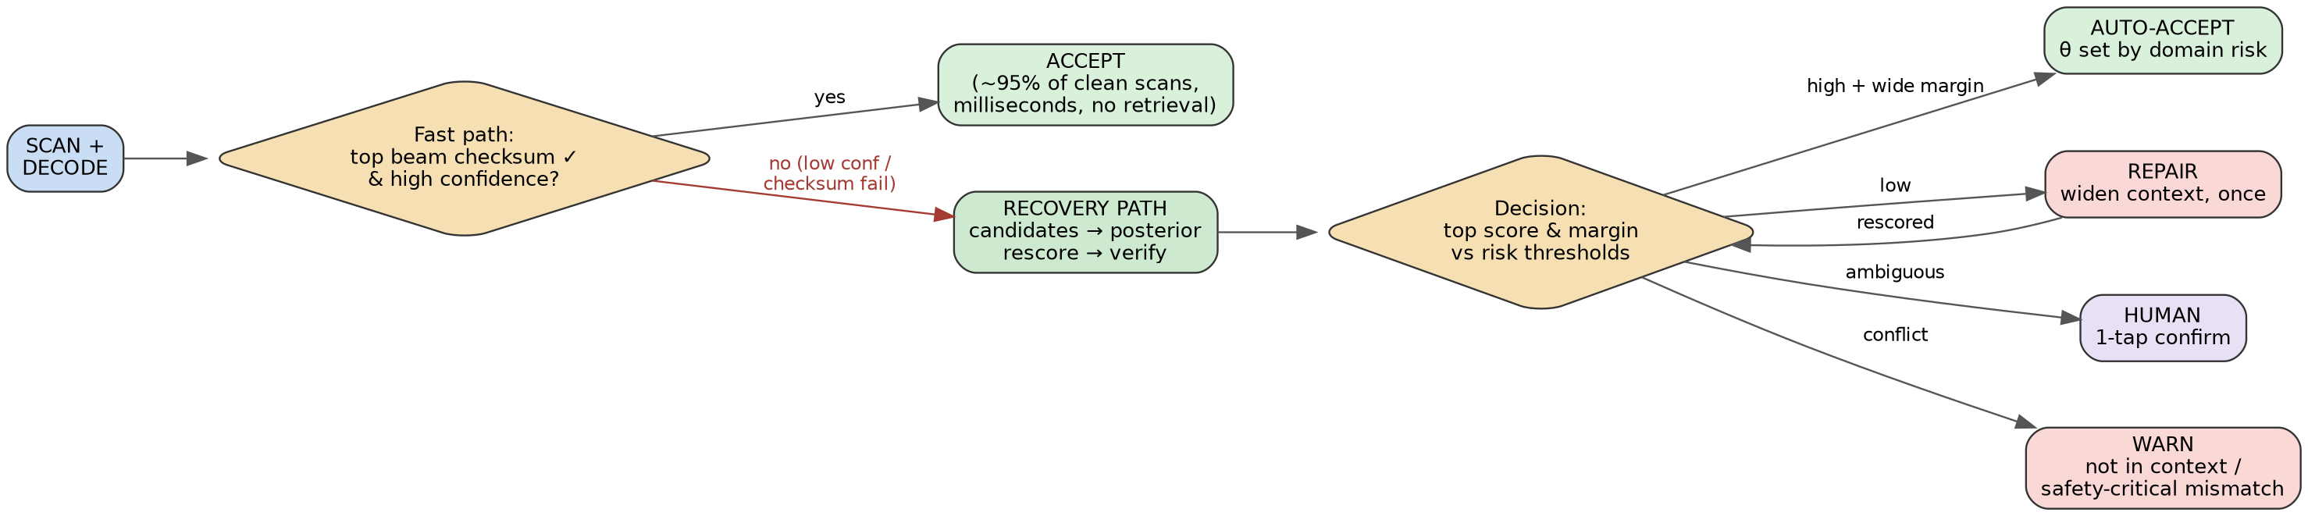
Figure 2 — Fast path vs recovery path.
if accept: AUTO-ACCEPT; write-back; done
elif tier < max_tier and not widened_yet:
widen one tier (pallet→PO→site→org); redo Stages 3–5 once
# auto-accept threshold θ_dom RISES with tier: wider search ⇒ less trust
elif 2–3 candidates pass math ∧ world: HUMAN one-tap (shown as products+photos)
elif best passes math but fails world: WARN 'not in this context'
else: HARD-FAIL → manual entry; event logged for the data engine
Figure 3 — Widening rings; trust decreases as scope increases. In safety-critical mode (medication) auto-correct is disabled at every tier: verify-and-warn only.

Stage 7 — Write-back
on confirmation of payload y for crop x:
E_code index += f(x) → record(y) # gallery learns this damage 'disguise'
hard_examples += (x, y) # periodic decoder fine-tune
Claimed precisely: retrieval-side improvement is immediate (the new damaged view is searchable at once); decoder-side improvement is periodic (fine-tuning), not instant.

5. Architecture Diagram
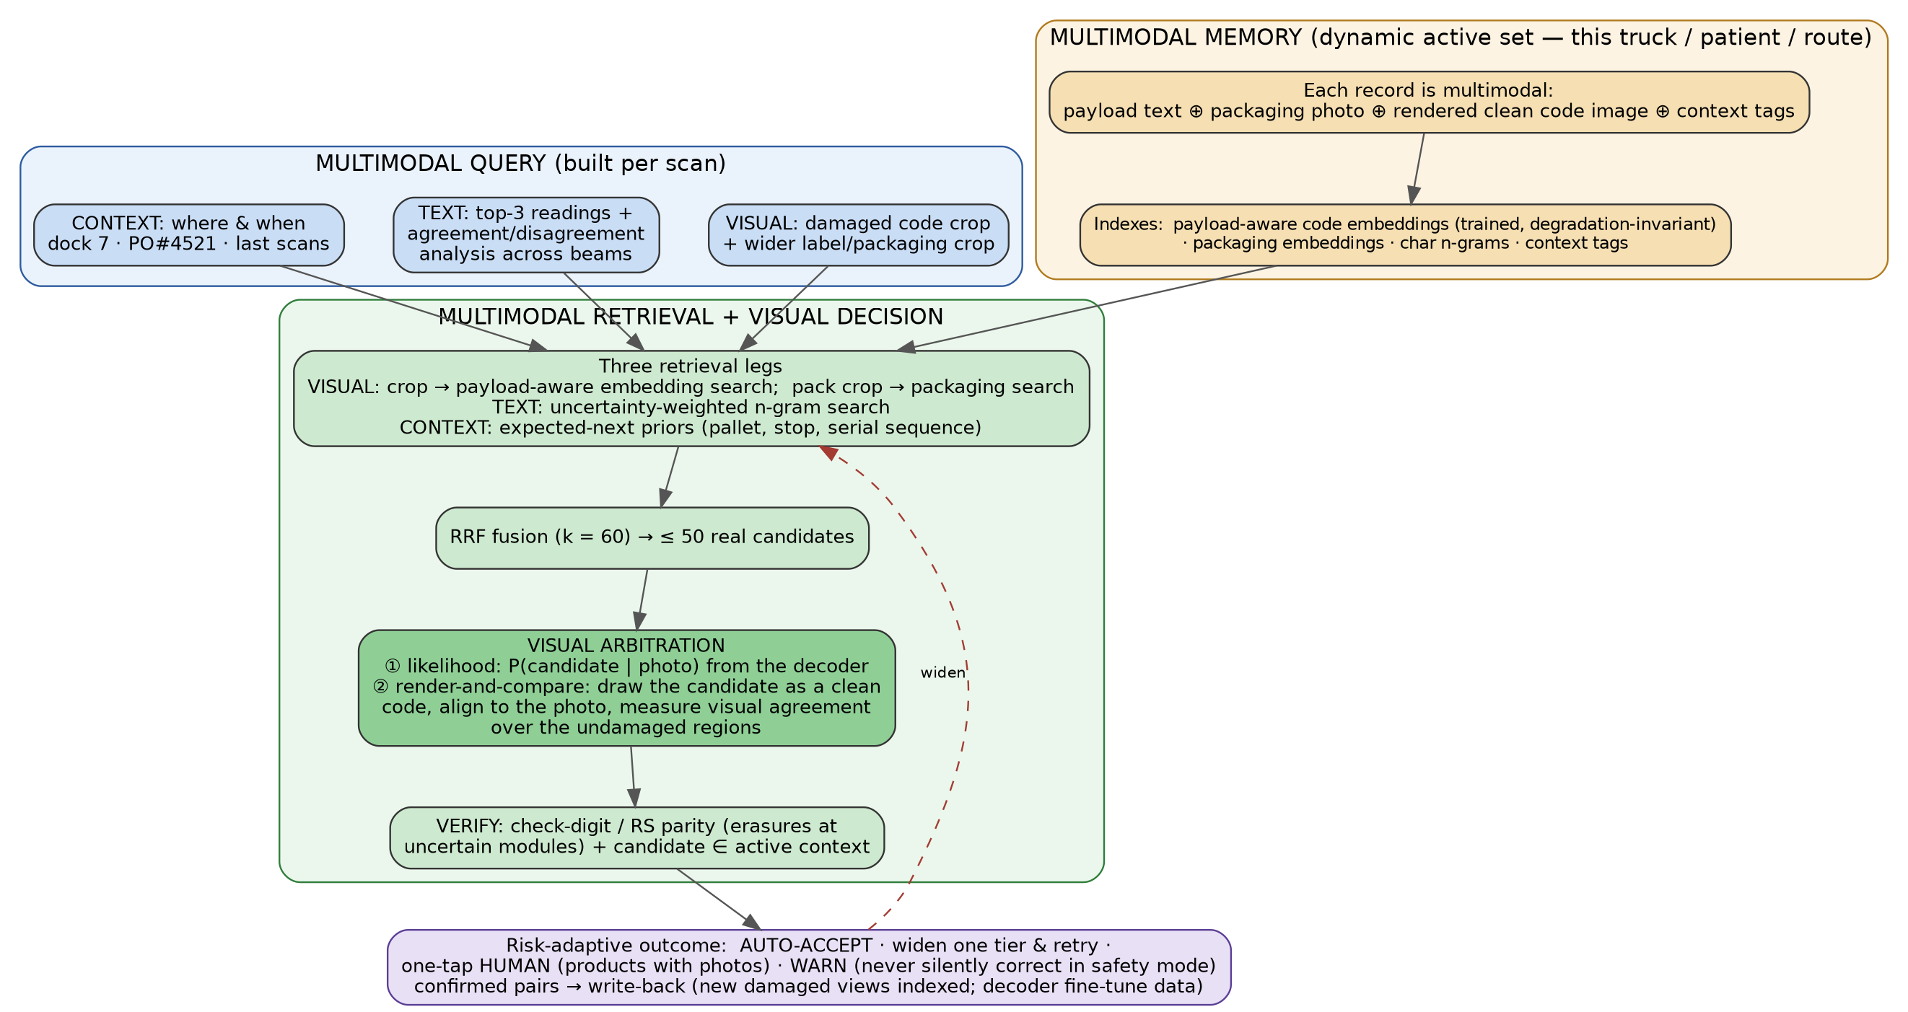
Figure 4 — The full system: multimodal query (photo + top-3 agreement analysis + context) over a dynamic multimodal memory, retrieval legs fused by RRF, render-and-compare arbitration, mathematical + membership verification, tier-widening loop, risk-adaptive outcome, write-back.

6. The Hard Cases — Handled Explicitly, Not Waved Away

6.1 Three damaged digits, truth in no beam (the case top-3 cannot touch)
y* = 8901030865268; damaged positions 10, 11, 12 ('5','2','6' all torn)
b1: …86 6 2 8 8 b2: …86 5 2 8 8 b3: …86 5 7 8 8 # y* in NO beam
agreement: positions 1–9 + 13 trusted; 10–12 damaged
consensus pattern: '890103086???8'
Pipeline behaviour: Stage 2’s wildcard pattern and hard trigrams (positions 1–9, plus the check digit) recall from the active set every payload matching ‘890103086???8’ — the truth is reachable although no beam contains it. Counting (Section 3.3): dₑ = 3 destroyed varying digits in a 200-item manifest → ≈ 20 pattern-consistent candidates before other evidence; the code-embedding leg and pallet prior cut this to 3–4; render-and-compare then tests each candidate’s rendered bars against the surviving fragments at three positions simultaneously — three positions of fragment evidence multiply, so separation is usually decisive. If the margin stays narrow → one-tap human with 2 product photos. Outcome guarantee: never a silent guess — auto-accept requires math + membership + margin.

6.2 Damage exactly on the discriminating digits, sibling products present
Dove Soap …5268 vs Dove Shampoo …5299 on the same pallet, tear covering positions 12–13. Text and context cannot separate them; this is the provable worst case. In order: (a) render-and-compare on the bar patterns of the damaged region — bars differ even when human-readable digits are gone, and fragments favour one sibling; (b) packaging leg if the pack is visible (soap vs shampoo packs differ strongly); (c) note the check digits differ (8 vs 9): the check-digit bars may survive when digits 10–12 are torn, making only one sibling mathematically consistent; (d) otherwise: two-photo one-tap. The residual human-tap rate is a headline metric, not a footnote.

6.3 Nothing consistent in the active set
Widen one tier and retry once. If a consistent, math-valid candidate exists at site/org tier but not locally → mis-shipment / mis-route warning — a logistics error detected, more valuable than a scan. If nothing is consistent anywhere → hard fail to manual entry, crop logged; a cluster of similar hard-fails is exactly the signal that the degradation model needs extending.

6.4 Torn edge: trailing digits missing entirely (unknown length)
Beams cannot even align. The pipeline copes because candidates come from the context: every active-set payload has known full length; render-and-compare warps each candidate’s full rendering onto the surviving region and scores only there; the quiet-zone detector bounds how many modules are missing. The consensus pattern is simply shorter — its trusted prefix still drives recall. No stage requires a complete reading to exist.

6.5 2D beyond the erasure budget
If destroyed modules exceed n−k even as erasures, RS cannot reconstruct — the DataMatrix path then degrades to exactly the 1D path: consensus query → retrieval → render-and-compare → membership; RS becomes a consistency filter (render the candidate’s full module grid; its parity structure must not contradict any confidently-read module).

6.6 Wrong or stale context data
An item legitimately present but missing from the manifest surfaces as a WARN — the gate makes the data error visible instead of absorbing it. Warn-rate is tracked; a rising warn-rate at one site is a data-quality alarm, not a model failure.

7. What Exactly Is Novel (and Aligned to the Vision Track)
- Model-agnostic beam-consensus retrieval: any black-box top-k decoder is coupled to dynamic context retrieval through agreement analysis and wildcard consensus patterns — candidates outside every beam remain reachable. Existing lexicon-constrained recognition consumes hard strings and needs model internals; this needs neither.
- Dynamic, tiered hypothesis space: the retrieval corpus is context-selected and widens with decreasing trust on failure — inherited from the proven skill-RAG loop, new to visual code recovery.
- Payload-aware damage-invariant code embeddings: a trained visual representation under which a torn code retrieves its own identity — with the honest, measured claim that off-the-shelf embeddings cannot (ablation).
- Render-and-compare verification: analysis-by-synthesis over the surviving pixels — decoder-independent, interpretable (the overlay can be shown to the worker), and the visual counterpart of the check digit.
- Image-driven RS erasure decoding: a pure image damage map converts error correction into erasure correction, doubling the recoverable budget with a hard mathematical accept — no decoder internals involved.
- Risk-adaptive correction budget: auto-fix permission coupled to context tier and domain cost (never in medication mode) — the trustworthy-vision story, with wrong-item rate as a first-class metric.
ICVGIP topic alignment: deep architectures for vision (ViT decoder, trained embeddings), multimodal learning (image+text+context fusion), trustworthy/robust vision (verification-first, safety policy), AI for societal-scale applications (frontline workers), all on-device.

8. The Pitch
Thirty seconds: “When a barcode is torn, today a human types 13 digits or skips a safety scan. But that torn code is one of 200 items on this truck, or 7 medicines on this chart — the answer already exists in context. Our system takes any decoder’s top-3 guesses, mines where they agree and disagree, searches only what is possible right now with the disagreements as wildcards, and then lets the photo itself prove the winner — by re-drawing each candidate over the damage and checking the surviving bars — double-checked by the barcode’s own mathematics. Clear cases auto-confirm in a second; ambiguous ones become a one-tap choice between two product photos; codes that don’t belong raise an alarm. Multi-digit damage — where top-3 predictions provably fail — is exactly where the gains are largest.”
For the skeptical reviewer, in one sentence each: Not lexicon decoding — the lexicon is dynamic, tiered, and queried through beam-consensus wildcard patterns, reaching candidates no beam proposed. Not a database lookup — candidates are proven by pixels (render-and-compare) and mathematics; membership only gates. Not single-digit toy cases — the combinatorial analysis (Section 3.2) and collision envelope (Section 3.3) define exactly where the method wins, degrades, and hands over — and all three regions are measured.

