Multimodal Dynamic RAG for Visual Barcode Recovery
The Photo Asks, the Memory Answers, the Photo Confirms
Concept, Architecture, and Complete Step-by-Step Use Cases

1. The Problem, With a Familiar Example
Look at any soap pack at home. Under the black lines is a number like 8901030865278. That number is all the barcode stores — no name, no price. The shop’s computer keeps a table that says “8901030865278 = Dove Soap 100g, ₹45”. The barcode is just the key; the table is the knowledge. Barcodes also carry built-in self-checking: 1D codes have a check digit (a small formula over the other digits — change one digit and the formula breaks), and 2D codes (the square QR-like ones) carry spare repair data (Reed–Solomon) that can rebuild the message if part of the square is destroyed — up to a limit.
Now imagine the label is torn, or soaked in rain, or rubbed off. The scanner beeps red. What happens next, millions of times a day: a warehouse worker types 13 digits by hand from a torn sticker; a delivery person retypes a 15-character tracking code standing in the rain; a nurse whose vial won’t scan skips the safety scan — a documented cause of medication errors. The damage broke the key.

2. The Idea: a Multimodal RAG System
Here is the observation everything rests on. That torn soap barcode is not one of the trillions of codes that exist in the world. It is one of the 200 items on this truck. The nurse’s vial is one of 7 medicines on this patient’s chart. The soggy parcel is one of 120 boxes in this van. The answer is already sitting in a short list — the system just has to find it, and prove it found the right one.
So we build a RAG system — retrieve, then generate/decide — where both the question and the knowledge are visual + textual (multimodal):
- The query is multimodal: the photo of the damaged code + the wider photo of the label/packaging + the model’s honest, uncertain reading of the digits + where-and-when context (which dock, which patient, which street).
- The memory is multimodal: each record in the dynamic knowledge base holds the payload text ⊕ a photo of the packaging/label ⊕ a rendered image of the clean barcode ⊕ context tags. Not a plain database table — a gallery with captions.
- The retrieval is multimodal: image searches image (damaged crop → trained code embeddings; pack crop → packaging photos), text searches text (uncertainty-weighted character pieces), and context ranks what is expected next — all fused into one shortlist by RRF, exactly the fusion used in the Knox skill RAG.
- The decision is visual: the photo itself confirms the winner, twice — once through the decoder’s exact probability of each candidate given the image, and once through render-and-compare: draw the candidate as a perfect clean barcode, lay it over the photo, and measure how well the visible bars agree. The verdict comes from pixels and mathematics, not from a lookup.
In simple terms: Think of a shopkeeper with a torn label: he glances at the pack (visual), half-reads the number (text), remembers what arrived this morning (context), pulls the matching item from the shelf (retrieval), and holds the fresh pack next to the torn one to be sure (render-and-compare). Our system does exactly this, in half a second.

2.1 Two honest technical notes that make the visual part real
Note 1 — ordinary image search cannot tell barcodes apart, so we train one that can. To a normal image-embedding model, every barcode looks the same: black bars on white. Dove Soap’s code and Dove Shampoo’s code land on nearly the same vector. We therefore train a payload-aware, damage-invariant embedding with contrastive learning: the same payload photographed under tear, blur, rain, or glare must map to nearby vectors; different payloads must map far apart. After training, the damaged crop itself becomes a working visual query — this is a genuine vision contribution of the work, and it is measured in an ablation, not assumed.
Note 2 — verification is visual synthesis, not a lookup. Because barcodes are perfectly renderable from their text, every candidate can be turned back into an ideal image. Render-and-compare aligns that ideal image with the photo, masks out the regions the decoder marked as destroyed, and scores bar-by-bar agreement on what is actually visible. A wrong candidate disagrees with the photo somewhere in the readable region and scores low. This is analysis-by-synthesis — the same closed-loop visual verification idea used per-step in the Knox/VESPER design, applied to codes.
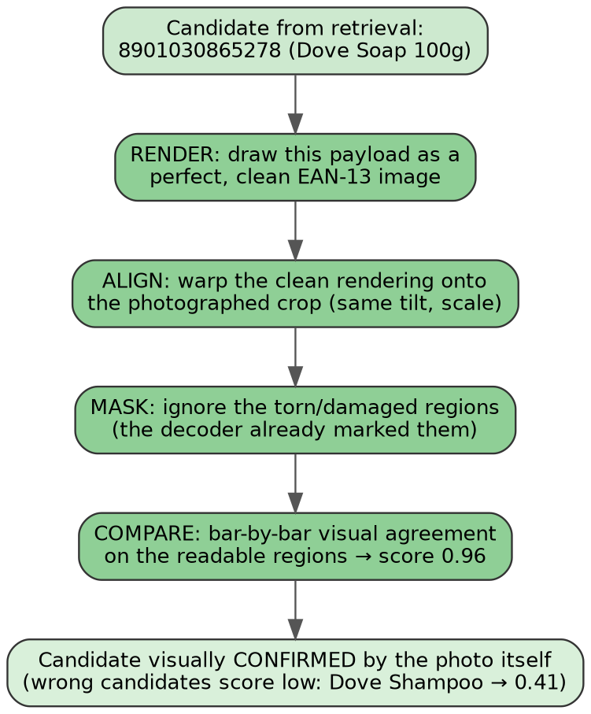
Figure 1 — Render-and-compare: the candidate is drawn as a clean code, aligned to the photo, damaged regions are masked, and visual agreement is scored on the readable bars. The right answer scores 0.96; the near-miss (one digit different) scores 0.41.

3. Architecture
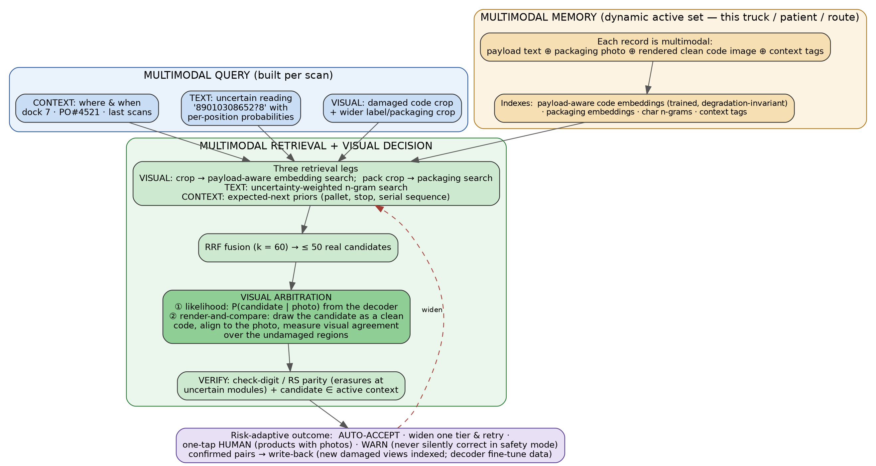
Figure 2 — Multimodal Dynamic RAG. A multimodal query (photo + uncertain text + context) searches a multimodal memory (payload ⊕ packaging photo ⊕ rendered clean code ⊕ tags) through three retrieval legs fused by RRF; visual arbitration (likelihood + render-and-compare) and mathematical verification decide; the loop widens the context on failure.

The pieces, one by one
- Reader (vision): a detector finds and straightens the code in the frame; a compact ViT + character decoder reads it and — crucially — reports per-position probabilities (“digit 12 is ‘1’ 34% / ‘7’ 31%”) and, for 2D codes, a map of which squares it could not see properly.
- Dynamic multimodal memory: when a truck docks / a wristband is scanned / a route starts, that context’s records become the active set — the live searchable gallery. Wider rings (whole warehouse, whole hospital) stand ready behind it.
- Three retrieval legs → RRF: visual (trained code embeddings + packaging photos), text (uncertainty-weighted character pieces), context (what is expected next on this pallet / route stop / serial sequence). RRF (k = 60) fuses ranks — agreement between different kinds of evidence is what wins.
- Visual arbitration: (a) each shortlisted candidate is passed back through the reader against the photo for its exact probability; (b) render-and-compare confirms with synthesized pixels. Two independent visual votes.
- Mathematical verification: check digit for 1D; for 2D, the unseen-squares map is handed to Reed–Solomon as erasures — repair reaches twice as far when the math is told where the holes are — giving a hard pass/fail.
- Context gate: the winner must belong to the active set (“is this on this truck?”). Not a database query deciding the answer — a membership gate catching dangerous mistakes: a code that is valid somewhere in the world but wrong here becomes a warning, never a silent booking.
- Risk-adaptive outcome + widening: clear winner → auto-accept; no winner → widen one ring (pallet → truck → warehouse) and retry once, with less permission to auto-decide the wider it goes; still unsure → show 2–3 candidates as products with photos, one tap; safety-critical (medicines) → warn only, never auto-fix.
- Write-back: every confirmed rescue stores the new damaged view into the visual index (the gallery learns new “disguises” of each product) and banks the (photo → true code) pair for periodic reader fine-tuning.
Figure 3 — Widening rings: search grows only on failure, and trust shrinks as it grows.

4. Use Cases — Every Step, With Familiar Examples

4.1 The kirana/warehouse story — torn soap label at a receiving dock
A worker at dock 7 unloads a truck against purchase order PO#4521.
Step 0 — The memory fills itself (before the truck arrives). The supplier’s digital list lands: 200 items. For each, the system stores a multimodal record:
text: 8901030865278 | Dove Soap 100g | PO 4521 | pallet PL-09
images: packaging photo (white-blue pack) + rendered clean EAN-13
vector: payload-aware embedding of the clean code
Step 1 — Scan. The worker points the phone at a box; the label is torn across the last digits. The detector crops and straightens the barcode, and also keeps the wider label crop.
Step 2 — Honest reading. The reader outputs guesses, admitting where it is blind:
A: 8901030865218 conf 0.61 check digit ✗
B: 8901030865278 conf 0.58 check digit ✓
digit 12 is torn: P('1')=0.34 P('7')=0.31
Step 3 — Recovery wakes up. Top guess fails its own math → the multimodal RAG takes over (clean scans never reach this point).
Step 4 — Multimodal query. [torn-code photo] + [wider label photo] + “89010308652?8, unsure 1-or-7” + {dock 7, PO 4521, personal-care pallet in progress}.
Step 5 — Three searches at once, over the 200 live records. VISUAL: the torn crop’s trained embedding lands nearest the Dove Soap clean-code vector (damage-invariance doing its job). TEXT: character-piece search ranks ...5278 first — 12 of 13 digits agree, and both the ‘1’ and ‘7’ alternatives were in the query. CONTEXT: the pallet being unloaded is personal care → Dove records boosted. RRF fuses → shortlist:
C1: Dove Soap 100g ...5278
C2: Dove Shampoo 180ml ...5298
C3: Pears Soap 75g ...12345
Step 6 — The photo decides, twice. Likelihood: the reader scores each candidate against the photo — C1: −0.9, C2: −4.2, C3: −21.7 (the surviving pixels at digit 12 look like ‘7’, not ‘9’). Render-and-compare: C1’s clean rendering agrees with the visible bars at 0.96; C2 only 0.41. Both visual votes: C1.
Step 7 — Mathematics + gate. C1’s check digit ✓. C1 is on this truck’s list ✓.
Step 8 — Outcome. Auto-accept: “✓ Dove Soap 100g — received”, one second, manifest ticked. The torn view of Dove Soap is added to the gallery (write-back). Without the system: 13 digits typed from a torn sticker.

4.2 The supermarket story — crumpled chips pack at billing
The hardware scanner already beeped red on a crumpled Lays pack.
Step 0 — Memory. The store’s 30,000 products, each a multimodal record (code text ⊕ pack photo ⊕ rendered code ⊕ aisle/department tags). All live; department and the customer’s basket act as gentle boosts, not filters.
Step 1 — Scan. Camera sees the crumpled pack; two crops: the wrinkled code, and the colourful pack itself.
Step 2 — Honest reading.
A: 8901491101887 conf 0.55 check ✗ B: 8901491101837 conf 0.52 check ✓
Step 3 — Recovery wakes up. Check-digit failure on top guess.
Step 4 — Multimodal query. [wrinkled-code photo] + [pack photo] + uncertain digits + {front counter, basket has 2 snack items}.
Step 5 — Three searches. VISUAL is the star here: the blue-and-yellow pack photo matches the stored Lays Magic Masala image directly — packaging is far more distinctive than bars when the catalog is huge. TEXT shortlists the near-miss codes out of 30k. CONTEXT boosts snacks. RRF → 4 candidates, Lays on top.
Step 6 — The photo decides. Likelihood −1.4 vs −5.1 for the runner-up; render-and-compare on the wrinkle-free stretches of the code agrees.
Step 7 — Math + gate. Check digit ✓; sold in this store ✓.
Step 8 — Outcome. Auto-accept: “Lays Magic Masala — ₹20” on the bill. If the margin had been narrow: two pack photos on screen, cashier glances at the pack, one tap. No supervisor with a keyring of override codes.

4.3 The hospital story — worn medicine vial (safety mode)
A nurse scans the patient’s wristband, then the vial. The vial’s square code is worn; its own built-in repair already gave up.
Step 0 — Memory. Scanning the wristband is the context switch: patient P-1042’s 7 prescribed medicines become the active set — each with code text ⊕ label photo ⊕ rendered code ⊕ dose schedule.
Step 1 — Scan. The curved, rubbed DataMatrix is cropped and flattened.
Step 2 — Honest reading, plus a map of the unreadable squares.
A: (01)08901234567894 (17)270331 (10)LOT4432 conf 0.57
unreadable squares: 9 modules marked
Step 3 — Mathematics with hints. The 9 marked squares are handed to Reed–Solomon as erasures — repair reaches twice as far when told where the holes are. Parity reconstructs and confirms guess A. A hard mathematical yes.
Step 4–5 — Retrieval as a cross-check. The decoded drug code searches the 7-record active set; the worn label photo matches the stored Amoxicillin label image. Everything points one way.
Step 6 — Gate + safety extras. Amoxicillin is on this patient’s chart ✓; expiry in the payload (2027-03) not passed ✓; the 08:00 dose is due now ✓.
Step 7 — Outcome. “✓ Amoxicillin 500mg — matches the order. Administer.”
Step 8 — The branch that matters. Suppose instead the code mathematically confirms as Atorvastatin — a drug NOT on this patient’s chart. Safety mode: the system never bends the answer toward the chart (that could hide a real wrong-medicine event). It identifies the vial against the hospital’s full list and alarms: “⚠ This appears to be Atorvastatin — not prescribed for this patient. Do not administer; call pharmacy.” The point is to keep the nurse scanning instead of skipping — skipped scans are how errors reach patients today.

4.4 The delivery story — rain-soaked parcel label
A courier at a doorstep; the label is soggy and smudged.
Step 0 — Memory. This morning’s route: 120 parcels — tracking code ⊕ a label photo taken automatically at the sorting hub ⊕ recipient ⊕ stop number ⊕ location. GPS keeps a rolling “nearby” subset live: 3 parcels within 300 m right now.
Step 1 — Scan. Wet label, glare; the code strip is cropped.
Step 2 — Honest reading.
A: TRK4482915580IN conf 0.48 check ✗ B: TRK4482915530IN conf 0.45 check ✓
Step 3 — Recovery wakes up.
Step 4 — Multimodal query. [wet-code photo] + [whole-label photo] + uncertain characters (3-or-8 at the smudge) + {GPS, stop 36 just done}.
Step 5 — Three searches over the 3 nearby parcels. VISUAL: the wet label photo matches the hub photo of the same parcel — the printed layout, stamps, and handwriting are distinctive even when the bars are not. TEXT: 14 of 15 characters agree with parcel B. CONTEXT: next expected stop is 37 → that parcel boosted. RRF: one clear winner.
Step 6 — The photo decides. Likelihood separates ‘3’ from ‘8’ at the smudge; render-and-compare on the dry stretch agrees.
Step 7 — Math + gate. Code-128 check character ✓; on this route, at this street ✓.
Step 8 — Outcome. Auto-accept: the proof-of-delivery screen opens for R. Sharma. Nothing typed in the rain. Had nothing matched nearby: widen 300 m → whole route → today’s hub list, with auto-decision allowed only in the first two rings.

4.5 The factory story — code etched on oily metal
A square code dot-punched straight onto a crankshaft: oil film, scratches, low contrast.
Step 0 — Memory. The station’s work order for the shift: ~150 expected part serials — serial text ⊕ the quality-camera’s reference photo of each part’s marking ⊕ sequence number.
Step 1 — Scan. The detector finds the faint dot grid on curved metal.
Step 2 — Honest reading + unreadable-squares map.
A: ENG-7742-0098-B conf 0.44 B: ENG-7742-0093-B conf 0.41
unreadable squares: 11 modules marked
Step 3 — Mathematics with hints. The 11 positions go to Reed–Solomon as erasures; parity reconstructs serial ...0093-B. Hard accept from the code’s own math.
Step 4–5 — Retrieval as the expecting witness. CONTEXT: the last scanned part was ...0092 — parts arrive nearly in order, so ...0093 was already top-ranked before the image finished. VISUAL: the oily crop’s embedding sits nearest that part’s reference marking. All three witnesses agree.
Step 6 — Gate. Serial belongs to this work order ✓, fits the sequence ✓.
Step 7 — Outcome. Auto-accept, traceability written, the line never stops. The precious failure branch: a serial that is mathematically valid but not in this work order → “⚠ Part not expected at this station — hold.” The gate just caught a mis-routed part — an assembly mistake, not a scanning mistake.

4.6 One pattern, five stories
 | Warehouse | Supermarket | Hospital | Delivery | Factory
Live memory | Truck list (~200) | Store catalog (~30k) | Patient’s chart (5–10) | Route ∩ GPS (3–120) | Work order (~150)
Strongest visual signal | Trained code embedding | Packaging photo | Label photo + RS math | Hub label photo | Reference marking + RS math
Gate question | On this truck? | Sold in this store? | On this patient’s chart? | On my route, near me? | In this work order, in turn?
Permission to auto-fix | Yes | Yes | Never — warn only | Yes (narrow rings) | Only with math confirmed
Final outcome | List ticked | Item billed | Administer / alarm | Delivery confirmed | Traceability logged

5. What Makes This a Vision Paper, Not a Database Paper
- The query is a photo (two photos, in fact — the code and its surroundings), enriched by an uncertainty-honest reading of it.
- The memory is a gallery: packaging photos, hub label photos, reference markings, rendered clean codes — retrieved by trained, damage-invariant visual embeddings (a measured contribution, since off-the-shelf embeddings provably cannot separate barcodes).
- The verdict is visual and mathematical: the decoder’s exact image likelihood, render-and-compare analysis-by-synthesis on the surviving pixels, and Reed–Solomon erasure decoding steered by the reader’s own uncertainty map. The context gate only guards the result; it never generates it.
- The loop is the Knox/VESPER loop: dynamic active knowledge, RRF fusion of heterogeneous evidence, per-step verification, mismatch-driven widening, write-back — transplanted from skills on a screen to codes in the physical world.

5.1 What we claim and what we do not
- Claim: large recovery gains on severely damaged codes versus classical decoders, a plain neural reader, exact lookup, and a fixed-dictionary method — gains growing with damage severity, measured per severity level and per memory size.
- Claim: each modality earns its keep — ablations remove the trained visual embedding, the packaging leg, the uncertainty-weighted text leg, the context priors, render-and-compare, and RS erasures one at a time.
- Do not claim: that off-the-shelf image search can identify barcodes (it cannot — that is precisely why the embedding is trained); that retrieval alone can separate two candidates differing only at destroyed positions (visual arbitration exists for that; the remainder go to a one-tap human, and we count them); or that the system improves without retraining (write-back feeds periodic fine-tuning).
- Safety stance: in medication mode the system never auto-corrects toward the expected list; conflicts alarm. Stale context data surfaces as warnings — the gate makes data problems visible instead of hiding them.

6. Summary
A damaged barcode is a half-erased key photographed in the messy real world — but it is always photographed somewhere, among a short list of things that could be there. This system turns that fact into a multimodal RAG loop: the photo and the half-reading form the question; a dynamic, image-and-text memory of what-is-possible-here answers with a shortlist; and the photo itself, through exact likelihoods and render-and-compare synthesis, plus the barcode’s own repair mathematics, proves which answer is right. The shopkeeper’s glance, the half-read number, the morning’s delivery memory, and the side-by-side comparison of a fresh pack with a torn one — automated, verified, and careful exactly where carelessness would hurt.

