Dynamic RAG for Damaged-Barcode Recovery
Retrieval-First Recognition: the Context Defines What a Damaged Code Can Be; Vision Verifies
Concept, Retrieval Mechanisms N1–N5, and Step-by-Step Use Cases

1. The Problem, In Plain Words
A barcode stores only a short string — a key into a database record. An EAN-13 on a soap pack stores 8901030865278; a shipping label stores TRK4482915530IN; a drug vial’s DataMatrix stores a drug code, expiry, lot and serial. Product names, prices, recipients — all live in the database. Barcodes also carry self-checking mathematics: 1D codes a check digit (a weighted-sum formula), 2D codes Reed-Solomon (RS) error-correction modules that restore the message up to a fixed damage budget.
Clean barcodes are a solved problem. Damaged ones — torn, faded, rain-soaked, oily, beyond the RS budget — defeat classical decoders and hardware scanners. The frontline worker then types 13–15 characters by hand, calls a supervisor, or skips the scan (in hospitals, a documented patient-safety problem).

2. The Idea: Retrieval-First Recognition
The standard framing of barcode recovery is vision-first: a stronger decoder reads more damage. Our framing is different, and it is the central claim of this work:
A damaged barcode cannot be reliably read in isolation — but it almost never occurs in isolation. It occurs inside an operational context (a shipment, a patient, a route, a work order) that the enterprise already maintains as data, and that context contains the answer. Recovery is therefore a retrieval problem first: dynamically retrieve the small set of payloads that can exist here and now, and use the image only to verify and arbitrate among them.
This inverts the pipeline. Under severe damage the decoder never free-generates the final answer; the answer can only come from the retrieved context set. The global universe of possible codes is ~10¹³; the dynamically retrieved universe is 5 to a few thousand. That reduction — performed by the Dynamic RAG layer, not by the vision model — is where the recovery power comes from. Vision contributes an uncertainty-aware reading and an exact image-likelihood for each retrieved candidate; it verifies, it does not decide the universe.
The division of labour is deliberate: roughly 70% of the mechanism and the novelty is retrieval — dynamic active-set selection, uncertainty-weighted query construction, multi-evidence fusion, mismatch-driven widening, retrieval-grounded verification and feedback — and 30% is vision — uncertain reading and likelihood arbitration. Section 3 states the retrieval mechanisms as explicit claims (N1–N5); Section 4 covers the supporting vision layer.
In simple terms: Instead of building a super-reader that squints harder at broken bars, we ask the enterprise’s own data “what codes are even possible right now?” — usually a tiny list — and then use the photo just to check which of those it is. The clever part is the asking: what to search, where to search, how to combine evidence, and when to widen the search.

2.1 Why not simply look up the decoder’s guesses?
- The correct string may be in none of the guesses — lookup dead-ends; fuzzy retrieval finds the real payload sharing 12 of 13 digits with a wrong guess.
- Two guesses may both exist — lookup cannot choose; context ranking and image arbitration can.
- A wrong guess may exist — lookup silently books the wrong item; the world check (“is it in this shipment?”) catches it.
- There may be no complete guess — you cannot look up a string with holes; you can retrieve real candidates from partial evidence and verify them.
Direct lookup is the degenerate case of this system at mild damage — where the recovery path is not even triggered.

3. The Dynamic RAG Core — Five Retrieval Mechanisms (N1–N5)
The retrieval stack is the Knox skill-RAG stack, unchanged: SQLite/Room for structured filters and priors, FTS/BM25 as the sparse index, USearch HNSW as the dense index, fused with RRF (k = 60), with mismatch-driven re-retrieval as the closed loop. What is new is what these mechanisms operate on and the five retrieval behaviours built on top of them.
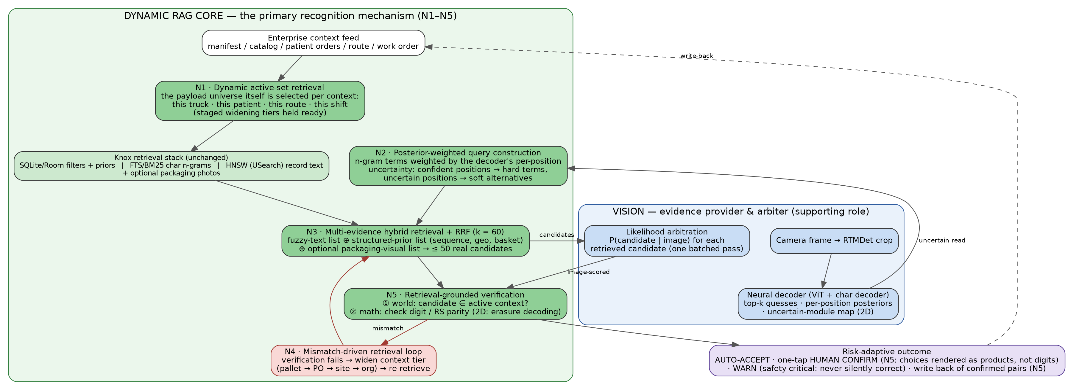
Figure 1 — Retrieval-first architecture. The Dynamic RAG core (green) is the primary recognition mechanism; the vision layer (blue) provides uncertain evidence in and image-likelihood arbitration back. N1–N5 mark the five retrieval mechanisms.

N1 — Dynamic active-set retrieval: the knowledge base itself is what gets retrieved
In classic RAG the corpus is fixed and the query varies. Here the first retrieval act selects the corpus: when a truck is assigned to dock 7, that truck’s 200 manifest payloads become the active set; when a nurse scans a wristband, that patient’s 7 medication orders become the active set; when a courier starts a route, those 120 packages do. Context size is the safety lever — fuzzy correction of a damaged code is only safe inside a small, context-selected universe — and the active set is held with pre-staged widening tiers (N4) rather than as a single flat list.
In simple terms: Before any scan happens, the system has already pulled the short list of codes that belong to this truck / this patient / this route. The “library” changes underneath the search, minute by minute — that is the ‘dynamic’ in Dynamic RAG.

N2 — Posterior-weighted query construction: the query encodes the decoder’s uncertainty
The sparse query is not a plain string. Character n-gram terms are weighted by the decoder’s per-position confidence: positions read with near-certainty contribute hard, highly-weighted terms; a damaged position contributes soft alternative terms (both ‘1’-context and ‘7’-context n-grams, weighted by their probabilities). The retrieval layer thus consumes the reader’s uncertainty directly, instead of receiving a single brittle guess. Example: from beams over 89010308652?8 with P(‘1’)=0.34, P(‘7’)=0.31 at the damaged position, the query carries n-grams for both continuations, so the true payload ranks first even though no beam matched it exactly.
In simple terms: The search query itself says “I’m sure about these digits, unsure between 1 and 7 here” — so the search can hedge exactly where the reading hedged.

N3 — Multi-evidence hybrid retrieval with RRF: one fusion, many kinds of evidence
Three ranked lists are produced and fused with RRF (k = 60), exactly as in the Knox skill RAG: (a) the sparse fuzzy-text list from N2’s query; (b) a structured-prior list from SQLite — scan-sequence neighbours (the pallet being worked, the next stop, the next serial), geo proximity, basket/department affinity; (c) optionally, a dense visual list matching a wider camera crop against stored packaging photos when the pack is visible. One precision note: the damaged barcode crop itself is never embedded for retrieval — barcode patterns of different payloads are visually near-identical, so embedding them discriminates nothing; image evidence about the code itself enters through the vision layer’s likelihood arbitration (Section 4).
In simple terms: Three independent hints — “the text looks close”, “it fits what’s expected next”, “the packet looks right” — are merged by the same rank-fusion rule the skill system uses. Agreement across hints is what earns a high rank.

N4 — Mismatch-driven retrieval loop: widening as a controlled escalation
Figure 2 — Context-widening tiers. Each verification failure escalates one tier; auto-correction is only permitted in the narrow tiers, and organisation-wide search is warn territory.
When verification (N5) fails, the loop widens the context one tier and re-retrieves: pallet → purchase order → site catalog → organisation. This is the execution-grounded re-retrieval of the Knox design, with one addition that matters for safety: the permission to auto-correct shrinks as the tier widens, because a fuzzy match against millions of codes is no longer safe. Tier is therefore both a retrieval scope and a trust level.
In simple terms: Didn’t find it on this pallet? Look at the whole truck. Not on the truck? Look at the warehouse — but the wider we look, the less we’re allowed to auto-decide, and the more we ask a human.

N5 — Retrieval-grounded verification, human-in-the-loop, and write-back
Verification is dual: world — is the candidate a member of the current active set? — and math — does the check digit / RS parity hold? The world check is itself a retrieval operation, and it is what converts the worst failure mode (silently booking a wrong-but-existing code) into a visible warning. When the system must ask a human, retrieval supplies the interface: the top candidates are rendered as products with names and photos — “Dove Soap or Dove Shampoo?” — not as 13-digit strings, which is what makes one-tap confirmation possible. Every confirmed scan writes back a verified (damaged crop → true payload) pair, harvested as hard examples for periodic decoder fine-tuning and threshold calibration.
In simple terms: The database check is part of the answer, not an afterthought; the human sees recognisable products, not digits; and every confirmed rescue becomes training data.

4. The Vision Layer — Supporting Role
Vision contributes three things, all in service of the retrieval core:
- Uncertainty-aware reading: RTMDet-tiny crops the code; a compact ViT encoder + character-level decoder outputs top-k guesses, per-position character probabilities (feeding N2), and for 2D codes an uncertain-module map.
- Likelihood arbitration: each retrieved candidate is teacher-forced through the decoder to obtain its exact probability given the image, P(candidate | image) — one batched pass over ≤50 candidates. Retrieval shortlists; the pixels arbitrate. This is the one job retrieval cannot do: separating two real candidates that differ only at a damaged position.
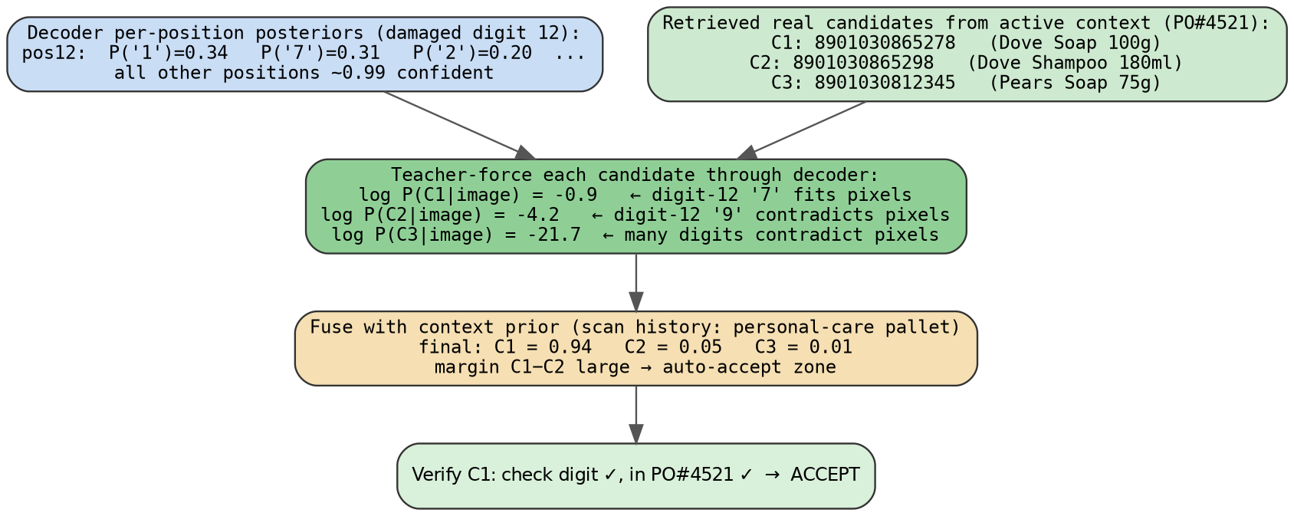
Figure 3 — Likelihood arbitration. Two retrieved candidates differ only at the damaged digit; their string distance is identical, their image-likelihood is not (−0.9 vs −4.2).
- RS-erasure decoding (2D): an RS code that corrects t errors at unknown positions corrects up to 2t missing symbols at known positions. The decoder’s uncertain-module map supplies those positions as erasures, roughly doubling the recoverable damage — and the result is confirmed or rejected by parity mathematics, a hard pass/fail.
In simple terms: The camera side reads with honesty about what it can’t see, tells the search where it is unsure, and — when the search returns a shortlist — measures which candidate the photo truly supports. For 2D codes it also points the barcode’s own repair math at the holes.

4.1 The decision policy
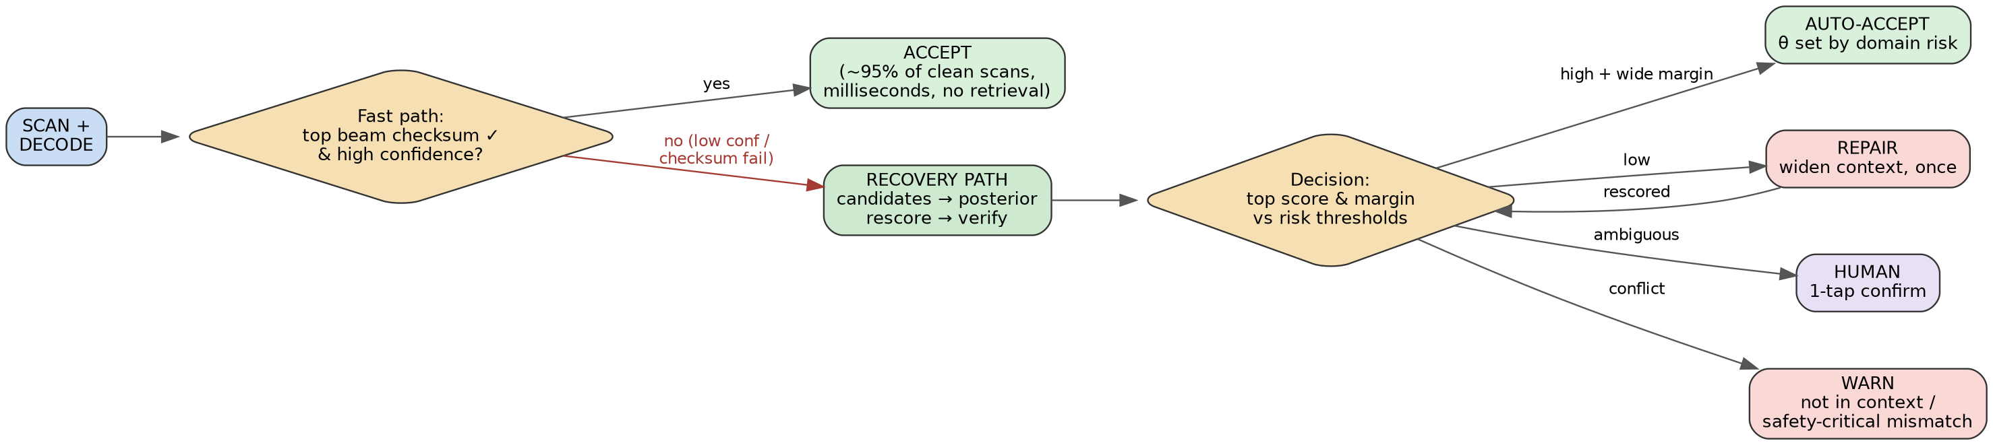
Figure 4 — Fast path vs recovery path. Clean scans exit at the decoder in milliseconds and never touch retrieval; the recovery path triggers only on low confidence or checksum failure.
Outcomes are risk-adaptive: auto-accept on a clear winner; one widening round (N4) otherwise; one-tap human confirmation when still ambiguous; and in safety-critical settings, warn — never silently correct. Thresholds are calibrated per domain on degraded validation data.

5. Use Cases — Step by Step
Each walkthrough labels the retrieval mechanism (N1–N5) doing the work at every step, with concrete data and the final outcome. Across domains, only three things change: the context store, the world-check question, and the correction budget.

5.1 Warehouse receiving — torn shipment label
Worker at dock 7, purchase order PO#4521.
N1 · Active set (offline). The digital manifest lands: 200 items become the live retrieval universe for dock 7. One record:
payload: 8901030865278 | Dove Soap 100g | EAN-13 | PO 4521 | pallet PL-09
Scan + read. RTMDet crops the torn label; the decoder reads with uncertainty:
A: 8901030865218 conf 0.61 check digit ✗
B: 8901030865278 conf 0.58 check digit ✓
posterior @ digit 12: P('1')=0.34 P('7')=0.31
Recovery triggers. Top beam fails its check digit; margin narrow → the RAG core takes over.
N2 · Query. N-gram terms weighted by the posteriors — hard terms for the 12 confident digits, soft alternatives (1/7) at the damaged position.
N3 · Retrieve + fuse. Sparse list: ...5278 ranks first (12/13 digits, both soft branches covered). Prior list: pallet PL-09 is personal care → Dove records boosted. Dense list: idle (no packaging in crop). RRF → 3 candidates: Dove Soap ...5278, Dove Shampoo ...5298, Pears ...12345.
Vision arbitration. Teacher-forcing: log P = −0.9 / −4.2 / −21.7 — the pixels at digit 12 support ‘7’, not ‘9’. Fused scores 0.94 / 0.05 / 0.01.
N5 · Verify. World: ...5278 ∈ PO#4521 ✓. Math: check digit ✓.
Outcome. Auto-accept — “✓ Dove Soap 100g — received”, manifest ticked, ~1 s. Write-back logs the (torn crop → payload) pair. Without the system: 13 digits typed by hand.

5.2 Retail checkout — crumpled packaging
Cashier scans a pack the hardware scanner rejected.
N1 · Active set. The store’s 30,000-SKU catalog is live; terminal department and current basket act as priors, not hard filters (a large active set uses soft scoping).
payload: 8901491101837 | Lays Magic Masala 52g | dept snacks | ₹20
Scan + read.
A: 8901491101887 conf 0.55 check ✗ | B: 8901491101837 conf 0.52 check ✓
N2 · Query. Posterior-weighted n-grams over the payload; product-name terms absent (nothing textual read).
N3 · Retrieve + fuse. Sparse list shortlists the near-match payloads out of 30k. Prior list: basket holds two snack items → snacks boosted. Dense list active: the wider camera crop shows the pack; packaging-photo match independently points at the Lays record. RRF → 4 candidates.
Vision arbitration. log P(B-payload | image) = −1.4, runner-up −5.1 — wide margin, and the packaging evidence agrees.
N5 · Verify. Check digit ✓; SKU in this store’s catalog ✓.
Outcome. Auto-accept — “Lays Magic Masala ₹20” billed. Narrow-margin fallback: two candidates rendered with pack photos, one tap (N5’s human interface). No supervisor call.

5.3 Hospital medication scan — worn vial label (safety-critical)
Nurse scans the wristband, then the vial; the DataMatrix’s own RS correction has already failed.
N1 · Active set. The wristband scan is the context switch: patient P-1042’s 7 active orders become the live set (time 08:02).
(01)08901234567894 | Amoxicillin 500mg | P-1042 | due 08:00 | oral
Scan + read. Curved, worn DataMatrix; beams plus the uncertain-module map:
A: (01)08901234567894 (17)270331 (10)LOT4432 conf 0.57
Vision: RS erasures. The flagged modules go to RS as erasures; parity reconstructs and confirms the codeword of beam A — a hard mathematical pass.
N2+N3 · Retrieve. Query from the decoded drug code; SQL restricted to the 7 orders; the Amoxicillin record dominates all lists; RRF trivial here — small active sets make retrieval nearly exact, which is the point of N1.
N5 · Verify. World: on this patient’s orders ✓. Extras read free from the payload: expiry 2027-03 ✓, dose due now ✓.
Outcome. Confirm to administer — “✓ Amoxicillin 500mg, matches order, due 08:00.”
The critical branch. If the vial parity-confirms as a drug not on P-1042’s orders, the correction budget is zero: the system never auto-corrects toward the order list (that could mask a genuine wrong-drug event). It identifies the vial against the formulary (an N4 widening used for identification, not correction) and alarms: “⚠ Appears to be Atorvastatin — NOT on this patient’s orders. Do not administer.” The win is keeping the nurse inside the scanning workflow — skipped scans are the documented failure mode of these systems.

5.4 Last-mile delivery — rain-soaked label
Courier at a doorstep, soggy Code-128.
N1 · Active set. The day’s route (120 packages) downloaded at the hub; GPS keeps a rolling sub-set live: undelivered stops within ~300 m → 3 packages.
TRK4482915530IN | R. Sharma | 12 MG Road | stop 37
Scan + read.
A: TRK4482915580IN conf 0.48 check ✗ | B: TRK4482915530IN conf 0.45 check ✓
N2 · Query. Posterior-weighted n-grams over the tracking ID; the smudged character contributes soft 3/8 alternatives.
N3 · Retrieve + fuse. Sparse list: B’s payload first (14/15 characters). Prior list: stop-sequence — last delivered 36 → stop 37 boosted; geo agrees. RRF over the 3 geo-live candidates.
Vision arbitration. The wet crop’s likelihood separates ‘3’ from ‘8’ at the smudge — wide margin for B.
N5 · Verify. Modulo-103 check character ✓; on this route, at this location ✓.
Outcome. Auto-accept — proof-of-delivery opens for R. Sharma. N4 note: had nothing matched nearby, the loop widens 300 m → full route → day’s hub manifest, with auto-correction allowed only in the first two tiers.

5.5 Manufacturing traceability — DPM code on oily metal
DataMatrix dot-peened onto a crankshaft: oil, scratches, low contrast.
N1 · Active set. Station 12’s work order for the shift: ~150 expected serials, plus a strong sequence prior (serials arrive nearly in order).
ENG-7742-0093-B | crankshaft assy | WO-518 | station 12 | seq 93
Scan + read. Damage exceeds the code’s normal RS budget:
A: ENG-7742-0098-B conf 0.44 | B: ENG-7742-0093-B conf 0.41
uncertain-module map: 11 modules flagged
Vision: RS erasures. 11 flagged positions handed to RS as erasures — double the reach of unknown-position errors — parity reconstructs serial ...0093-B. Hard accept.
N3 · Retrieve (confirmation role). Prior list: last scan ...0092 → ...0093 top-ranked before the image was even consulted; SQL confirms membership in WO-518. Retrieval and mathematics agree.
N5 · Verify. RS parity ✓; in WO-518 ✓; fits sequence ✓.
Outcome. Auto-accept, traceability written, no line stoppage. The valuable failure branch: a serial that parity-confirms but is not in this work order → “⚠ Part not expected at this station — hold.” An N5 world-check catching an assembly error, not merely a scan error.

5.6 One pattern, five domains
 | Warehouse | Retail | Hospital | Courier | Factory
N1 active set | Manifest (~200) | Catalog (~30k, soft-scoped) | Patient orders (5–10) | Route ∩ GPS (3–120) | Work order (~150)
Strongest N3 evidence | Fuzzy text + pallet prior | Packaging visual + basket prior | Order membership | Geo + stop sequence | Serial sequence + RS math
N5 world check | On this truck? | In this store? | On patient’s orders? | On route, near me? | In WO, in sequence?
Correction budget | Auto-correct | Auto-correct | Zero — warn only | Auto-correct (narrow tiers) | Math-confirmed only
Outcome | Manifest ticked | Item billed | Administer / alarm | POD opens | Traceability logged

6. What We Claim — and What We Do Not
- We claim that dynamic, context-scoped retrieval is the primary recovery mechanism: ablations must show accuracy as a function of active-set tier (N1/N4), with the plain decoder, exact-lookup, and static-global-lexicon baselines collapsing at severe damage while the retrieval-first system degrades gracefully.
- We claim that each retrieval mechanism earns its place: N2 (posterior-weighted queries) vs plain-string queries; N3 (multi-evidence RRF) vs single-evidence retrieval; N4 (tiered widening) vs flat search; N5 (world check) measured as wrong-item errors converted into warnings.
- We claim unchanged latency on clean scans: the recovery path triggers only on low confidence or checksum failure.
- We do not claim that retrieval alone suffices: two payloads in the same active set differing only at destroyed positions are indistinguishable without the image — the vision layer’s likelihood arbitration exists precisely for this, and remaining collisions route to one-tap human confirmation. We report the collision rate as a function of active-set size.
- We do not claim that the damaged barcode crop can be found by image-embedding similarity (barcode patterns are not visually distinctive — the dense index holds record text and packaging photos, never bare barcode crops), nor that the system improves without retraining (write-back collects verified hard examples for periodic fine-tuning).
- Honest limits: stale or wrong context data surfaces as warnings rather than being hidden; decoder probabilities are calibrated on degraded validation data before any threshold is set; the correction budget is a hard policy, not a tunable score, in safety-critical mode.

7. Summary
Damaged-barcode recovery is reframed as a Dynamic RAG problem: the operational context — a manifest, a patient’s orders, a route, a work order — already contains the answer, and the five retrieval mechanisms (dynamic active sets, posterior-weighted queries, multi-evidence RRF fusion, mismatch-driven tiered widening, retrieval-grounded verification with human-in-the-loop and write-back) do the heavy lifting of finding it. The vision layer reads with honest uncertainty, lets the barcode’s own mathematics repair what it can, and arbitrates among retrieved candidates with exact image likelihoods. The retrieval stack is the Knox skill-RAG stack, unchanged — proof that the Dynamic RAG design generalises from routing skills to recovering the physical world’s most ubiquitous machine-readable text.

