VESPER — Complete End-to-End Flow
Dynamic Skill Creation (M1–M4) + Visually-Verified, Execution-Grounded Skill Retrieval (V1–V4) — how the system actually works, step by step, with the active components highlighted at every stage.
Knox AI · SRI-Bangalore · Invention Disclosure (Draft v2) · Inventor: Kaushik Kamal Kalita · Architectural direction: Sharmila Mani · Novelty coordination: Renju C Nair

How to read this document
The flow below has 20 steps in three phases. Phase A (Steps 1–6) turns a request into either an applicable skill or a measured capability gap. The Creation Branch (Steps 7–10) runs only when there is a gap: the Dynamic Skill Creation pipeline builds, certifies and deploys a new skill, then rejoins the main flow. Phase B (Steps 11–20) is the visually-verified execution loop. Each step page shows: what happens, which components are active (highlighted teal in the diagram), and a concrete worked example. Three running examples are used throughout: the WiFi repair, the vague “fix this” storage request, and the Sunday-night skill that does not exist yet.

Reference architecture (FIG. 1) — two coupled loops, one skill graph
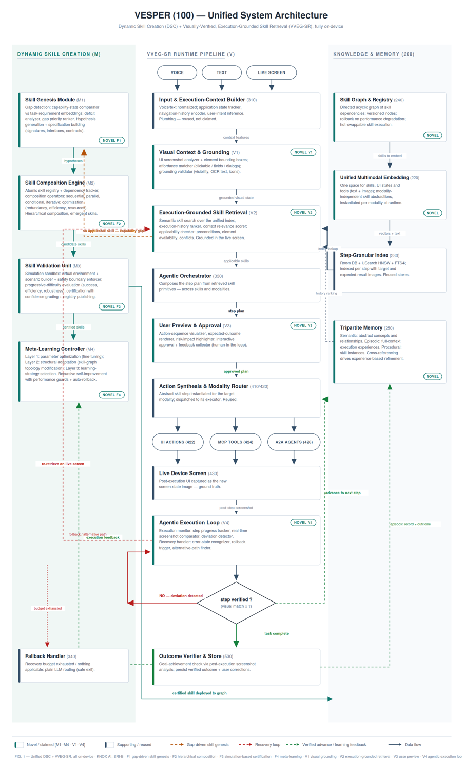

PHASE A — From request to decision (Steps 1–6)

STEP 1 — Receive multimodal input
Active components: Input chips (voice / text / live screen)
The request arrives in any mix: spoken words, typed text, and — critically — the live device screen. Unlike today's pipeline, the screen is treated as part of the request itself, not as decoration.
Example: the user says “I can't connect to the WiFi” while the WiFi settings page shows “Connection failed”. Both the sentence AND that screen enter the pipeline. In a second scenario, the user only types “fix this” over a storage-full warning — the words alone are useless; the screen carries the whole meaning.
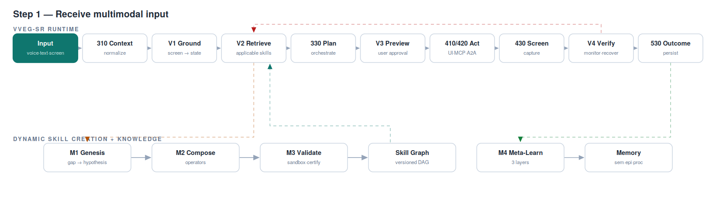

STEP 2 — Normalize & build execution context (310)
Active components: Input & Execution-Context Builder (310) — supporting, not claimed
Voice is transcribed (ASR) and text normalized. The module then assembles the execution context: which app is open, the recent navigation history, and the inferred user intent. This context is what later makes retrieval “execution-grounded” rather than just word-matching.
Example: for the WiFi request, the context becomes {app: Settings ▸ WiFi, nav: Home → Settings → WiFi, intent: connectivity-repair}. ASR itself is deliberately unclaimed commodity plumbing — its output matters, its mechanics do not.
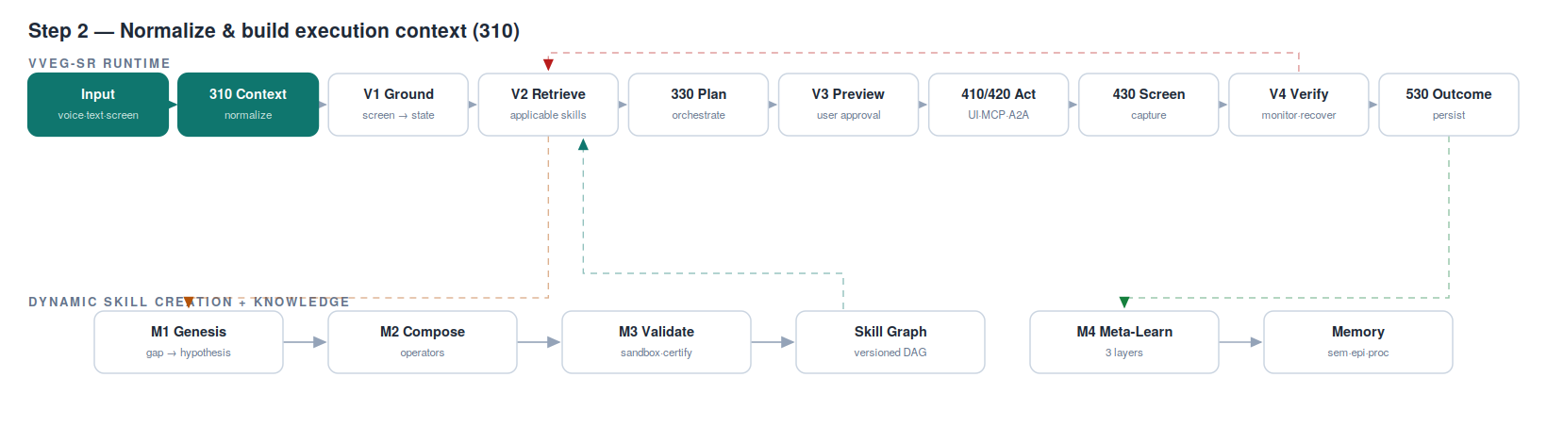

STEP 3 — Visual grounding of the live screen (V1)
Active components: V1 Visual Context & Grounding — NOVEL V1
The screenshot is converted from pixels into validated, machine-usable structure in three passes: (1) the visual context extractor finds every UI element with its bounding box; (2) the affordance matcher identifies what can actually be done — clickable elements, text fields, open menus or dialogs; (3) the grounding validator confirms each element is really there and actionable (visibility check, OCR text verification, icon recognition).
Example: the storage warning becomes {dialog: “Storage almost full”, body: “…2% free…”, buttons: [Free up space (clickable), Dismiss]}. Retrieval and every later action will reason over this grounded state — never over raw pixels, and never over assumptions.
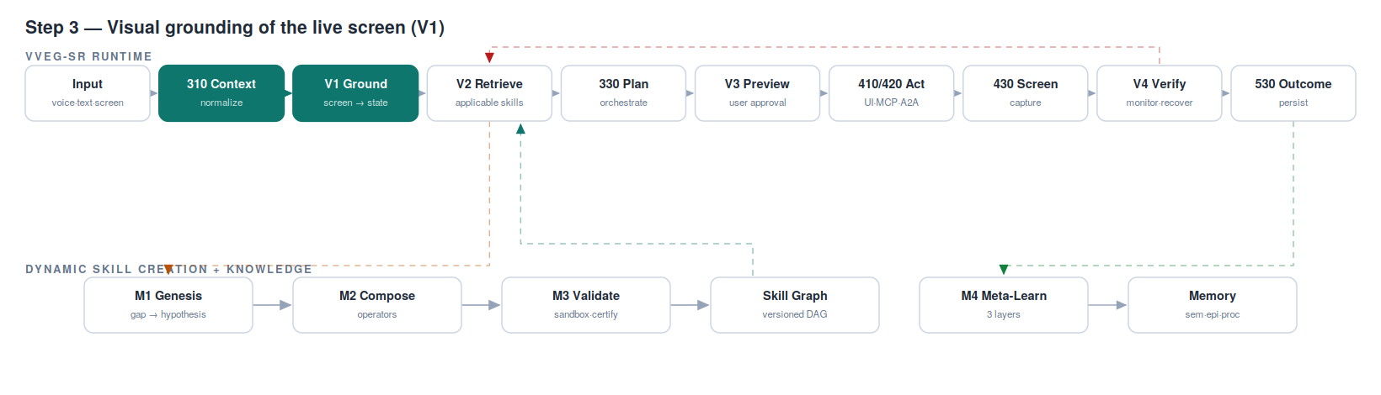

STEP 4 — Execution-grounded retrieval (V2)
Active components: V2 Skill Retrieval Engine + Skill Graph — NOVEL V2
The system searches the versioned skill graph through the unified multimodal index. Three signals rank candidates: semantic similarity (dense + lexical hybrid, reused from production), the execution-history ranker (skills that verified successfully in similar contexts rank higher — fed from episodic memory), and a context-relevance scorer that uses the grounded visual state from V1.
Example: for “I can't connect to the WiFi” + the failed-WiFi screen, connectivity.reset_network ranks top at ≈0.88 similarity. For “fix this” + storage screen, the storage skill wins purely because the screen's grounded state sits near its step images in the shared vector space — the screen, not the words, makes the pick.
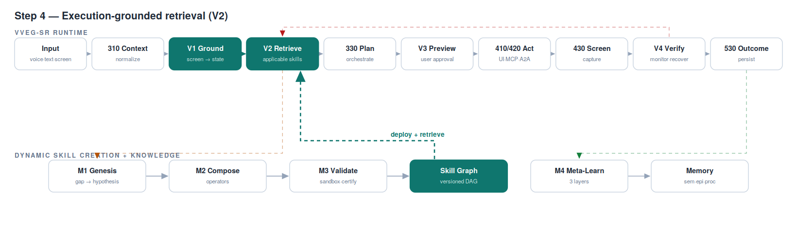

STEP 5 — Applicability check (V2)
Active components: V2 Skill Applicability Checker — NOVEL V2
Ranking is not enough — a skill must be applicable HERE and NOW. The precondition validator checks the skill's declared preconditions against the grounded screen; the element-availability checker confirms its target elements exist on this UI; the conflict detector confirms nothing currently running clashes with it.
Example: the storage skill declares precondition “a storage dialog or storage settings screen is present” — TRUE on this screen, so it passes. The same skill on the home screen would be rejected even with a high similarity score. This is what stops confidently-wrong skills from ever firing (limitation L5).
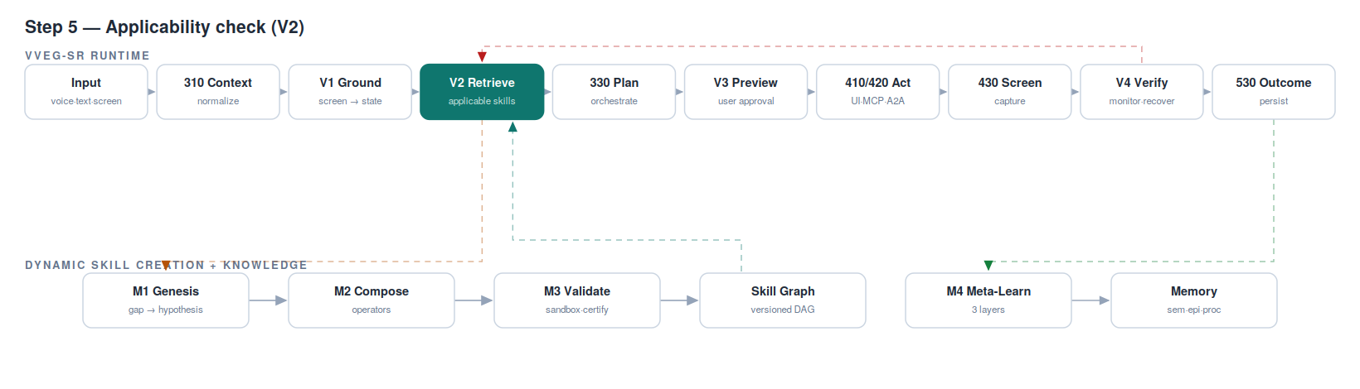

STEP 6 — Decision — applicable skill, or capability gap?
Active components: V2 decision point → gap trigger to M1 (amber)
Two exits. If at least one skill passes applicability → continue to Step 11 (orchestration). If NOTHING passes → the system does not shrug and fall back. It emits a GAP SIGNATURE — the measured embedding difference between what the task requires and what the skill graph can do — and hands it to M1. A retrieval miss becomes a creation work-order. This coupling is the heart of the invention.
Example: “Every Sunday night, silence work notifications and turn on data saver.” No skill covers this compound scheduled behaviour. Today: permanent fallback. Here: gap signature {scheduling + notification-mode + data-saver, compound, recurring} → Step 7.
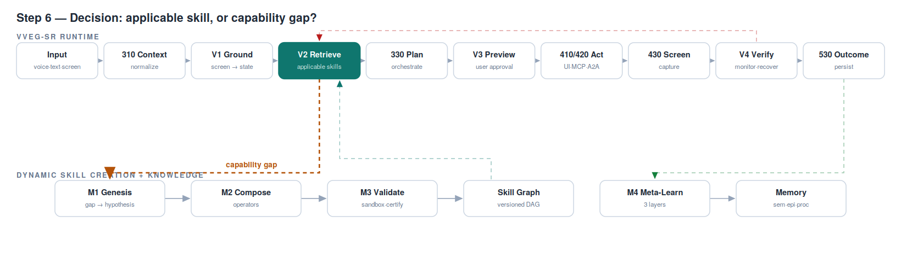

CREATION BRANCH — Gap-driven skill genesis (Steps 7–10)
This branch runs only when Step 6 finds a capability gap. It is the Dynamic Skill Creation pipeline in action — and it rejoins the main flow at Step 11 with a skill that did not exist before.

STEP 7 — Gap detection & skill hypothesis (M1)
Active components: M1 Skill Genesis Module — NOVEL F1
The capability-state comparator quantifies the gap: current capability embeddings vs task-requirement embeddings — missing capability is measured, not guessed. The action-sequence hypothesizer then explores combinations of atomic primitives the agent already has; the precondition inferrer and effect predictor annotate each candidate; hypotheses are ranked by predicted utility, novelty and composition complexity. The winner becomes a formal specification (signature, interface, contract).
Example: primitives already exist for set-notification-mode, toggle-data-saver, and run-on-schedule. M1's top hypothesis: a composite that schedules the two toggles for Sunday 22:00, with contract “after execution: work notifications silenced AND data saver ON”.
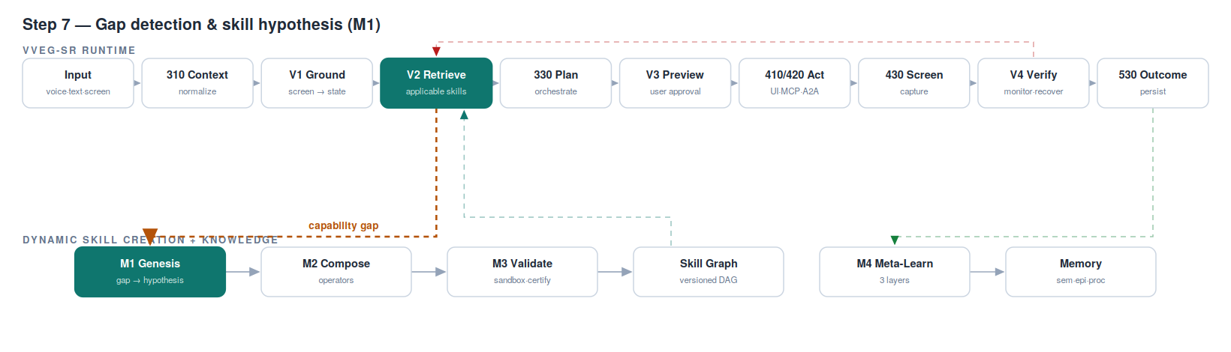

STEP 8 — Compose the candidate skill (M2)
Active components: M2 Skill Composition Engine — NOVEL F2
The atomic skill registry supplies certified primitives; four formal operators assemble them: sequential (sᵢ → sⱼ), parallel (sᵢ ∥ sⱼ), conditional (if c then sᵢ else sⱼ), iterative (s* until condition). An optimization pass removes redundancy. Crucially, composition validity is verified through formal constraint satisfaction: each step's preconditions must be guaranteed by an earlier step's effects or the starting state — checkable, not opinion.
Example: iterative(every Sunday 22:00) → sequential( conditional(work profile active → silence work notifications), toggle(data saver, ON) ). The constraint check catches that “silence work notifications” requires the work profile to exist — so the conditional guard is mandatory, not optional.
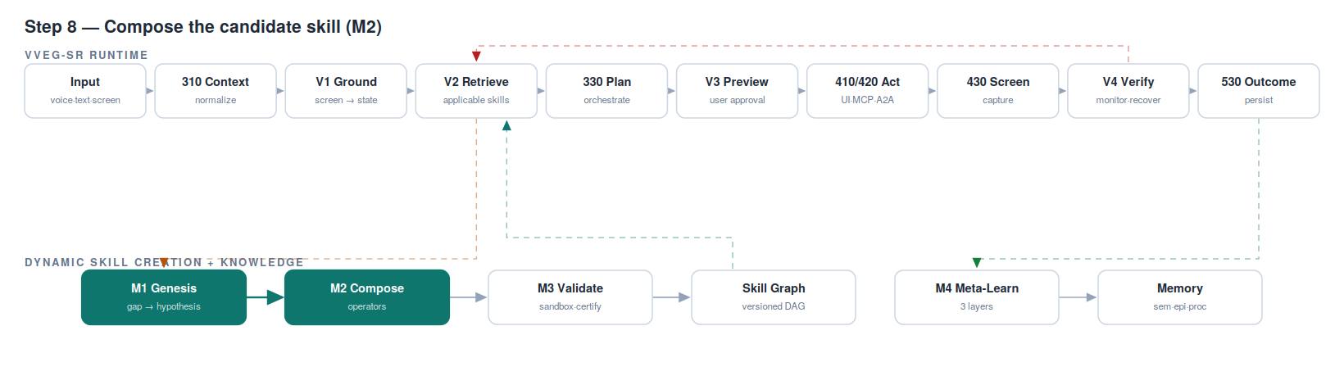

STEP 9 — Sandbox validation & certification (M3)
Active components: M3 Skill Validation Unit — NOVEL F3/F9
No created skill touches the real device untested. A virtual environment generator spins up an isolated simulated device; a scenario builder produces test situations of PROGRESSIVE difficulty and diversity; a safety boundary enforcer guarantees the candidate cannot reach real user state. Success rate, efficiency and robustness are measured; a confidence score and certification grade are assigned; only then does the registry publisher deploy.
Example curriculum for the Sunday skill: (easy) plain Sunday 22:00 → pass; (harder) weekday 22:00 → must NOT fire → pass; (edge) DND already enabled → FAIL, the draft toggled DND off. M2 patches the conditional; re-test passes; certification grade B — which runtime policy maps to “always show the user a preview”.
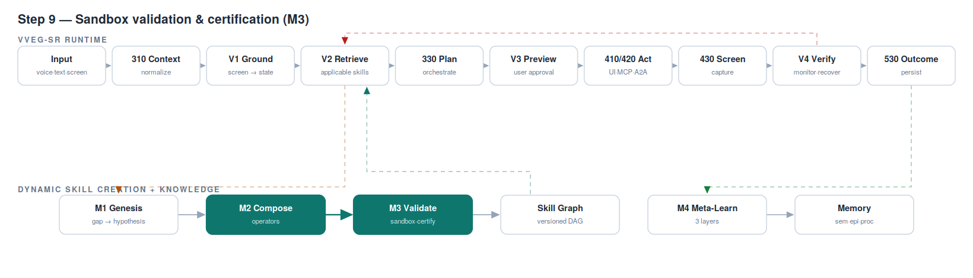

STEP 10 — Deploy to the skill graph & re-retrieve
Active components: Versioned Skill Graph (240) + V2 — NOVEL (Claims C1/C2)
The certified skill is added as a new node in the directed acyclic graph of skill dependencies — versioned, so any future degradation can roll back in one step, and hot-swappable, so deployment never interrupts the system. It indexes through the exact same path as hand-authored skills: one index, two origins, zero special cases. V2 immediately re-retrieves and this time the applicability check passes.
Example: sunday_night_mode v1 lands in the graph with dependencies on its three primitives. The original request now resolves: the flow continues to Step 11 with a skill that did not exist minutes ago.
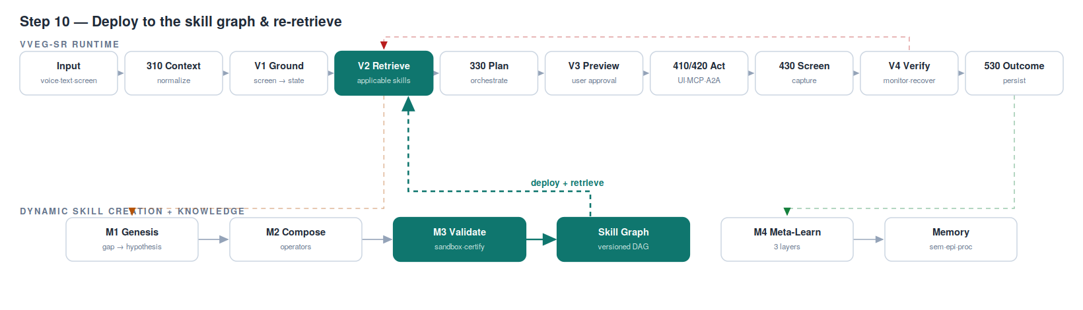

PHASE B — The visually-verified execution loop (Steps 11–20)

STEP 11 — Orchestrate the step plan (330)
Active components: Agentic Orchestrator (330) — supporting, not claimed
The orchestrator composes the concrete step plan from the retrieved skill's primitives — across skills and across modalities where needed. It emits ONE step at a time rather than a frozen script, because every executed step changes the world and the next decision should see the new world. The orchestration mechanics are supporting; the loop it conducts (V1–V4) is what the claims describe.
Example: the WiFi skill unrolls to: open WiFi settings → forget network → toggle WiFi off → toggle on → reconnect. Five steps, held loosely — Step 18 will show why loose matters.
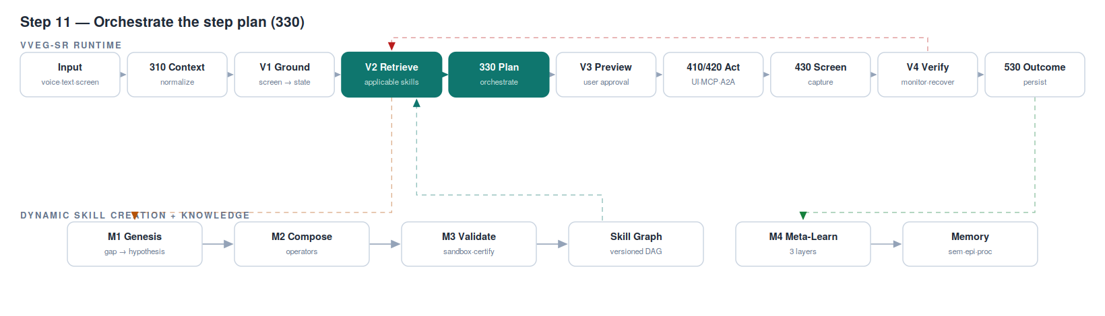

STEP 12 — User preview & approval (V3)
Active components: V3 User Preview & Approval — NOVEL V3
Before anything touches the device, the plan is shown to the human: an action-sequence visualizer lists the steps, an expected-outcome renderer shows what the screen should look like after, and a risk/impact highlighter flags anything destructive or uncertain. Per-step confidence indicators are certification-aware — a newly created or low-grade skill is visibly flagged. The user approves, modifies, or rejects; every correction is logged as training signal.
Example: the new Sunday skill shows: “Every Sunday 22:00: (1) silence work notifications (reversible); (2) enable data saver (reversible — may pause background sync, highlighted). Confidence: B — newly created skill.” The user excludes one messaging app from step 1; that edit is captured and will refine the skill.
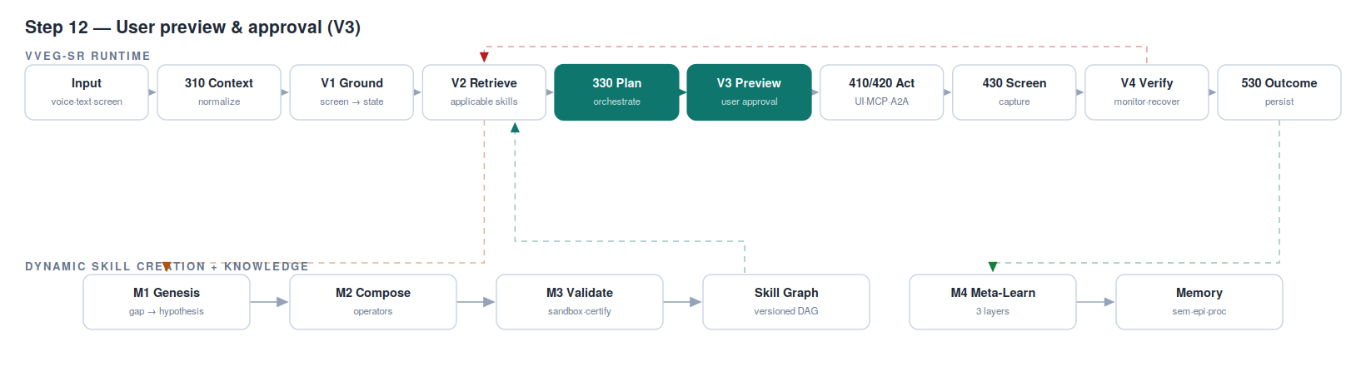

STEP 13 — Ground & synthesize the concrete action
Active components: V1 (grounding) + Action Synthesizer (410) — synthesis supporting
The abstract step (“forget the network”) is grounded onto the CURRENT screen using V1's element map, then synthesized into a concrete executable action — structured JSON or generated code — that targets the actual on-screen element. Separating step intent from concrete action is what lets one skill survive different UI versions, themes and languages.
Example: step 2's intent “forget the saved network” becomes {action: tap, element: network-row “Home_WiFi” ▸ button “Forget”, bounds: …} — coordinates resolved from the live screen at this instant, not from screenshots taken at authoring time.
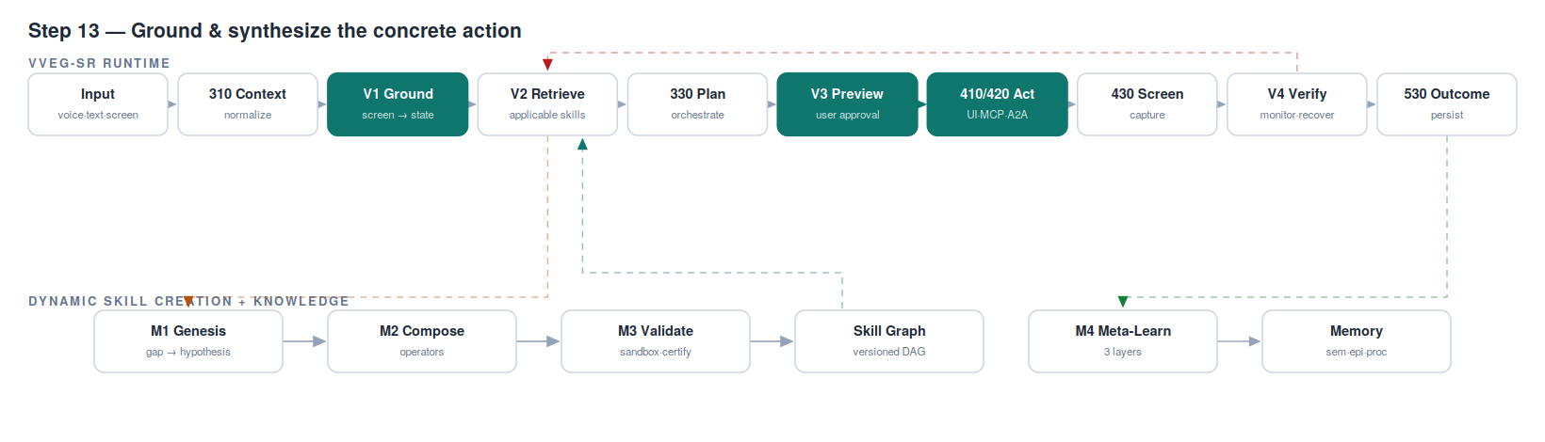

STEP 14 — Route to the modality & execute
Active components: Backend Router (420) → UI actions (422) / MCP tools (424) / A2A agents (426) — supporting
The same abstract step could execute as a UI tap, an MCP tool call, or a delegated agent-to-agent request. The router dispatches to the right executor; adapters make modalities hot-swappable — adding an executor never touches a skill. This modality-independent abstraction, instantiated per modality, is the cross-modal flow (skills / UI / tools) running on the unified embedding space.
Example: “forget network” runs as an in-app UI action. In an enterprise variant, “fetch the device policy” from the same plan would route to an MCP tool, and “notify IT” to an A2A agent — three modalities, one plan, one skill graph.
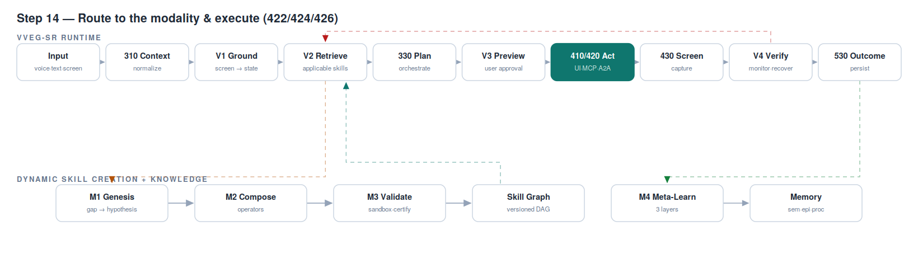

STEP 15 — Capture the new live screen (430)
Active components: Live Device Screen (430)
Immediately after the action executes, the new screen is captured. This screenshot is the ground truth for this step — not the executor's return code, not an assumption. Whatever the device actually shows is what the system will judge itself against.
Example: after tapping “Forget”, the captured screen unexpectedly shows a confirmation dialog: “Forget Home_WiFi? [Cancel] [Forget]”. The executor reported success — it did tap. But the task state is NOT what the skill expected. Only the screen knows that.
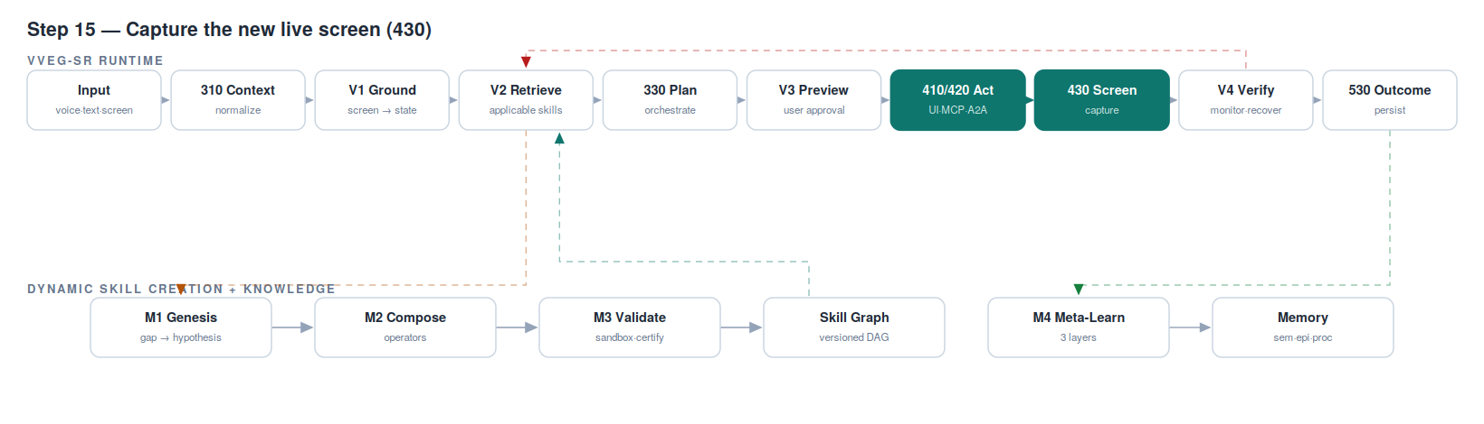

STEP 16 — Visual verification of the step (V4)
Active components: V4 Execution Monitor — NOVEL V4
The real-time screenshot comparator embeds the captured screen and compares it against the step's stored expected visual state; the step progress tracker and deviation detector watch the trajectory. Match at or above threshold τ → the step truly succeeded. Below τ → deviation, caught the instant it happens — not at task end, not never.
Example (τ = 0.82, illustrative): step 1's screen scores 0.91 → verified. Step 2's screen — the surprise dialog — scores 0.64 → DEVIATION. A single-shot pipeline would have fired steps 3–5 against that dialog and reported success on a failed task.
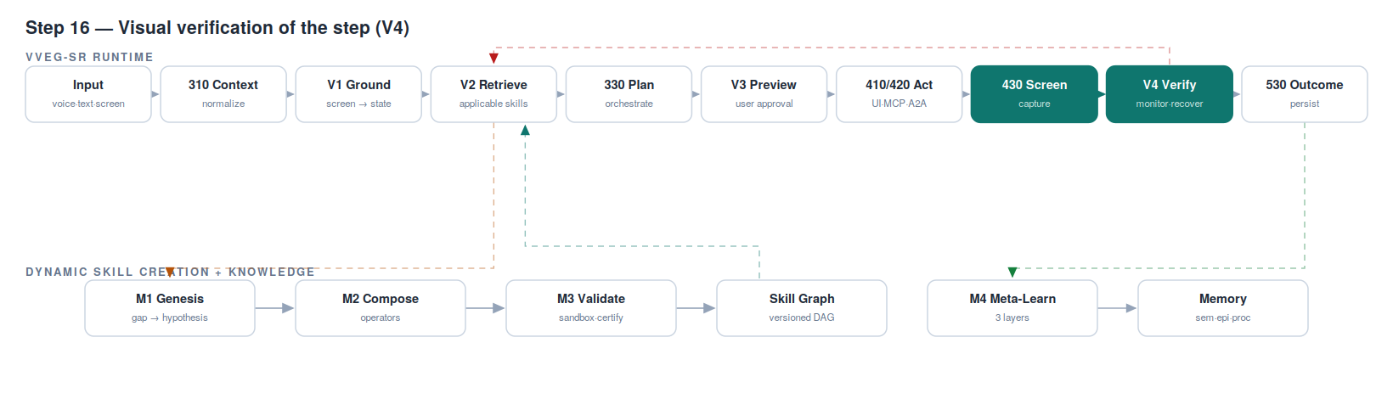

STEP 17 — Verified — advance to the next step
Active components: V4 advance path (green)
On a verified match the step pointer advances and the loop returns to Step 13 for the next step. When the last step verifies, the flow proceeds to Step 20. Advancing ONLY on visual proof is what makes multi-step execution trustworthy: each step stands on a verified predecessor.
Example: after the recovery in Step 18, steps 3, 4 and 5 of the WiFi skill each execute and verify in turn (toggle off → toggle on → reconnect), each against its own expected visual state.
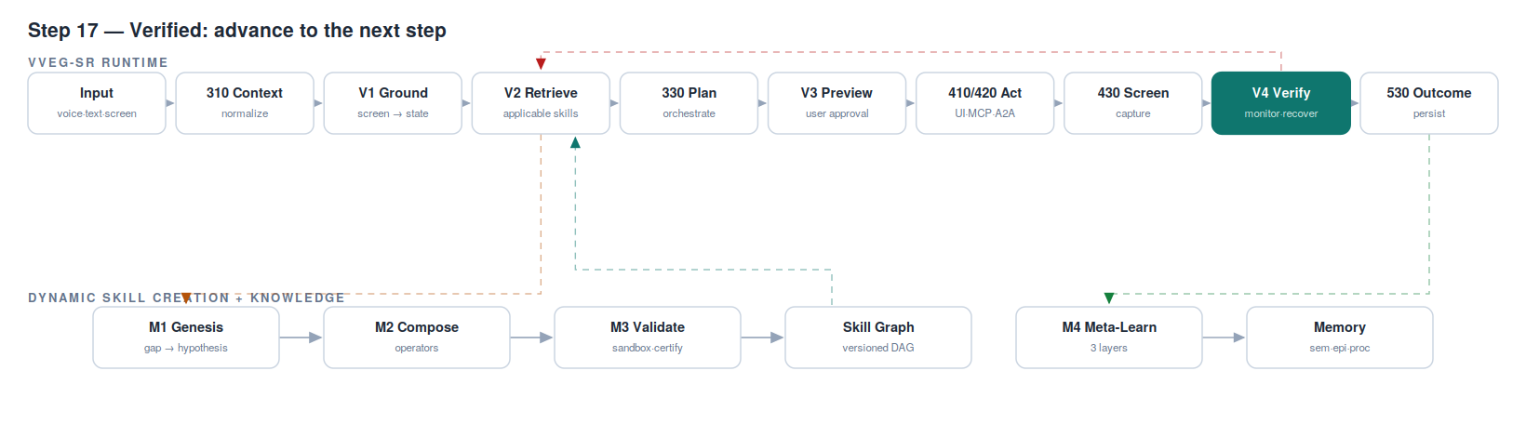

STEP 18 — Deviation — rollback & re-grounded recovery
Active components: V4 Recovery Handler → V2 — NOVEL V4 + V2 (red loop)
On deviation, the error-state recognizer classifies what happened; the rollback trigger returns to the last verified state if needed; the alternative-path finder re-enters V2 using the CURRENT screen as the query — execution-grounded RE-retrieval: the screen that proves failure becomes the query that finds the fix. A recovery step (possibly from a different skill) is spliced in via M2's operators and executed. All of this runs under a bounded budget, so recovery can never become thrashing.
Example: the dialog state is recognized; re-retrieval on the dialog screen returns “tap Forget in the confirmation dialog”; a DIFFERENT action is synthesized (not a blind retry of the same tap); it executes and verifies at 0.88. In the UI-drift scenario, this same path splices a step from another skill that matches a redesigned Settings app — runtime cross-skill composition.
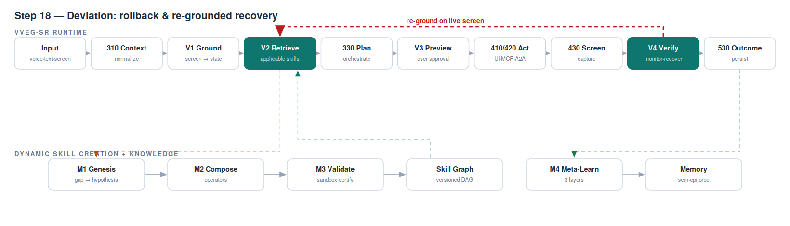

STEP 19 — Budget exhausted — safe fallback (340)
Active components: Fallback Handler (340) — reused
If recovery attempts exhaust their budget, the system exits through the proven fallback: plain LLM routing, exactly as production behaves today. This is the design guarantee: for every input the system either executes with per-step visual verification, asks the human, or declines into fallback. There is no fourth, unverified path — and the floor of the whole system is the current system.
Example: an app is mid-crash and every recovery lands on a black screen; after the budgeted attempts the task exits to fallback with a clear report of what was tried — instead of looping forever or pretending success.
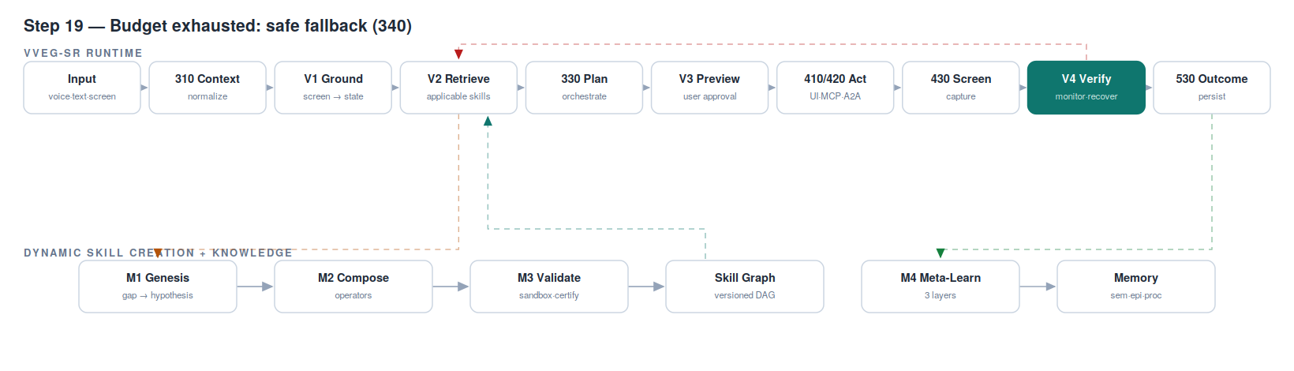

STEP 20 — Outcome, persistence & meta-learning
Active components: Outcome Store (530) → Tripartite Memory (250) → M4 — NOVEL F4 (green loop)
The outcome verifier checks goal achievement via post-execution screenshot analysis and reports the result. The full trace — success AND every recovered deviation — persists to episodic memory. From there M4's three layers consume it: parameters fine-tune (Layer 1), the skill graph's structure adapts (Layer 2), and learning strategy itself adjusts (Layer 3) — all under performance guards with automatic version rollback. Nothing the system lives through is wasted.
Example: the WiFi trace teaches the skill to expect the Forget dialog — next run has no deviation at all. The Sunday skill's logged user-correction (excluded messaging app) folds into v2 of the skill. The drift incident flags the stale skill for a structural refresh of its visual states. Every failure became fuel.
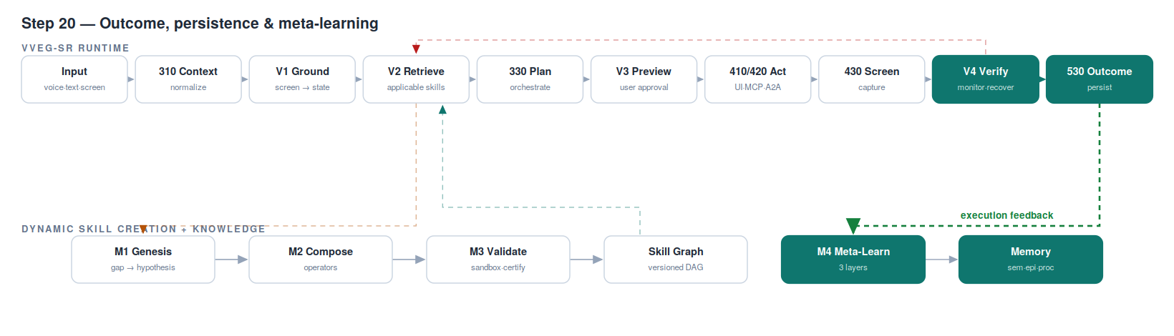

The flow at a glance
Step | Stage | Component(s) | Novel?
1–2 | Input & context | Input · 310 Context Builder | Supporting
3 | Visual grounding | V1 | NOVEL V1
4–6 | Grounded retrieval + gap decision | V2 · Skill Graph | NOVEL V2
7 | Gap → hypothesis | M1 Genesis | NOVEL F1
8 | Composition | M2 Composition Engine | NOVEL F2
9 | Sandbox certification | M3 Validation Unit | NOVEL F3/F9
10 | Deploy & re-retrieve | Skill Graph (240) · V2 | NOVEL (C1/C2)
11 | Orchestration | 330 Orchestrator | Supporting
12 | Preview & approval | V3 | NOVEL V3
13–15 | Ground, act, capture | V1 · 410/420 · 430 | Supporting
16–18 | Verify · advance · recover | V4 (· V2 on recovery) | NOVEL V4
19 | Safe exit | 340 Fallback | Reused
20 | Outcome & learning | 530 · Memory (250) · M4 | NOVEL F4

Design guarantee: for every input, the system either executes with per-step visual verification, asks the human (V3), or declines into the proven fallback (340). There is no fourth path — and every miss, deviation and correction is consumed as learning signal. The system's floor is today's system; its ceiling grows with use.

