Context-Grounded Neural Barcode Recovery
Dynamic Retrieval, Posterior Rescoring and Risk-Adaptive Repair for Damaged Barcodes, On-Device
Technical Concept v2 — revised after internal review

1. Problem and Idea
A barcode stores only a short string — a key into an enterprise database (manifest, catalog, patient orders, delivery route, work order). Clean barcodes are a solved problem. Damaged barcodes — torn, faded, wet, scratched, oily — defeat classical decoders and hardware scanners, forcing frontline workers into manual typing, supervisor calls, or skipped scans.
Our idea: when a barcode is damaged, the decoded string is not a trusted key but noisy evidence. The system therefore: (1) reads the image with an uncertainty-aware neural decoder; (2) dynamically retrieves the small set of payloads that are even possible in the current operational context; (3) scores each retrieved real candidate against the image itself using the decoder’s exact likelihood; (4) verifies mathematically (check digit / Reed-Solomon) and against the world (membership in context); and (5) applies a risk-adaptive policy — auto-accept, repair, one-tap human confirm, or warn — where the correction budget scales with the cost of a wrong answer.
The retrieval machinery is a transplant of a proven on-device Dynamic RAG stack (context-conditioned active knowledge, hybrid recall, verification, mismatch-driven re-retrieval and repair) from skill routing to visual decoding.

1.1 Why not just look up the decoder’s guesses directly
- The correct string may be in none of the guesses. Exact lookup dead-ends; fuzzy recall over the context set finds the real payload sharing 12 of 13 digits with a wrong guess.
- Two guesses may both exist. Only image-grounded scoring plus context priors can choose between them.
- A wrong guess may exist. Silently receiving the wrong item is the worst failure; the membership check (“is it in this shipment?”) catches it.
- There may be no complete key. You cannot look up a string with holes; you can score real candidates against the partial evidence.
Exact lookup is the special case at mild damage. The results should — and are expected to — show the exact-lookup baseline matching our system at mild degradation and collapsing at severe degradation, where retrieval + rescoring keeps recovering.

1.2 What it resolves
Today (scan fails) | With this system
Manual typing of 12–15 char codes; supervisor calls; line stops | Zero-touch accept or a single tap on candidates shown with product names and photos
Silent wrong-item errors when a misread happens to exist in the DB | World check: the code must exist in the current context or it is flagged
Nurses skip failed medication scans (unsafe workarounds) | Warn-only policy keeps the nurse inside the safe scanning workflow
Every damaged label is a fresh failure | Confirmed (crop, payload) pairs are harvested as training data — the decoder improves with deployment

2. Architecture (v2)
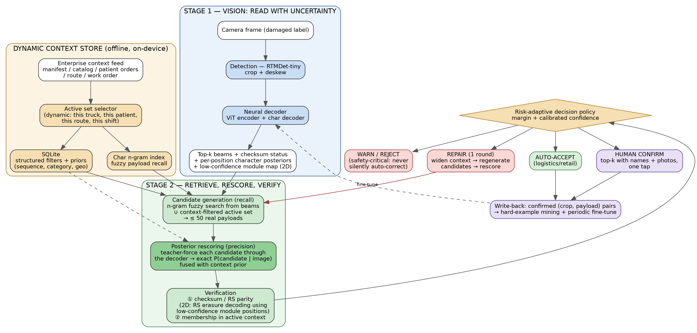
Figure 1 — Revised architecture. Recall is cheap and wide (n-gram fuzzy search over the dynamically selected context set); precision comes from exact decoder-posterior rescoring of real candidates against the image; verification adds checksum/RS-erasure and context membership; a risk-adaptive policy routes the outcome.

2.1 Stage 1 — Read with uncertainty
- Detection: RTMDet-tiny crops and deskews the barcode region.
- Decoder: compact ViT encoder + character-level autoregressive decoder (trained on synthetically degraded data, 8 symbologies; first token = symbology). It emits top-k beams, and crucially the per-position character posterior distributions — i.e., not just “digit 12 is 1” but “digit 12: P(1)=0.34, P(7)=0.31, …”. For 2D codes it also emits a low-confidence module map (which grid cells it is unsure about).

2.2 Dynamic context store
One record per valid payload in the enterprise context, with operational metadata and priors (scan sequence, category, geo). The active set selector is the dynamic element: the retrievable universe switches per truck, patient, route or shift — 5 to a few thousand payloads instead of 10¹³ global GTINs. Context size is the safety lever: fuzzy correction is only safe in a small, context-selected universe. Indexing: SQLite for filters/priors + a character n-gram index for fuzzy payload recall (whole-string text search cannot fuzzy-match digit strings; n-grams can).

2.3 Stage 2 — Retrieve, rescore, verify (the core)
Candidate generation (recall): n-gram fuzzy search seeded by the beams, unioned with the context-filtered active set — yields ≤ 50 real payloads. Recall must be high; precision is the next step’s job.
Posterior rescoring (precision): each candidate is teacher-forced through the decoder to compute its exact conditional likelihood P(candidate | image) — one batched forward pass, cheap on-device. This is the heart of the method: the image, not string similarity, decides among real candidates. Scores are fused with context priors (scan history, sequence, geo).
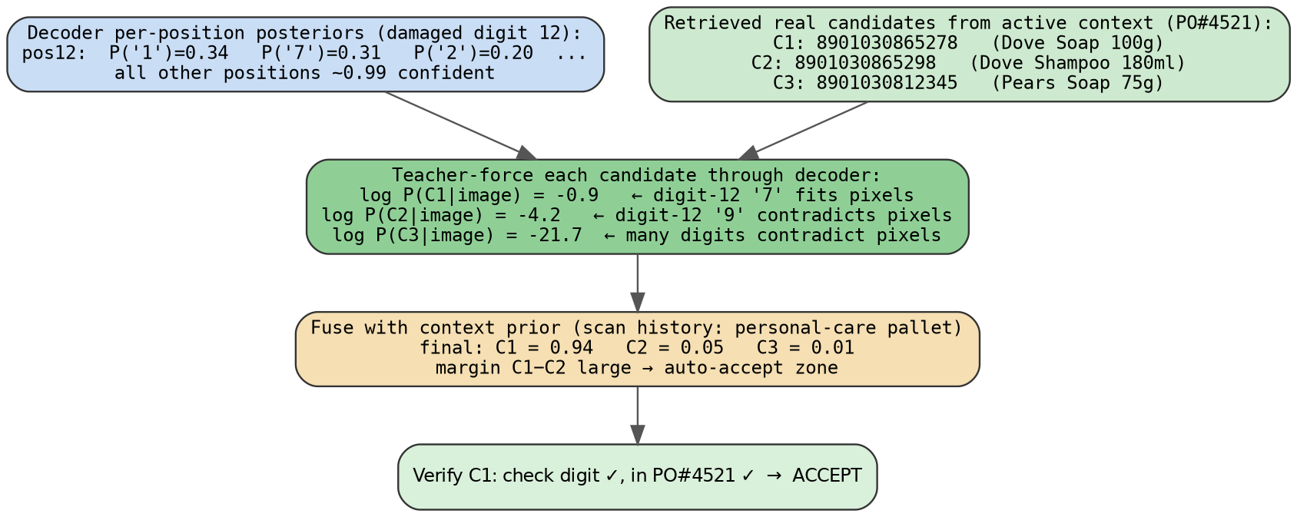
Figure 2 — Posterior rescoring on the running example. String-distance alone cannot separate two candidates differing in one digit; the decoder’s pixel-grounded likelihood can.
Verification: (1) math — check digit (1D) or Reed-Solomon parity (2D). For 2D, the decoder’s low-confidence module map is passed to RS as erasure positions: RS corrects twice as many erasures as unknown errors, so telling it “where” roughly doubles the recoverable damage — a principled, verifiable gain unique to structured codes. (2) world — membership of the candidate in the retrieved context set.

2.4 Decision policy and repair
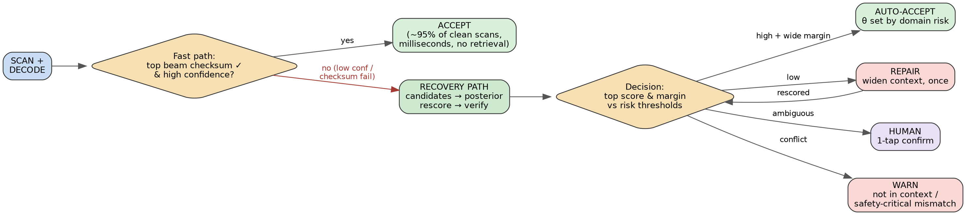
Figure 3 — Fast path vs recovery path. Clean scans (the vast majority) never touch retrieval and exit in milliseconds; the recovery path triggers only on low confidence or checksum failure, so added latency lands exactly where a failed scan would otherwise cost minutes.
- Auto-accept: top candidate passes both checks with a wide margin over the runner-up; thresholds are domain-risk-dependent.
- Repair (one round): on mismatch, widen the context (drop filters, boost categories/sequence from history), regenerate candidates, rescore — the direct analogue of mismatch-driven re-retrieval and repair in the original Dynamic RAG design.
- Human confirm: ambiguous margin → top-k with product names and photos, one tap. Retrieval is what turns raw digits into recognizable choices.
- Warn: candidate conflicts with context (not on this truck / not on this patient’s orders) → flag, never silently correct in safety-critical mode.
- Write-back (honest version): confirmed (damaged crop, payload) pairs are logged as verified hard examples for periodic decoder fine-tuning and threshold calibration — deployment continuously harvests exactly the failures that matter. (We do not claim instant no-retraining improvement.)

2.5 What we deliberately changed from v1, and why
v1 claim | Problem under review | v2 replacement
Dense visual retrieval: embed the damaged barcode crop, match against clean reference barcode embeddings | Barcodes of different products look nearly identical (bars on white); generic embeddings cluster them together and discriminate nothing | Demoted to optional signal: packaging-context matching when the wider crop shows the pack; the primary image-grounded signal is decoder-posterior rescoring
“BM25 fuzzy match on payload digits” | Whole-string BM25 cannot fuzzy-match digit strings; and coarse string similarity cannot separate candidates one digit apart | Character n-gram index for high-recall candidate generation + exact P(candidate | image) rescoring for precision
“Index write-back improves the system without retraining” | Only helps if embeddings are discriminative (see row 1); oversold | Write-back = verified hard-example harvesting for periodic fine-tuning + calibration
Repair described loosely as “re-decode constrained to candidates” | Under-specified | Precisely defined: context widening → candidate regeneration → batched posterior rescoring; plus RS-erasure decoding for 2D

3. Use Cases
Same pipeline in five frontline domains; what changes is the context store, the world-check question, and the repair policy — which scales with the cost of a wrong answer.

3.1 Warehouse receiving — torn / scratched shipment labels
Worker at a receiving dock scans boxes against a purchase order.
Barcode content: EAN-13/ITF-14 product codes, e.g. 8901030865278 (last digit = check digit).
Context store: the truck’s digital manifest, ~200 payloads, activated when the truck is assigned to the dock.
Dynamic context: dock, active PO, shift, recent scan history (same-pallet items correlate).
World check: “On this truck’s manifest?”
Repair policy: auto-correct allowed — small set, recoverable errors.
Outcome: auto-tick on the manifest or a one-tap choice with product photos; no typing 13 digits per damaged box.

3.2 Retail checkout / shelf audit — faded, crumpled packaging
Cashier scans a pack the hardware scanner rejected.
Barcode content: EAN-13/UPC-A keys into the store catalog.
Context store: store POS catalog (~30k SKUs) with department metadata and pack photos.
Dynamic context: terminal/department zone, current basket.
World check: “A SKU this store sells?”
Repair policy: auto-correct allowed; with a large catalog, candidate generation leans on the basket/department priors, and the optional packaging-context signal earns its keep here.
Outcome: item billed instantly or a two-candidate tap; no supervisor call.

3.3 Hospital medication administration — worn, curved vial labels
Nurse scans the patient wristband, then the drug (BCMA workflow).
Barcode content: GS1 DataMatrix: drug code + expiry + lot + serial, with built-in RS error correction that fails beyond its budget — exactly where our RS-erasure decoding extends the range.
Context store: hospital formulary + the scanned patient’s active orders (5–10 records); the wristband scan sets the context.
Dynamic context: patient identity, dose schedule vs current time.
World check: “On this patient’s active orders?” plus expiry and dose-time checks read from the payload for free.
Repair policy: verify-and-warn only. The system never auto-corrects toward the patient’s order list — that could mask a genuine wrong-drug event. A vial that appears to be an unordered drug triggers an alarm and is identified against the full formulary.
Outcome: the nurse stays inside the safe scanning workflow instead of skipping failed scans — the documented BCMA “workaround” problem.

3.4 Last-mile delivery — rain-soaked, smudged shipping labels
Courier scans a wet label at the doorstep.
Barcode content: Code-128 tracking IDs, e.g. TRK4482915530IN (internal check character).
Context store: the day’s route, ~120 packages with recipient, address, geo, stop order.
Dynamic context: live GPS (packages within ~300 m), remaining stops, stop sequence.
World check: “On my route, near my position?”
Repair policy: auto-correct allowed; widening goes route → day’s hub manifest.
Outcome: proof-of-delivery opens automatically; no typing 15 characters in the rain.

3.5 Manufacturing traceability — DPM codes etched on metal
Line worker scans a DataMatrix dot-peened onto an oily, scratched part.
Barcode content: part serials, e.g. ENG-7742-0093-B, in DPM DataMatrix — the hardest imaging conditions.
Context store: the station’s work order / BOM, ~150 expected serials.
Dynamic context: station, work order, scan sequence — serials arrive nearly in order, a very strong prior.
World check: “Expected at this station under this work order, in sequence?”
Repair policy: the flagship for RS-erasure decoding: the decoder marks destroyed modules as erasures, RS recovers up to twice the normal damage budget; a retrieved candidate that completes the uncertain characters is then accepted or rejected by parity mathematics, not by guesswork.
Outcome: traceability without line stoppage; a valid serial that is not in this work order flags a mis-routed part — catching an assembly error, not just a scan error.

3.6 One pattern, five domains
 | Warehouse | Retail | Hospital | Courier | Factory
Context store | Manifest (~200) | Catalog (~30k) | Patient orders (5–10) | Route (~120) | Work order (~150)
Dynamic context | PO + dock + history | Dept + basket | Wristband + time | GPS + stops | Station + sequence
World check | On this truck? | In this catalog? | On patient’s orders? | On route, near me? | In WO, in sequence?
Repair policy | Auto-correct | Auto-correct | Warn only | Auto-correct | RS-erasure confirmed
Outcome | Tick manifest | Add to bill | Administer / alarm | POD flow | Traceability log

4. Worked Example (Warehouse, end to end)

Offline — before the truck arrives
Manifest PO#4521 lands digitally: 200 items for dock 7, one record each:
payload: 8901030865278 | product: Dove Soap 100g
PO: 4521 | dock: 7 | category: personal care | priors: pallet grouping
Indexed into SQLite (filters, priors) and the character n-gram index. These 200 payloads become the active set.

Online — one scan
- Worker scans a torn label; RTMDet crops it.
- Decoder beams: A 8901030865218 (0.61, checksum ✗), B 8901030865278 (0.58, ✓), C 8901030865216 (0.44, ✗). Digit 12 is torn; the per-position posterior says P(1)=0.34, P(7)=0.31 — genuinely uncertain. Note the top-confidence beam is wrong.
- Fast path declines (checksum failure on top beam, low margin) → recovery path.
- Candidate generation: n-gram search over the 200 active payloads seeded by the beams → 3 real candidates (Dove Soap ...5278, Dove Shampoo ...5298, Pears ...12345).
- Posterior rescoring (Figure 2): teacher-forcing gives log P = −0.9 / −4.2 / −21.7 — the pixels at digit 12 fit ‘7’ far better than ‘9’. Fused with the pallet prior: 0.94 / 0.05 / 0.01. Margin is wide.
- Verification: candidate 1 check digit ✓, in PO#4521 ✓ → auto-accept.
- Phone: “✓ Dove Soap 100g — received”, manifest ticked, ~1 second, zero extra effort. The (torn crop, confirmed payload) pair is logged as a verified hard example.
Why direct lookup would have failed here: guess A fails the checksum and exists on no manifest; a top-1 lookup system dead-ends or, against a global database, silently matches some other real product. Recall found the true payload from a 12/13-digit partial match; the image itself — via posterior rescoring — separated two candidates one digit apart, which no string-distance method can do.

5. Honest Assessment — Will It Work?

5.1 Where confidence is high
- Context scoping is information-theoretically sound: shrinking 10¹³ possible payloads to ~200 makes multi-character correction reliable and safe.
- Posterior rescoring is exact and cheap: it is the decoder’s own probability, computed in one batched pass over ≤ 50 candidates — no new model, no approximation.
- RS-erasure decoding is textbook coding theory applied at the right place: erasures are twice as correctable as errors, and the decoder knows where the erasures are.
- The fast path preserves clean-scan latency; the recovery path replaces minutes of manual fallback, so its extra tens of milliseconds are irrelevant.

5.2 Known risks and mitigations
Risk | Mitigation / measurement
Confusable pairs inside the context set (two products one digit apart on the same truck) — retrieval alone cannot separate them | Posterior rescoring separates them via pixels; when the margin is still narrow, the policy routes to one-tap human confirm. Measure: collision rate vs context size (a core ablation).
Decoder posteriors may be over-confident on degraded inputs | Calibrate (temperature scaling) on a degraded validation set; report reliability diagrams; thresholds set per domain risk.
“This is just lexicon-constrained decoding” (reviewer) | Own it, then differentiate: the lexicon is dynamic and context-selected; scoring is image-grounded, not lexicon-projected; verification is dual (math + world); the repair policy is risk-adaptive. Include a static-lexicon baseline to quantify the gap.
Context data may be wrong or stale (item legitimately missing from manifest) | The warn path exists precisely for this; world-check conflicts surface data problems instead of hiding them.
Safety-critical over-trust (healthcare) | Warn-only policy hard-coded for that mode; the system never auto-corrects toward the expected list.

5.3 Expected result shape
Accuracy vs degradation severity: at mild damage, the plain decoder and exact-lookup baseline match our system (retrieval adds nothing, by design). As severity rises, classical decoders and exact lookup collapse toward zero recovery while retrieval + posterior rescoring degrades gracefully. That widening gap — reported per severity level, per context-set size, and per component (recall only / +rescoring / +RS-erasure / +priors) — is the claim, the ablation table, and the paper.

6. Summary
The Dynamic RAG concept survives the domain transplant intact: context-conditioned active knowledge, wide recall, verification, mismatch-driven repair. What v2 fixes is the physics: barcodes are not visually distinctive objects, so image evidence enters through the decoder’s exact likelihood rather than through generic embedding similarity; fuzzy text matching is a recall device, not a decision device; and error-correction mathematics (checksums, RS erasures) supplies verification that most vision systems can only wish they had. The result is a decoder that treats its own output as evidence to be verified against the world — which is what damaged barcodes, and the people who scan them for a living, actually need.

