INTERNAL INVENTION DISCLOSURE · KNOX AI · SRI-B
On-Device Multimodal Skill Agent with Execution-Grounded Retrieval and Per-Step Visual Verification
Codename VESPER — Visually-verified, Execution-grounded Skill Procedure Execution & Retrieval
An on-device agent that retrieves and composes a multi-step skill from a shared text+image vector space, executes it one step at a time, verifies each step against the live device screen, and on visual failure re-retrieves and repairs — so retrieval relevance is grounded in real on-device visual execution outcomes rather than fixed at query time.
Field | Detail
Status | Draft for internal review (patent committee · Renju CNAIR · S. Mani)
Classification target | GUI-automation + computer vision + multimodal information retrieval
Source of truth | Uploaded “Dynamic Skill” Confluence flow (Phases 1–3, §3.2, §7, §8)
Note | Verbal / architectural elements are marked [ASSUMPTION] or listed in §16. Nothing here is a final legal claim.
Legend: new module reused from current RAG ★ patentable core (feedback loop)

Contents
01 Proposed invention title
02 Executive summary
03 Current system / existing RAG flow
04 Problem and limitations
05 Proposed invention and key novelty
06 Detailed end-to-end architecture
07 Component-wise explanation
08 Detailed numbered technical workflow
09 Use cases
10 Complete request walkthrough & skill data model
11 Novelty & differentiators
12 Patent figure plan
13 Creating professional PNG / PPT diagrams
14 High-level claim concepts
15 Assumptions, open questions & items to confirm
16 Consolidated invention disclosure

1 · Proposed invention title
Primary: On-Device Multimodal Skill Agent with Execution-Grounded Retrieval and Per-Step Visual Verification.
Codename: VESPER — Visually-verified, Execution-grounded Skill Procedure Execution & Retrieval.
One-line: retrieval relevance is determined by on-device, per-step visual execution outcome — not by query-time similarity alone.

2 · Executive summary
The existing on-device “Dynamic Skill” RAG takes a text query, performs hybrid retrieval over text-only SKILL.md chunks, and selects one skill for single-shot execution. It has three structural blind spots: it ignores the live screen (often the only real disambiguator), it discards visual content inside skill documents, and it never checks whether execution worked.
This invention restructures the system into a closed multimodal loop:
- Multimodal input — voice + text + a screenshot of the current screen — is fused into one query.
- A shared text+image embedding space indexes skills at step granularity; each step carries an instruction, a target image, and an expected-result image.
- An orchestration agent executes steps via heterogeneous backends (in-app / MCP / A2A) using dynamically synthesized actions (JSON/code).
- After each step a visual verifier embeds the new live screen and compares it to that step's expected-result image.
- On mismatch the system synthesizes a corrected action and re-retrieves the next step using the current screen.
★ CORE The defensible novelty is item 5: retrieval driven by per-step on-device visual execution feedback, at step granularity. This differs from ordinary RAG (retrieve once, no feedback), corrective/agentic RAG (text-relevance feedback), and GUI agents (screen-checking without authored per-step visual success-conditions driving retrieval re-grounding).

3 · Current system / existing RAG flow
Indexing (once): SKILL.md → Chunking (~2048 chars, section boundaries) → Embedding (768-dim, L2-normalized) → Storage: Room DB (skill_chunk), USearch (HNSW), FTS4 (skill_chunk_fts).
Retrieval (per query): query → Normalization → Vector Search (HNSW, M=16, efSearch=50, top-20) + BM25 (FTS4) → RRF Fusion (1/(60+vRank)+1/(60+bRank), k=60).
Selection: Section Boost (+20%/match, max +100%) → Disambiguation (−30% to −40%) → Aggregation (group by skill_path, SUM) → Selection (score > 0.02?) → return skill + routing JSON, else fallback.
[A0] Runtime assumed Android on-device; embedder assumed on-device ONNX (diagram states only “768-dim, L2-normalized”).

4 · Problem and limitations
# | Limitation | Consequence
L1 | Text-only query. Live screen never used. | Vague queries fall below 0.02 → fallback; correct skill not picked.
L2 | Visual content discarded. Chunking keeps text only. | Image-bearing skills under-represented and lose selection — invisibly.
L3 | Single-shot, no execution feedback. | No recovery if the pick or a step is wrong.
L4 | Whole-skill granularity. | Cannot compose a procedure or repair one step from another skill.
L5 | No per-step grounding before action. | Confidently-wrong skills execute incorrect actions.
L6 | UI / version drift unhandled. | Execution breaks when real UI differs from authored screenshots.

5 · Proposed invention and key novelty

Structural changes
- C1 Multimodal input fusion: voice→text + text + screenshot-of-state → one query.
- C2 Shared text+image embedding space (Version 2): one model embeds both; a text query natively retrieves image steps. On-device candidates exist (MobileCLIP2, SigLIP-2). [A1]
- C3 Step-granular multimodal skills: step = {instruction, target image, expected-result image}.
- C4 Heterogeneous, dynamically synthesized actions → in-app / MCP / A2A.

Key novelty (★ the claim sits here)
- N1 — per-step visual success-condition authored into the step, verified by embedding-similarity between live screen and expected-result image.
- N2 — execution-grounded retrieval: on mismatch, re-retrieve the next/repair step using the current live screen.
- N3 — mismatch-driven action repair: synthesize a different action, not a blind retry.
- N4 — on-device step composition: the executed procedure is assembled from verifiable step primitives, possibly across skills.
★ Ordinary RAG retrieves once with no feedback; corrective/agentic RAG feeds back text relevance; GUI agents verify screens but without authored per-step visual success-conditions driving retrieval re-grounding at step granularity, on-device. The fusion of N1–N4 is the inventive step.

6 · Detailed end-to-end architecture
Layered view: L0 input · L1 indexing (offline) · L2 retrieval · L3 orchestration agents · L4 action · L5 verification · L6 feedback (★).
Reused (from current RAG) | Swapped | Built new
Hybrid retrieval, RRF, section boost, threshold/selection, fallback | text-only embedder → shared multimodal embedder; whole-skill chunk → step-level chunk | shared-space indexer, step format with expected-result image, multimodal fuser, per-step visual verifier, action synthesizer, backend router, orchestration agents, execution-grounded re-retrieval loop ★
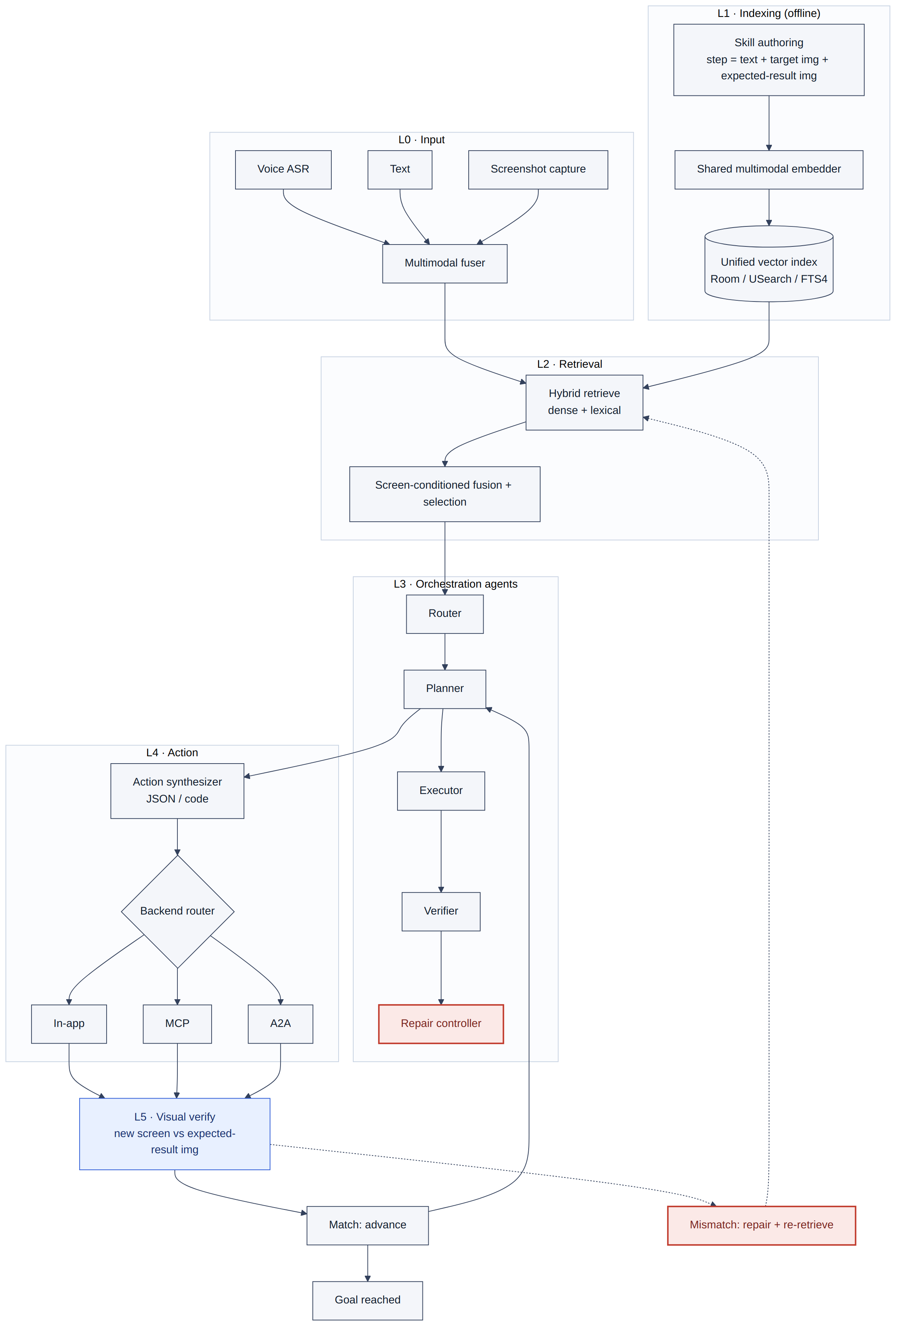
FIG. 1 — Overall system architecture. L0–L6 layered architecture. The dashed red returns (verify→re-retrieve, repair controller) are the inventive feedback loop.
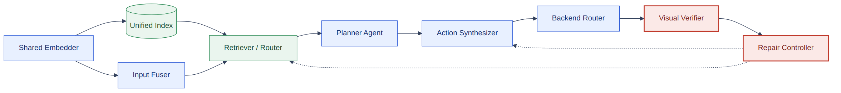
FIG. 9 — Component block diagram. Module interfaces. Dashed returns from the Repair Controller into Retriever and Synthesizer form the loop.

7 · Component-wise explanation
Component | Purpose | Input → Output | Method
Multimodal Input Fuser | Build one query from voice+text+screen | audio,text,screenshot → fused query vector | ASR; shared-space embedding
Skill Indexer | Make step text + images retrievable | authored skills → index entries | shared embedder; step records
Shared Multimodal Embedder | One vector space for text & images | text|image → dense vector | MobileCLIP2 / SigLIP-2, ONNX
Retriever / Router | Pick/compose; screen-condition | fused query → candidate steps | dense+lexical hybrid; threshold
Planner Agent | Order/compose steps to the goal | candidates,goal,screen → step N | agentic planning over primitives
Action Synthesizer | Turn step N into a concrete action | step N,screen → action (JSON/code) | template-fill or code-gen [OPEN]
Backend Router | Dispatch to the right executor | action → result | in-app / MCP / A2A adapters
Visual Verifier ★ | Confirm step succeeded | new screen,expected img → match | embedding-similarity, threshold τ
Repair Controller ★ | Recover from visual failure | mismatch,screen → action + re-retrieval | synthesize different action; re-query
Fallback | Safe exit | no-match → plain LLM routing | reuse current fallback

8 · Detailed numbered technical workflow (input → final action)
- Receive input in any mix: voice, text, screenshot of current screen.
- Transcribe voice → text (if present).
- Capture/normalize the screenshot as the current screen-state image.
- Fuse text + screen-state into one query in the shared embedding space.
- Retrieve candidate steps/skills (dense + lexical), with the live screen conditioning the ranking.
- Select / compose: pick a dominant skill, or have the Planner compose a step-set. Nothing clears confidence → fallback.
- Initialize step pointer N = 1.
- Synthesize the action for step N (JSON/code) from the step spec + current screen.
- Route the action to its backend (in-app / MCP / A2A) and execute.
- Capture the new live screen after execution.
- Verify: embed the new screen; compute similarity to step N's expected-result image.
- Match (≥ τ): advance N ← N+1; if more steps → step 8, else → step 16.
- Mismatch (< τ) → repair: (a) re-retrieve using the current live screen; (b) synthesize a different action; (c) re-execute (step 9). Bounded budget; exhausted → fallback/escalate.
- (Optional) Approval gate: high-risk actions require user confirmation before execution.
- Loop until all steps verify or budget exhausts.
- Goal reached: report success; optionally persist outcome for future ranking.

9 · Use cases (example data & decisions)

Use case 1 — Multimodal happy path with one repair (WiFi)
Input: voice “I can't connect to WiFi” + screenshot = WiFi settings (failed). Routing: live WiFi screen reinforces connectivity → selected. Skill (5 steps): open WiFi → forget network → toggle off → toggle on → reconnect. Execution: step 2 “forget network” verify → mismatch → re-retrieve + corrected tap → match; remaining steps match. Outcome: goal reached; per-step repair fixed a failure single-shot would miss. See FIG. 5.

Use case 2 — Screen disambiguates a vague query (storage)
Input: text “fix this” + screenshot = storage-full warning. Today: words carry no signal → best skill < 0.02 → fallback. Invention: the screenshot vector sits near storage step-images → storage skill crosses threshold and is selected — the screen, not the words, made the pick. Counterfactual: same words on a battery-saver screen → battery skill. See FIG. 6.

Use case 3 — UI drift → re-retrieval + cross-skill composition (★)
Input: text “turn off mobile data to save data” + screenshot = redesigned Settings (app updated; authored screenshots stale). Execution: step 1 verify vs stale image → mismatch (drift) → re-retrieve using the current screen → a step from a different skill's library matches the new UI → splice in → continue verified live. Outcome: the procedure that ran was composed at runtime across skills — impossible for whole-skill single-shot retrieval. Clearest demonstration of N2 + N4. See FIG. 7.

10 · Complete request walkthrough & skill data model
This section makes the runtime concrete: (a) how a skill with image-steps is stored and embedded, (b) what happens end-to-end when a user asks, and (c) how the image-steps react during execution. Numbers are illustrative (threshold τ = 0.82).

10.1 How a query is handled (lifecycle)
- Arrive — input may be voice, typed text, a screenshot of the current screen, or any mix.
- Transcribe & capture — voice → text (ASR); the current screen is captured as a screen-state image.
- Fuse — text + screen-state are embedded into one query vector in the shared space.
- Retrieve — dense + lexical search over the unified index; the live screen conditions the ranking.
- Decide — pick a dominant skill, compose a step-set, or (if nothing clears confidence) fall back to plain LLM routing.
- Execute the step loop — per step: synthesize action → run via backend → verify against the step's expected-result image → advance or repair.
Query situation | How it is handled “properly”
Clear query, no screenshot | Text-only retrieval (degrades gracefully to today's behaviour) → skill picked.
Vague query + informative screen | Screen vector lifts the correct skill over the threshold — the screen makes the pick.
Ambiguous, both signals weak | Nothing clears confidence → fallback to plain LLM routing (no wrong action forced).
Goal spans multiple skills | Planner composes a step-set from primitives across skills.
Step fails mid-task | Re-retrieve with the live screen + synthesize a different action (repair), bounded budget.
UI/version drift | Verification fails vs stale image → re-ground on the live screen and splice a matching step.

10.2 How image-step skills are stored for embedding
A skill is an ordered list of steps. Each step carries three things embedded into the same shared space, each with a distinct runtime role:
Step field | Purpose | Embedded? | Retrieval? | Verification?
instruction (text) | What the step does | Yes | Yes (dense + FTS4) | No
target_image | What to act on (where to tap) | Yes | Yes (grounding) | No
expected_result_image ★ | What success looks like | Yes | Optional | Yes — success oracle
Example skill as authored:
skill: connectivity.reset_network
steps:
- id: s1 order: 1
instruction: "Open Wi-Fi settings"
target_image: s1_target.png # the Wi-Fi entry to tap
expected_result_image: s1_done.png # Wi-Fi panel is open
- id: s2 order: 2
instruction: "Forget the saved network"
target_image: s2_target.png # the network row / Forget button
expected_result_image: s2_done.png # network removed from list
- id: s3..s5 ... (toggle off -> toggle on -> reconnect)
Where it lands at index time: the three vectors per step go into USearch (one shared vector index); step metadata + raw image assets + ordering go into Room (skill_chunk extended with chunk_type=step, step_order, asset_id, role); the instruction text goes into FTS4 for lexical recall. The expected_result_image vector is tagged role=verifier so it is available as the per-step success oracle at execution time, not only for retrieval. See FIG. 10.
reuse The stores (Room / USearch / FTS4) and their retrieval paths are reused; only the schema is extended and the embedder is swapped to the shared text+image model. [A3] assumes skills are authored with target and expected-result images.
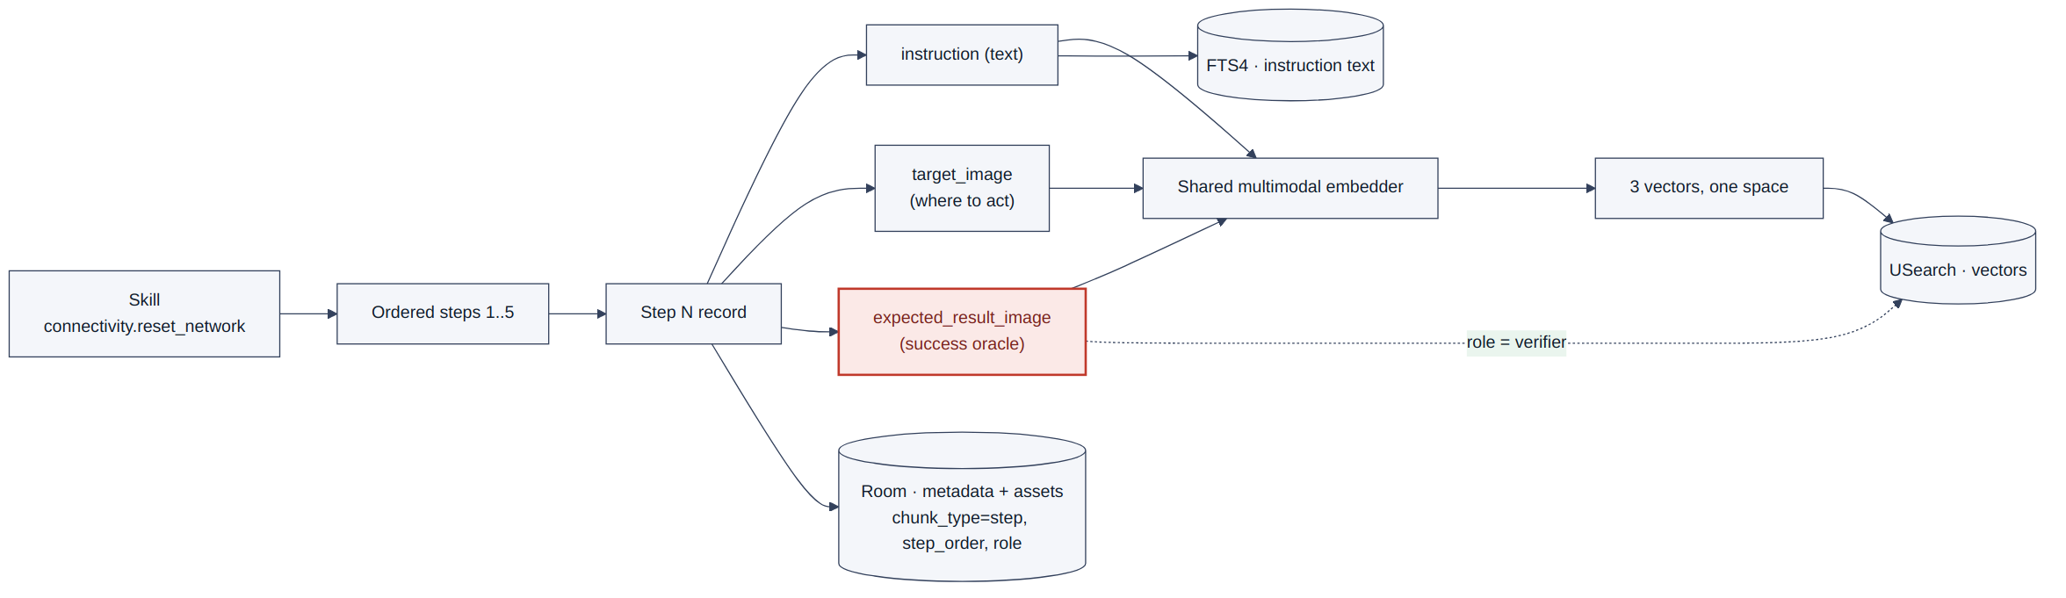
FIG. 10 — Skill-step data model & embedding. Each step contributes three vectors to one shared index; the expected-result image is tagged as the verifier (success oracle).

10.3 Complete worked trace — “I can't connect to the Wi-Fi”
Voice query “I can't connect to the wifi” spoken while the phone shows the Wi-Fi screen with “Connection failed”. τ = 0.82 (similarity threshold), illustrative numbers.
- Transcribe + capture — ASR → “I can't connect to the wifi”; screen captured → screen-state = Wi-Fi settings (failed).
- Fuse — text + screen-state → one query vector.
- Retrieve — shared-space search ranks connectivity.reset_network top (query↔skill similarity ≈ 0.88), well clear of other skills.
- Select — connectivity clears confidence → its 5-step procedure is loaded; step pointer N = 1.
- Step 1 “Open Wi-Fi settings” — synthesize action {tap, target=s1_target} → execute in-app → capture → similarity to s1_done = 0.91 ≥ τ → match → N = 2.
- Step 2 “Forget the saved network” — synthesize tap → execute → capture → similarity to s2_done = 0.64 < τ → mismatch (a confirm dialog appeared instead).
- Repair — re-retrieve using the current screen → fetch a corrected step (tap “Forget” in the confirm dialog) → synthesize a different action → execute → similarity = 0.88 ≥ τ → match → N = 3.
- Steps 3–5 (toggle off → toggle on → reconnect) — each executed, each verified → all match.
- Goal reached — screen shows “Connected” → report success; optionally persist the outcome.
A single-shot text RAG would have picked a skill (at best) and fired all five steps blind; the per-step visual check caught the Step-2 dialog and the repair recovered it. See FIG. 11; runtime messaging is also in FIG. 8.

10.4 How image-steps “react” during execution
- target_image → grounds the action. Before acting, the executor locates the step's target on the live screen so the synthesized action lands on the right element even if positions shifted.
- expected_result_image → judges the outcome ★. After acting, the new live screen is embedded and compared to this image; similarity ≥ τ means the step truly succeeded. This drives advance-vs-repair and makes retrieval accountable to execution (N1–N2).
★ The expected-result image is not just another retrievable chunk — it is the per-step success oracle. Comparing the live screen against it (in the shared space) is the mechanism that converts a passive RAG into a closed, self-correcting loop.
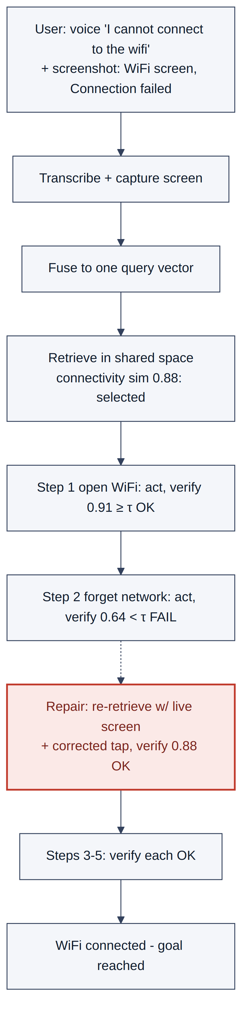
FIG. 11 — Request lifecycle (worked trace). Concrete trace: Step-2 verification fails (0.64 < τ); the repair path re-retrieves on the live screen and recovers before continuing.

11 · Novelty & differentiators
Capability | RAG chatbot | OCR tool | Generic GUI agent | This invention
Output | text answer | extracted text | actions | verified multi-step device actions
Uses live screen | No | No | Sometimes | Yes — query + per-step verifier
Visual corpus content | dropped/OCR | is the input | varies | embedded directly, step-bound
Retrieval feedback | none | n/a | text re-plan | on-device visual execution outcome ★
Granularity | chunk | page | task | step primitive (composable)
Per-step success-condition | No | No | implicit | authored, similarity-verified
Failure recovery | No | No | retry/replan | repair + retrieval re-grounding
Backends | text gen | none | one harness | in-app / MCP / A2A, synthesized
Plain statement: a RAG chatbot answers; OCR reads; a GUI agent acts/replans on text. This system makes retrieval accountable to on-device visual execution outcomes at step granularity, using authored per-step visual success-conditions — a single feedback loop none of the three has.

12 · Patent figure plan
FIG | Title | Shows | Type
1 | Overall system architecture | Layers L0–L6; reuse vs new | Block
2 | End-to-end flow | Input → retrieve → step loop → verify → repair/advance | Flowchart
3 | Vision + RAG + agent processing | Shared embedder feeding indexing & query | Data-flow
4 | Approval & action execution | Selection → approval → synthesis → backend → verify | Flowchart
5 | Use case 1 (WiFi, repair) | Concrete trace with one repair | Use-case
6 | Use case 2 (vague query) | Screen vs words routing | Use-case
7 | Use case 3 (UI drift) | Re-grounding + cross-skill splice | Use-case
8 | Sequence diagram | Time-ordered messages across modules | Sequence
9 | Component block diagram | Modules + interfaces | Block
10 | Skill-step data model & embedding | How image-steps are stored/embedded | Data-flow
11 | Request lifecycle (worked trace) | End-to-end with a repair | Use-case
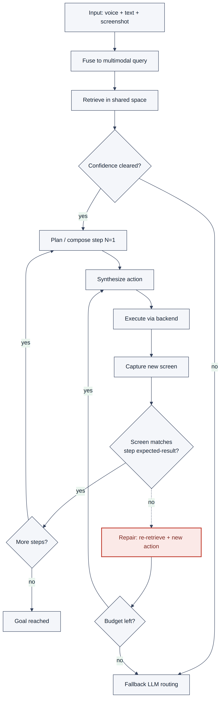
FIG. 2 — End-to-end flow. Top-to-bottom flow. The dashed “no” branch from verification into Repair is the core loop.
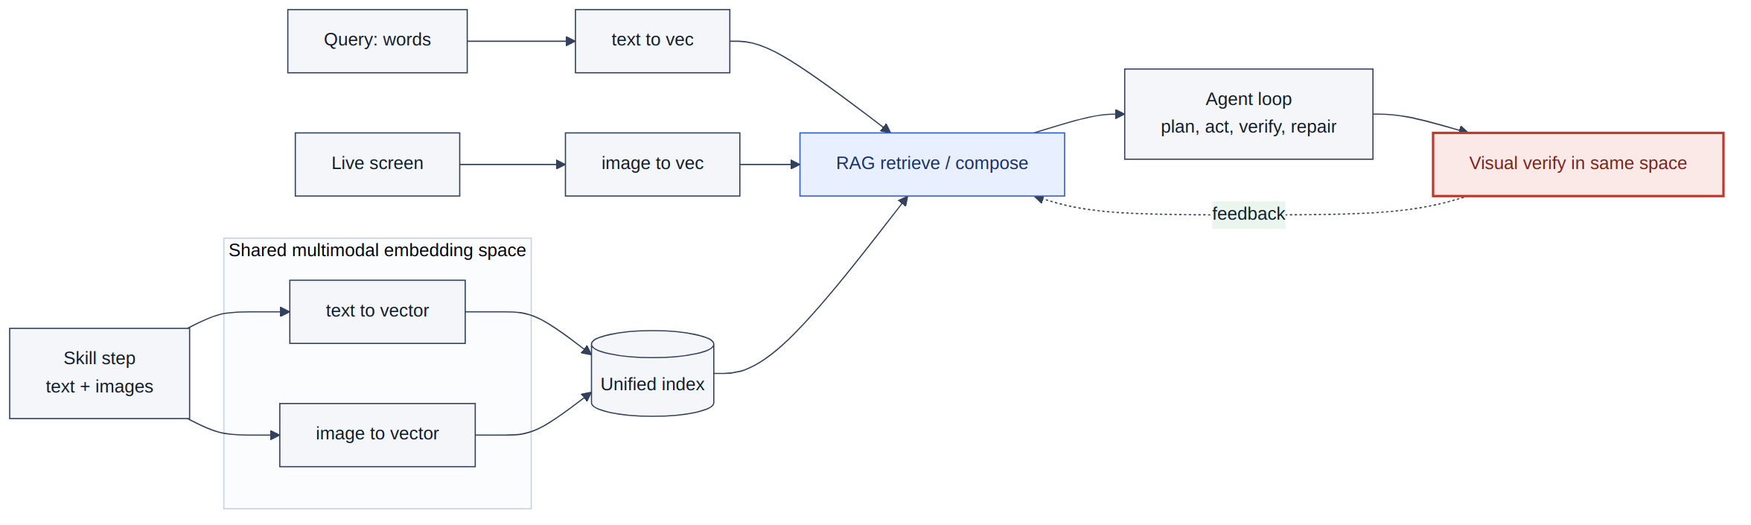
FIG. 3 — Vision + RAG + AI-agent processing. One shared space serves both indexing and query; the dashed verifier→RAG arrow closes the loop.
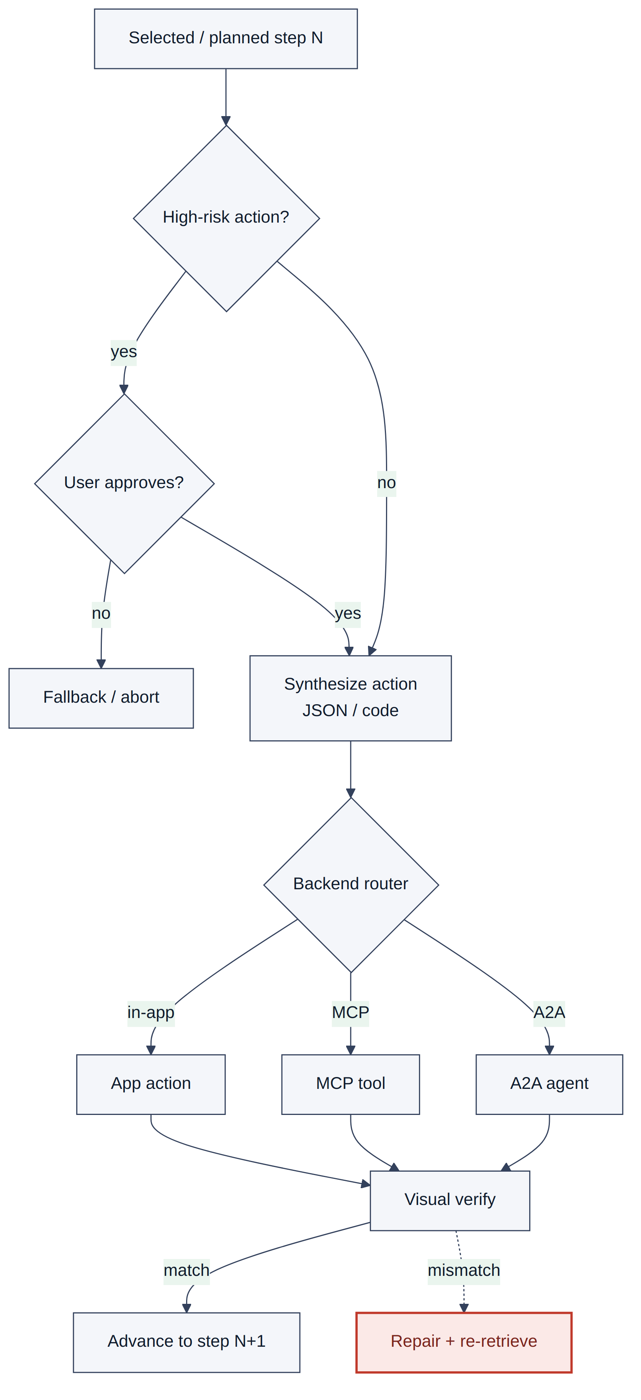
FIG. 4 — Approval & action execution. Optional approval gate for high-risk actions; three backends collapse into one verification node.
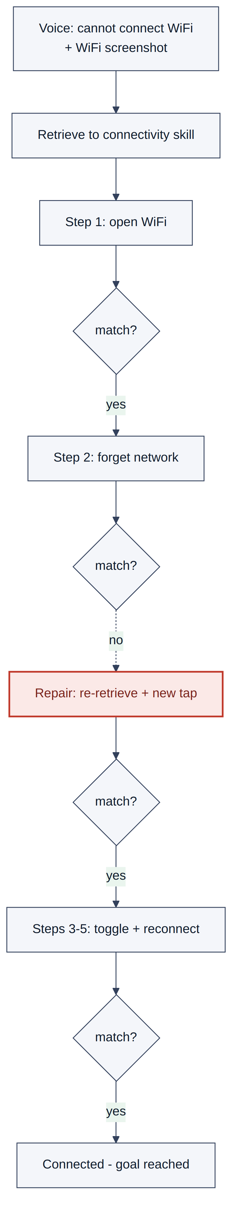
FIG. 5 — Use case 1 (WiFi, with repair). Step 2 fails verification; the repair path recovers before continuing.
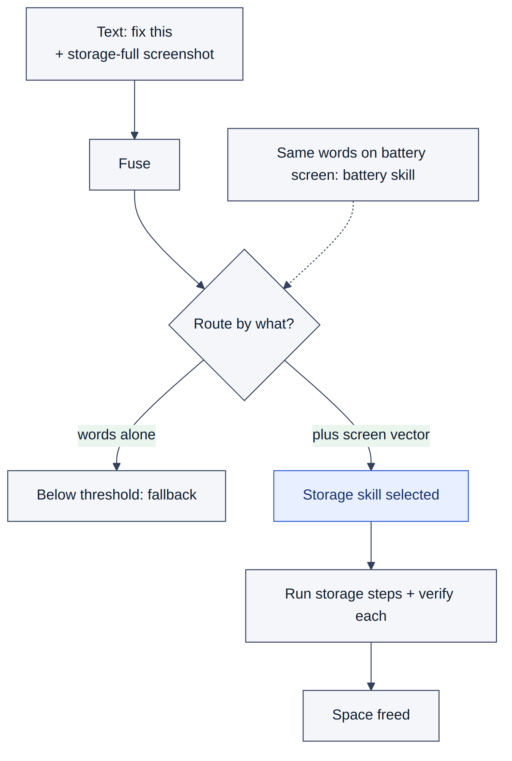
FIG. 6 — Use case 2 (vague query, screen disambiguation). The screen vector, not the words, lifts the correct skill over the selection threshold.
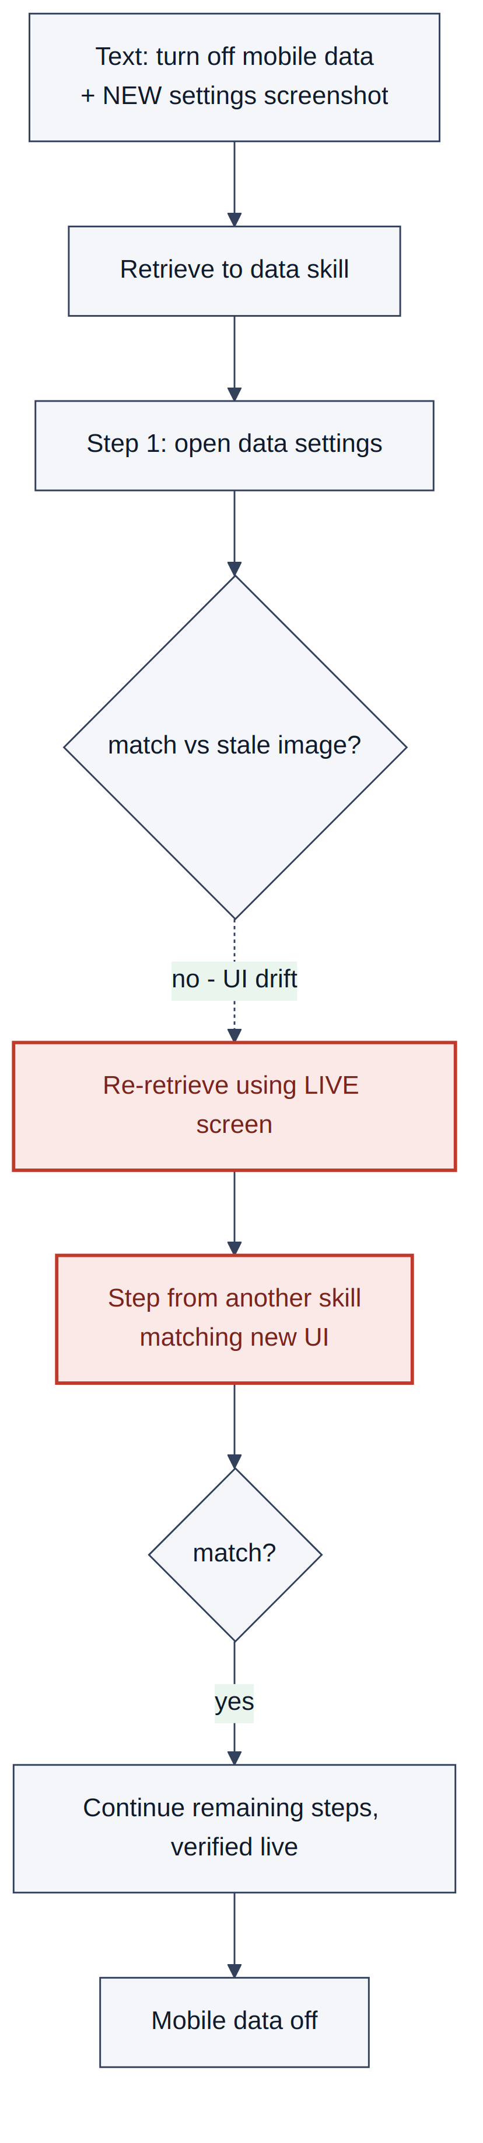
FIG. 7 — Use case 3 (UI drift, re-retrieval + composition). On drift, retrieval re-grounds on the live screen and splices a matching step from another skill.
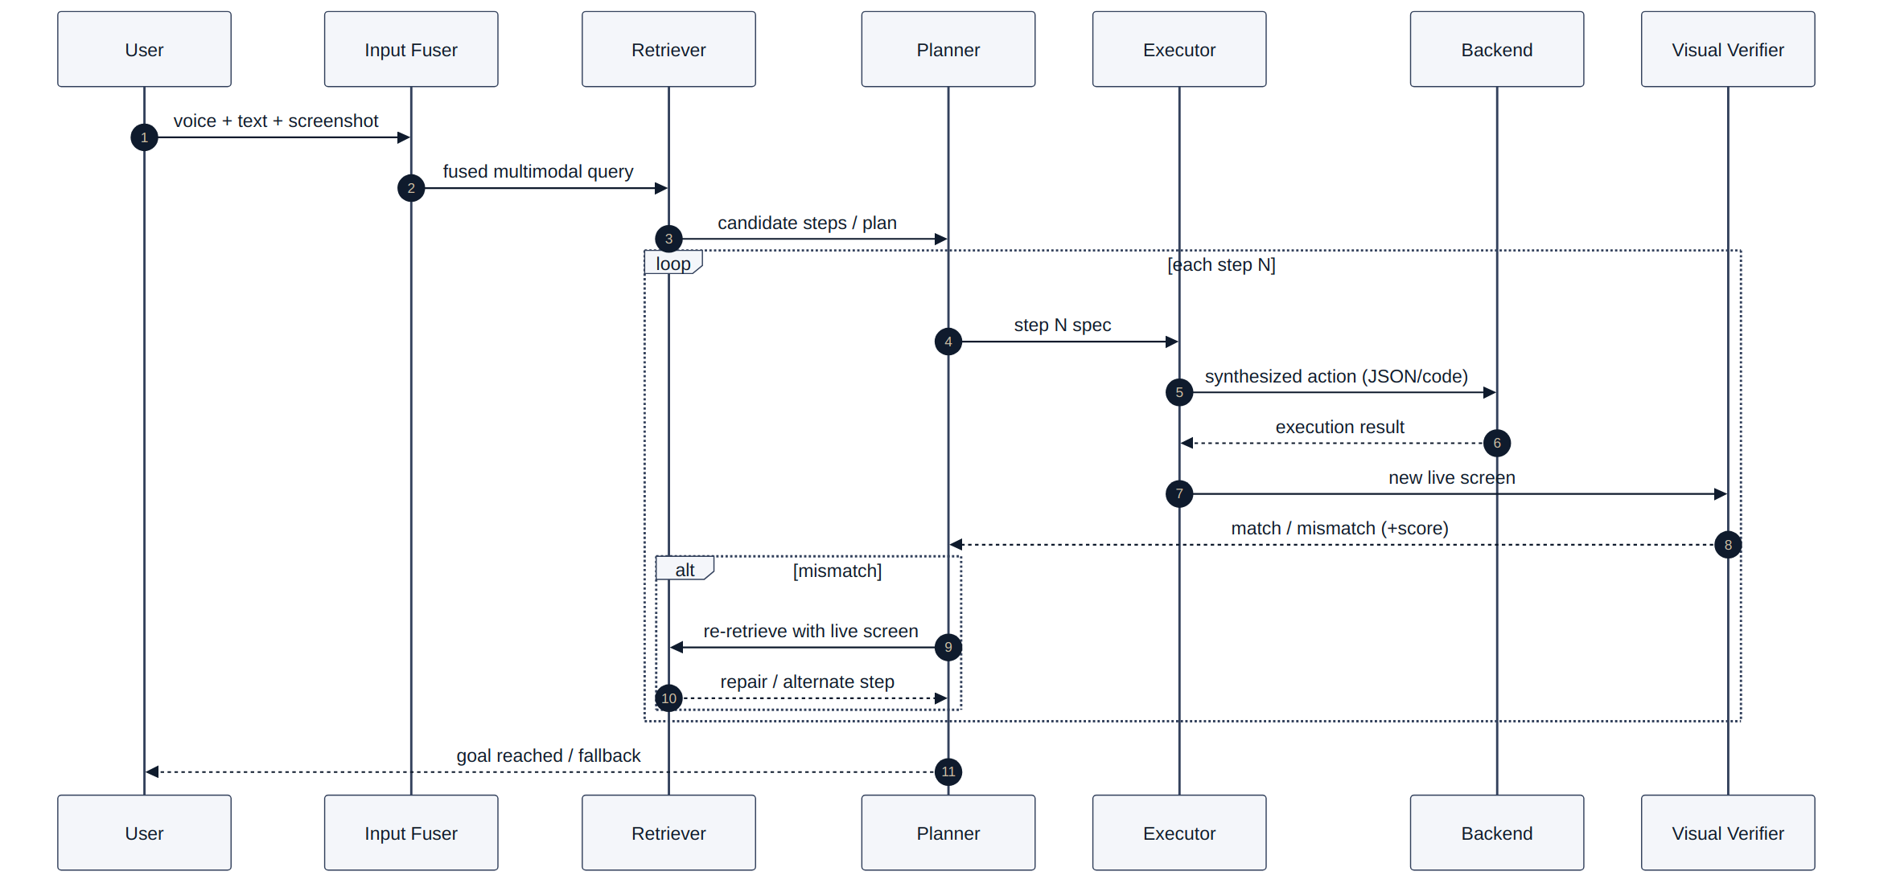
FIG. 8 — Sequence diagram. The alt mismatch block is the execution-grounded re-retrieval interaction.

13 · Creating professional PNG / PPT diagrams
General: canvas 1920×1080 (16:9); export PNG at 2× (3840×2160). Palette: reuse = green (#2E8B57/#EAF5EE), new = blue (#2D5BD7/#E8F0FF), ★ loop = red dashed (#C0392B). One sans font, 18–24 pt node text, 28–32 pt titles. Solid arrows = forward flow; dashed red = feedback; diamonds = decisions. Number every figure “FIG. N”.
- FIG. 1: five swimlanes L0–L6; index as a cylinder; shade reuse-green vs new-blue; make the two red dashed returns prominent.
- FIG. 2 / 4 / 5–7: one per slide; render the mismatch/repair node in red so the differentiator is obvious.
- FIG. 3: center the shared embedding space; single dashed verifier→RAG arrow.
- FIG. 8: standard UML sequence; shade the alt mismatch block.
- FIG. 9: modules as boxes with labeled input/output ports; dashed boundary grouping reuse vs new.
Toolchain: the diagrams in this document were rendered from Mermaid source. Easiest path to edit — copy each Mermaid block (from the companion .md/.html) into mermaid.live → export SVG → open in PowerPoint/Illustrator → recolor to the palette → export PNG @2×. Rebuild FIG. 1/9 as native PPT shapes if you need them editable; keep FIG. 2/4/8 as SVGs. Use one master slide for shared fonts/colors.

14 · High-level claim concepts (not final legal claims)

System concept
An on-device system comprising a shared text-image embedding index of skill steps, each step associated with a visual success-condition; a retriever that selects/composes steps from a fused query including a device screenshot; an executor that synthesizes and dispatches per-step actions to heterogeneous backends; a verifier that compares the post-action live screen to the step's visual success-condition; and a controller that, on a verification failure, re-retrieves a subsequent step using the live screen and synthesizes a corrected action.

Method concept
Capturing multimodal input including a device screen; retrieving/composing a multi-step procedure from a shared multimodal space; for each step synthesizing and executing an action, then verifying the resulting live screen against an authored visual success-condition; and on mismatch, re-retrieving using the live screen and synthesizing a different action, thereby grounding retrieval in visual execution outcome.

Dependent directions
Screen-conditioned ranking that lifts a candidate above a selection threshold; step-level composition across skills; graceful degradation to text-only when no screenshot is available; bounded repair/retry budget then fallback; optional approval gate for high-risk actions; backend selection among in-app/MCP/A2A; expected-result as image embedding verified by similarity threshold τ; integrity/version-drift handling via re-grounding.

15 · Assumptions, open questions & items to confirm
Resolved: shared text+image space (Version 2) feasible; on-device candidates exist (MobileCLIP2 / SigLIP-2, ONNX-quantized).
Blockers — confirm on the Knox build (collapse a branch if false): [A2] Screenshot access at routing time (permissions, timing) — the whole loop depends on this. [A3] Skills authored with step images + expected-result images — who authors, in what format. [A1] On-device embedder meets latency/battery budget (verification runs every step).
Design forks (change novelty/build): visual success-condition authored vs auto-derived (authored = stronger, narrower novelty — recommended); dynamic action = generate code vs fill JSON templates; MCP/A2A near-term vs aspirational (in-app assumed primary); voice firm vs future; verification metric = pure similarity vs hybrid.
Process / legal: inventorship to be confirmed (contributors: K. Kalita; architectural direction S. Mani; novelty coordination Renju CNAIR) — a legal determination, not assumed here. Prior-art sweep required before drafting claims. Classes: G06F 9/451, G06V (30/40), G06F 16/532–538 & 16/55x, G06N, G06F 11/14, G06F 3/16.
★ Honest posture: broad framings (multimodal RAG, agentic RAG, GUI agent) are prior-art-dense. The fileable invention is the specific combination N1–N4 — execution-grounded re-retrieval driven by authored per-step visual success-conditions, on-device. Prior-art risk levels here are internal hypotheses, not search results.

16 · Consolidated invention disclosure
Field | Entry
Title | On-Device Multimodal Skill Agent with Execution-Grounded Retrieval and Per-Step Visual Verification (VESPER)
Inventors | K. Kalita; others to confirm (R. CNAIR; architectural direction S. Mani)
Team / org | Knox AI, SRI-B
Field | On-device agentic GUI automation; multimodal information retrieval; computer vision
Problem | Text-only single-shot skill RAG ignores the live screen, discards visual skill content, and never verifies execution — causing mis-routing, lost skills, wrong actions, no recovery under UI drift.
Solution | Closed multimodal loop: fuse voice+text+screenshot; retrieve/compose step-granular skills from a shared text+image space; execute per-step across in-app/MCP/A2A; verify each step against an authored visual success-condition; on mismatch re-retrieve using the live screen and synthesize a corrected action.
Key novelty | Retrieval grounded in on-device per-step visual execution outcome (N2), via authored visual success-conditions (N1), with mismatch-driven repair (N3) and runtime step composition (N4).
Differentiators | Not a chatbot (acts), not OCR (verifies + retrieves), not a generic GUI agent (authored per-step visual goals drive retrieval re-grounding at step granularity, on-device).
Primary effects | Higher correct-routing on ambiguous queries; recovery from step failures and UI drift; reduced wrong-action execution; adaptive cross-skill procedures.
Reused | Hybrid retrieval, RRF, section boost, threshold/selection, fallback.
New | Shared embedder + step index, multimodal fuser, per-step visual verifier, action synthesizer, backend router, orchestration agents, execution-grounded re-retrieval loop.
Figures | FIG. 1–11 (architecture, flow, vision+RAG+agent, approval/exec, 3 use cases, sequence, components, data model, lifecycle).
Maturity | Concept + architecture; prototyping pending confirmation of [A1]/[A2]/[A3].
Blockers / open | Screenshot access; authoring with expected-result images; on-device embedder budget; action-synthesis approach; MCP/A2A scope; inventorship; prior-art sweep.
Risk posture | Fileable if claimed narrowly on N1–N4; broad claims expected to face dense prior art.
Next steps | (1) Confirm blockers on Knox build; (2) prior-art sweep; (3) draft claims with counsel; (4) prototype the verify→re-retrieve loop for evidence.
Internal draft — all items marked [ASSUMPTION]/[A#]/[OPEN] require confirmation before external filing. Prior-art risk levels are internal hypotheses, not search results.

