Context-Grounded Neural Barcode Recovery
Recovering Damaged Barcodes On-Device with the Knox Dynamic RAG Stack
Concept, Architecture, and Step-by-Step Use Cases

1. The Problem, In Plain Words
A barcode stores only a short string of text — nothing more. An EAN-13 on a soap pack stores 8901030865278; a shipping label stores a tracking ID like TRK4482915530IN; a DataMatrix on a drug vial stores a drug code, expiry, lot, and serial. The product name, the price, the recipient — all of that lives in a database. The barcode is only the key that opens the right database record.
Built into most barcodes is some self-checking mathematics. 1D codes carry a check digit (a weighted-sum formula over the other digits — if one digit is misread, the formula fails). 2D codes carry Reed-Solomon (RS) error correction — spare modules that can restore the message when part of the grid is destroyed, up to a fixed budget.
When a barcode is clean, scanning is a solved problem. When it is damaged — torn, faded, rain-soaked, scratched, oily, beyond what RS can repair — classical decoders and hardware scanners return nothing. The frontline worker then types a 13–15 character code by hand, calls a supervisor, or skips the scan. In a hospital, skipping the medication scan is a documented patient-safety problem; in a warehouse it is minutes lost per box; on a delivery route it is a courier typing tracking IDs in the rain.
In simple terms: A barcode is a key to a database record, with some built-in math for self-checking. Damage breaks the key, the scan fails, and a human pays for it in time or risk.

2. The Idea, In One Page
When a barcode is damaged, the decoded string is not a trusted key — it is noisy evidence. Our system treats it that way, in five moves:
① Read with uncertainty. A neural decoder reads the damaged crop and outputs not one answer but its top-k guesses, and for every character position, a probability over what that character could be (“digit 12: P(1)=0.34, P(7)=0.31…”).
② Retrieve what is possible right now. The same Dynamic RAG stack used for Knox skill routing retrieves, from the enterprise context, the small set of payloads that can even occur here and now: this truck’s manifest, this patient’s medication orders, this courier’s route. Global universe: ~10¹³ codes. Retrieved universe: 5 to a few thousand.
③ Let the image decide. Each retrieved real candidate is run back through the decoder to compute its exact probability given the image, P(candidate | image). String similarity can shortlist candidates; only the pixels can choose between two candidates that differ in one digit.
④ Verify twice. Math check: does the check digit / RS parity hold? World check: does this payload exist in the retrieved context? A guess must pass both.
⑤ Act by risk. Auto-accept when the winner is clear (warehouse, retail, courier); one round of repair (widen the context, retrieve again, rescore) when it is not; a one-tap human confirmation when still ambiguous; and in safety-critical settings (medication), warn — never silently correct.
In simple terms: Instead of trusting a shaky reading, the system asks “what codes are even possible right now?”, checks each possibility against the picture and the math, and only then acts — cautiously where mistakes are dangerous.

2.1 Why not simply look up the guesses in the database?
Direct lookup of the top guesses fails in four realistic ways, each covered by one part of the design:
- The correct string is in none of the guesses. Lookup dead-ends. Fuzzy retrieval finds the real payload that shares 12 of 13 digits with a wrong guess (covered by ②).
- Two guesses both exist in the database. Lookup cannot choose. The image can (③).
- A wrong guess exists in the database. Lookup silently books the wrong item — the worst failure. The world check catches it, because the wrong item is not on this truck / this patient’s orders (④).
- There is no complete guess. Half the label is gone; you cannot look up a string with holes, but you can score whole real candidates against the partial evidence (③).
When damage is mild, direct lookup and our system behave identically — retrieval adds nothing and is not even triggered. The value appears exactly where lookup collapses: severe damage.

3. Architecture

3.1 The retrieval stack is the Knox skill-RAG stack, unchanged
The retrieval machinery is deliberately identical to the Dynamic Skill RAG already built and shipped for Knox: the same three indexes, the same fusion, the same closed loop. Only two things change: what is indexed (barcode context records instead of SKILL.md files) and how a result is verified (barcode mathematics + context membership instead of visual screen-state similarity).
Component | Knox Skill RAG | Barcode Recovery
Indexed documents | SKILL.md skill procedures | Barcode context records: payload + product/part/drug + operational metadata
Structured store | SQLite / Room | SQLite / Room — context filters and priors (PO, patient, route stop, scan sequence)
Sparse index | FTS4 / BM25 over skill text | FTS / BM25 over character n-grams of payloads and product names
Dense index | USearch HNSW over skill embeddings | USearch HNSW over record text embeddings; optionally packaging photos
Fusion | RRF, k = 60 | RRF, k = 60 — identical
Query | User intent / task text | Decoded guesses + context signals (location, PO, scan history)
Verification | Screen state vs expected step (embedding similarity) | Check digit / RS parity + membership in the active context set
Mismatch handling | Execution-grounded re-retrieval | Context widening + re-retrieval
Repair | Mismatch-driven action repair | Posterior rescoring of retrieved candidates against the image; RS-erasure decoding for 2D
Dynamic element | Skills retrieved per query | Active payload set switched per truck / patient / route / shift

One precision note on the dense index: we do not embed the damaged barcode crop itself for retrieval. Barcode patterns of different payloads are visually near-identical (black bars on white), so generic image embeddings cannot tell them apart. The dense leg therefore indexes what is distinctive — the textual record (product name, category, metadata) and, optionally, packaging photos matched against a wider camera crop when the pack is visible. Image evidence about the barcode itself enters through Step ③ (posterior rescoring), where it is exact rather than approximate.

3.2 The pipeline
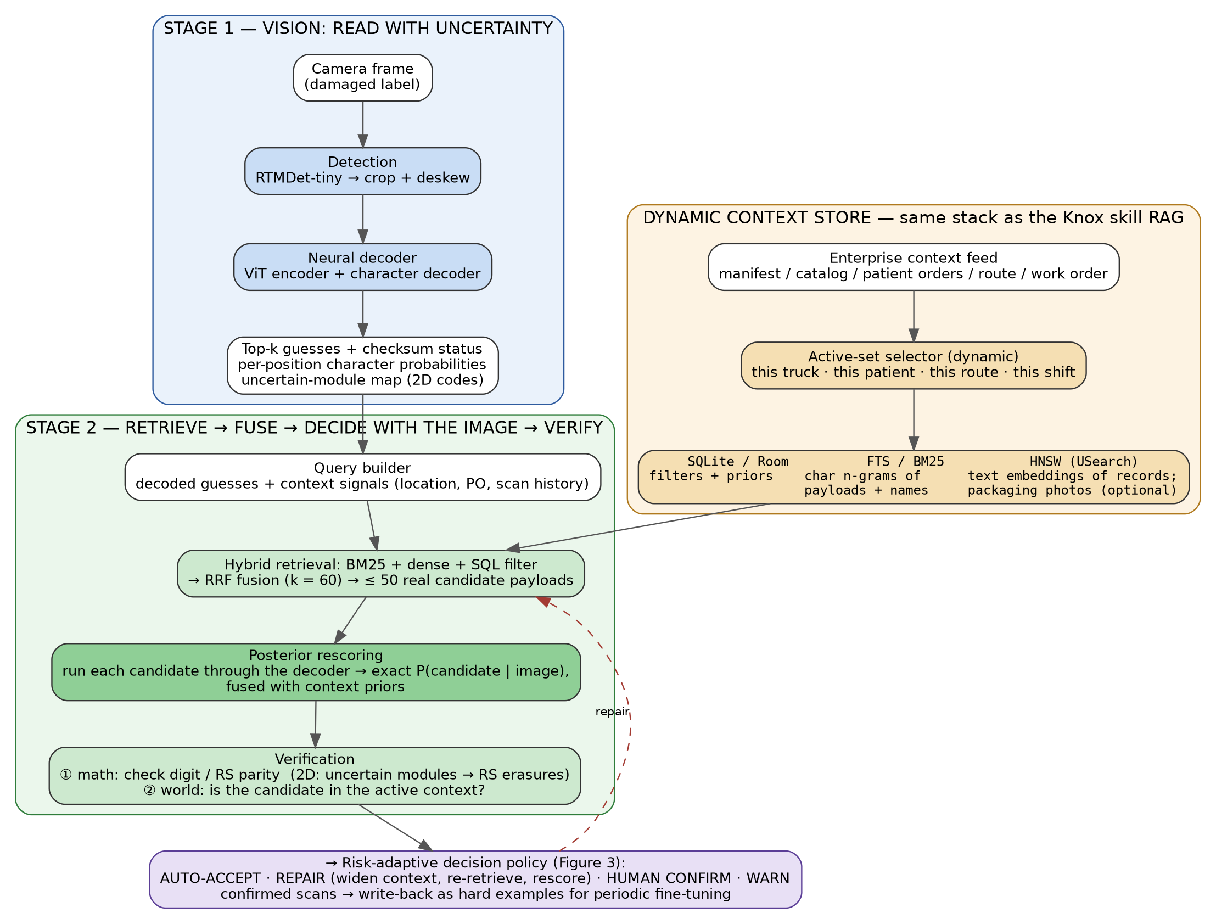
Figure 1 — End-to-end architecture. Stage 1 reads the damaged code with uncertainty. The Dynamic Context Store is the Knox RAG stack (SQLite + BM25/FTS + HNSW, RRF k=60) indexing the enterprise’s valid payloads, with an active set that switches per truck/patient/route/shift. Stage 2 retrieves real candidates, lets the image choose among them, and verifies with math + context.

3.3 The two mechanisms that make it accurate

Posterior rescoring — the image chooses among real candidates
After retrieval produces ≤50 real payloads, each one is run through the decoder in “teacher-forcing” mode: the decoder is asked, character by character, “how probable is exactly this string, given this image?” Summing the per-character log-probabilities gives the exact conditional likelihood P(candidate | image). This is one batched forward pass — cheap on-device — and it uses information no string-matching method has: the pixels.
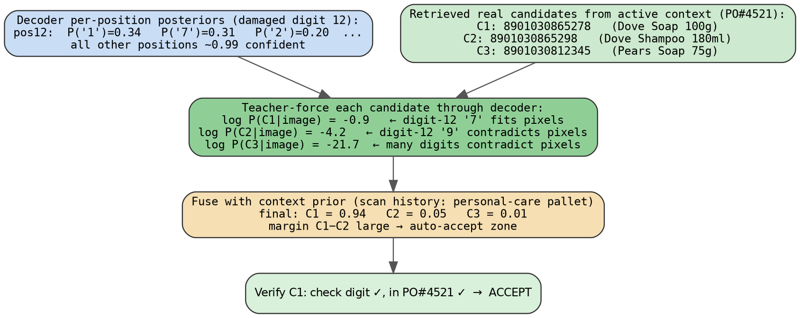
Figure 2 — Posterior rescoring on a real scenario. Two candidates differ only at the damaged digit 12 (‘7’ vs ‘9’). Their string distance to the decoder’s guess is identical; their pixel-grounded likelihood is not (−0.9 vs −4.2). The image decides.
In simple terms: Retrieval makes a shortlist of real codes; then we ask the model “which of these does the photo actually look like?” and it answers with a precise probability for each.

RS-erasure decoding — telling the math where the damage is (2D codes)
Reed-Solomon correction has a useful property: a code that can fix t errors at unknown positions can fix up to 2t missing symbols at known positions (“erasures”). Our decoder knows which grid modules it is unsure about — so we hand those positions to the RS decoder as erasures. The same physical damage that defeats a classical scanner (which does not know where the damage is) becomes recoverable, and the result is confirmed or rejected by parity mathematics, not by guesswork.
In simple terms: 2D codes carry spare “repair” data. Repair goes twice as far if you know where the holes are — and our model knows. So we point at the holes and let the barcode’s own math finish the job, with a hard pass/fail at the end.

3.4 The decision policy
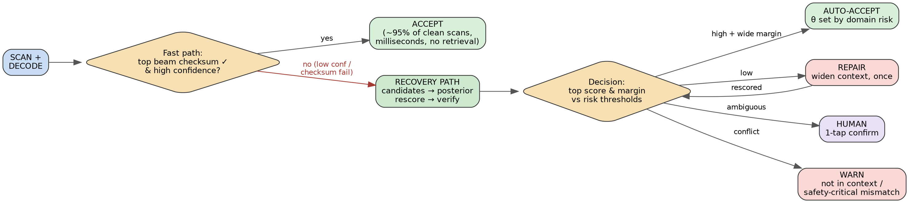
Figure 3 — Fast path vs recovery path. Clean scans (the vast majority) exit at the decoder in milliseconds and never touch retrieval. The recovery path triggers only on low confidence or checksum failure — exactly the scans that would otherwise cost minutes of manual fallback.
- Auto-accept: winner passes both checks with a wide margin over the runner-up. Thresholds are set per domain risk.
- Repair (one round): no winner → widen the context (drop the PO filter, boost categories and sequence neighbours from scan history), re-retrieve, rescore. The direct analogue of Knox’s mismatch-driven re-retrieval.
- Human confirm: still ambiguous → the top candidates are shown with product names and photos (retrieval is what turns raw digits into recognisable choices); the worker taps once.
- Warn: the best candidate conflicts with the context (“not on this truck”, “not on this patient’s orders”) → flag it. In safety-critical mode the system never silently corrects.
- Write-back: every confirmed scan yields a verified (damaged crop → true payload) pair — exactly the hard examples worth collecting. They feed periodic decoder fine-tuning and threshold calibration. (We claim gradual improvement through retraining, not instant learning.)

4. Use Cases — Step by Step
Five frontline scenarios, each processed through the same pipeline. Every walkthrough shows the concrete data at each step and the final outcome. What varies across domains is only: the context store, the world-check question, and the repair policy — which scales with the cost of a wrong answer.

4.1 Warehouse receiving — torn shipment label
A worker at dock 7 receives boxes against purchase order PO#4521.
Step 0 — Context store (offline, before the truck arrives). The digital manifest lands: 200 items. One record each, e.g.:
payload: 8901030865278 | product: Dove Soap 100g | symbology: EAN-13
PO: 4521 | dock: 7 | category: personal care | pallet: PL-09
Step 0 — (cont.) Indexing. SQLite holds the metadata and priors; BM25/FTS indexes character n-grams of the 200 payloads and product names; HNSW indexes the record texts. The active-set selector marks these 200 records as “live” for dock 7 today.
Step 1 — Scan and detect. The worker scans a box with a torn label. RTMDet finds the barcode in the frame, crops and deskews it.
Step 2 — Decode with uncertainty. The decoder outputs beams — note the tear has made digit 12 ambiguous, and the most confident guess is wrong:
A: 8901030865218 conf 0.61 check digit ✗
B: 8901030865278 conf 0.58 check digit ✓
posterior @ digit 12: P('1')=0.34 P('7')=0.31 P('2')=0.20
Step 3 — Fast path declines. Top beam fails the check digit and the margin is narrow → the recovery path triggers.
Step 4 — Retrieve. Query = beams + context {dock 7, PO#4521, last 5 scans: personal-care pallet}. BM25 n-gram search over the 200 live payloads returns the near-matches; SQL keeps only PO#4521; the dense leg stays idle here (no packaging visible in the crop, and digits carry no text meaning). RRF fuses to 3 real candidates:
C1: 8901030865278 Dove Soap 100g
C2: 8901030865298 Dove Shampoo 180ml
C3: 8901030812345 Pears Soap 75g
Step 5 — Posterior rescoring. Each candidate is teacher-forced through the decoder against the crop:
log P(C1|image) = -0.9 ← digit-12 '7' fits the pixels
log P(C2|image) = -4.2 ← digit-12 '9' contradicts the pixels
log P(C3|image) = -21.7 ← many digits contradict the pixels
Step 5 — (cont.) Prior fusion. Scan-history prior (same pallet = personal care) nudges C1/C2 up; final scores 0.94 / 0.05 / 0.01 — a wide margin.
Step 6 — Verify. C1: check digit ✓ (math), present in PO#4521 ✓ (world). Both pass.
Step 7 — Outcome. Auto-accept. The phone shows “✓ Dove Soap 100g — received”, the manifest line is ticked, total time ~1 second, zero extra effort. The (torn crop → 8901030865278) pair is logged as a verified hard example. Without the system: the worker types 13 digits from a torn label.

4.2 Retail checkout — crumpled packaging
A cashier scans a crumpled chips pack that the hardware scanner has already rejected.
Step 0 — Context store. The store’s POS catalog: ~30,000 SKUs, each with payload, product name, department, price, and a clean pack photo. Whole catalog is “live”; the terminal’s department and the current basket act as priors, not hard filters.
payload: 8901491101837 | Lays Magic Masala 52g | dept: snacks | ₹20
Step 1 — Scan and detect. Camera frame of the crumpled pack; RTMDet crops the wrinkled barcode, and also captures the wider pack crop (packaging is visible here).
Step 2 — Decode.
A: 8901491101887 conf 0.55 check ✗
B: 8901491101837 conf 0.52 check ✓
Step 3 — Fast path declines. Checksum failure on the top beam → recovery path.
Step 4 — Retrieve. BM25 n-grams over 30k payloads shortlist the near-matches; SQL boosts dept = snacks (basket already holds two snack items); the dense leg is active here — the wider pack crop is matched against stored pack photos and independently points at the Lays record. RRF fuses to 4 candidates.
Step 5 — Posterior rescoring. The wrinkled barcode crop scores the candidates; guess-B’s payload wins with log P = −1.4, runner-up −5.1 — wide margin. The packaging match agrees.
Step 6 — Verify. Check digit ✓; SKU exists in this store’s catalog ✓.
Step 7 — Outcome. Auto-accept. “Lays Magic Masala ₹20” lands on the bill instantly. Fallback case: had the margin been narrow, the cashier would see two candidates with pack photos and tap the right one — still faster than a supervisor call or a manual price lookup.

4.3 Hospital medication scan — worn vial label (safety-critical)
A nurse scans the patient’s wristband, then the drug vial, before administration (BCMA workflow). The vial’s DataMatrix is worn and curved; its built-in RS correction has already failed.
Step 0 — Context store. Two layers: the hospital formulary (all stocked drugs), and per patient, the active medication orders. Scanning the wristband selects the active set — for patient P-1042, just 7 records:
(01)08901234567894 | Amoxicillin 500mg | P-1042 | due 08:00, 20:00 | oral
Step 1 — Scan and detect. Wristband scan sets context = P-1042 (time now 08:02). Vial scan: RTMDet crops the curved DataMatrix.
Step 2 — Decode. Beams over the GS1 payload; the decoder also emits the uncertain-module map:
A: (01)08901234567894 (17)270331 (10)LOT4432 conf 0.57
B: (01)08901234567897 (17)270331 (10)LOT4482 conf 0.49
Step 3 — Math check with erasures. The uncertain modules are handed to the RS decoder as erasures. RS now recovers and confirms the codeword consistent with beam A — parity passes. (Had parity failed for all beams, the system would proceed on retrieval + rescoring alone, at lower confidence.)
Step 4 — Retrieve. SQL restricts to P-1042’s 7 orders; BM25 matches the decoded drug code; the dense leg matches “Amoxicillin” record text. One candidate dominates.
Step 5 — Verify — world + safety extras. Drug is on this patient’s active orders ✓; payload expiry 2027-03 not passed ✓; dose due now ✓.
Step 6 — Outcome. Confirm to administer: “✓ Amoxicillin 500mg — matches order, due 08:00.”
Step 7 — The critical branch. Suppose instead the vial decodes, with RS parity confirmed, to Atorvastatin — a drug not on P-1042’s orders. Policy: the system never auto-corrects toward the patient’s order list, because doing so could mask a genuine wrong-drug event. It identifies the vial against the full formulary and raises: “⚠ This appears to be Atorvastatin — NOT on this patient’s orders. Do not administer; verify with pharmacy.” The value here is keeping the nurse inside the scanning workflow — the documented failure mode of barcode medication systems is nurses skipping failed scans.

4.4 Last-mile delivery — rain-soaked label
A courier at a doorstep scans a soggy shipping label.
Step 0 — Context store. The day’s route, downloaded each morning: ~120 packages.
TRK4482915530IN | R. Sharma | 12 MG Road | stop 37 | geo 12.9716,77.5946
Step 1 — Scan and detect. Wet, glare-heavy frame; RTMDet crops the Code-128 strip.
Step 2 — Decode.
A: TRK4482915580IN conf 0.48 check char ✗
B: TRK4482915530IN conf 0.45 check char ✓
Step 3 — Fast path declines. Low confidence → recovery path.
Step 4 — Retrieve. SQL: undelivered packages within 300 m of current GPS → 3 candidates; BM25 n-grams over tracking IDs rank B’s payload first (14 of 15 characters); stop-sequence prior boosts stop 37 (last delivered: 36). RRF fuses.
Step 5 — Posterior rescoring. The wet crop scores the 3 candidates; B’s payload wins with a wide margin — the smudged character reads ‘3’ far better than ‘8’.
Step 6 — Verify. Code-128 check character ✓ (modulo-103); package on this route, at this location ✓.
Step 7 — Outcome. Auto-accept. Proof-of-delivery flow opens for R. Sharma automatically. Without the system: typing TRK4482915530IN by hand, in the rain, or calling the hub.

4.5 Manufacturing traceability — DPM code on oily metal
A line worker scans a DataMatrix dot-peened onto a crankshaft: low contrast, oil film, scratches — the hardest imaging conditions.
Step 0 — Context store. The station’s work order for the shift:
ENG-7742-0093-B | crankshaft assy | WO-518 | station 12 | seq 93
Step 1 — Scan and detect. RTMDet localises the faint dot grid on curved metal.
Step 2 — Decode. Damage exceeds the code’s normal RS budget. Beams:
A: ENG-7742-0098-B conf 0.44
B: ENG-7742-0093-B conf 0.41
uncertain-module map: 11 modules flagged
Step 3 — Math check with erasures. The 11 flagged modules go to RS as erasures — twice the correction reach of unknown-position errors. RS reconstructs and parity-confirms the codeword for serial ...0093-B. This is a hard mathematical accept, not a guess.
Step 4 — Retrieve (confirmation role here). SQL: serials expected at station 12 under WO-518; sequence prior: last scan was ...0092 → ...0093 strongly expected. Retrieval agrees with the RS result.
Step 5 — Verify. RS parity ✓ (already); serial in WO-518 ✓; fits sequence ✓.
Step 6 — Outcome. Auto-accept; traceability record written, no line stoppage. The valuable failure branch: a serial that parity-confirms but is not in this work order → “⚠ Part not expected at this station — possible mis-routed part. Hold.” The system catches an assembly error, not merely a scan error.

4.6 One pattern, five domains
 | Warehouse | Retail | Hospital | Courier | Factory
Context store | Manifest (~200) | Catalog (~30k) | Patient orders (5–10) | Route (~120) | Work order (~150)
Dynamic context | PO + dock + pallet history | Dept + basket | Wristband + dose time | GPS + stop sequence | Station + serial sequence
World check | On this truck? | In this store’s catalog? | On this patient’s orders? | On my route, near me? | In this WO, in sequence?
Repair policy | Auto-correct | Auto-correct | Warn only — never auto-fix | Auto-correct | RS-erasure confirmed
Final outcome | Manifest ticked | Item billed | Administer / alarm | POD opens | Traceability logged

Two design rules run through all five: context size is the safety lever — correcting a damaged code is only safe because the candidate universe is 5–30,000 context-selected items rather than 10¹³ global codes — and the correction budget scales with the cost of a wrong answer, from full auto-correct at the dock to warn-only at the bedside.

5. What We Claim — and What We Do Not
- We claim: large recovery gains on severely damaged codes, growing with degradation severity, versus classical decoders (ZXing/ZBar), the plain neural decoder, and an exact-lookup baseline — measured per severity level, per context-set size, and per component (retrieval only / + rescoring / + RS erasures / + priors).
- We claim: unchanged latency on clean scans — the recovery path triggers only on low confidence or checksum failure, and its cost (one batched decoder pass over ≤50 candidates) replaces minutes of manual fallback.
- We claim: safer failure behaviour — the world check converts “silently booked the wrong item” into a visible warning; in medication mode, the system warns and never auto-corrects.
- We do not claim: that retrieval helps on mildly damaged codes (it is not even triggered); that the damaged barcode crop can be identified by image-embedding similarity (barcode patterns are not visually distinctive — image evidence enters only through exact posterior rescoring); or that the system improves instantly without retraining (write-back collects verified hard examples for periodic fine-tuning).
- Honest limits: if two payloads on the same manifest differ only at the destroyed positions, no method can separate them from the image — the policy routes exactly these cases to one-tap human confirmation, and we measure how often they occur (collision rate vs context size). Decoder probabilities are calibrated on degraded validation data before thresholds are set. Stale or wrong context data surfaces as warnings rather than being hidden.

6. Summary
The Knox Dynamic RAG stack — SQLite + BM25/FTS + HNSW with RRF fusion, a dynamically selected active knowledge set, verification, and mismatch-driven re-retrieval and repair — transplants cleanly from skill routing to damaged-barcode recovery. What the barcode domain adds is unusually strong verification: check digits, Reed-Solomon parity with erasure decoding, and membership in a context that the enterprise already maintains. What the neural decoder adds is exact, image-grounded arbitration among retrieved candidates. Together they turn a failed scan — today a manual, error-prone interruption — into an automatic or one-tap recovery, with a correction policy that becomes strictly more cautious as the cost of being wrong rises.

