Project Brief & Architecture: ChefStack Restaurant OS
1. Executive Summary
ChefStack is a unified, multi-tenant Software-as-a-Service (SaaS) platform designed to serve as the complete Operating System for restaurants. It replaces fragmented, legacy systems by combining Point-of-Sale (POS), Back-of-House Inventory (OpsHub), and Document Management into a single ecosystem.
Beyond standard SaaS utility, ChefStack operates as a Dual-Sided Marketplace. It connects restaurants with food distributors (B2B) for automated procurement, and connects consumers with other restaurants in the network (B2C) for cross-promotional marketing.
2. Business Model: How ChefStack Generates Profit
The financial architecture is designed to capture value at multiple stages of a restaurant's lifecycle. Revenue is generated through four distinct pillars:
A. Setup, Onboarding, & Hardware (One-Time Fees)
Restaurants pay upfront for full-service digital and physical onboarding.
- Digital Setup: Configuring Google Business profiles, integrating with 3rd-party delivery apps (DoorDash, UberEats), building their custom website, and providing professional food photography.
- System Setup: Manual data entry of their existing inventory, menus, and vendor lists into the ChefStack database.
- Hardware: Installation of POS terminals and Kitchen Tablets.
B. Module-Wise SaaS Subscriptions (Recurring Monthly Revenue)
ChefStack uses an à la carte subscription model. Restaurants only pay for the software modules they actively use.
- POS Module: Core front-of-house sales processing.
- OpsHub Module: Inventory management, Document storage (compliance/invoices), and AI-driven insights.
- Advanced Analytics: Premium dashboards for deep business intelligence.
C. B2B Procurement Marketplace (Commission Revenue)
ChefStack acts as a bridge between restaurants and food distributors.
- The Flow: A restaurant searches for a bulk ingredient (e.g., "50lb Bag of Onions"). ChefStack displays options and prices from multiple integrated distributors. The AI Procurement Engine can also auto-draft these orders based on low stock.
- The Profit: When a restaurant places an order through ChefStack, the platform takes a percentage commission from the distributor for routing the sales volume to them.
D. B2C Marketing & Cross-Pollination (Performance-Based Revenue)
A shared customer loyalty and marketing network.
- The Flow: ChefStack tracks diner identities across all restaurants using the POS (e.g., via phone number). If a loyal customer of Restaurant A receives a marketing email from ChefStack to try Restaurant B, and they successfully dine there, ChefStack tracks that transaction.
- The Profit: ChefStack takes a percentage cut of the final bill from Restaurant B as a finder's/marketing fee.
3. Core System Features
- Manager Portal (OpsHub): A web-based dashboard for viewing analytics, managing vendor logistics (lead times, contact methods), and uploading compliance documents.
- Bulk Inventory System: Tracks raw stock quantities, sets Minimum (Alert) and Maximum (Target) thresholds. Note: Excludes micro-recipe ingredient tracking to reduce staff friction.
- AI Procurement Engine: Monitors inventory thresholds and automatically drafts order requests (Emails/SMS) to vendors when stock is low. Managers review, approve, or discard these drafts.
- Delivery Discrepancy Tracking: Allows kitchen staff to log when a vendor delivers less than what was ordered, creating an auditable history.
- Cross-Restaurant Marketing: Uses POS data to build a customer identity graph for automated, cross-restaurant promotions.
4. System Architecture Diagram
This diagram illustrates how the client-facing applications connect to the core backend, and how the marketplace and marketing engines sit on top of the data.
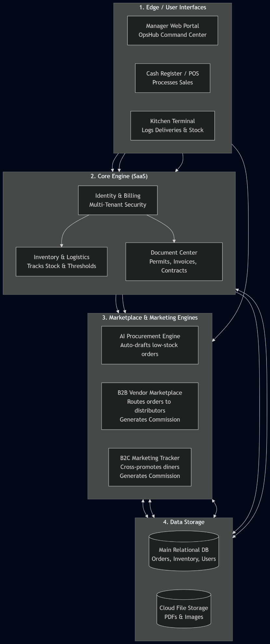

5. Database Entity-Relationship Diagram (ERD)
This normalized schema reflects the exact multi-tenant architecture required to run the business logic, isolating restaurant data while maintaining global ledgers for commissions.
